Joshua — People, Places & Things: Deep Bible Research
The Book of Joshua is the great transition from wilderness to inheritance, from Moses to Joshua, and from promise to possession. Its central question is not merely, “How did Israel conquer Canaan?” but “Will Israel trust and obey Yahweh, who is faithful to His covenant promises?”
Joshua has four major movements: entering Canaan (1–5), conquering key territories (6–12), distributing the land (13–22), and renewing the covenant/ Joshua's farewell (23–24).

I. THE BOOK AT A GLANCE
Category | Joshua
Hebrew name | Yehoshua — “Yahweh is salvation”
Greek form | Iēsous
Main character | Joshua son of Nun
Tribe | Ephraim
Predecessor | Moses
Successor | No single national successor; Judges follows
Setting | Canaan, east and west of Jordan
Main theme | God's faithfulness to His promises
Major theological issue | Faithful obedience to Yahweh
Key chapters | 1, 2, 3–4, 6, 7–8, 9–10, 14, 20, 22, 23–24
Traditional conquest date | c. 1406 BC
Alternative scholarly chronology | often places Israel's emergence/conquest processes in the 13th–12th centuries BC
The date is debated. Some conservative chronologies place the conquest around 1406 BC, while other reconstructions place Israel's emergence in Canaan later.

II. JOSHUA — THE CENTRAL PERSON
Joshua son of Nun
Joshua's name means essentially “Yahweh saves.” His earlier name was Hoshea/Hosea; Moses gave him the name Joshua (Numbers 13:8, 16).
His name becomes enormously important in biblical theology:
Joshua → Hebrew Yehoshua → Greek Iēsous → Jesus
So Joshua's name itself points toward the idea:
Yahweh saves.
He is not Jesus, of course, but his name and role provide an important Old Testament backdrop to the New Testament name of Jesus.

III. JOSHUA'S LIFE BEFORE THE BOOK OF JOSHUA
Joshua doesn't suddenly appear in Joshua 1.
His biography begins much earlier.
1. Joshua and the Amalekites
Exodus 17:8–16
Joshua first appears as Israel's military commander against Amalek.
Moses says:
“Choose for us men and go out and fight with Amalek.”
Joshua obeys.
This is significant because Joshua is introduced as a warrior before he becomes Israel's national leader.

2. Joshua's relationship with Moses
Joshua becomes Moses' assistant.
Exodus 24:13
He accompanies Moses toward Sinai.
Exodus 32:17
Joshua is with Moses during the golden-calf crisis.
Exodus 33:11
Joshua remains near the tent of meeting.
Joshua therefore learns leadership by serving Moses before succeeding Moses.
That is one of the major leadership principles of the book:
Joshua's authority is developed through years of faithfulness.

IV. THE TWELVE SPIES
Numbers 13–14
This is arguably the most important event in Joshua's preparation.
Twelve spies investigate Canaan.
Only two give a faith-filled report:
- Joshua
- Caleb
The other ten emphasize the strength of the Canaanites.
Joshua and Caleb essentially say:
God has promised the land; therefore we should trust Him.
Because Israel refuses to believe, the wilderness generation is condemned to wander.
Joshua and Caleb survive.
This means Joshua enters Canaan carrying something extremely important:
He already knows what unbelief costs.

V. JOSHUA AND MOSES
There is an extraordinary parallel between the two leaders.
Moses | Joshua
Leads Israel out of Egypt | Leads Israel into Canaan
Crosses Red Sea | Crosses Jordan
Sends spies | Sends spies
Encounters God at Sinai | Encounters God at covenant ceremonies
Gives covenant law | Renews covenant
Battles enemies | Battles Canaanite kings
Gives farewell speech | Gives farewell speeches
Dies before entering Canaan | Dies after Israel receives inheritance
Joshua is deliberately presented as the successor who continues Moses' mission.
God tells Joshua:
“As I was with Moses, so I will be with you.”
— Joshua 1:5
That is crucial.
Joshua isn't told:
“Be a better Moses.”
He is told:
“I will be with you as I was with Moses.”

VI. THE MAJOR PEOPLE OF JOSHUA
A. Joshua
Joshua 1–24
Leader, warrior, covenant mediator, land distributor and final covenant-renewal leader.

B. Moses
Although he is already dead when Joshua begins, Moses remains foundational.
The entire mission rests on God's promises given through Moses.

C. Rahab
Rahab
Joshua 2
Rahab is one of the most remarkable people in the book.
She:
- lives in Jericho
- receives Israelite spies
- hides them
- deceives the king's representatives
- acknowledges Yahweh's supremacy
- asks for protection
- becomes incorporated into Israel
Her confession is astonishing:
Joshua 2:9–11
She has heard what Yahweh did:
- Red Sea
- Amorite kings
- Israel's victories
Her conclusion:
“The LORD your God, he is God in the heavens above and on the earth beneath.”
Rahab therefore represents a fascinating reversal:
A Canaanite woman believes while many Israelites had previously refused to believe.
She is later remembered in:
- Matthew 1:5
- Hebrews 11:31
- James 2:25

VII. ACHAN — THE MAN WHO STOLE THE DEVOTED THINGS
Achan
Joshua 7
Jericho is defeated.
Then Israel attacks Ai.
Israel loses.
Joshua initially doesn't understand why.
God reveals:
Israel has sinned.
Achan had taken items from Jericho.
The principle is extremely serious:
Israel is a covenant community.
One person's rebellion affects the community.
Achan's story contrasts dramatically with Rahab.
Rahab, a Canaanite, trusts Israel's God.
Achan, an Israelite, violates God's command.

VIII. ELEAZAR THE PRIEST
Eleazar
Eleazar, son of Aaron, works alongside Joshua in distributing the inheritance.
Joshua 14:1
This demonstrates the partnership between:
- Joshua — civil/military leadership
- Eleazar — priestly leadership
Israel's settlement is therefore both political and covenantal.

IX. CALEB
Caleb
Caleb is one of Joshua's most important companions.
He was one of the twelve spies.
He and Joshua alone remained faithful.
Joshua 14:6–15
Caleb is now 85 years old.
Yet he says:
“Give me this hill country.”
This is one of the greatest statements of spiritual perseverance in Scripture.
Caleb doesn't say:
“I'm too old.”
He says, essentially:
God kept His promise; now give me what He promised.

X. PHINEHAS
Phinehas
Joshua 22 is one of the most important chapters for understanding Israel's tribal unity.
The eastern tribes build an altar.
The western tribes fear apostasy.
Phinehas leads the investigation.
The altar turns out not to be for sacrifice but as a witness of unity between the tribes.
The episode teaches:
Misunderstanding can threaten covenant unity.
The tribes resolve the matter through investigation rather than immediate civil war.

XI. THE GIBEONITES
The Gibeonites are among the most fascinating people in Joshua.
Joshua 9
They know Israel is coming.
They disguise themselves as travelers from a distant land.
They trick Israel into making a covenant with them.
Joshua makes the treaty without first seeking the LORD.
That little detail is spiritually significant.
Joshua's great military problem wasn't lack of courage.
It was failure to seek God.

XII. THE MAJOR PLACES
1. Shittim
Israel's final major encampment east of Jordan.
Joshua 2:1
Joshua sends spies from here.

2. Jordan River
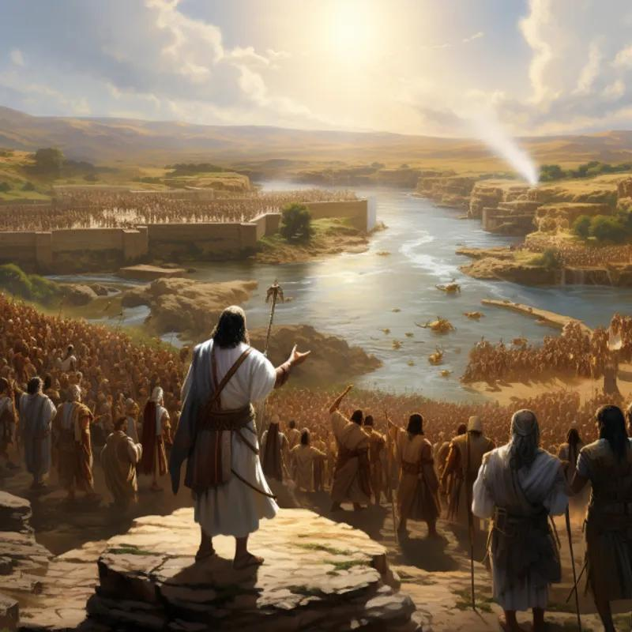
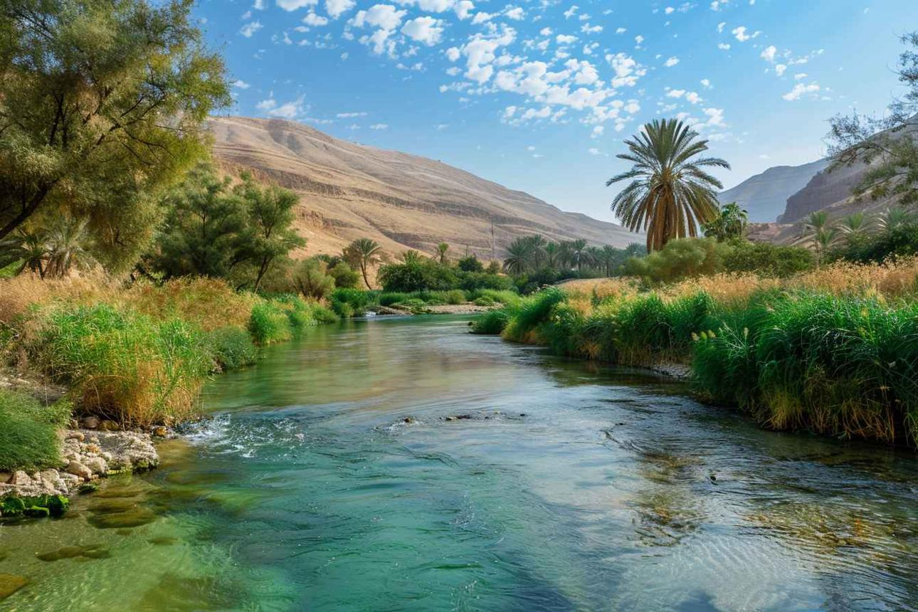
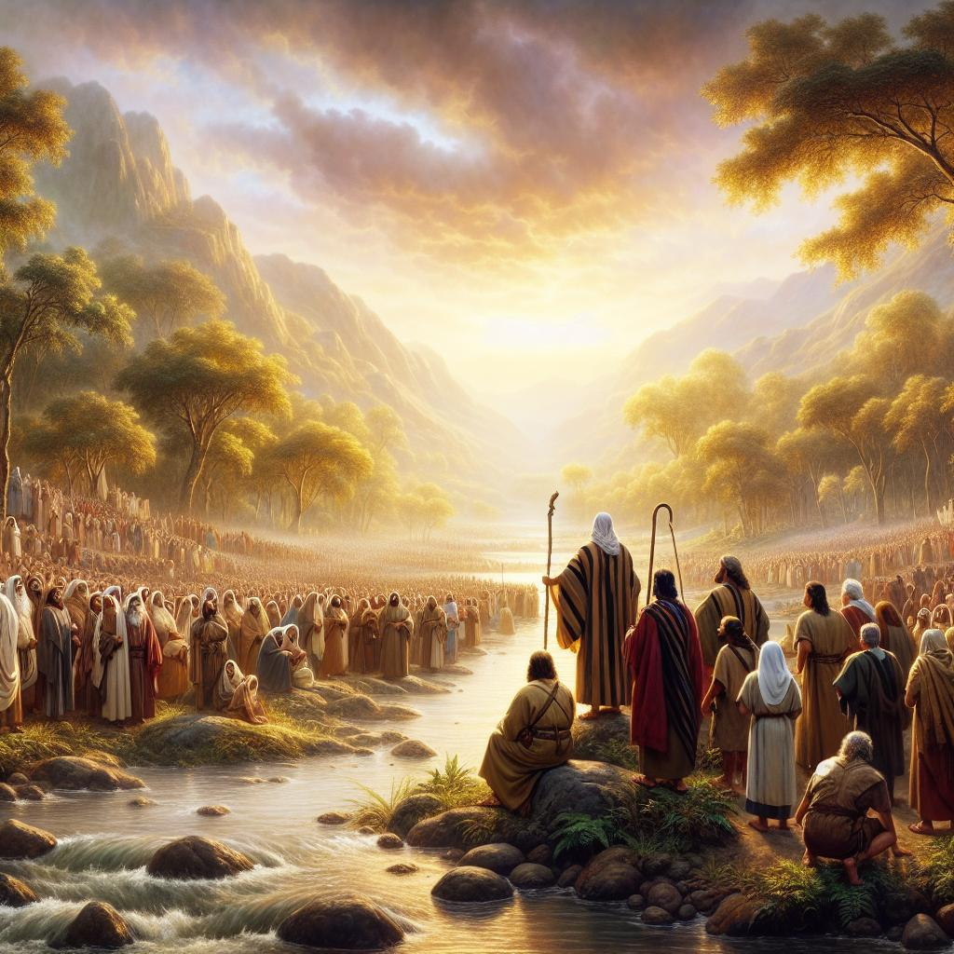
5
Joshua 3–4
Israel crosses the Jordan on dry ground.
The event intentionally echoes:
Red Sea → Jordan River
Moses:
Egypt → wilderness
Joshua:
wilderness → Promised Land
The Jordan becomes a geographical and theological boundary.

3. Gilgal
Joshua 4:19
Israel establishes its first major camp in Canaan.
Twelve stones are erected as a memorial.
Gilgal becomes Joshua's operational headquarters.
It represents:
Remember what God has done.

4. Jericho
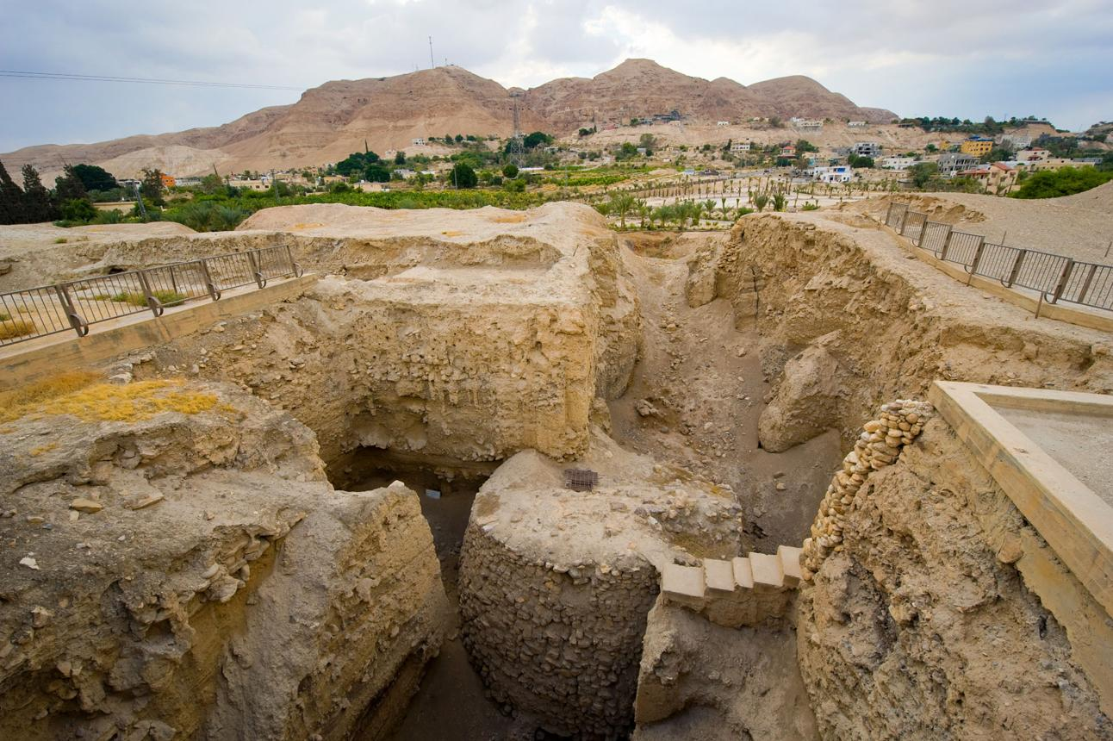
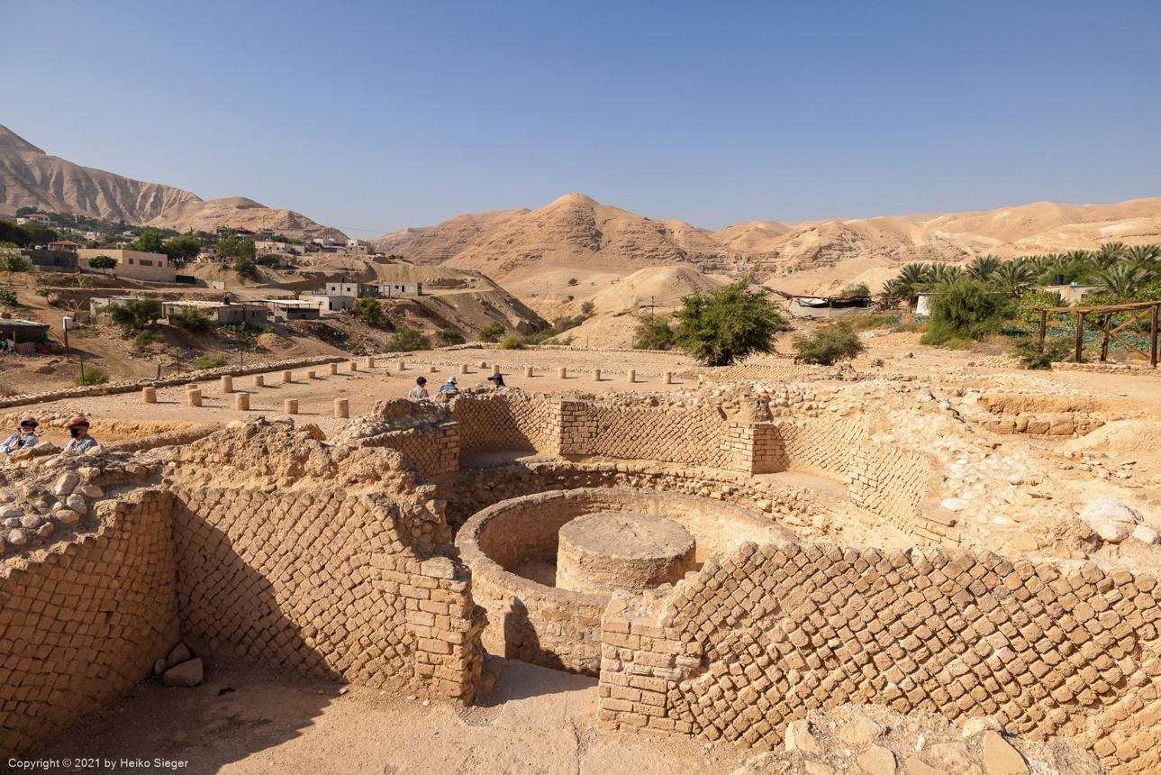
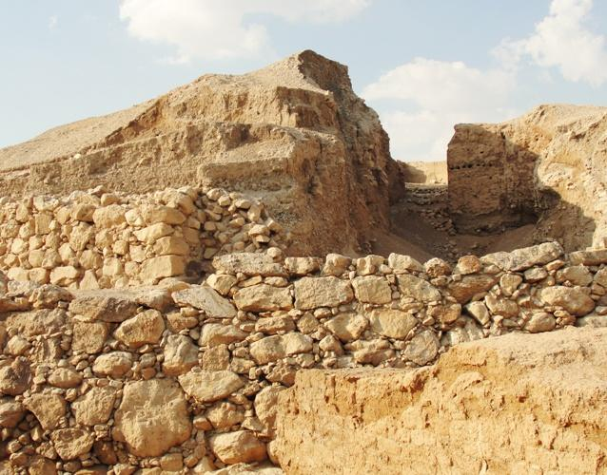
6
Joshua 6
Jericho is probably the most famous city in Joshua.
Israel doesn't conquer it through conventional siege warfare.
Instead:
- March around the city.
- Do so for six days.
- On the seventh day, march seven times.
- Priests blow trumpets.
- The people shout.
- The walls fall.
Jericho therefore becomes a theological demonstration:
Victory belongs to Yahweh.
The archaeological interpretation of Jericho remains debated, particularly concerning the date and nature of its destruction. Archaeology does not provide a simple consensus that directly confirms the biblical narrative in every detail.

5. Ai
Joshua 7–8
Ai is where Israel learns that spiritual obedience matters more than military strength.
First attempt:
Israel loses.
Why?
Achan's sin.
Second attempt:
Israel follows God's instructions.
Israel wins.
The biblical location of Ai has been heavily debated; the identification with et-Tell presents chronological difficulties, because excavations there have not yielded a Late Bronze Age occupation corresponding neatly to Joshua's account.

6. Bethel
Bethel lies near Ai.
It is an extremely important biblical site going all the way back to:
- Abraham
- Jacob
- Judges
- Samuel
- Kings
Joshua's campaign around Ai and Bethel strategically affects the central highlands.

7. Mount Ebal
Joshua 8:30–35
Joshua builds an altar to Yahweh.
The covenant is publicly proclaimed.
Mount Ebal is connected with Moses' commands in Deuteronomy 27.
Opposite it stands:
Mount Gerizim
Together they create one of the great covenant landscapes of the Old Testament.

8. Shechem
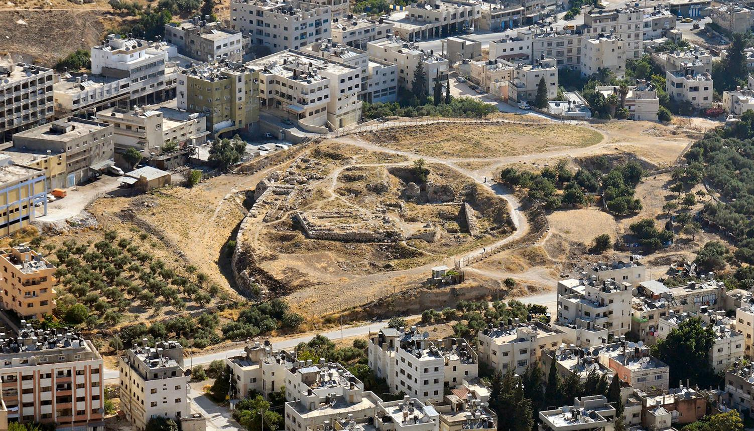
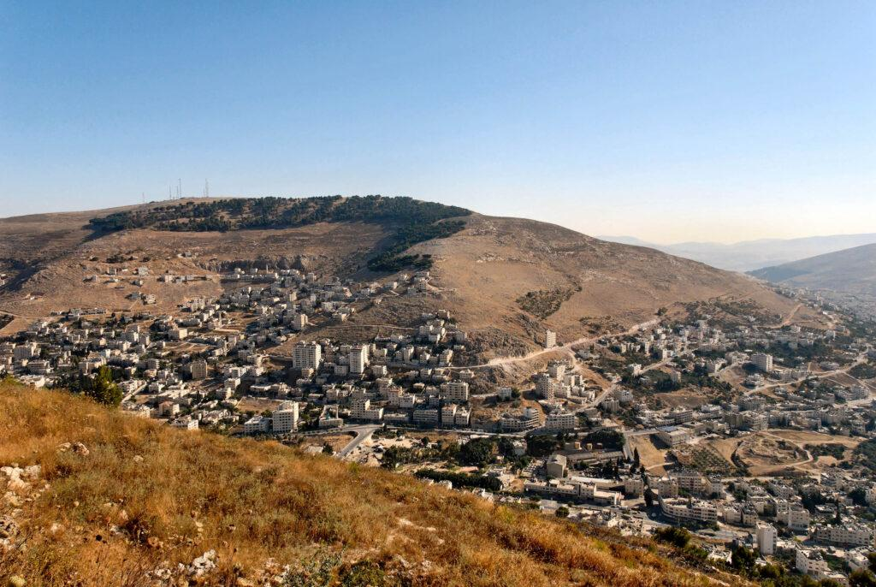
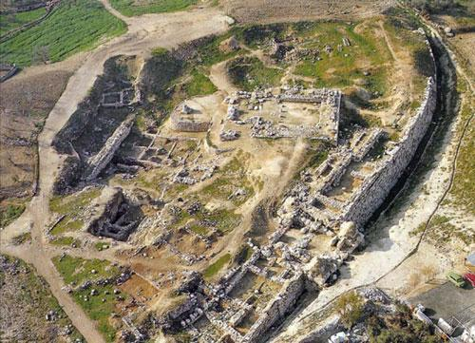
6
Shechem is one of the Bible's great covenant locations.
It connects:
- Abraham
- Jacob
- Joseph
- Joshua
Joshua 24 culminates here.
Israel renews its covenant with Yahweh.
Joshua asks:
“Choose this day whom you will serve.”
Then comes the famous declaration:
“But as for me and my house, we will serve the LORD.”
Joshua 24:15

9. Gibeon
Gibeon
Gibeon becomes the catalyst for Joshua 10.
Because Gibeon has made peace with Israel, the Amorite kings attack it.
Joshua marches to defend Gibeon.
God intervenes dramatically.

10. Beth-horon
Joshua 10
Joshua pursues the Amorite coalition through the Beth-horon ascent/descent.
The geographical terrain is extremely important.
Israel's victory is aided by:
a divinely sent hailstorm.

11. Jerusalem
The king of Jerusalem, Adoni-zedek, leads the southern coalition.
Jerusalem is therefore already a significant political center during the events of Joshua.
Interestingly, Joshua does not establish Jerusalem as Israel's capital.
That comes much later under David.

12. Hebron
Hebron becomes Caleb's inheritance.
Joshua 14:13–15
It becomes one of the most important cities in Judah.
Hebron connects Joshua's narrative with:
- Abraham
- Sarah
- Isaac
- Rebekah
- Jacob
- David

13. Lachish
Lachish is involved in the southern campaign.
It later becomes one of the great fortified cities of Judah.
Archaeological evidence indicates substantial destruction at several Canaanite sites during the broader Late Bronze/Iron Age transition, although connecting specific destructions directly to Joshua remains debated.

14. Hazor
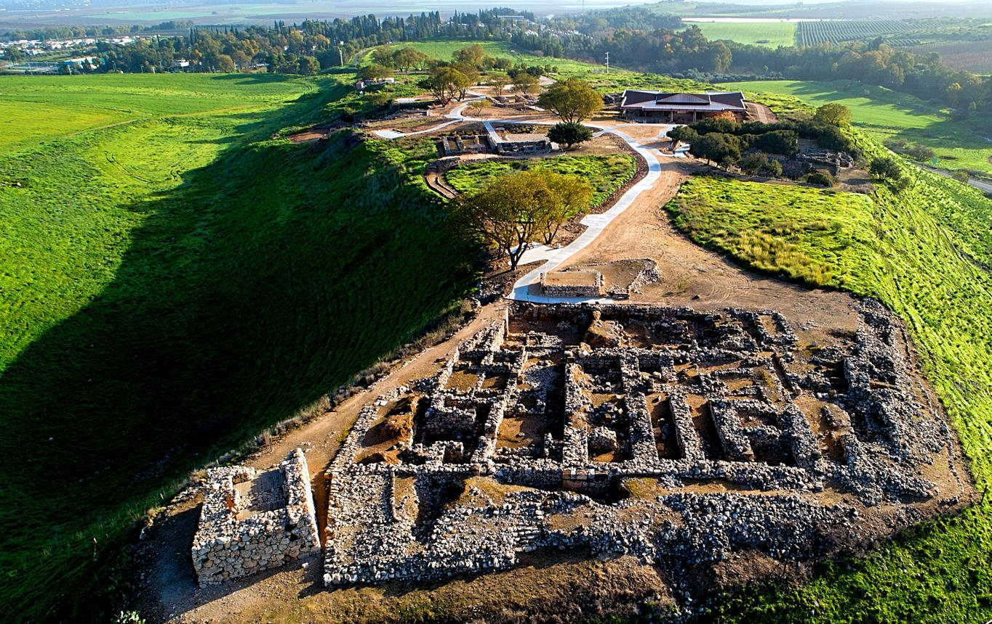
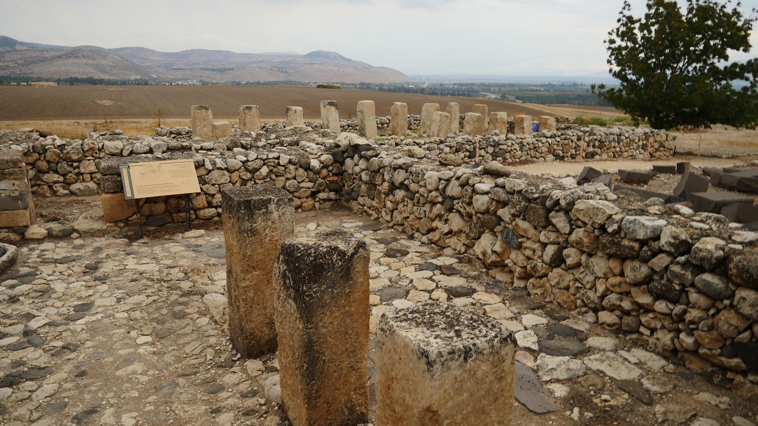
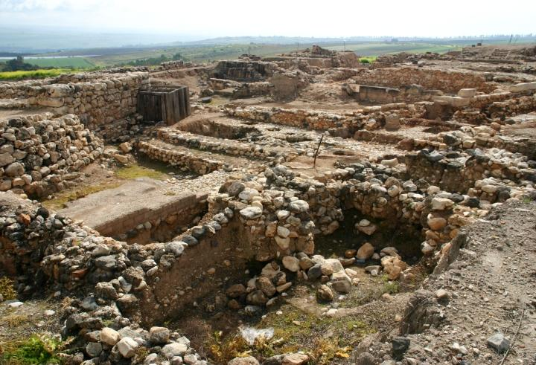
5
Hazor is the great northern city.
Joshua 11
Its king is Jabin.
Joshua defeats the northern coalition and burns Hazor.
Hazor is particularly important archaeologically because it was a major Late Bronze Age city and experienced destruction in the relevant broad period, although attributing that destruction specifically to Joshua remains debated.

XIII. THE MAJOR BATTLES
Campaign 1 — Central Canaan
Jericho
Joshua 6
Ai
Joshua 7–8
Mount Ebal
Joshua 8
This establishes Israel in the central region.

XIV. CAMPAIGN 2 — SOUTHERN CANAAN
Joshua 10
The southern coalition includes:
- Jerusalem
- Hebron
- Jarmuth
- Lachish
- Eglon
Joshua defeats them.
The famous phrase:
“Sun, stand still at Gibeon.”
Joshua 10:12
This is one of the Bible's most discussed miracle passages.
The theological point is unmistakable:
Yahweh fights for Israel.

XV. CAMPAIGN 3 — NORTHERN CANAAN
Joshua 11
The northern kings unite under the leadership of the king of Hazor.
Joshua defeats them.
Hazor is burned.
The narrative repeatedly emphasizes:
“Joshua captured all the land.”
Yet later chapters and especially Judges demonstrate that Israel still faced remaining Canaanite populations and unfinished settlement.
This is an important biblical tension.

XVI. JOSHUA'S CONQUEST — TOTAL OR INCOMPLETE?
This deserves careful attention.
Joshua says:
The land was given.
Judges says:
Much remained to be possessed.
Joshua 11:23 says:
“So Joshua took the whole land…”
But Joshua 13:1 says:
“There remains yet very much land to possess.”
These statements aren't necessarily contradictory.
A useful way to understand them is:
Joshua emphasizes decisive conquest and divine grant.
Judges emphasizes incomplete occupation and continuing struggle.
The conquest can therefore be understood as decisive but not exhaustive.
That distinction is crucial.

XVII. THE LAND DISTRIBUTION
Joshua 13–21
This section is often skipped.
Don't skip it.
These chapters demonstrate that the promise isn't merely:
“Israel won some battles.”
The promise is:
“Israel received an inheritance.”

XVIII. THE TWELVE TRIBES
The land is distributed among the tribes.
West of Jordan
- Judah
- Simeon
- Benjamin
- Dan
- Ephraim
- Manasseh
- Issachar
- Zebulun
- Asher
- Naphtali
East of Jordan
- Reuben
- Gad
- half-Manasseh
The eastern tribes had already received territory through Moses.

XIX. JUDAH
Judah receives a massive territory in southern Canaan.
Its future significance is enormous.
Within Judah eventually arise:
- Bethlehem
- Hebron
- Jerusalem
- David's dynasty
- the Davidic Messiah
Joshua's land distribution therefore prepares the geography of later biblical history.

XX. CITIES OF REFUGE
Joshua 20
Six cities are designated as cities of refuge.
Three east of Jordan:
- Bezer
- Ramoth-gilead
- Golan
Three west:
- Kedesh
- Shechem
- Hebron
Their purpose:
A person who accidentally killed someone could flee there for protection from the avenger of blood until proper judgment.
This demonstrates that Israel's justice system distinguished:
murder ≠ accidental killing.

XXI. LEVITICAL CITIES
The Levites receive cities rather than one large tribal territory.
Why?
Because their inheritance is fundamentally associated with:
Yahweh and His service.
Joshua 21 records 48 Levitical cities.
This is a fascinating theological principle:
The tribe dedicated to God's service is distributed throughout Israel.

XXII. THE EASTERN TRIBES AND THE ALTAR
Joshua 22
Reuben, Gad and half-Manasseh return east.
They build an altar.
The western tribes nearly go to war.
Why?
They think the altar represents apostasy.
But the eastern tribes explain:
It is a witness that we belong to Yahweh and to Israel.
This chapter is about:
Unity
Worship
Misunderstanding
Covenant identity

XXIII. JOSHUA'S FAREWELL
Joshua 23
Joshua is old.
His message is remarkably simple:
Don't compromise.
He warns Israel:
- Don't turn aside.
- Don't mix with pagan worship.
- Don't abandon Yahweh.
- Don't forget the covenant.
Joshua understands something that later generations forget:
Possessing the land is easier than remaining faithful in the land.

XXIV. JOSHUA 24 — THE GREAT COVENANT RENEWAL
This is the theological climax.
Joshua gathers Israel at Shechem.
He reviews Israel's history:
Abraham
↓
Isaac
↓
Jacob
↓
Egypt
↓
Exodus
↓
Wilderness
↓
Canaan
↓
Inheritance
Notice the emphasis:
God did it.
God chose.
God called.
God delivered.
God protected.
God gave.
God fought.
God provided.
Therefore:
Israel must respond in covenant faithfulness.

XXV. “CHOOSE THIS DAY”
Joshua 24:15 is probably the most famous verse in the book.
“Choose this day whom you will serve…”
But notice the context.
Joshua isn't presenting an abstract lifestyle decision.
He's confronting Israel with:
Yahweh vs. idols.
The choice is:
Who will be your God?
Joshua then makes his personal declaration:
“As for me and my house, we will serve the LORD.”

XXVI. IMPORTANT OBJECTS / “THINGS” IN JOSHUA
1. Twelve memorial stones
Joshua 4
Twelve stones represent the twelve tribes.
Purpose:
Remember.
God knows human beings forget.

2. Ark of the Covenant
The Ark goes before Israel across Jordan.
This is enormously symbolic.
Israel isn't saying:
“Our army is powerful.”
The message is:
“God goes before us.”

3. Trumpets
Joshua 6
The priests blow trumpets around Jericho.
The conquest is presented as worshipful obedience rather than ordinary military technology.

4. The devoted things — ḥērem
This is one of the hardest subjects in Joshua.
Certain people and possessions are placed under the ḥērem, often translated:
- devoted
- banned
- devoted to destruction
This is connected with God's judgment on Canaanite wickedness and the unique covenant circumstances of Israel's conquest.
It should not be treated as a general command for Christians to wage religious war.

XXVII. THE MOST IMPORTANT THEMES
1. God's faithfulness
Joshua 21:45 is one of the key verses:
“Not one word of all the good promises that the LORD had made… had failed.”
That may be the theological center of Joshua.
God keeps His promises.

2. Courage
Joshua 1 repeatedly says:
Be strong and courageous.
But biblical courage isn't self-confidence.
It is confidence in:
God's presence + God's promise.

3. Obedience
Joshua repeatedly connects:
obedience → blessing
and
disobedience → defeat.
Achan illustrates this dramatically.

4. Remembering
Joshua is filled with memorials.
- Twelve stones
- Written law
- Altars
- Covenant ceremonies
- Historical recitation
Why?
Because biblical faith is deeply connected with remembering God's acts.

5. Holiness
Jericho is not merely a military event.
It is a test of Israel's holiness.
Achan's sin demonstrates that Israel cannot presume upon God's presence while violating God's covenant.

6. Inheritance
The land is repeatedly called an inheritance.
This connects Joshua all the way back to:
Abrahamic promise → Exodus → Sinai → wilderness → Canaan.
Joshua is therefore the book where a major portion of the Abrahamic promise becomes geographically tangible.

XXVIII. JOSHUA AND JESUS
This is one of the richest theological connections.
Joshua's Hebrew name:
Yehoshua — Yahweh saves
Jesus' Hebrew/Aramaic name:
Yeshua
Greek:
Iēsous
Joshua leads Israel into an earthly inheritance.
Jesus leads His people into salvation and ultimately the eternal inheritance.
Joshua gives Israel rest in Canaan.
Hebrews later develops the idea that Joshua did not provide the final or ultimate rest:
Hebrews 4:8–11
The argument is profound:
Joshua → earthly rest
Jesus → ultimate rest
So Joshua points beyond himself.

XXIX. JOSHUA AND REVELATION
There is another major biblical connection.
Joshua enters the Promised Land.
Revelation ends with God's people in the renewed creation.
Joshua gives Israel a land inheritance.
Revelation presents God's people receiving the final inheritance.
Joshua begins Israel's life in the land.
Revelation brings God's dwelling with humanity to its consummation.
The biblical storyline therefore moves:
Eden → Abraham → Exodus → Sinai → Joshua → David → Exile → Christ → Church → New Creation
Joshua is a major hinge in that story.

XXX. JOSHUA — PEOPLE, PLACES & THINGS MASTER INDEX
PEOPLE
- Joshua
- Moses
- Caleb
- Rahab
- Achan
- Eleazar
- Phinehas
- Gibeonite leaders
- Adoni-zedek
- Jabin
- Canaanite kings
- Amorite kings
PLACES
- Shittim
- Jordan River
- Gilgal
- Jericho
- Ai
- Bethel
- Mount Ebal
- Mount Gerizim
- Shechem
- Gibeon
- Beth-horon
- Jerusalem
- Hebron
- Jarmuth
- Lachish
- Eglon
- Hazor
- Bezer
- Ramoth-gilead
- Golan
- Kedesh
- Timnath-serah
THINGS
- Ark of the Covenant
- Twelve stones
- Circumcision
- Passover
- Trumpets
- Walls of Jericho
- The devoted things
- Altar
- Covenant
- Written Law
- Land inheritance
- Tribal boundaries
- Cities of refuge
- Levitical cities
- Memorials
- Oath
- Covenant renewal

XXXI. THE BOOK OF JOSHUA CHAPTER-BY-CHAPTER
Chapters | Main subject
1 | Joshua commissioned
2 | Rahab and spies
3 | Jordan crossed
4 | Twelve memorial stones
5 | Circumcision and Passover
6 | Jericho
7 | Achan and defeat at Ai
8 | Ai conquered; covenant ceremony
9 | Gibeonite deception
10 | Southern campaign; sun stands still
11 | Northern campaign; Hazor
12 | List of defeated kings
13 | Remaining land; eastern tribes
14 | Caleb receives Hebron
15 | Judah's inheritance
16 | Ephraim
17 | Manasseh
18 | Benjamin and remaining divisions
19 | Simeon, Zebulun, Issachar, Asher, Naphtali, Dan
20 | Cities of refuge
21 | Levitical cities
22 | Eastern tribes and altar
23 | Joshua's farewell
24 | Covenant renewal; Joshua's death

XXXII. THE BIG PICTURE
Joshua is much more than a book about military conquest.
Its deeper structure is:
PROMISE
↓
God promised Abraham the land.
PREPARATION
↓
Israel is formed through Exodus and covenant.
LEADERSHIP
↓
Moses → Joshua.
ENTRY
↓
Jordan River.
FAITH
↓
Jericho.
DISOBEDIENCE
↓
Achan and Ai.
VICTORY
↓
Central, southern and northern campaigns.
INHERITANCE
↓
The land is divided among the tribes.
REST
↓
Israel settles in the land.
WARNING
↓
Do not abandon Yahweh.
COVENANT
↓
Shechem.
DECISION
↓
“Choose this day whom you will serve.”
HOPE
↓
God has fulfilled His promises.
That makes Joshua one of the great covenant books of the Old Testament. The central message isn't ultimately “Israel was strong enough to conquer Canaan.” It is:
God is faithful to His promises, and His people must respond with faith, obedience, courage, remembrance, and exclusive devotion to Him.
The archaeological evidence is particularly worth studying separately because Jericho, Ai, Hazor, Lachish, Gibeon, and the question of the conquest date involve significant debates rather than a simple “archaeology proves/disproves Joshua” conclusion.
This document was prepared by doulos777 and was originally A.I. source.

