Ruth — People, Places & Things: Deep Bible Research
The Book of Ruth is only 4 chapters and 85 verses, but it is one of the Bible’s richest books for understanding redemption, covenant loyalty, providence, the role of the kinsman-redeemer, Israelite family law, Gentile inclusion, David’s ancestry, and ultimately the genealogy of Jesus Christ.
Ruth is set “in the days when the judges ruled” (Ruth 1:1), yet it ends with David (4:17–22). That makes Ruth a remarkable bridge between Judges → David → Messiah.

I. THE BOOK OF RUTH AT A GLANCE
Category | Information
Chapters | 4
Verses | 85
Setting | Days of the Judges
Primary locations | Bethlehem, Moab
Main characters | Ruth, Naomi, Boaz
Secondary characters | Elimelech, Mahlon, Chilion, Orpah, unnamed nearer redeemer
Central issue | Survival and restoration of Naomi's family
Central concept | Redemption
Key Hebrew concept | ḥesed — loyal/covenant love
Key legal concept | go'el — redeemer
Agricultural background | Barley and wheat harvest
Royal connection | Ruth → Obed → Jesse → David
Messianic connection | Ruth → Obed → Jesse → David → Jesus
Jewish liturgical connection | Megillah traditionally read at Shavuot
Ruth belongs to the Five Megillot in the Hebrew Bible and is traditionally associated with the Feast of Weeks/Shavuot. In Christian Bibles it follows Judges, emphasizing its historical setting.

II. THE BIG STORY
Ruth 1 — Loss and Return
Famine comes to Judah.
Elimelech takes Naomi and their two sons from Bethlehem to Moab.
Then:
- Elimelech dies.
- Mahlon dies.
- Chilion dies.
- Naomi is left with Ruth and Orpah.
- Naomi decides to return to Bethlehem.
- Orpah returns to Moab.
- Ruth refuses to leave Naomi.
Ruth 2 — Providence in the Field
Ruth goes to glean.
She happens to enter the field of Boaz.
From the human perspective, it looks accidental.
From the theological perspective, it is divine providence.
Boaz protects Ruth and provides abundantly for her.
Ruth 3 — The Request for Redemption
Naomi tells Ruth to approach Boaz at the threshing floor.
Ruth asks Boaz to act as her redeemer.
Boaz agrees—but there is a problem:
another relative is closer.
Ruth 4 — Redemption Accomplished
Boaz goes to the city gate.
The nearer redeemer declines.
Boaz accepts the responsibility.
He marries Ruth.
Ruth gives birth to Obed.
Obed becomes:
Jesse → David.
Thus the story that began with famine ends with the establishment of the Davidic line.

III. THE PEOPLE OF RUTH
1. Ruth
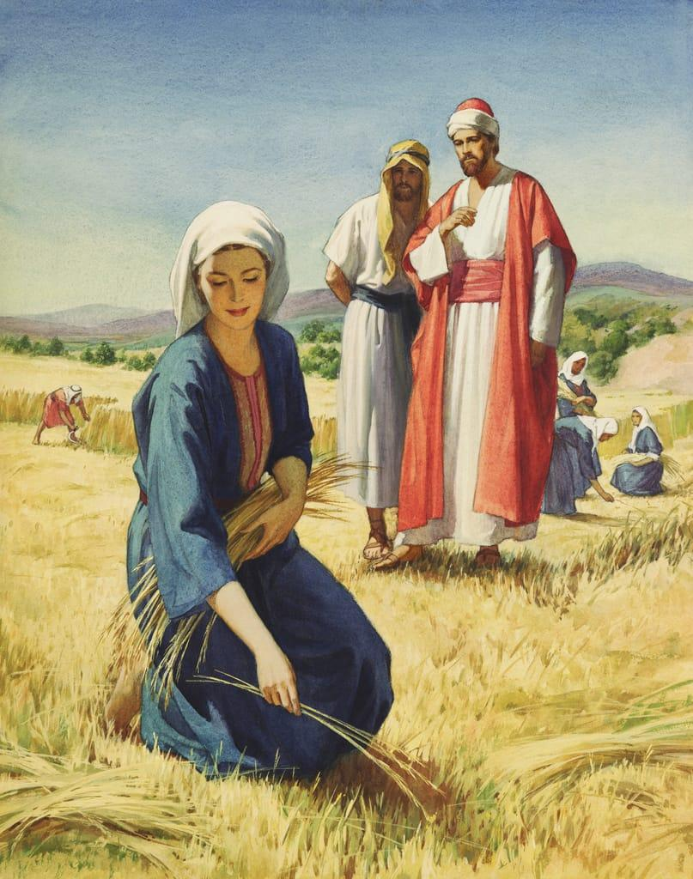
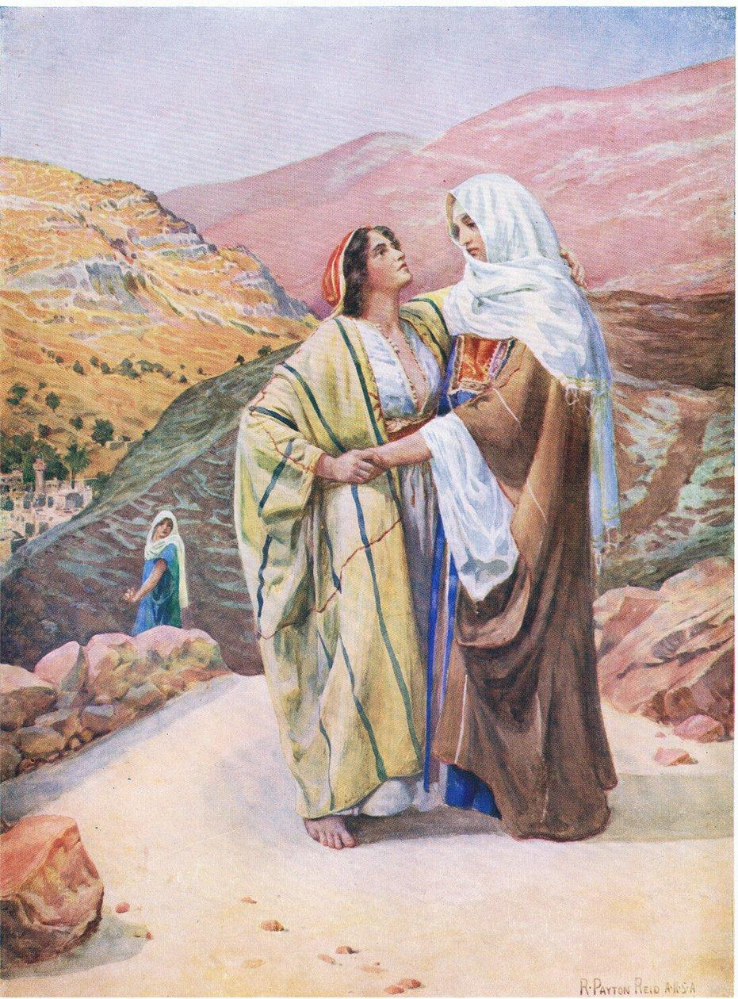
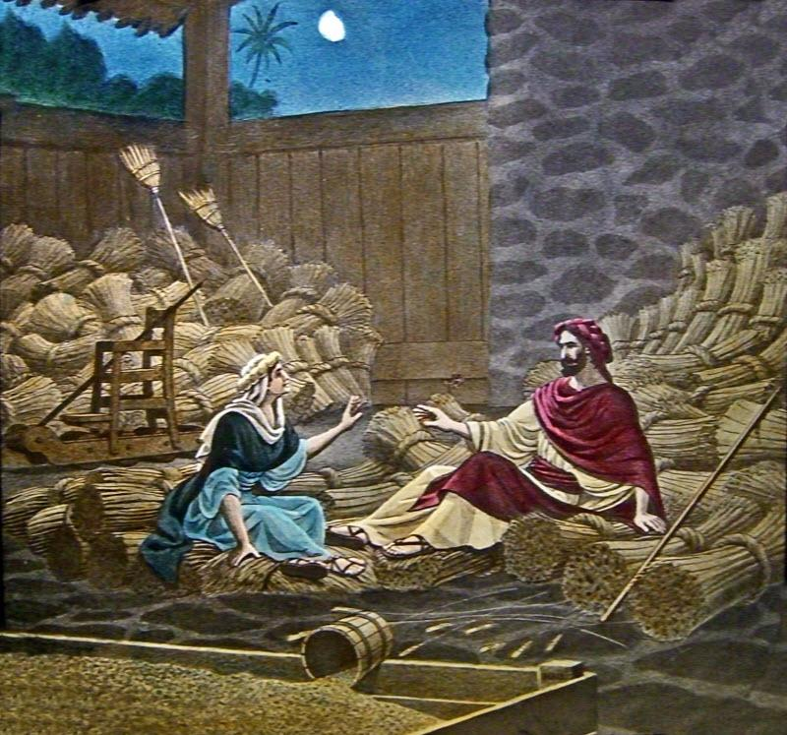
5
Identity: Moabite woman
Family: Daughter-in-law of Naomi
Husband: Mahlon
Second husband: Boaz
Son: Obed
Descendant: King David
Ruth is one of Scripture's great examples of faith expressed through covenant loyalty.
Her famous declaration:
“Where you go I will go... your people shall be my people, and your God my God.”
— Ruth 1:16
is much more than an emotional statement.
Ruth is abandoning:
- homeland
- family
- ethnic identity
- economic security
- religious environment
- future prospects
and embracing Naomi, Israel, and Yahweh.
The narrative deliberately identifies her repeatedly as “Ruth the Moabitess.” Her foreign identity is important because the story emphasizes what God does through an unexpected outsider.
Ruth's character
Ruth demonstrates:
- loyalty
- courage
- humility
- initiative
- hard work
- sexual purity
- kindness
- faith
- perseverance
- willingness to sacrifice
She begins the book as a widowed foreigner.
She ends it as the mother of Obed and ancestor of David.

2. Naomi
Naomi is the emotional center of much of chapter 1.
Her name is associated with pleasantness, but she says:
“Call me Mara.”
because she believes the Almighty has dealt bitterly with her (Ruth 1:20).
Her transformation is profound:
Ruth 1
Naomi:
empty → bitter → widowed → childless → hopeless
Ruth 4
Naomi:
restored → holding Obed → surrounded by women → family line preserved
The women of Bethlehem declare:
“A son has been born to Naomi.”
The book therefore isn't merely Ruth's redemption story.
It is also Naomi's restoration story.
Naomi begins believing that God has emptied her.
God ultimately fills her house again.

3. Boaz
Boaz is one of the Bible's clearest pictures of a righteous redeemer.
He is:
- wealthy
- respected
- related to Elimelech
- morally upright
- generous
- protective
- legally careful
- compassionate
Ruth 2 introduces him as a man of standing/wealth.
He immediately notices Ruth and asks who she is.
When he learns what she has done for Naomi, he blesses her.
Boaz recognizes that Ruth has come to take refuge under the wings of Israel's God.
That is significant because in Ruth 2:12 Boaz essentially says:
You have come under Yahweh's wings—and may He reward you.
Then Boaz himself becomes the instrument through which that protection is provided.

4. Elimelech
Name: Elimelech
Meaning: “My God is king”
He is:
- husband of Naomi
- father of Mahlon and Chilion
- resident of Bethlehem
- member of the clan of Judah
Because of famine, he leaves Bethlehem and moves to Moab.
The text does not explicitly say that his decision to leave Israel was sinful.
That is important.
The Bible tells us what happened but does not directly pronounce judgment on the move.
Elimelech dies in Moab.
His death creates the family crisis that drives the rest of the story.

5. Mahlon
Mahlon is Naomi and Elimelech's son.
He marries Ruth.
He dies childless.
His death is critical to the redemption problem because the family line of Elimelech appears to be disappearing.

6. Chilion
Chilion is the second son.
He marries Orpah.
Like Mahlon, he dies childless.
Thus Naomi loses:
husband + two sons.
The family is apparently finished.
But God is not finished.

7. Orpah
Orpah is frequently misunderstood.
The Bible does not portray her as evil.
Naomi encourages both women to return to their mothers' homes.
Orpah does exactly that.
Ruth, however, refuses.
The contrast is therefore not necessarily:
bad woman vs. good woman
but:
one woman returns home while another embraces an entirely new identity and destiny.

8. The Nearer Redeemer
This man is deliberately left unnamed.
That is fascinating.
He has the legal right to redeem Elimelech's property before Boaz does.
But when he learns that the transaction involves Ruth, he refuses.
The text gives him no heroic identity.
He is simply:
“the nearer redeemer.”
His anonymity contrasts strongly with Boaz.
Boaz becomes part of the permanent biblical story.
The nearer redeemer disappears into history.

9. Obed
Obed is the son of:
Boaz + Ruth
He is the father of:
Jesse
and grandfather of:
David
Thus Ruth's story becomes Israel's royal story.

10. Jesse
Jesse is the father of David.
Ruth 4 deliberately concludes its genealogy with David.
This tells us that the book is not merely about one family's marriage.
It is about God's providential preparation of the Davidic dynasty.

11. David
The book ends:
“Obed begat Jesse, and Jesse begat David.”
David is the literary destination of the book.
Ruth begins in the chaos of the Judges.
Ruth ends with David.
That is a major theological transition.
Judges → Ruth → David
The book shows that even during Israel's darkest period, God was quietly preparing the royal line.

IV. THE PLACES OF RUTH
1. Bethlehem
Bethlehem of Judah is the central location.
The name Bethlehem means approximately:
“house of bread.”
The irony is striking.
The house of bread experiences famine.
Elimelech leaves Bethlehem because there is no food.
Later Naomi and Ruth return to Bethlehem at the beginning of the barley harvest.
Bethlehem therefore moves from:
famine → harvest → fullness → David.
And centuries later:
Bethlehem → Jesus.
Matthew specifically connects Ruth and Boaz to the genealogy of Jesus (Matthew 1:5).

2. Moab
Moab lies east of the Dead Sea.
It is the homeland of Ruth and Orpah.
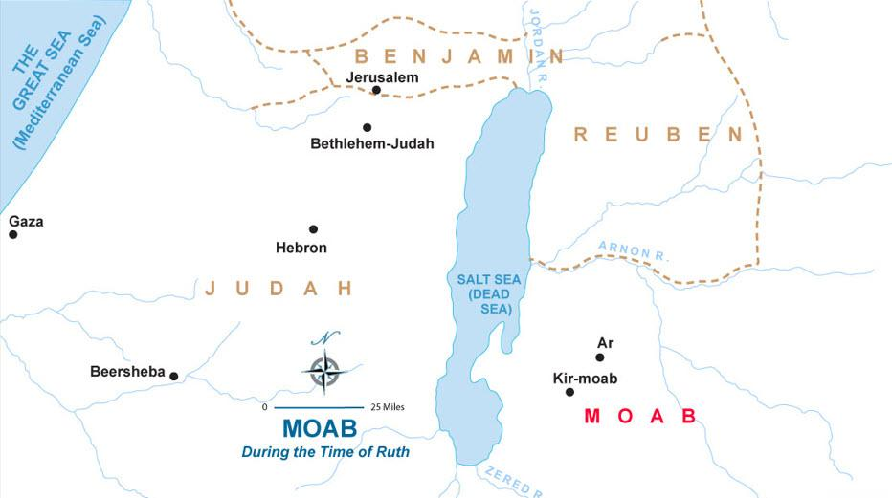
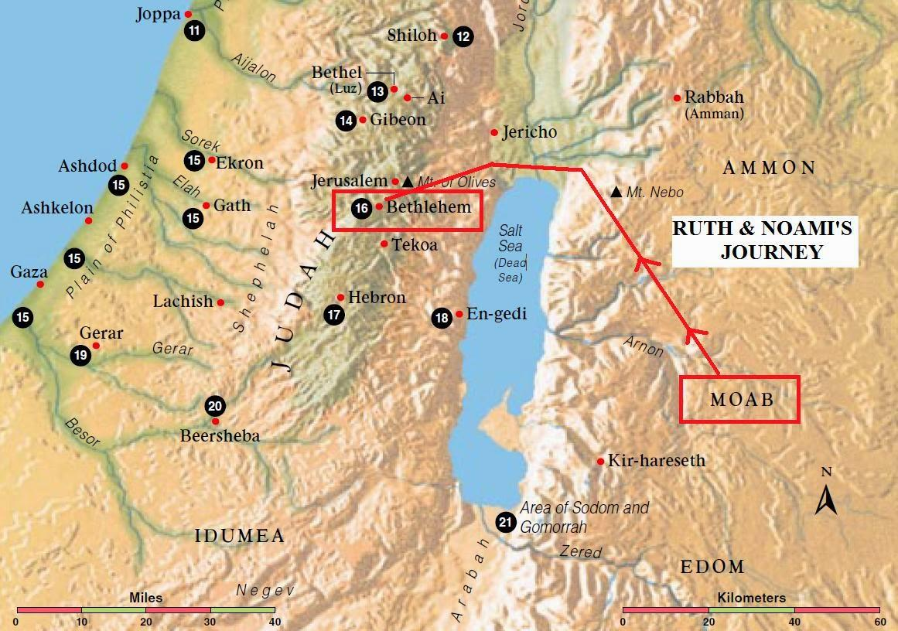
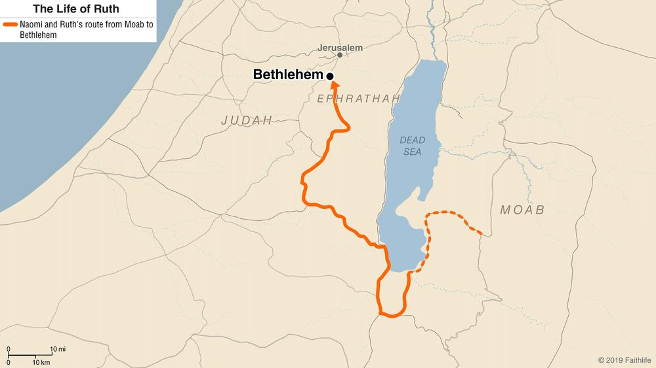
6
Moab has a complicated relationship with Israel.
Moabites descend from Lot (Genesis 19:30–38).
Israel encountered Moab during the wilderness journey.
Moabite history includes:
- Balak
- Balaam
- Israel's sin at Peor
- Eglon
- Ehud
- David's later conflict with Moab
The Book of Ruth therefore deliberately places a Moabite woman inside the genealogy of Israel's greatest king.
That is one of the book's great surprises.

3. The Road from Moab to Bethlehem
Ruth and Naomi travel from Moab back to Judah.
The physical journey symbolizes Ruth's spiritual journey.
She moves:
Moab → Judah
foreign land → covenant community
widowhood → marriage
emptiness → fullness
uncertainty → Davidic ancestry

4. The Fields of Boaz
The field is where Ruth gleans.
This connects Ruth directly with Israel's laws concerning the poor.
Israel was commanded not to harvest every last portion of the field.
Instead, some was to remain for:
- poor people
- foreigners
- widows
See:
- Leviticus 19:9–10
- Leviticus 23:22
- Deuteronomy 24:19–22
Ruth is therefore experiencing Torah provision in action.

5. The Threshing Floor
Ruth 3 occurs at the threshing floor.
The threshing floor was where harvested grain was processed.
It becomes the setting for Ruth's request that Boaz act as redeemer.
This scene must be read carefully.
It is not presented as sexual immorality.
The narrative emphasizes:
- Ruth's request
- Boaz's integrity
- his concern for her reputation
- his willingness to marry her
- the legal obstacle involving the nearer redeemer
Boaz's response demonstrates remarkable restraint.

6. The City Gate
Ruth 4 moves from the threshing floor to the city gate.
The gate was a public place associated with:
- legal proceedings
- elders
- contracts
- commercial transactions
- community decisions
Boaz therefore handles redemption publicly and legally.
He doesn't secretly acquire Ruth.
He settles the matter before the elders.

V. THE “THINGS” OF RUTH
1. Famine
The entire story begins with:
famine.
Famine forces movement.
But God's providence uses that movement to position Ruth within the Davidic line.

2. Harvest
Harvest is everywhere in Ruth.
There is:
barley harvest
and later:
wheat harvest.
Harvest represents:
- provision
- life
- economic opportunity
- God's blessing
The story begins with famine and moves toward harvest.

3. Gleaning
Gleaning is crucial.
Ruth doesn't simply receive charity.
She works.
She gathers what the harvesters leave behind.
This demonstrates the practical operation of Israel's law protecting the vulnerable.
Ruth's position is especially difficult because she is both:
widow + foreigner.
Yet Israel's Torah creates a place for her.

4. The Kinsman-Redeemer — Go'el
This is probably the single most important “thing” in Ruth.
Hebrew:
גֹּאֵל — go'el
Often translated:
redeemer / kinsman-redeemer.
The concept involves a close family member who can act on behalf of a relative.
Relevant Old Testament laws include:
- Leviticus 25 — redemption of property
- Deuteronomy 25:5–10 — levirate marriage
- Numbers 35 — family responsibility involving blood vengeance
Ruth combines these concepts in a unique narrative situation.
Boaz becomes the person who restores:
property + family name + future offspring + security.

5. Redemption
The Hebrew Bible's redemption vocabulary is extraordinarily important here.
Ruth 4 demonstrates that redemption involves cost.
Boaz must take responsibility.
Redemption is not merely:
“I feel sorry for you.”
It is:
“I will assume responsibility for your restoration.”
That provides a powerful biblical framework for understanding redemption elsewhere in Scripture.

6. Ḥesed — Loyal Love
One of the major theological words associated with Ruth is:
חֶסֶד — ḥesed
It can convey:
- steadfast love
- covenant loyalty
- kindness
- faithfulness
- lovingkindness
Ruth demonstrates ḥesed toward Naomi.
Boaz demonstrates ḥesed toward Ruth.
And ultimately God demonstrates covenant faithfulness through the entire story.
The human acts of kindness become instruments of divine providence.

7. Wings
Boaz tells Ruth that she has come to take refuge under the wings of Yahweh (Ruth 2:12).
Then in Ruth 3:9, Ruth asks Boaz to spread his wing/garment over her.
This creates a beautiful literary connection:
Ruth seeks refuge under God's wings.
Then:
God provides Boaz as the means of that refuge.
Theologically:
God's providence often operates through human obedience.

8. The Sandal
Ruth 4:7–8 mentions the removal of a sandal.
This represents an ancient legal/customary transaction.
The narrator actually explains the custom because it was no longer familiar to later readers.
The sandal becomes a physical symbol that the redemption transaction has been legally completed.

9. The Gate and Elders
The elders function as witnesses.
Boaz does everything openly.
The transaction is publicly recognized.
This is important because Ruth is ultimately about legitimate restoration, not merely romance.

10. Marriage
The marriage of Boaz and Ruth is the climax of the personal storyline.
But marriage isn't the final climax.
The true climax is:
Obed → Jesse → David.
The marriage becomes part of God's larger redemptive plan.

VI. THE GENEALOGY — RUTH 4:18–22
This genealogy is extremely important.
Perez
↓
Hezron
↓
Ram
↓
Amminadab
↓
Nahshon
↓
Salmon
↓
Boaz
↓
Obed
↓
Jesse
↓
David
Ruth therefore connects:
Judah → Boaz → Ruth → Obed → Jesse → David
The genealogy reaches back to Perez, son of Judah and Tamar.
That is significant because Tamar was also a woman whose unusual circumstances became part of the Messianic genealogy.

VII. RUTH AND THE DAVIDIC COVENANT
Ruth predates David's kingship.
Yet the book is structured to lead us toward him.
The book begins:
“In the days when the judges ruled...”
and ends:
“...David.”
That is deliberate literary architecture.
The theological message is:
God was working toward the Davidic kingdom even while Israel was experiencing the chaos of Judges.
The period of Judges appears chaotic from the human perspective.
But God's providence is operating underneath the chaos.

VIII. RUTH AND JESUS CHRIST
This is where Ruth becomes especially important for Christian theology.
Matthew 1:5 gives:
Salmon → Boaz → Obed
and identifies Ruth in Jesus' genealogy.
The sequence continues:
Ruth → Obed → Jesse → David → ... → Jesus
So Ruth, a Moabite woman, becomes an ancestor of Israel's king and ultimately appears within the genealogy of Christ.
This beautifully illustrates a major biblical theme:
God's redemptive purposes extend beyond ethnic and national boundaries.
Ruth's inclusion anticipates the New Testament revelation that Gentiles would be incorporated into God's redeemed people.
The ESV's study material explicitly connects Ruth's redemption theme to the broader New Testament picture of people from the nations becoming members of God's household through Christ.

IX. RUTH AND JUDGES — THE CONTRAST
This is one of the most important ways to read Ruth.
Judges
- violence
- idolatry
- tribal conflict
- moral collapse
- foreign oppression
- repeated apostasy
Ruth
- faithfulness
- kindness
- family loyalty
- hard work
- sexual purity
- generosity
- legal integrity
- redemption
Ruth therefore functions almost like a bright window during the dark period of Judges.
The historical setting is the same, but the atmosphere is radically different.

X. THE GREAT REVERSALS IN RUTH
The book is filled with reversals.
Beginning | End
Famine | Harvest
Moab | Bethlehem
Death | Birth
Widowhood | Marriage
Childlessness | Obed
Emptiness | Fullness
Foreign woman | Member of Judah's family
Poverty | Provision
Hopelessness | Hope
No future | Davidic future
Naomi bitter | Naomi restored
Ruth outsider | Ruth ancestor of David
This is one reason Ruth is such a profound study in divine providence.

XI. “BY CHANCE” — RUTH 2:3
One of the most beautiful theological ironies occurs when Ruth goes out to glean and comes to the field belonging to Boaz.
Humanly:
“It just happened.”
Theologically:
God was arranging circumstances.
Ruth doesn't know the future.
She doesn't know:
- Boaz's identity
- the genealogy
- David
- the Messiah
- God's larger plan
She simply goes to work.
That is an important biblical lesson:
Providence frequently looks ordinary while it is happening.

XII. RUTH'S SPIRITUAL JOURNEY
Ruth's story can be mapped as:
1. Moab
Her old world.
2. Decision
“I will go with Naomi.”
3. Bethlehem
Entering Israel.
4. Gleaning
Working faithfully.
5. Boaz
Meeting the redeemer.
6. Threshing floor
Requesting redemption.
7. City gate
Legal redemption.
8. Marriage
Restoration.
9. Obed
New life.
10. David
A place in God's kingdom purposes.

XIII. MAJOR THEOLOGICAL THEMES
1. Divine Providence
God's name isn't constantly mentioned through dramatic miracles.
Instead, God works through:
- famine
- travel
- death
- harvest
- ordinary work
- human kindness
- legal customs
- marriage
- childbirth
Ruth teaches us that God can be sovereign without being spectacular.

2. Redemption
Boaz is the human redeemer.
But the book points beyond Boaz.
Boaz restores Ruth and Naomi's family.
Christ ultimately accomplishes redemption on a much greater scale.
A careful distinction is important:
Boaz is not a one-to-one allegorical representation of Jesus.
But Boaz's role provides a biblical category that helps Christians understand redemption.

3. Covenant Loyalty
Ruth's famous vow is a remarkable expression of commitment.
She doesn't merely say:
“I love you, Naomi.”
She says:
your people → my people
your God → my God
your destiny → my destiny

4. Gentile Inclusion
Ruth is a Moabite.
Yet God brings her into the family from which David comes.
This anticipates the broader biblical story of God's grace reaching the nations.

5. God's Care for the Vulnerable
Ruth and Naomi represent two particularly vulnerable categories:
widow + foreigner.
Yet the Torah provides protection for precisely such people.
Ruth demonstrates what happens when God's commands concerning the vulnerable are actually practiced.

XIV. IMPORTANT QUESTIONS RAISED BY RUTH
Was Ruth actually converted to Yahweh?
Her declaration in Ruth 1:16–17 strongly indicates a decisive identification with Naomi's people and God.
Was Boaz much older than Ruth?
The text doesn't give his age. Ruth 3:10 may indicate that Ruth could have pursued younger men, but we should not manufacture an exact age difference.
Did Ruth and Boaz practice levirate marriage?
Not strictly in the technical Deuteronomy 25 sense.
Ruth combines elements of:
- family redemption
- land redemption
- preservation of family name
- marriage obligation
The narrative should therefore not simply be labeled “ordinary levirate marriage.”
Was Ruth a princess?
Some later Jewish traditions say so, but the canonical biblical text does not identify her as a princess.
Did God approve of Ruth being a Moabite?
The story itself portrays Ruth positively and makes her an ancestor of David. Whatever broader questions one raises from Deuteronomy's restrictions concerning Moabites, Ruth's narrative emphasizes her loyalty to Yahweh and her incorporation into Israel.

XV. RUTH'S FOUR CHAPTERS AS A REDEMPTION PATTERN
Ruth 1 — Return
Naomi comes home.
Ruth 2 — Provision
Ruth finds food.
Ruth 3 — Request
Ruth asks for redemption.
Ruth 4 — Redemption
Boaz acts.
That produces:
Provision → Redemption → Restoration → David

XVI. PEOPLE–PLACES–THINGS MASTER INDEX
PEOPLE
Major
- Ruth
- Naomi
- Boaz
Family
- Elimelech
- Mahlon
- Chilion
- Obed
- Jesse
- David
Other
- Orpah
- unnamed nearer redeemer
- elders
- Bethlehem women
- harvesters

PLACES
- Bethlehem
- Judah
- Moab
- Fields of Boaz
- Threshing floor
- City gate
- Road between Moab and Judah
- Region of Ephrath/Ephrathah

THINGS / CONCEPTS
- Famine
- Harvest
- Barley
- Wheat
- Gleaning
- Field
- Sheaves
- Threshing floor
- Grain
- Sandal
- City gate
- Elders
- Redemption
- Go'el
- Ḥesed
- Marriage
- Widowhood
- Inheritance
- Family name
- Genealogy
- Covenant loyalty
- Wings
- Refuge
- Davidic line
- Messianic genealogy

XVII. THE MOST IMPORTANT CONNECTIONS
The Book of Ruth should not be studied in isolation.
Ruth ↔ Genesis
Judah → Tamar → Perez
Ruth's genealogy reaches back to Perez.
Ruth ↔ Leviticus
Gleaning laws
Leviticus 19:9–10.
Ruth ↔ Deuteronomy
Gleaning + family obligations
Deuteronomy 24–25.
Ruth ↔ Judges
Ruth occurs during the Judges period.
Ruth ↔ Samuel
Ruth ends with David's genealogy, preparing for Samuel's history of David.
Ruth ↔ Psalms
The language of refuge under God's wings resonates with later biblical imagery.
Ruth ↔ Matthew
Ruth enters the genealogy of Jesus in Matthew 1:5.

XVIII. THE BIG PICTURE
The Book of Ruth is ultimately a story of God bringing life out of apparent death.
At the beginning:
Bethlehem has famine.
A family leaves.
The father dies.
Two sons die.
Two women become widows.
One woman is foreign.
The family line appears finished.
But by chapter 4:
Ruth is married.
Naomi has a grandson.
The family line continues.
Obed is born.
Jesse is born.
David is coming.
And eventually:
the Messiah comes through the Davidic line.
So the central movement of Ruth can be summarized:
Famine → faith → faithfulness → providence → redemption → restoration → David → Messiah.
That is why this tiny four-chapter book is enormously important in the Bible's grand story of redemption.
A particularly powerful way to remember Ruth
Naomi shows God's restoration.
Ruth shows covenant loyalty.
Boaz shows redemption.
Obed shows new life.
David shows God's kingdom purpose.
Jesus shows the ultimate Redeemer.

This document was created by doulos777 and was A.I. in origin.

