Judges — People, Places & Things: Deep Bible Research
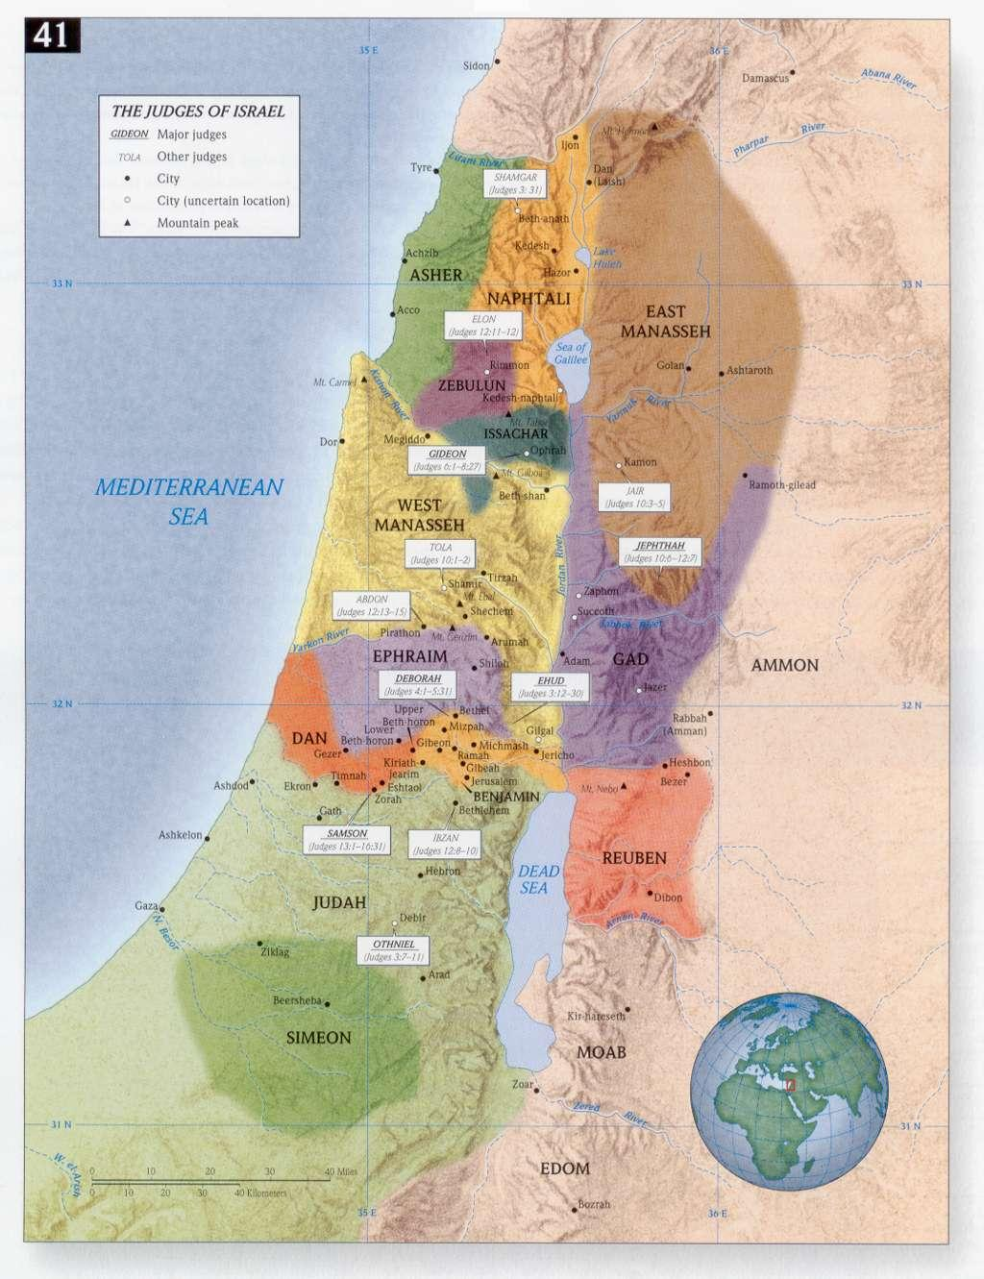
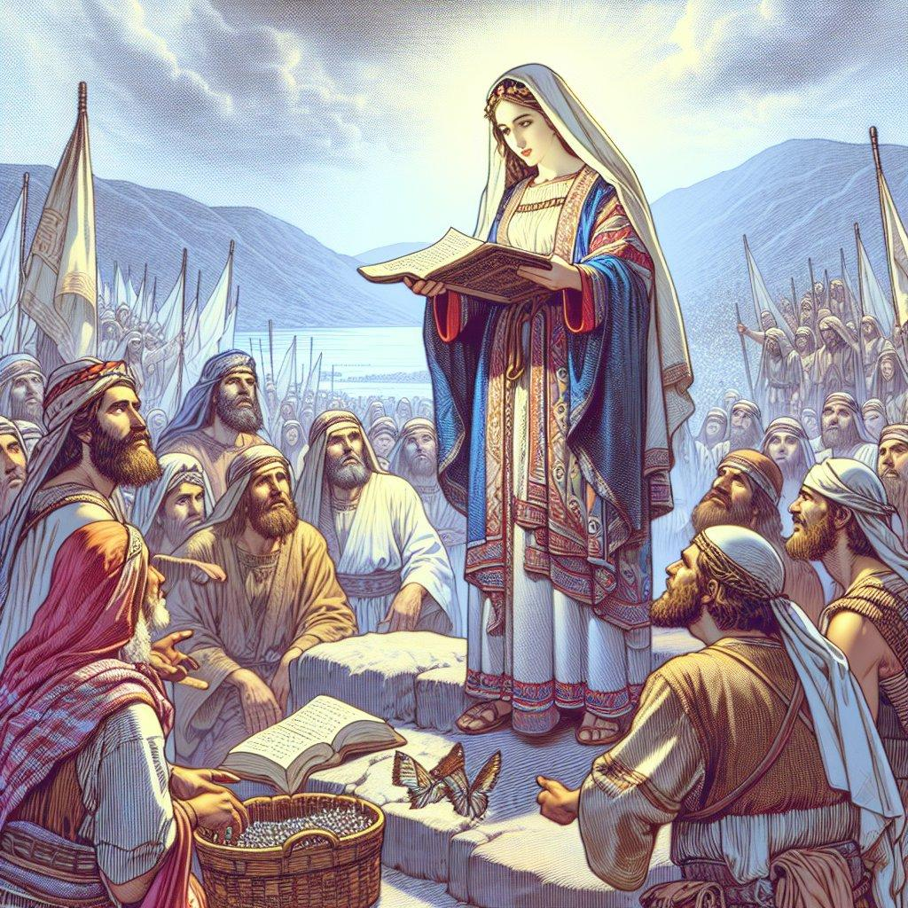
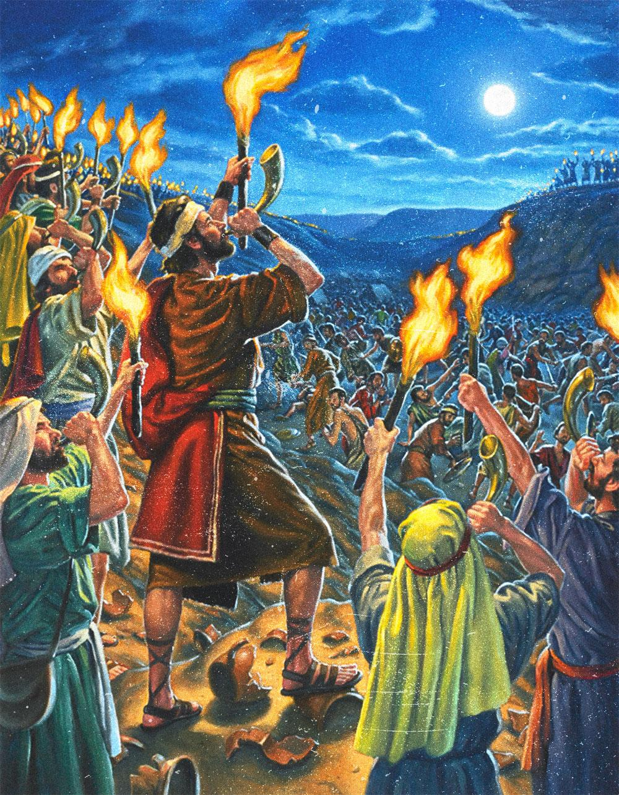
5
The Book of Judges is one of the most important—and darkest—books in the Old Testament. It explains what happened to Israel after Joshua's death and before the establishment of the monarchy. The book repeatedly shows Israel abandoning Yahweh, suffering oppression, crying out, being delivered, and then falling back into sin.
Its central refrain summarizes the tragedy:
“Everyone did what was right in his own eyes.”
—Judges 21:25
The book therefore isn't simply a collection of heroic stories about Samson, Gideon, and Deborah. It is a theological explanation of Israel's downward spiral when God's people reject God as their King.

1. THE BOOK AT A GLANCE
Category | Information
Hebrew name | Shoftim — שֹׁפְטִים
English name | Judges
Old Testament | Book #7
After | Joshua
Before | Ruth / 1 Samuel
Main setting | Canaan
Period | Between conquest and monarchy
Major theme | Israel's covenant unfaithfulness
Repeated problem | Idolatry
Repeated consequence | Oppression
Repeated response | Crying to God
Repeated divine response | God raises a deliverer
Final condition | Moral, spiritual and social collapse
The English word judge can be misleading. The major judges in this book aren't primarily courtroom officials. They function largely as regional deliverers, military leaders, and tribal rulers raised up during crises.

2. WHERE JUDGES FITS IN BIBLICAL HISTORY
The broad sequence is:
Abraham → Isaac → Jacob → Joseph → Exodus → Moses → Joshua → Judges → Samuel → Saul → David
The transition is crucial.
Joshua
Israel enters Canaan and receives its inheritance.
Judges
The conquest is incomplete, Israel compromises with the remaining Canaanites, idolatry spreads, and the tribes repeatedly fall into apostasy.
Samuel
The period of tribal judges gives way to monarchy.
Saul
Israel receives its first king.
David
Israel receives the king through whom the Davidic covenant is established.
Thus Judges is a bridge between Joshua and the monarchy. The Samuel narratives explicitly portray the transition from the period of judges to kingship.

3. THE THREE MAJOR SECTIONS
The book has a remarkably deliberate structure.
I. Israel's failure — Judges 1–2
Israel doesn't completely drive out the inhabitants of Canaan.
The problem isn't merely military.
It becomes spiritual compromise.
Israel begins living alongside the peoples whose gods and practices God had warned them against.
Judges 2 then gives the theological explanation for everything that follows.

II. Israel's judges — Judges 3–16
This is the famous section containing:
- Othniel
- Ehud
- Shamgar
- Deborah
- Barak
- Gideon
- Abimelech
- Tola
- Jair
- Jephthah
- Ibzan
- Elon
- Abdon
- Samson
Some lists distinguish 12 judges in the principal judge accounts, while others include associated figures such as Barak and Abimelech in different ways.

III. Israel itself collapses — Judges 17–21
This section is often overlooked.
There is no major foreign oppressor driving the narrative.
Instead, Israel becomes its own enemy.
Chapters 17–18
Micah's idol and the tribe of Dan.
Chapters 19–21
The Levite's concubine, the outrage at Gibeah, civil war against Benjamin, and the desperate attempt to preserve the tribe of Benjamin.
The book ends not with triumph but with:
“Everyone did what was right in his own eyes.”
That is the ultimate diagnosis of Judges.

4. THE CYCLE OF JUDGES
The recurring pattern is one of the most important things to understand.
1. Israel sins
“The children of Israel again did evil in the sight of the LORD.”
2. God gives them over
An enemy nation oppresses Israel.
3. Israel cries out
The people appeal to God.
4. God raises a deliverer
A judge appears.
5. Deliverance
The enemy is defeated.
6. Peace
The land experiences a period of rest.
7. The judge dies
8. Israel falls again
And the cycle begins again.
Judges 2:11–19 essentially provides the theological template for the entire book.
But there's something deeper:
It isn't really a circle.
It becomes a downward spiral.
The judges themselves increasingly reflect the moral condition of the nation.
Othniel → Ehud → Deborah → Gideon → Jephthah → Samson
The stories become progressively darker.

5. THE MAJOR PEOPLE
OTHNIEL — Judges 3:7–11
Tribe: Judah
Enemy: Cushan-Rishathaim, king of Mesopotamia
Length of rest: 40 years
Othniel is the first judge.
He is the simplest model of the deliverer:
Israel sins → oppression → Israel cries → Spirit of Yahweh comes upon Othniel → deliverance.
He establishes the basic pattern for the book.

6. EHUD
Judges 3:12–30
Tribe: Benjamin
Enemy: Moab
King: Eglon
Ehud is one of the most unusual deliverers in Scripture.
He is described as left-handed.
He makes a short sword and conceals it where the guards apparently don't expect it.
He gains private access to King Eglon and kills him.
The story is intentionally shocking.
It demonstrates that God can deliver Israel through an unlikely person whom conventional military expectations might overlook.

7. SHAMGAR
Judges 3:31
Shamgar receives only one verse.
He kills 600 Philistines with an oxgoad.
This illustrates an important feature of Judges:
Not every judge receives a lengthy biography.
Some are merely mentioned as deliverers.

8. DEBORAH
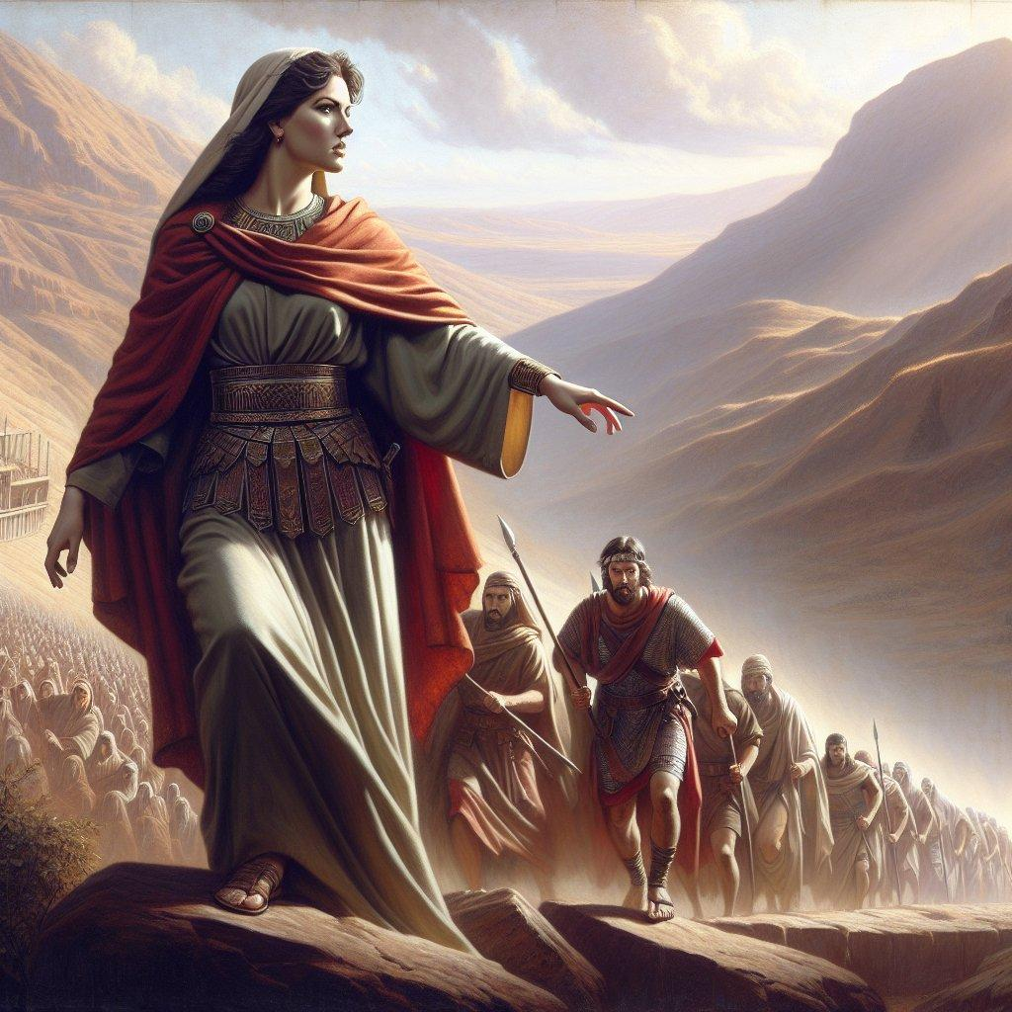
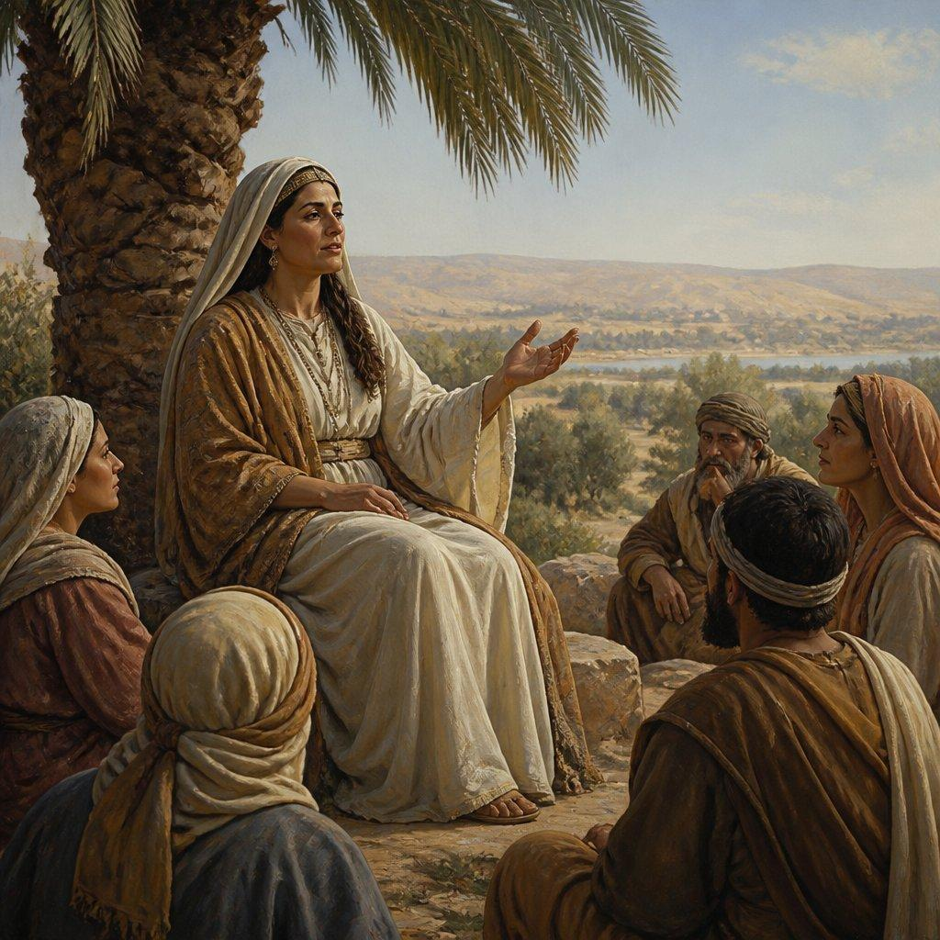
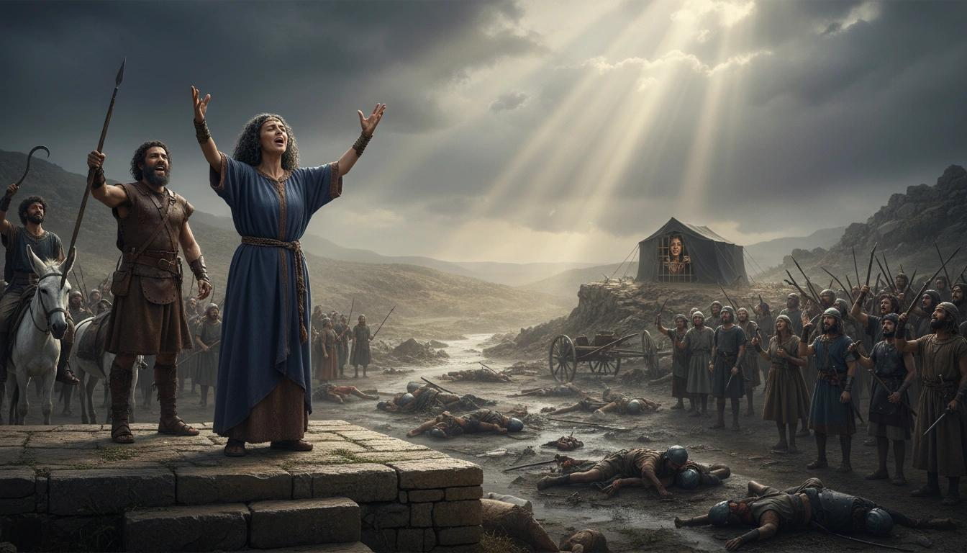
6
Judges 4–5
Deborah is one of the most significant women in the Old Testament.
She is described as:
- prophetess
- judge
- leader
- wife of Lappidoth
Her primary location is associated with the hill country of Ephraim, where she sits under the palm of Deborah.
Enemy
Jabin, king of Canaan
Military commander
Sisera
Israelite commander
Barak
The battle takes place around the Kishon River.
Sisera's military advantage includes 900 iron chariots.
Yet God defeats him.
Sisera ultimately escapes on foot and enters the tent of Jael, who kills him.

9. JAEL
Jael is one of the strangest and most memorable figures in Judges.
She is the wife of Heber the Kenite.
She welcomes Sisera into her tent, gives him milk, covers him, and then kills him with a tent peg.
Judges 5 celebrates her:
“Most blessed of women be Jael.”
This event illustrates a recurring theme:
God's deliverance doesn't always come through conventional military power.

10. THE SONG OF DEBORAH — JUDGES 5
Judges 5 is one of the great poetic passages of the Old Testament.
It is valuable for studying:
- ancient Israelite warfare
- tribal participation
- geography
- theology
- poetic imagery
- Israelite tribal relationships
The poem names tribes that participated and criticizes tribes that remained on the sidelines.
This gives us an unusual glimpse into the decentralized tribal structure of early Israel.

11. GIDEON
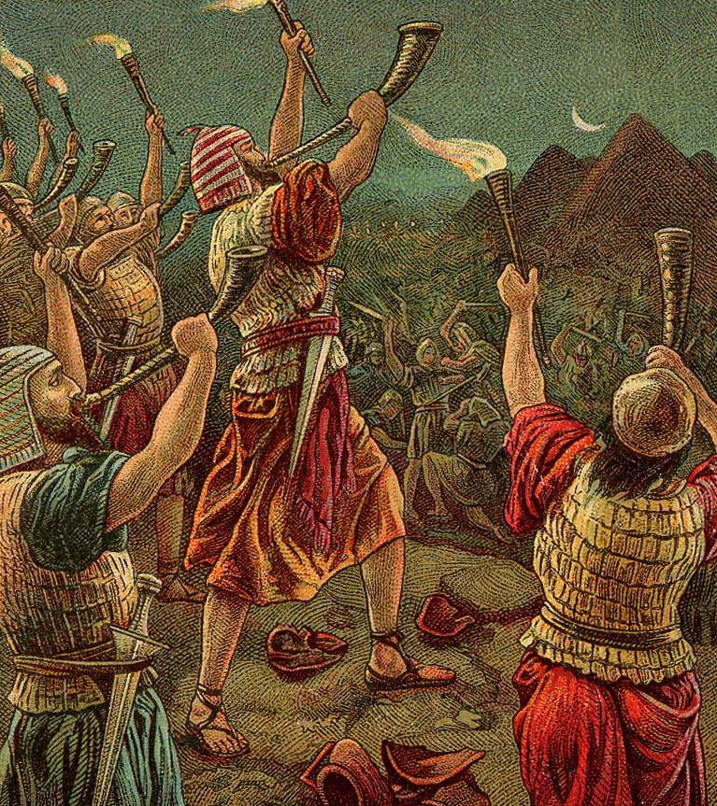
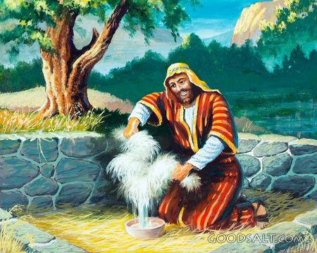
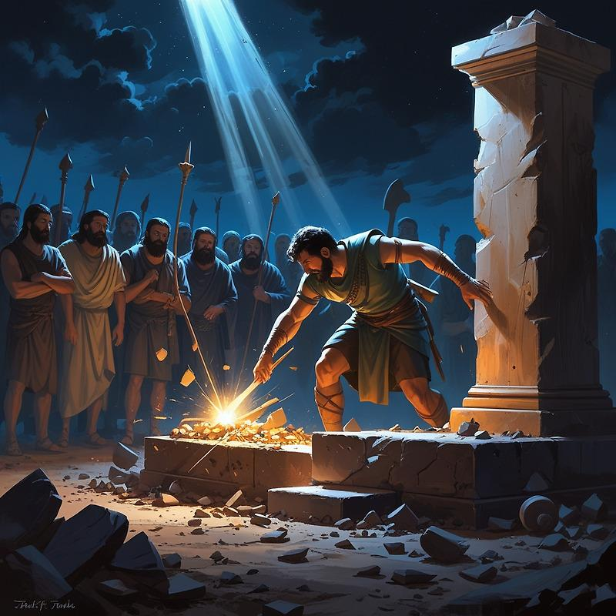
4
Judges 6–8
Gideon is probably the most psychologically complex judge.
Enemy
Midianites
Location
Ophrah
Tribe
Manasseh
Gideon initially appears fearful.
When the angel of Yahweh encounters him, Gideon is threshing wheat in a winepress.
He asks for signs.
He later tests God with the famous fleece.
Yet God uses him spectacularly.

12. THE 300 MEN
Judges 7 is one of the best-known military episodes in Scripture.
Gideon's army is reduced to only:
300 men
against an enormous Midianite force.
God deliberately reduces Israel's military strength so that Israel cannot boast:
“My own hand has saved me.”
The weapons are unusual:
- trumpets
- jars
- torches
The psychological effect causes the Midianites to turn against one another.
The theological point is enormous:
God's deliverance does not depend upon Israel's military strength.

13. GIDEON'S CONTRADICTION
Gideon says:
“The LORD will rule over you.”
That's excellent theology.
But Gideon's subsequent actions become increasingly king-like.
He acquires enormous wealth, many wives, and seventy sons.
He also makes an ephod, which becomes a snare to Israel.
Thus Gideon illustrates a major theme:
A person can say the right theological words while gradually compromising in practice.

14. ABIMELECH
Judges 9
Abimelech is not a faithful judge.
He is Gideon's son.
He attempts to become king.
He murders his brothers—except Jotham—and establishes himself as ruler at Shechem.
His story is essentially a political tragedy.
Jotham's parable of the trees is one of the most important political parables in the Old Testament.
It warns about the danger of incompetent or destructive leadership.
Abimelech eventually dies when a woman drops a millstone on his head.

15. TOLA AND JAIR
Judges 10:1–5
These are minor judges.
Tola
From Issachar.
Jair
A Gileadite associated with Manasseh's Transjordan territory.
Their short notices demonstrate that the period wasn't simply a succession of six famous heroes.
There were numerous local leaders during the period.

16. JEPHTHAH
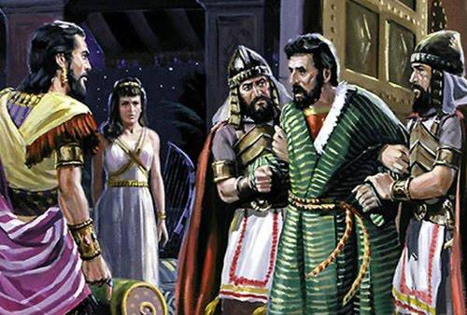
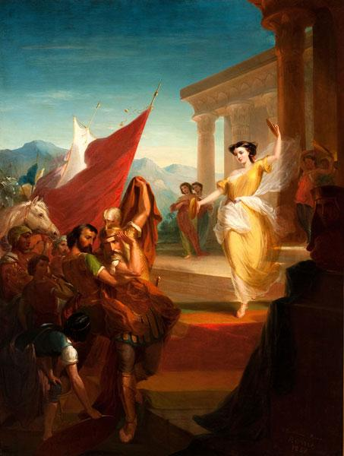
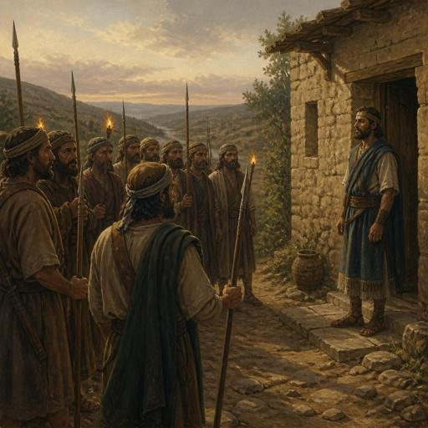
6
Judges 10:6–12:7
Jephthah is one of the most tragic figures.
Background
He is the son of Gilead and a prostitute.
His half-brothers drive him away.
He becomes associated with a group of adventurers.
Later, when Ammon threatens Israel, the elders ask him to return and lead them.

17. JEPHTHAH'S VOW
This is among the most debated passages in Judges.
Jephthah vows:
“Whatever comes out of the doors of my house ... shall surely be the LORD's.”
The first thing that comes out is his daughter.
Major interpretations
There are two principal approaches:
1. Jephthah actually sacrifices his daughter.
This interpretation sees the passage as describing an appalling act demonstrating Israel's spiritual degeneration.
2. His daughter is devoted to lifelong virginity rather than physically sacrificed.
This interpretation emphasizes the daughter's mourning of her virginity and the possibility that the vow involved dedication rather than killing.
Either interpretation makes the theological point disturbing:
Jephthah's understanding of God has become profoundly distorted.
The Law explicitly condemns human sacrifice (Lev. 18:21; 20:2–5; Deut. 12:31).

18. SHIBBOLETH
Judges 12 gives us one of the earliest examples of a dialect test.
The Gileadites defeat the Ephraimites.
Those attempting to cross the Jordan are asked to pronounce:
“Shibboleth.”
Those unable to pronounce it correctly are identified as Ephraimites.
This episode demonstrates how tribal and regional distinctions could become deadly.

19. IBZAN, ELON AND ABDON
Judges 12:8–15 gives brief accounts of three more judges:
Ibzan
From Bethlehem.
Elon
A Zebulunite.
Abdon
An Ephraimite.
Their stories emphasize family, social standing, and local leadership more than military exploits.

20. SAMSON
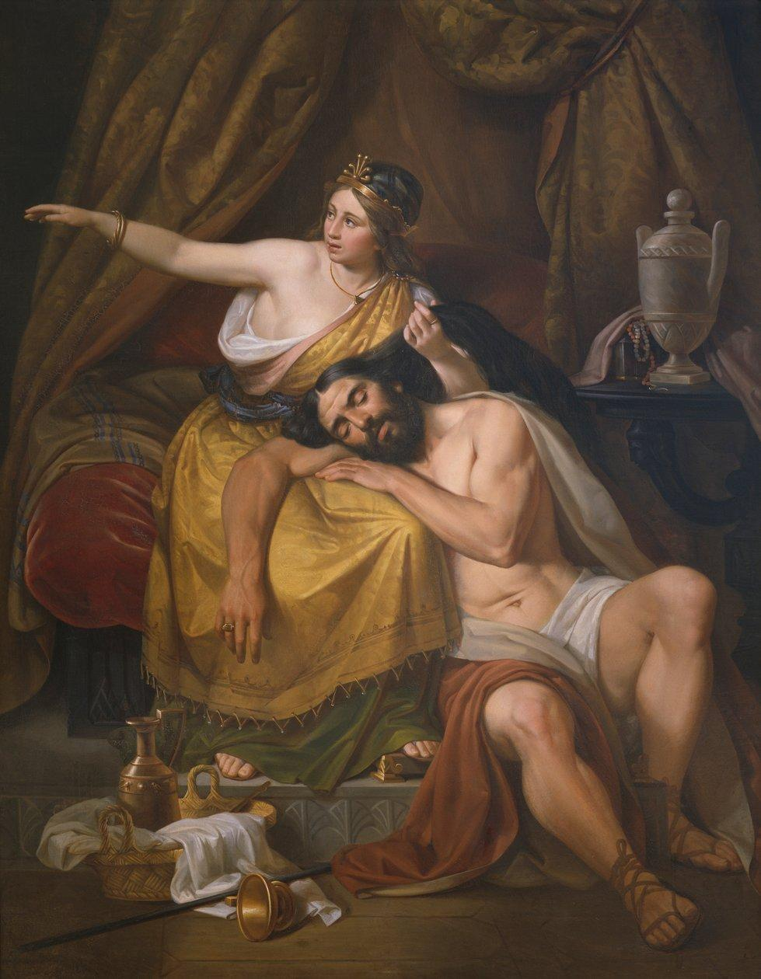
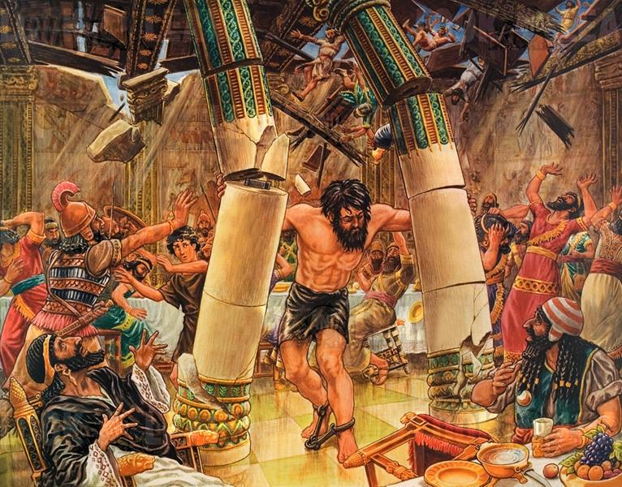
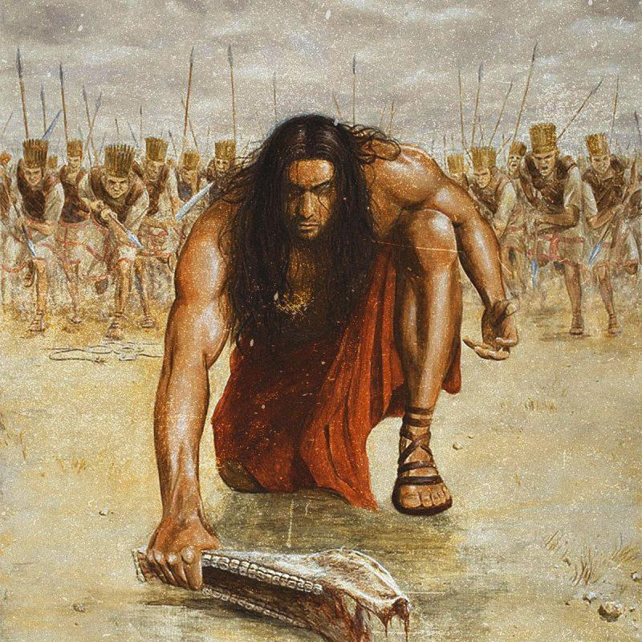
6
Judges 13–16
Samson is the final major judge and arguably the most tragic.
Tribe
Dan
Enemy
Philistines
Birth
His birth is announced by an angel.
Nazirite connection
His mother is told that the child will be dedicated to God.
Samson's life therefore begins with enormous promise.
But his character is profoundly flawed.

21. SAMSON'S STRENGTH
Samson's strength is associated with his Nazirite consecration.
Judges 13 connects his calling with the Nazirite regulations of Numbers 6.
His hair becomes the visible sign of his dedication.
But the deeper issue isn't simply hair.
Samson repeatedly violates the spirit of his calling.
He pursues:
- Philistine women
- revenge
- personal gratification
- violence
Yet God continues to use him.
This creates one of the book's great theological paradoxes:
God can use a deeply flawed person without approving that person's behavior.

22. DELILAH
Delilah lives in the Valley of Sorek.
The Philistine rulers offer her money to discover Samson's secret.
She repeatedly pressures him until he tells her about his hair.
Samson is captured, blinded, imprisoned, and forced to grind grain.
Eventually his hair begins to grow again.

23. SAMSON'S DEATH
The Philistines gather at the temple of Dagon.
Samson prays for strength.
He pushes against the temple pillars.
The building collapses.
Samson kills more Philistines in his death than during his life.
His final act is therefore simultaneously:
- an act of judgment
- an act of deliverance
- an act of personal vengeance
- a tragic death
Samson is not presented as a simple hero.
He is a picture of God's power operating through a morally compromised deliverer.

24. THE PEOPLE OF JUDGES
The book isn't only about the judges.
The people themselves are major characters.
Israel repeatedly:
- forgets Yahweh
- worships Baals
- worships Ashtaroth
- follows surrounding gods
- compromises with Canaanite culture
- abandons covenant faithfulness
The disturbing progression is:
Israel fights Canaanites → Israel lives among Canaanites → Israel imitates Canaanites → Israel becomes increasingly indistinguishable from Canaan.
That is the theological tragedy.

25. MAJOR PLACES
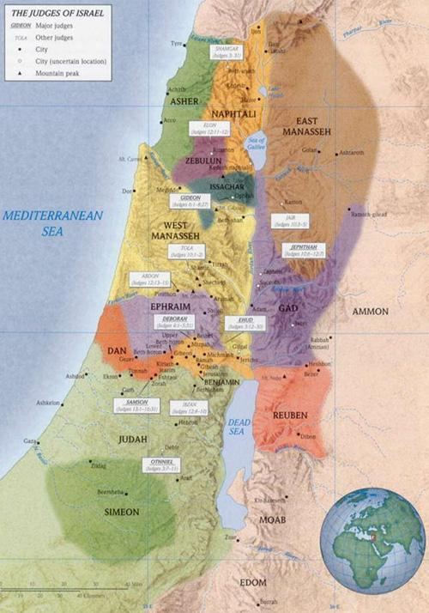
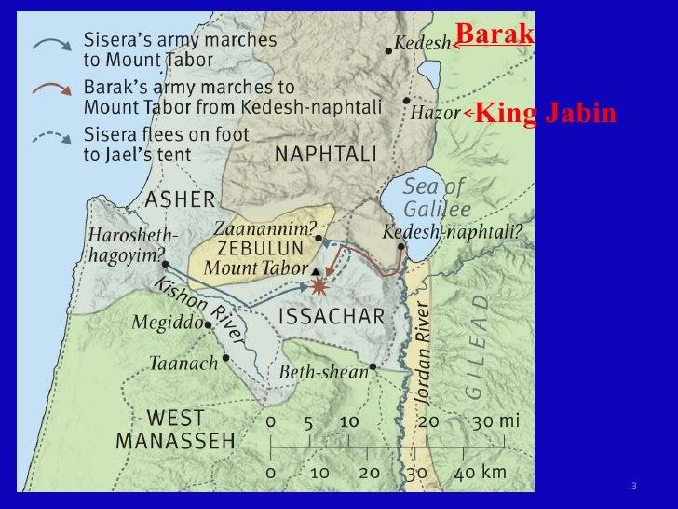
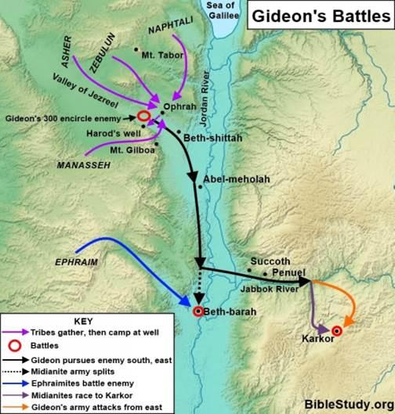
5
Important locations include:
Shechem
Important in Gideon's family history and Abimelech's rise.
Ophrah
Gideon's hometown.
Jezreel Valley
Important battlefield territory.
Mount Tabor
Associated with Deborah and Barak.
Kishon River
Battle area in Judges 4–5.
Gilead
East of the Jordan; important for Jephthah.
Mizpah
Associated with Jephthah.
Bethlehem
Associated with Ibzan and later with Ruth.
Ephraim
Important tribal territory.
Gibeah
Center of the horrific events of Judges 19–21.
Shiloh
Important sanctuary location.
Dan / Laish
The Danites migrate northward and capture Laish, renaming it Dan.
Gaza
One of the major Philistine cities and associated with Samson.
Ashkelon
Philistine city.
Timnah
Associated with Samson's marriage.
Valley of Sorek
Associated with Samson and Delilah.
Dagon's temple
Location of Samson's final act.

26. THE MAJOR NATIONS
Canaanites
The general indigenous population remaining in the land.
Moab
Oppresses Israel during Ehud's story.
Philistines
Become one of Israel's most persistent enemies, particularly in Samson's narrative.
Midianites
Oppress Israel during Gideon's time.
Ammonites
Oppress Israel east of the Jordan and become Jephthah's principal enemy.
Amalekites
Appear alongside Midian in Gideon's story.
These enemies are not random.
The geographic pattern demonstrates that Israel's tribal structure left different regions vulnerable to different neighboring powers.

27. MAJOR GODS AND RELIGIOUS OBJECTS
Yahweh
The covenant God of Israel.
Baal
Canaanite storm/fertility deity.
Baal worship becomes one of the principal manifestations of Israel's apostasy.
Ashtaroth
Associated with Canaanite religious practice.
Dagon
Philistine deity associated particularly with Samson's final episode.
Micah's idol
Judges 17–18 describes a private cult involving an image and a Levite priest.
Gideon's ephod
An object made after Gideon's victory that becomes a spiritual snare.
The religious problem of Judges isn't merely:
“Israel doesn't believe in God.”
It is:
“Israel attempts to combine Yahweh worship with the religious practices of the surrounding peoples.”

28. THE LEVITE AND HIS CONCUBINE
Judges 19
This is among the darkest narratives in Scripture.
A Levite travels through Benjamin and stays at Gibeah.
A mob attacks the house.
The concubine is abused and dies.
The Levite then sends pieces of her body throughout Israel.
The result is national outrage and civil war.
The story intentionally echoes the depravity associated with Sodom.
The shocking theological message is:
Israel has become like the pagan world it was supposed to replace.

29. THE BENJAMITE WAR
Judges 20–21
Israel assembles against Benjamin.
Benjamin initially defeats the larger Israelite army.
Eventually Israel wins and nearly annihilates the tribe.
Then Israel realizes:
“One of the tribes of Israel is about to disappear.”
The nation that was supposed to possess the land together is now destroying itself.
This is the culmination of Judges.

30. THE MOST IMPORTANT PHRASE
Three times the book emphasizes the problem:
Judges 17:6
“Everyone did what was right in his own eyes.”
Judges 18:1
“In those days there was no king in Israel.”
Judges 19:1
“In those days, when there was no king in Israel...”
Judges 21:25
“In those days there was no king in Israel. Everyone did what was right in his own eyes.”
The final verse deliberately combines the two ideas:
No king → everyone does what is right in his own eyes.
But there's an important theological question:
Is the answer simply a human king?
Not necessarily.
Israel already had a King:
Yahweh.
The deeper problem is that Israel refuses to live under God's rule.
That becomes particularly important when Samuel later warns Israel about what human kings can become.

31. PEOPLE–PLACE–THING INDEX
PEOPLE
Israelites
- Othniel
- Ehud
- Shamgar
- Deborah
- Barak
- Jael
- Gideon
- Abimelech
- Tola
- Jair
- Jephthah
- Ibzan
- Elon
- Abdon
- Samson
- Delilah
- Micah
- Jotham
- Heber
- Sisera
- Jabin
- Eglon
PLACES
- Canaan
- Jerusalem
- Bethlehem
- Shechem
- Ophrah
- Gilead
- Mizpah
- Ephraim
- Mount Tabor
- Kishon River
- Jezreel
- Gibeah
- Shiloh
- Dan
- Laish
- Gaza
- Ashkelon
- Timnah
- Valley of Sorek
- Jordan River
THINGS
- Ark of the Covenant
- Baal worship
- Ashtaroth
- Dagon
- idols
- ephod
- altar
- tent peg
- sword
- oxgoad
- trumpets
- jars
- torches
- fleece
- Nazirite vow
- temple
- millstone
- Shibboleth
- tribal inheritance
- covenant
- idolatry

32. THE BIG THEOLOGICAL THEMES
1. God's faithfulness
Israel repeatedly fails.
God repeatedly delivers.
The hero of Judges is therefore ultimately God, not the judges.
2. Human leadership deteriorates
The judges become increasingly flawed.
The leaders increasingly resemble the people they lead.
3. Sin has consequences
Idolatry produces oppression, violence, division and ultimately civil war.
4. God's mercy is astonishing
Israel repeatedly abandons God.
God repeatedly hears their cries.
5. External deliverance isn't enough
The judges can defeat Israel's enemies.
They cannot cure Israel's heart.
6. Israel needs a righteous king
Judges points toward Samuel and David—but ultimately the biblical story moves toward the need for a perfect King.

33. JUDGES AND JESUS CHRIST
From a Christian canonical perspective, Judges creates a profound contrast.
The judges are:
- temporary
- imperfect
- sinful
- mortal
- inconsistent
Jesus is presented as:
- righteous
- sinless
- permanent
- perfectly obedient
- the true Shepherd
- the true King
- the final Deliverer
The judges repeatedly rescue Israel from external enemies.
Christ's saving work addresses the deeper problem:
sin itself.
So Judges creates a longing:
Israel needs a Deliverer who doesn't eventually become part of the problem.
That longing becomes progressively clearer through Samuel, David, the prophets, and ultimately the New Testament.

34. A VERY IMPORTANT READING KEY
Don't read Judges as:
“Here are twelve heroes we should imitate.”
Read it as:
“Here is what happens when God's covenant people abandon their King.”
Deborah is admirable.
Gideon is complicated.
Jephthah is tragic.
Samson is deeply flawed.
And Israel itself becomes increasingly corrupt.
The book intentionally prevents us from putting our hope in human heroes.

35. JUDGES — THE DOWNWARD SPIRAL
A useful way to remember the entire book:
Joshua
↓
Conquest and inheritance
Judges 1
↓
Incomplete conquest
Judges 2
↓
Compromise
Judges 3–5
↓
God raises deliverers
Judges 6–8
↓
Gideon's contradictions
Judges 9
↓
Abimelech's destructive kingship
Judges 10–12
↓
Jephthah's tragedy
Judges 13–16
↓
Samson's collapse
Judges 17–18
↓
Idolatry
Judges 19–21
↓
Sexual violence + civil war + near destruction of Benjamin
Judges 21:25
↓
“Everyone did what was right in his own eyes.”
That is the central diagnosis of Judges.
And it sets up the next great question of Scripture:
What kind of king does Israel actually need?
That question leads directly into 1 Samuel, Saul, David, the Davidic covenant, the prophets, and ultimately the Messiah.
For a truly deep People, Places & Things study, Judges is especially rich because its geography, tribal relationships, military conflicts, Canaanite religion, judges, and repeated covenant cycles all fit together into one theological narrative.

This document was created by doulos777 and its source was A.I.

