The Tabernacle — Comprehensive Deep Bible Research Study
The Tabernacle is one of the richest theological subjects in Scripture. It was Israel's portable sanctuary, but it was much more than a tent. It revealed God's holiness, God's presence, the way sinners approach God, sacrifice, priesthood, covenant, worship, and ultimately Christ.
A central theme is:
“Let them make me a sanctuary; that I may dwell in their midst.” — Exodus 25:8
The Tabernacle therefore answers a fundamental biblical question:
How can a holy God dwell among a sinful people?

1. The Tabernacle at a Glance
Feature | Biblical significance
Hebrew name | Mishkan — dwelling/place of dwelling
Basic purpose | God's dwelling among Israel
First commanded | Exodus 25
Construction | Exodus 35–40
Dedicated | Exodus 40
Main location | Israel's wilderness camp
Priestly tribe | Levi
High priest | Aaron
Main entrance | East
Holy Place | First room
Most Holy Place | Inner room
Central object | Ark of the Covenant
Divine manifestation | Glory cloud
Major themes | Presence, holiness, sacrifice, priesthood, atonement
NT fulfillment | Christ, His sacrifice, His priesthood, and God's dwelling with His people

2. The Great Purpose of the Tabernacle
Exodus 25:8
“And let them make me a sanctuary; that I may dwell in their midst.”
This is the foundational verse.
God did not merely want Israel to know about Him.
He wanted to dwell among them.
Compare:
- Genesis 3 — humanity is separated from God's immediate presence.
- Exodus — God establishes His dwelling among Israel.
- John 1:14 — Christ comes and dwells among humanity.
- Revelation 21:3 — God permanently dwells with His people.
There is an enormous biblical movement:
Eden → Tabernacle → Temple → Christ → Church → New Jerusalem

3. The Tabernacle in the Overall Story of Scripture
Eden
God dwells with humanity.
Fall
Sin separates humanity from God's holy presence.
Tabernacle
God establishes His presence among redeemed Israel.
Temple
The sanctuary becomes permanently associated with Jerusalem.
Christ
God's presence comes among humanity personally.
Church
God dwells among His people by the Holy Spirit.
New Jerusalem
God's dwelling with humanity becomes eternal.
Revelation 21:3 brings the theme to its climax:
“Behold, the dwelling place of God is with man.”
The Tabernacle is therefore part of one enormous biblical theme:
God dwelling with His people.

4. The Tabernacle and Mount Sinai
The Tabernacle instructions occur immediately after Israel's covenant relationship with God.
Important sequence:
Exodus 19 — Israel arrives at Sinai
↓
Exodus 20 — Ten Commandments
↓
Exodus 24 — Covenant confirmed
↓
Exodus 25–31 — Tabernacle instructions
↓
Exodus 32 — Golden calf
↓
Exodus 33 — God's presence becomes the central issue
↓
Exodus 34 — Covenant renewed
↓
Exodus 35–40 — Tabernacle constructed
↓
Exodus 40 — Glory of God fills it
This is important.
The Tabernacle is not primarily about architecture.
It is about covenant fellowship between God and His people.

5. The Tabernacle Was God's Dwelling
Exodus repeatedly emphasizes God's dwelling.
Exodus 29:45
“I will dwell among the people of Israel and will be their God.”
Exodus 29:46
God identifies Himself as the One who brought Israel out of Egypt “that I might dwell among them.”
This is extraordinary.
The Exodus was not merely:
Israel escaped slavery.
The ultimate purpose was:
God redeemed a people for fellowship with Himself.

6. The Tabernacle's Three Main Areas
The sanctuary consisted of:
- Outer Court
- Holy Place
- Most Holy Place
The movement inward represents increasing sacredness.
Camp → Court → Holy Place → Most Holy Place
And access becomes increasingly restricted.
Outer Court
Israelites could bring sacrifices.
Holy Place
Priests ministered.
Most Holy Place
Only the high priest entered, and only once a year.
Hebrews 9:6–7 explains this restriction.

7. The Basic Layout
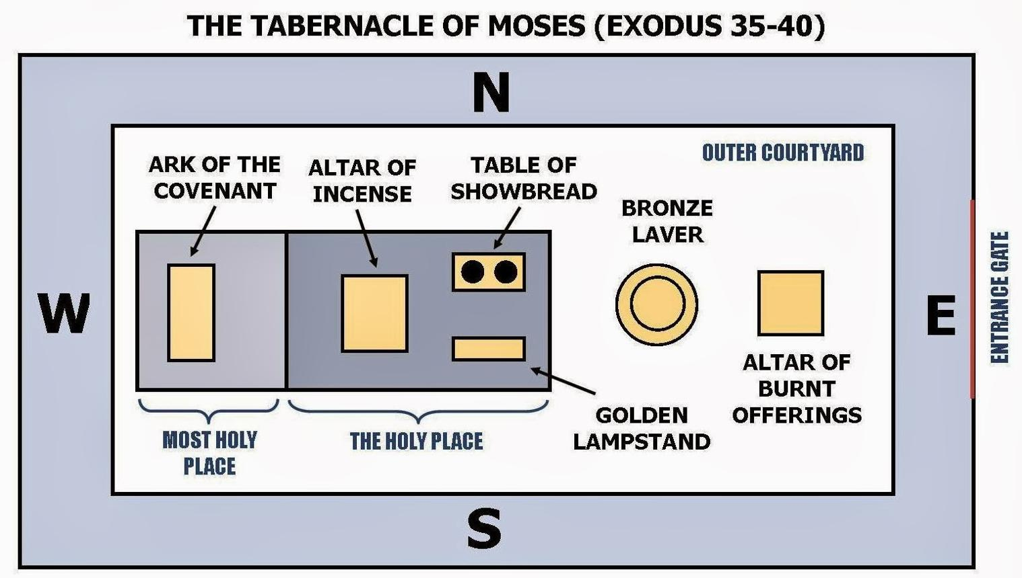
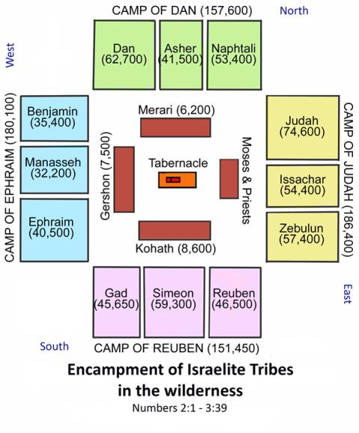
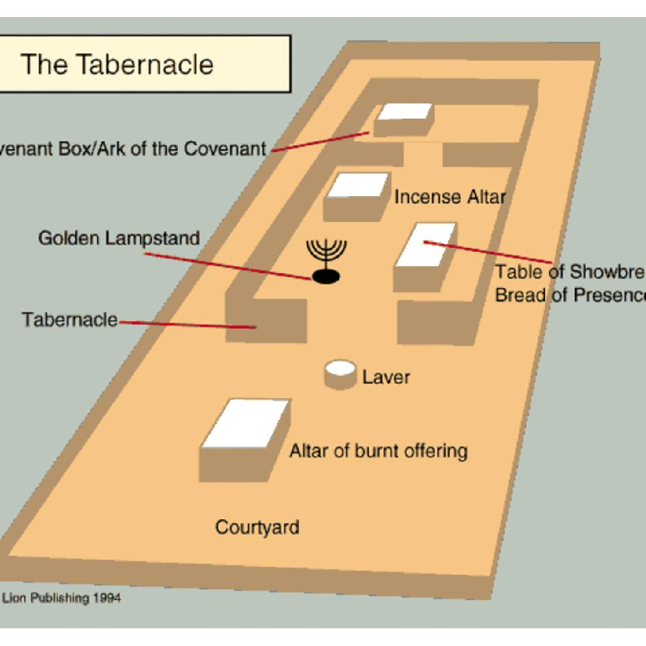
5
A simplified arrangement:
EAST
⬇
Entrance
⬇
OUTER COURT
- Bronze altar
- Bronze laver/basin
⬇
HOLY PLACE
- Table of Bread
- Golden Lampstand
- Altar of Incense
⬇
MOST HOLY PLACE
- Ark of Covenant
- Mercy Seat
- Cherubim
⬆
WEST

8. The Tabernacle Faced East
The entrance was on the eastern side.
Exodus 27:13–16 describes the eastern side and its gate.
This is interesting when compared with Genesis.
After humanity's expulsion from Eden:
Genesis 3:24 — cherubim guard the way to the tree of life.
The Tabernacle's entrance allows God's covenant people to approach through the prescribed means.
Cherubim also appear prominently in the Tabernacle.
This creates an important biblical connection between:
Eden → cherubim → God's presence → sanctuary

9. The Outer Court
The court surrounded the sanctuary.
Exodus 27:9–19 gives its dimensions and construction.
The court separated the sacred sanctuary from the ordinary camp.
Its major objects were:
- Bronze altar
- Bronze laver/basin

10. The Bronze Altar
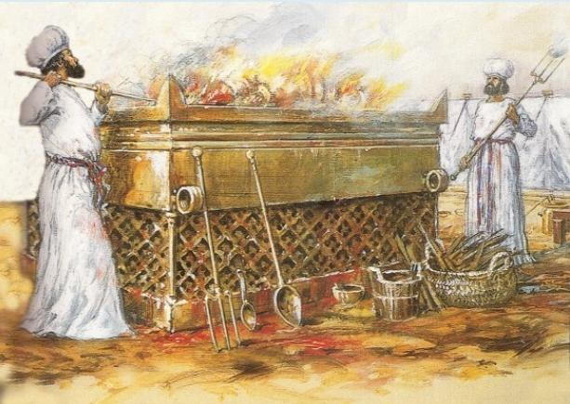
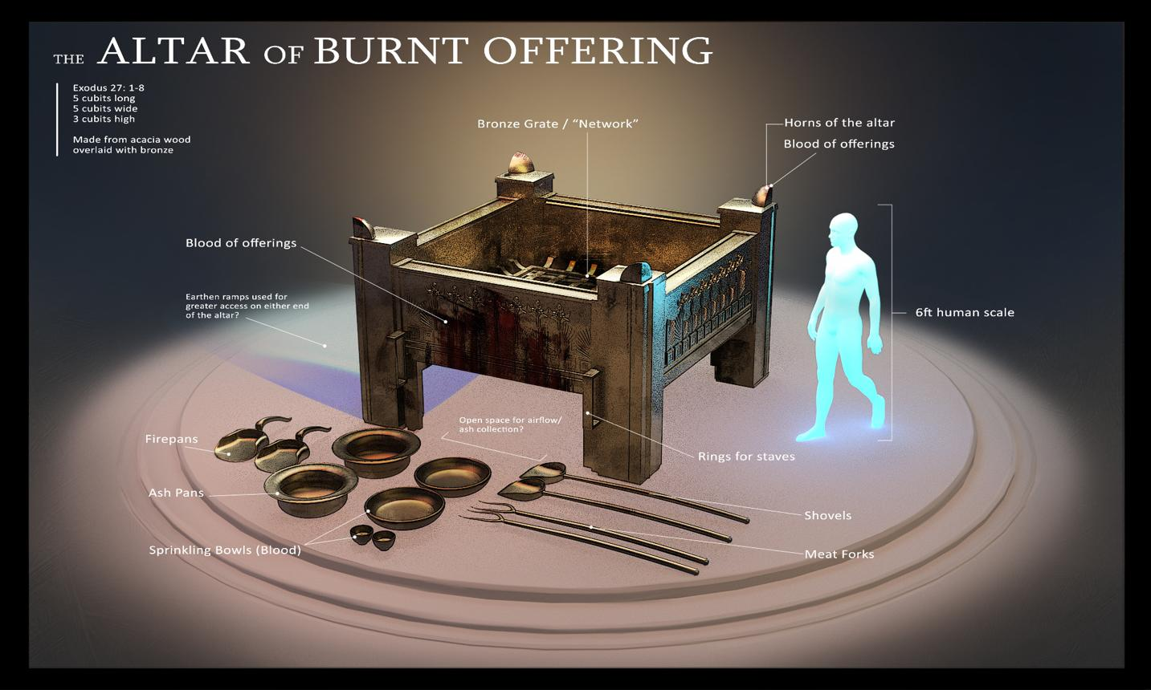
6
Exodus 27:1–8
The bronze altar was where sacrifices were offered.
This is the first major object encountered after entering the court.
That theological order matters:
Approach to God requires sacrifice.
Leviticus develops this extensively.
Key sacrifices
- Burnt offering
- Grain offering
- Peace offering
- Sin offering
- Guilt offering
The sacrificial system ultimately points toward the greater sacrifice of Christ.

11. Christ and the Bronze Altar
Hebrews 10:10:
“We have been sanctified through the offering of the body of Jesus Christ once for all.”
The Old Testament sacrifices were repeated.
Christ's sacrifice is once for all.
Old Covenant
Many sacrifices
↓
Repeated continually
Christ
One sacrifice
↓
Perfect and sufficient
Hebrews 10:11–14 contrasts the repeated priestly sacrifices with Christ's completed work.

12. The Bronze Laver
Exodus 30:17–21
The priests washed at the bronze basin before entering the tent or ministering at the altar.
The principle is clear:
God is holy, and those who minister before Him must approach appropriately.
Compare:
- Psalm 24:3–4
- Isaiah 6:5–7
- John 13:8–10
- Ephesians 5:26
- Hebrews 10:22
The laver should not be turned into an overly precise allegory, but the biblical theology of cleansing and consecration is unmistakable.

13. The Tabernacle Building
The sanctuary itself was divided into two rooms:
Holy Place
and
Most Holy Place
The structure consisted of boards, curtains, coverings, bars, sockets, and other components.
Exodus 26 gives the major construction instructions.

14. The Curtains
Exodus 26:1–6 describes the inner curtains.
They included:
- fine twined linen
- blue
- purple
- scarlet
- cherubim
The colors and craftsmanship communicate extraordinary beauty and holiness.
Cherubim again emphasize the heavenly character of God's dwelling.

15. The Coverings
The Tabernacle had multiple coverings.
Exodus 26:14 mentions:
- goat-hair covering
- ram skins
- outer covering
This created both protection and separation.
The sanctuary was beautiful within, while externally it was covered and protected.

16. The Holy Place
Inside the Holy Place were three principal objects:
1. Table of Bread
2. Golden Lampstand
3. Altar of Incense
Each served a specific function in Israel's worship.

17. The Table of Bread
Exodus 25:23–30
Also called the Table of the Bread of the Presence.
Twelve loaves were arranged before the Lord.
The twelve loaves corresponded naturally to the twelve tribes of Israel.
This emphasizes:
Israel continually represented before God in His sanctuary.
The table also communicates God's provision and covenant fellowship.

18. Jesus and the Bread
Jesus declares:
“I am the bread of life.” — John 6:35
We should distinguish the Old Testament object from later Christian interpretation.
But the biblical theme of bread, God's provision, life, fellowship, and God's presence reaches its fulfillment in Christ.

19. The Golden Lampstand
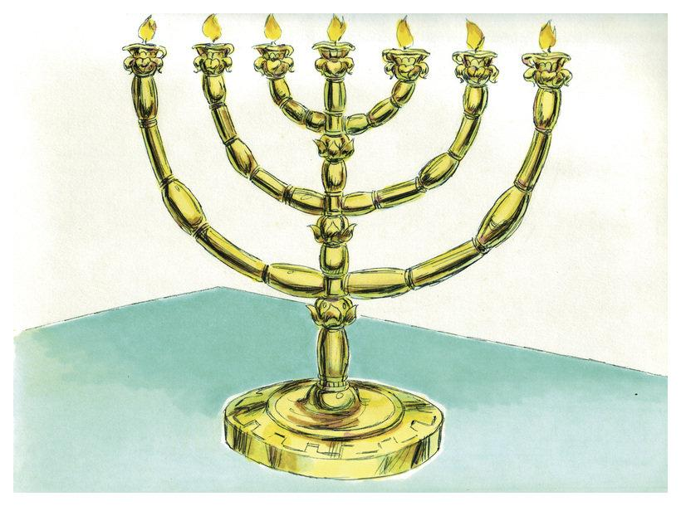
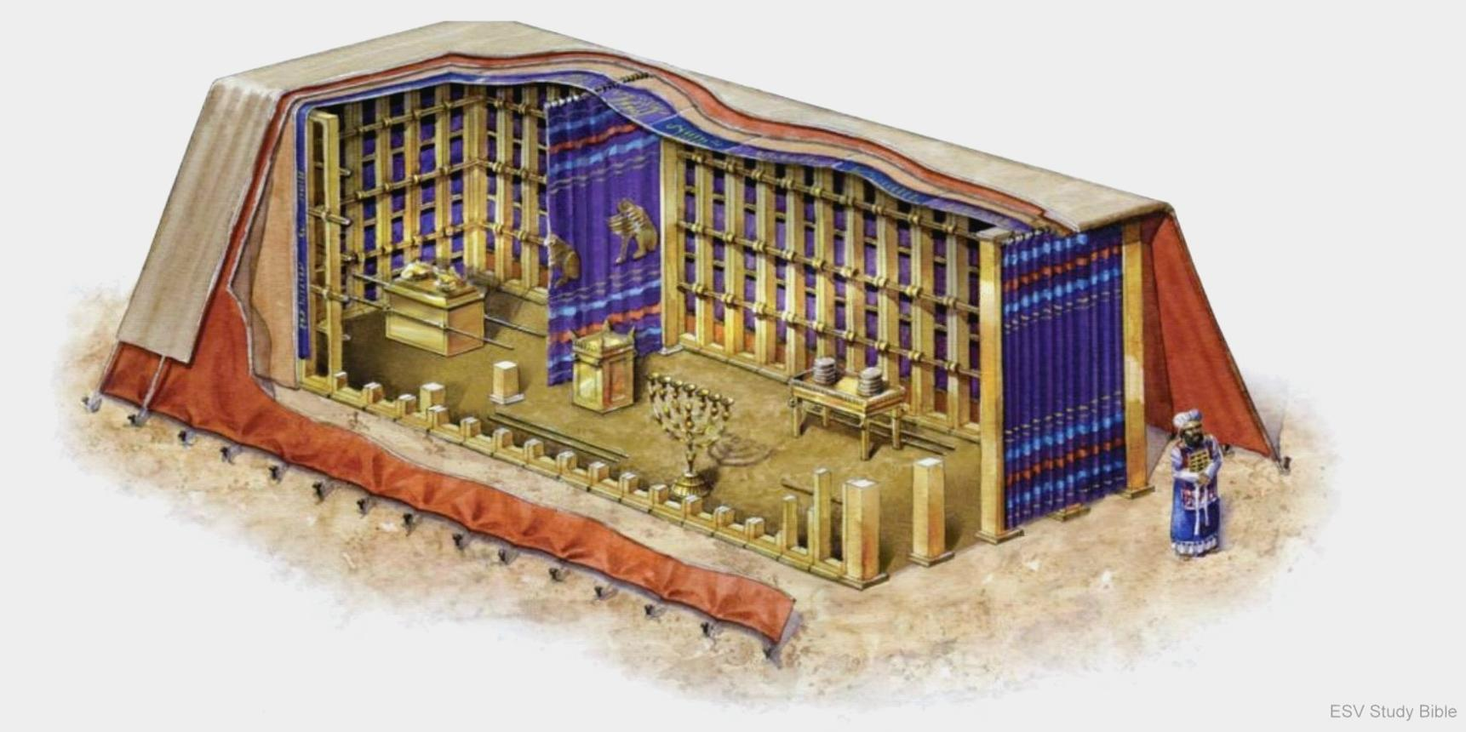
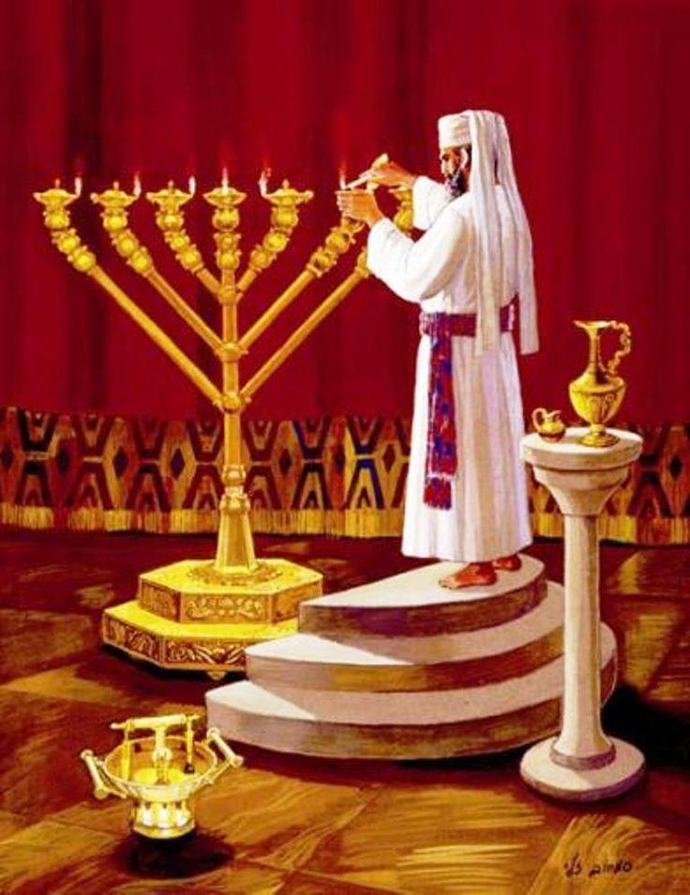
6
Exodus 25:31–40
The lampstand had seven lamps.
It provided light inside the Holy Place.
Israel's sanctuary had no ordinary natural lighting system inside.
The lampstand therefore symbolized the necessity of divine light.

20. Light in the Bible
The lampstand fits into a much larger biblical theme:
Genesis 1 — God creates light
↓
Tabernacle — lampstand provides sanctuary light
↓
Psalms — God is light
↓
Isaiah — God's servant becomes light
↓
John — Christ is the Light
↓
Revelation — God's glory illuminates the eternal city
Jesus says:
“I am the light of the world.” — John 8:12

21. The Altar of Incense
Exodus 30:1–10
The golden altar stood before the veil separating the Holy Place from the Most Holy Place.
Incense was burned regularly.
Psalm 141:2 gives the theological connection:
“Let my prayer be counted as incense before you.”
Revelation develops this imagery.
Revelation 5:8
The bowls of incense are identified with:
“the prayers of the saints.”
Revelation 8:3–4
Incense rises together with the prayers of God's people.
Thus the altar of incense is deeply associated with prayer and worship before God.

22. The Veil
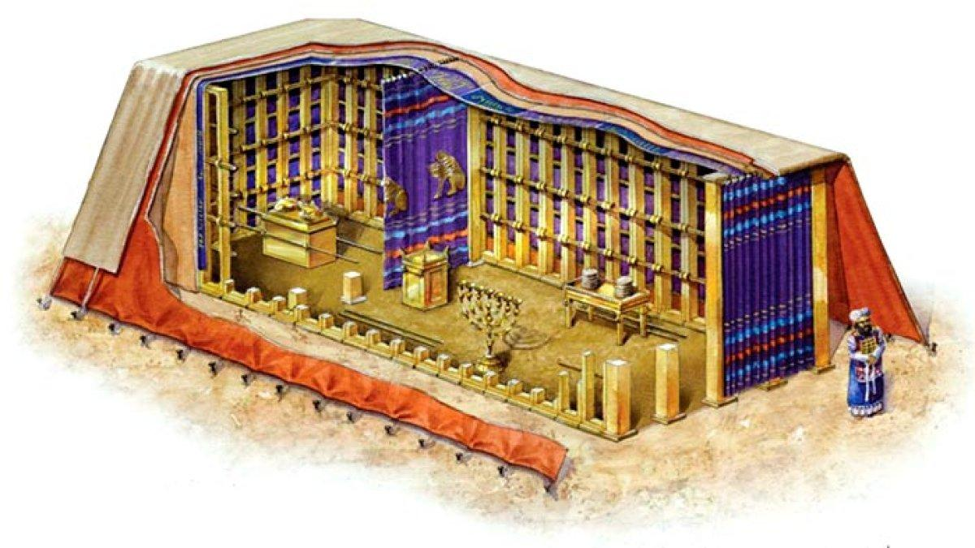
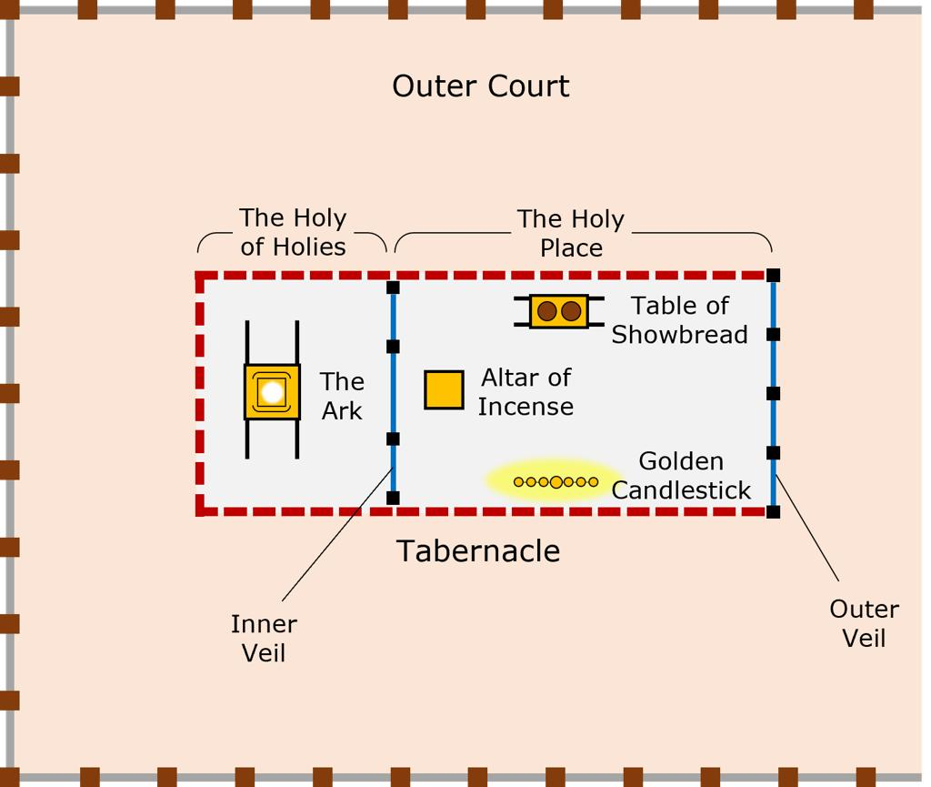
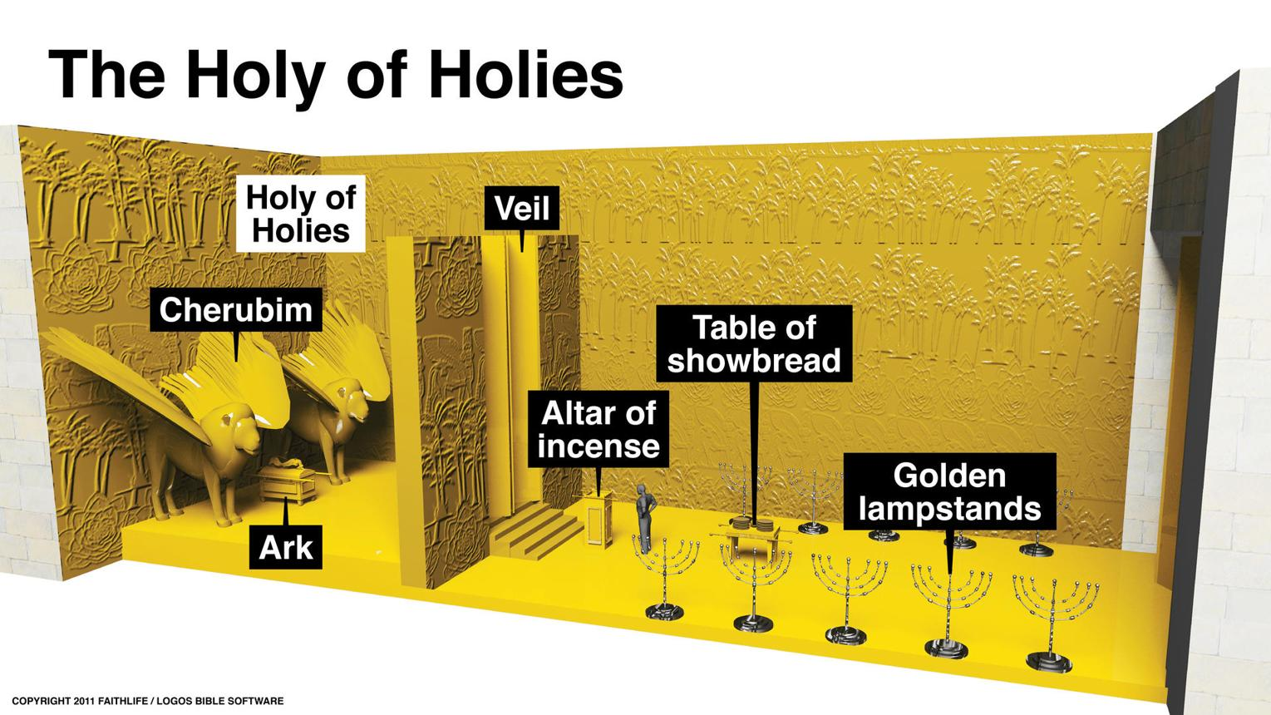
8
The veil separated the Holy Place from the Most Holy Place.
Exodus 26:31–33
It was made with:
- blue
- purple
- scarlet
- fine twined linen
- cherubim
The veil communicated:
God is present, but sinful humanity cannot approach Him casually.

23. The Most Holy Place
The Most Holy Place contained the most important object in the entire sanctuary:
The Ark of the Covenant
Exodus 26:33 describes the veil as separating the Holy Place from the Most Holy Place.
Only the high priest entered the inner sanctuary, and only on the Day of Atonement.
Leviticus 16 is therefore essential to understanding the Tabernacle.

24. The Ark of the Covenant
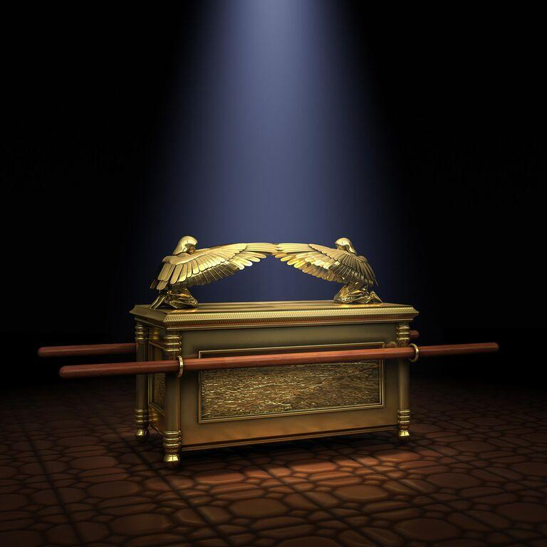
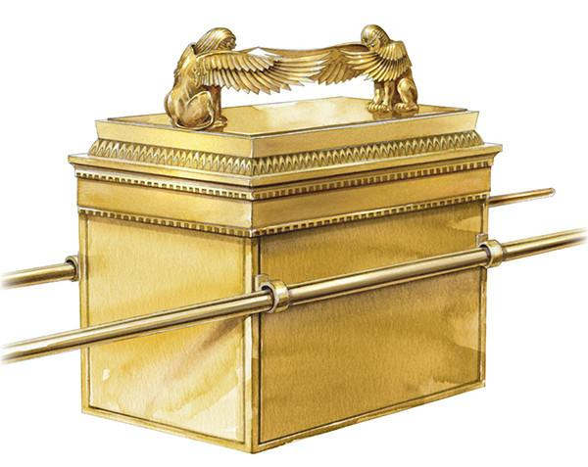
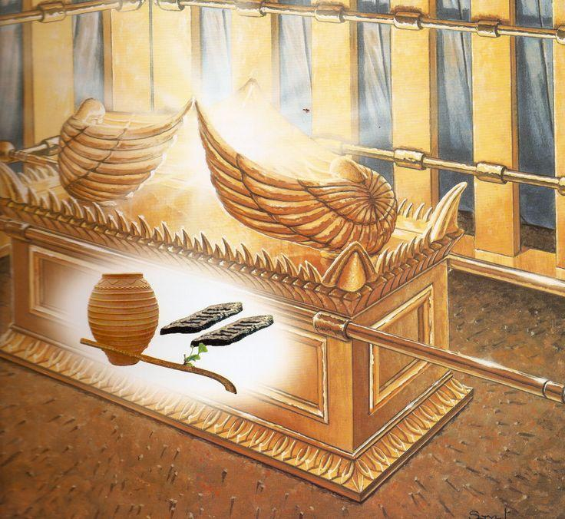
6
Exodus 25:10–22
The Ark was made of acacia wood and overlaid with gold.
It contained the testimony of God's covenant.
The Ark represented God's throne-like presence among Israel.

25. The Mercy Seat
The cover of the Ark was called the mercy seat.
Hebrew:
kapporet
Cherubim were positioned over it.
Exodus 25:22
God says:
“There I will meet with you.”
This is one of the most important statements concerning the Tabernacle.
God's meeting place with Israel was associated with:
the Ark + mercy seat + God's presence.

26. The Ark and God's Throne
The Ark is repeatedly associated with God's kingship.
Examples:
- 1 Samuel 4:4
- 2 Samuel 6:2
- Psalm 80:1
- Psalm 99:1
Psalm 99:1:
“The LORD reigns; let the peoples tremble! He sits enthroned upon the cherubim.”
This imagery connects the sanctuary with God's heavenly kingship.

27. What Was Inside the Ark?
Several biblical passages identify contents associated with the Ark.
Hebrews 9:4
It mentions:
- golden urn containing manna
- Aaron's staff that budded
- tablets of the covenant
Compare:
- Exodus 16:33–34 — manna
- Numbers 17:10 — Aaron's staff
- Deuteronomy 10:1–5 — covenant tablets
These objects testify to:
God's provision → God's appointed priesthood → God's covenant law

28. The Cherubim
Cherubim appear repeatedly in Scripture.
They are associated with God's presence and holiness.
Genesis 3:24
Cherubim guard Eden.
Exodus 25:18–22
Cherubim are above the mercy seat.
Ezekiel 1
Cherub-like heavenly beings appear in Ezekiel's vision.
Ezekiel 10
The cherubim are associated with God's glory.
This suggests a major sanctuary theme:
The Tabernacle evokes the heavenly throne room of God.

29. The Glory of God
The Tabernacle culminates in Exodus 40.
Exodus 40:34
“Then the cloud covered the tent of meeting, and the glory of the LORD filled the tabernacle.”
This is the climax.
Israel has:
- been redeemed from Egypt
- entered covenant
- received God's law
- built the sanctuary
And now:
God's glory fills the sanctuary.

30. The Cloud
The cloud guided Israel.
Exodus 40:36–38
When the cloud lifted:
Israel traveled.
When the cloud remained:
Israel stayed.
God's presence therefore directed Israel's journey.
This connects the Tabernacle with the wilderness journey itself.

31. The Tabernacle Was Mobile
This is crucial.
It was not a permanent building.
Israel was traveling.
God's dwelling moved with His people.
The theological picture is powerful:
God did not merely tell Israel where to go.
God went with them.

32. The Tabernacle and the Wilderness
Israel's wilderness experience was characterized by:
- God's presence
- God's provision
- God's holiness
- Israel's rebellion
- God's judgment
- God's mercy
The Tabernacle stood at the center of this relationship.

33. The Camp Around the Tabernacle
Numbers 2 describes Israel's tribal arrangement around the sanctuary.
The Tabernacle was located centrally.
This communicated something visually:
God was at the center of Israel's national life.
The nation was organized around God's presence.

34. The Levites
The Levites were assigned responsibility for the sanctuary.
Numbers 3–4 provides extensive details.
Different Levite families had different responsibilities.
Gershonites
Curtains and coverings.
Kohathites
Holy objects.
Merarites
Boards, bars, pillars, bases, etc.
This demonstrates that worship was not casual.
God established specific order and responsibility.

35. Aaron and the Priesthood
Aaron was appointed high priest.
Exodus 28–29 describes his garments and consecration.
The priest represented Israel before God.
The high priest was especially associated with:
- sacrifice
- atonement
- holiness
- intercession
- entering God's presence

36. The High Priest's Garments
Exodus 28
The high priest wore:
- breastpiece
- ephod
- robe
- woven tunic
- turban
- sash
The garments were designed:
“for glory and for beauty.” — Exodus 28:2

37. Israel Carried on the High Priest
The high priest's garments contained stones representing Israel.
Exodus 28:9–12
Names of the tribes were engraved on stones on his shoulders.
Exodus 28:29
The names of Israel's sons were carried over his heart.
This provides a beautiful picture of representation:
The priest enters God's presence bearing God's people.

38. Holiness to the LORD
The high priest wore a gold plate on his forehead.
Exodus 28:36
It was engraved:
“Holy to the LORD.”
This summarizes the entire sanctuary system.
God's dwelling requires holiness.

39. The Day of Atonement
Leviticus 16 is indispensable for understanding the Tabernacle.
Once each year the high priest entered the Most Holy Place.
This was the Day of Atonement — Yom Kippur.
The high priest offered sacrifices for:
- himself
- his household
- the priests
- Israel
- the sanctuary

40. The Two Goats
Leviticus 16:7–10 describes two goats.
One was sacrificed.
The other became the scapegoat.
Leviticus 16:21–22
Aaron confessed Israel's sins over the goat and it was sent away into the wilderness.
The imagery communicates the removal of guilt.

41. The Blood
Blood is central to the Tabernacle's sacrificial system.
Leviticus 17:11:
“For the life of the flesh is in the blood.”
The blood was associated with atonement.
This becomes foundational for New Testament theology.

42. Christ and the Tabernacle
The book of Hebrews provides the clearest extended explanation.
Hebrews 8–10 compares:
Old Covenant sanctuary
with
Christ's heavenly ministry.

43. Christ as the Greater High Priest
Hebrews 4:14:
“We have a great high priest who has passed through the heavens, Jesus, the Son of God.”
Aaron was a high priest.
Jesus is the greater High Priest.
Aaron was mortal.
Jesus lives forever.
Aaron repeatedly offered sacrifices.
Jesus offered Himself.

44. Christ Entered the Greater Sanctuary
Hebrews 9:11:
“But when Christ appeared as a high priest of the good things that have come, then through the greater and more perfect tent...”
The earthly Tabernacle pointed beyond itself.
The earthly sanctuary was a copy/shadow of a greater heavenly reality.

45. Christ's Blood
Hebrews 9:12:
“He entered once for all into the holy places, not by means of the blood of goats and calves but by means of his own blood.”
This is one of the most important Tabernacle fulfillment passages.
Old system
Animal blood.
Christ
His own blood.
Old system
Repeated sacrifices.
Christ
Once for all.

46. The Veil and Christ's Death
The Gospels record an extraordinary event.
Matthew 27:51
“And behold, the curtain of the temple was torn in two, from top to bottom.”
Also:
- Mark 15:38
- Luke 23:45
The veil being torn signifies a dramatic change in access to God.
Hebrews explains the theological significance.

47. A New and Living Way
Hebrews 10:19–20:
“We have confidence to enter the holy places by the blood of Jesus, by the new and living way that he opened for us through the curtain...”
The Tabernacle's restricted access points toward Christ.
Through Christ:
Access to God is opened.

48. John 1:14 and the Tabernacle
One of the most profound connections occurs in John 1:14.
“And the Word became flesh and dwelt among us.”
The Greek verb eskēnōsen carries the idea of dwelling/tabernacling.
So John presents Jesus as God's presence dwelling among humanity.
Exodus
God dwells among Israel in the Tabernacle.
John
God dwells among humanity in Christ.
This is a major biblical-theological connection.

49. Jesus Is Greater Than the Tabernacle
The Tabernacle was God's dwelling.
Jesus is God incarnate.
The Tabernacle contained God's manifested presence.
Jesus is the eternal Word who became flesh.
John 2:19–21 further shifts attention from the physical temple to Christ's body.

50. The Church and God's Dwelling
The Tabernacle theme does not end with Christ's earthly ministry.
The New Testament applies God's dwelling language to believers.
1 Corinthians 3:16
“You are God's temple and that God's Spirit dwells in you.”
1 Corinthians 6:19
The believer's body is described as a temple of the Holy Spirit.
Ephesians 2:21–22
Believers are being built together into:
“a dwelling place for God by the Spirit.”
Thus:
Tabernacle → Temple → Christ → Church

51. Revelation Brings the Story Full Circle
Revelation 21:3:
“Behold, the dwelling place of God is with man.”
The Greek word relates to dwelling/tabernacle.
Notice the progression:
Genesis
God dwells with humanity.
Exodus
God dwells with Israel.
John
God dwells among humanity in Christ.
Church
God dwells in His people through the Spirit.
Revelation
God dwells permanently with redeemed humanity.

52. The Tabernacle and Eden
There are remarkable thematic parallels.
Eden | Tabernacle
God's presence | God's presence
Cherubim | Cherubim
Holy space | Holy space
Humanity serves God | Priests serve God
God's glory | God's glory
Access lost because of sin | Access restricted because of holiness
The Tabernacle can therefore be understood as part of God's continuing purpose to restore humanity to His presence.

53. The Tabernacle and Sinai
Sinai is another major connection.
At Sinai:
God descends.
In the Tabernacle:
God dwells among Israel.
The sanctuary becomes a continuing manifestation of the Sinai covenant relationship.

54. The Tabernacle and the Temple
The Temple was not an entirely new theological concept.
It developed the sanctuary pattern.
Important transitions:
Tabernacle → Shiloh → Jerusalem Temple
Key passages:
- Joshua 18:1
- 1 Samuel 1:3
- 1 Kings 6
- 2 Chronicles 5
Solomon's Temple becomes the permanent sanctuary associated with Jerusalem.

55. David and the Tabernacle
David brought the Ark to Jerusalem.
2 Samuel 6
The Ark became central to Jerusalem's worship.
David's desire to build a permanent house for God is recorded in:
2 Samuel 7
But God tells David that his son will build the house.
This leads to Solomon's Temple.

56. Solomon's Temple and the Tabernacle
The Temple expands the sanctuary concept.
Yet the theological center remains:
God's presence.
1 Kings 8:10–11
When the priests bring the Ark into the Temple:
“the cloud filled the house of the LORD.”
Compare:
Exodus 40:34
The cloud fills the Tabernacle.
The same glory-presence pattern appears again.

57. The Tabernacle and God's Holiness
One of the most important lessons is:
God is near, but God is holy.
The sanctuary demonstrates both truths simultaneously.
God says:
“I will dwell among you.”
But God also establishes:
- sacrifices
- priests
- washing
- boundaries
- veils
- blood
- regulations
Why?
Because God's holiness cannot be treated casually.

58. The Tabernacle and Sin
The entire sacrificial system assumes something fundamental:
Sin separates people from God.
Therefore the sanctuary continually addresses:
- guilt
- impurity
- sin
- atonement
- forgiveness
- reconciliation
This ultimately prepares the theological ground for the cross.

59. The Tabernacle and Covenant
The Ark contained the covenant testimony.
Therefore the sanctuary was inseparable from God's covenant.
The pattern is:
God redeems → God establishes covenant → God dwells → Israel worships → Israel must remain holy.

60. The Tabernacle as a Teaching Model
The sanctuary taught Israel through physical realities.
They could see:
- sacrifice
- priesthood
- washing
- light
- bread
- incense
- veil
- Ark
- blood
- glory
The physical sanctuary became a theological education system.

61. A Word of Caution About Symbolism
There are many popular teachings that assign a precise spiritual meaning to every measurement, color, material, hook, socket, and piece of furniture.
Some may provide devotional insights.
But Scripture does not explicitly interpret every detail.
A sound study should distinguish:
Explicit biblical interpretation
What Scripture directly explains.
Biblical typology
What later Scripture identifies as fulfilled or anticipated.
Theological inference
A reasonable connection based on biblical themes.
Devotional symbolism
A possible spiritual application that should not be presented as certain biblical interpretation.
This distinction is essential for deep Bible study.

62. Major Tabernacle Themes
Theme 1 — God's Presence
Exodus 25:8
God desires to dwell among His people.

Theme 2 — Holiness
Leviticus 19:2
“You shall be holy, for I the LORD your God am holy.”
The sanctuary teaches God's holiness.

Theme 3 — Sacrifice
Leviticus 17:11
Blood is central to atonement.

Theme 4 — Priesthood
Aaron and his descendants represent Israel.

Theme 5 — Atonement
Leviticus 16.
The Day of Atonement is foundational.

Theme 6 — Access
The veil restricts access.
Christ opens access.

Theme 7 — Glory
Exodus 40:34.
God's glory fills the sanctuary.

Theme 8 — Covenant
The Ark contains the covenant testimony.

Theme 9 — Worship
The Tabernacle organizes Israel's worship.

Theme 10 — God's Guidance
The cloud directs Israel.

63. Key Tabernacle Passages
For a comprehensive study, read these passages together:
Exodus
- Exodus 25–31
- Exodus 35–40
Leviticus
- Leviticus 1–7
- Leviticus 8–10
- Leviticus 16
- Leviticus 17
Numbers
- Numbers 1–4
- Numbers 7
- Numbers 9
- Numbers 10
- Numbers 18
Deuteronomy
- Deuteronomy 10
- Deuteronomy 12
Historical Books
- Joshua 18
- 1 Samuel 1–6
- 2 Samuel 6–7
- 1 Kings 8
- 2 Chronicles 5–7
Psalms
Especially:
- Psalm 24
- Psalm 26
- Psalm 27
- Psalm 63
- Psalm 73
- Psalm 84
- Psalm 132
Prophets
- Isaiah 6
- Ezekiel 8–11
- Ezekiel 40–48
- Zechariah 3
New Testament
- John 1:14
- John 2:19–21
- Romans 3:21–26
- 1 Corinthians 3:16–17
- 1 Corinthians 6:19
- 2 Corinthians 6:16
- Ephesians 2:19–22
- Hebrews 7–10
- Revelation 7:15
- Revelation 15:5
- Revelation 21:3, 22–23

64. The Book of Hebrews — The Essential Tabernacle Commentary
If you want to understand the Tabernacle from a New Testament perspective, Hebrews is indispensable.
Hebrews 8
The earthly sanctuary is described as a copy and shadow.
Hebrews 9
The sanctuary, priesthood, blood, veil, and Day of Atonement are explained.
Hebrews 10
Christ's once-for-all sacrifice and new access to God are emphasized.
The argument can be summarized:
Old Tabernacle
↓
Temporary
↓
Shadow
↓
Repeated sacrifices
versus
Christ
↓
Greater High Priest
↓
Heavenly sanctuary
↓
Perfect sacrifice
↓
Once for all
↓
Direct access to God

65. The Tabernacle as a Portrait of Redemption
The overall movement is remarkably coherent:
Outside
The sinner approaches.
Bronze altar
Sacrifice.
Laver
Cleansing.
Holy Place
Priestly service.
Veil
Restricted access.
Most Holy Place
God's immediate covenant presence.
Christ
Perfect sacrifice and perfect priest.
Cross
The veil is torn.
Hebrews
Access is opened.
Revelation
God dwells permanently with His people.

66. The Gospel in the Tabernacle
The Tabernacle does not mean that every object is secretly a direct prediction of a particular detail of Jesus' life.
But the entire system establishes categories that the New Testament applies to Christ:
Sacrifice → Christ's sacrifice
Priest → Christ the High Priest
Blood → Christ's blood
Atonement → Christ's atoning work
Veil → access through Christ
Presence → Christ's incarnation
Dwelling → Spirit indwelling believers
Glory → God's ultimate dwelling with His people

67. The Central Message
If the entire Tabernacle had to be reduced to one theological sentence:
A holy God makes a way to dwell among a sinful people through sacrifice, priesthood, cleansing, covenant, and atonement.
And the New Testament announces the fulfillment:
Jesus Christ is the ultimate meeting place between God and humanity.
John 1:14:
“The Word became flesh and dwelt among us.”
Hebrews 10:19:
“We have confidence to enter the holy places by the blood of Jesus.”
Revelation 21:3:
“Behold, the dwelling place of God is with man.”

68. One-Year Deep Study Framework
For an especially deep study, work through the subject in this order:
Phase 1 — Exodus
Exodus 25–40
Study every object and construction instruction.
Phase 2 — Priesthood
Exodus 28–29; Leviticus 8–10
Study Aaron and the priests.
Phase 3 — Sacrifices
Leviticus 1–7
Study every offering.
Phase 4 — Atonement
Leviticus 16
Study Yom Kippur in detail.
Phase 5 — Camp and Levites
Numbers 1–4
Study how Israel camped and how the sanctuary was transported.
Phase 6 — Ark
Study:
Exodus 25 → Numbers 10 → Joshua → 1 Samuel → 2 Samuel → 1 Kings 8
Phase 7 — Temple
Study:
1 Kings 6–8
Compare the Temple with the Tabernacle.
Phase 8 — Prophetic Presence
Study:
Isaiah 6; Ezekiel 8–11; Ezekiel 40–48
Phase 9 — Christ
Study:
John 1–2
especially John 1:14 and John 2:19–21.
Phase 10 — Hebrews
Study:
Hebrews 7–10
This is the most important New Testament interpretation.
Phase 11 — Church
Study:
1 Corinthians 3; 6; 2 Corinthians 6; Ephesians 2
Phase 12 — New Creation
Study:
Revelation 21–22
The story ends with God's permanent dwelling among His people.

69. The Tabernacle — Big Picture
EDEN
God dwells with humanity
↓
FALL
Sin separates humanity from God
↓
EXODUS
God redeems Israel
↓
TABERNACLE
God dwells among Israel
↓
TEMPLE
God's dwelling established in Jerusalem
↓
JESUS CHRIST
God dwells among humanity in the flesh
↓
CROSS
Christ provides perfect atonement
↓
HOLY SPIRIT
God dwells in His people
↓
CHURCH
Believers become God's dwelling place
↓
NEW JERUSALEM
God permanently dwells with His people
Final Key
The Tabernacle is ultimately about presence.
Not merely:
“Where does Israel worship?”
But:
“How can God dwell among His people?”
Exodus gives the answer in shadow:
sacrifice + priesthood + cleansing + covenant + atonement + God's presence.
Hebrews gives the greater answer:
Jesus Christ — the perfect High Priest and once-for-all sacrifice.
And Revelation gives the final answer:
“Behold, the dwelling place of God is with man.” — Revelation 21:3
That makes the Tabernacle one of the most important biblical studies for understanding the relationship between Genesis, Exodus, Leviticus, the priesthood, sacrifice, the Temple, Christ, Hebrews, the Holy Spirit, and Revelation.
This document was created by doulos777 and the source material was A.I. origin

