Exodus — People, Places, and Things
A Very Deep Bible Research Guide
The Book of Exodus is much more than the story of Israel leaving Egypt. It is the story of God forming a people, revealing His name, defeating oppressive power, establishing covenant, giving His law, instituting worship, and coming to dwell among His people.
Exodus moves from slavery → redemption → wilderness → covenant → worship → divine presence. The first part centers on Egypt and deliverance; the second centers on Sinai, covenant, law, and the Tabernacle.
Major theological movement:
God remembers → God hears → God sees → God knows → God comes down → God delivers → God leads → God makes covenant → God dwells among His people.

I. THE BOOK OF EXODUS AT A GLANCE
Hebrew name: Shemot — “Names”
Greek name: Exodos — “departure,” “going out”
English: Exodus
The Hebrew title comes from the opening words, “These are the names,” while the Greek title emphasizes Israel's departure from Egypt.
Major divisions
Chapters | Major movement
Exodus 1–2 | Israel oppressed; Moses born
Exodus 3–4 | God calls Moses
Exodus 5–11 | Pharaoh challenged; plagues
Exodus 12–13 | Passover and Exodus
Exodus 14–15 | Red Sea deliverance
Exodus 16–18 | Wilderness provision
Exodus 19–24 | Sinai covenant and Law
Exodus 25–31 | Tabernacle instructions
Exodus 32–34 | Golden calf and covenant renewal
Exodus 35–40 | Tabernacle constructed
Exodus 40 | God's glory fills the Tabernacle
Scholarly overviews commonly divide Exodus into the Egyptian deliverance, wilderness journey, Sinai revelation/covenant, and Tabernacle sections.

II. PEOPLE OF EXODUS
1. Moses
Hebrew: Mosheh
Role: Prophet, deliverer, mediator, lawgiver, shepherd, covenant representative.
Moses is the dominant human figure in Exodus.
Major stages of Moses' life
1. Hebrew child — Exodus 1–2
2. Egyptian royal environment — Exodus 2
3. Fugitive — Exodus 2
4. Shepherd in Midian — Exodus 2–3
5. Called by God — Exodus 3
6. Deliverer of Israel — Exodus 5–15
7. Mediator of covenant — Exodus 19–24
8. Intercessor after the golden calf — Exodus 32–34
9. Builder/supervisor of the Tabernacle — Exodus 35–40
Moses' unique significance
Moses stands between:
God ↕ Moses ↕ Israel
He receives God's revelation and communicates it to Israel.
Yet Exodus repeatedly shows that Moses is not Israel's ultimate savior.
God is.
God says:
“I have surely seen the affliction of my people…” — Exodus 3:7
Moses is the instrument; God is the Redeemer.

III. AARON
Aaron is Moses' older brother.
Role:
- spokesman for Moses
- first high priest
- representative of priesthood
- mediator in Israel's worship
Exodus 4:14–16 introduces Aaron as Moses' spokesman.
Later Aaron becomes Israel's first high priest.
His garments, priestly responsibilities, and role in the sanctuary are developed especially in Exodus 28–29.
Aaron's great paradox
Aaron is both:
High priest
and
participant in the golden-calf failure
Exodus therefore presents priesthood as necessary but imperfect.
That becomes important for later biblical theology concerning the priesthood and ultimately Christ.

IV. MIRIAM
Miriam is Moses and Aaron's sister.
References: Exodus 2:4–8; 15:20–21
She watches over Moses as an infant.
Later she is explicitly called:
“Miriam the prophetess”
She leads Israel's women in worship after the Red Sea crossing.
Miriam's significance
She represents:
- female leadership
- prophetic ministry
- musical worship
- celebration of redemption
Her song parallels Moses' song in Exodus 15.

V. PHARAOH
Pharaoh is not given a personal name in Exodus.
He is repeatedly identified simply as Pharaoh, the king of Egypt.
This is extremely important narratively.
The story becomes:
Pharaoh says: “Who is the LORD?”
God answers: “I AM.”
Exodus 5:2 is one of the great theological confrontations in Scripture:
“Who is the LORD, that I should obey his voice?”
The rest of Exodus answers Pharaoh's question.

VI. THE EGYPTIAN MIDWIVES
Shiphrah and Puah
Exodus 1:15–21
These two women refuse Pharaoh's command to kill Hebrew male infants.
They fear God more than Pharaoh.
This makes them among the first human examples in Exodus of resistance to unjust authority.
Their theology
Pharaoh possesses:
political power
The midwives possess:
moral courage
God honors their obedience.
Exodus 1 therefore introduces a recurring biblical theme:
Human rulers may command, but God's authority is ultimate.

VII. MOSES' PARENTS
Amram
Moses' father.
Exodus 6:20
Jochebed
Moses' mother.
Exodus 6:20
She hides Moses for three months.
When she can hide him no longer, she places him in a basket among the reeds of the Nile.
The Hebrew narrative deliberately presents Moses' survival as an act of faith and providence.

VIII. PHARAOH'S DAUGHTER
She discovers Moses in the Nile.
Exodus 2:5–10
She recognizes that the child is Hebrew but rescues him.
The irony is profound:
Pharaoh orders Hebrew sons killed.
Pharaoh's own household rescues a Hebrew son.
The child destined to confront Pharaoh is raised within Pharaoh's environment.

IX. ZIPPORAH
Zipporah is Moses' wife.
Exodus 2:21
She is the daughter of Reuel/Jethro, priest of Midian.
She also plays a striking role in Exodus 4:24–26 when she circumcises her son.
This difficult passage emphasizes the seriousness of God's covenant sign.

X. JETHRO / REUEL
Moses' Midianite father-in-law.
Exodus 2:18–21; 3:1; 18:1–27
He is called:
- Reuel
- Jethro
He is identified as priest of Midian.
Jethro's importance
In Exodus 18, Jethro:
- hears what God has done
- praises God
- offers sacrifice
- recognizes God's superiority
- advises Moses concerning leadership
His administrative counsel leads to a delegation of authority among Israel's leaders.

XI. THE ISRAELITES
Exodus begins with descendants of Jacob.
Genesis ended with Jacob's family in Egypt.
Exodus begins by listing those names again.
This creates continuity:
Abraham → Isaac → Jacob → Israel → twelve tribes → Exodus generation
The descendants multiply greatly.
The very thing Pharaoh fears becomes the means by which God's promise to Abraham continues.

XII. THE ELDERS OF ISRAEL
The elders repeatedly represent Israel before Moses.
They are particularly important in:
- Exodus 3
- Exodus 4
- Exodus 12
- Exodus 17
- Exodus 18
- Exodus 19
- Exodus 24
They function as representatives of the covenant community.

XIII. THE ANGEL OF THE LORD
Exodus 3:2 introduces:
“the angel of the LORD”
who appears in the burning bush.
But the narrative quickly moves from the angel speaking to Moses to God speaking.
This creates an important theological phenomenon found throughout Scripture: divine presence mediated through the “angel of the LORD.”
The passage should be studied alongside:
- Genesis 16
- Genesis 22
- Genesis 31
- Exodus 3
- Judges 6
- Judges 13

XIV. GOD / YHWH
The central Person of Exodus is not Moses.
It is YHWH.
The entire narrative revolves around God's identity.
Major divine self-revelations
Exodus 3:
“I AM WHO I AM.”
Exodus 6:
God identifies Himself as YHWH and emphasizes His covenant relationship with Abraham, Isaac, and Jacob.
Exodus 34:
God proclaims His character:
- merciful
- gracious
- slow to anger
- abounding in steadfast love
- faithful
- forgiving
- yet morally just
Exodus therefore reveals not merely God's power but God's character.

XV. THE PEOPLE OF EXODUS — A DEEP CHARACTER MAP
Allies and servants of God
- Moses
- Aaron
- Miriam
- Shiphrah
- Puah
- Jochebed
- Pharaoh's daughter
- Zipporah
- Jethro
Opposing power
- Pharaoh
- Egyptian taskmasters
Representatives of Israel
- elders
- tribal leaders
- priests
- Levites
Divine beings
- God/YHWH
- angel of the LORD

XVI. PLACES IN EXODUS
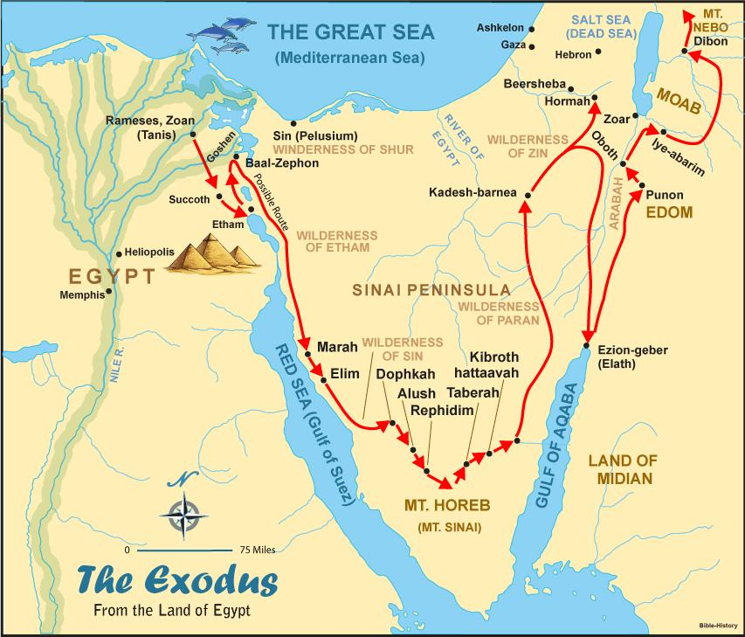
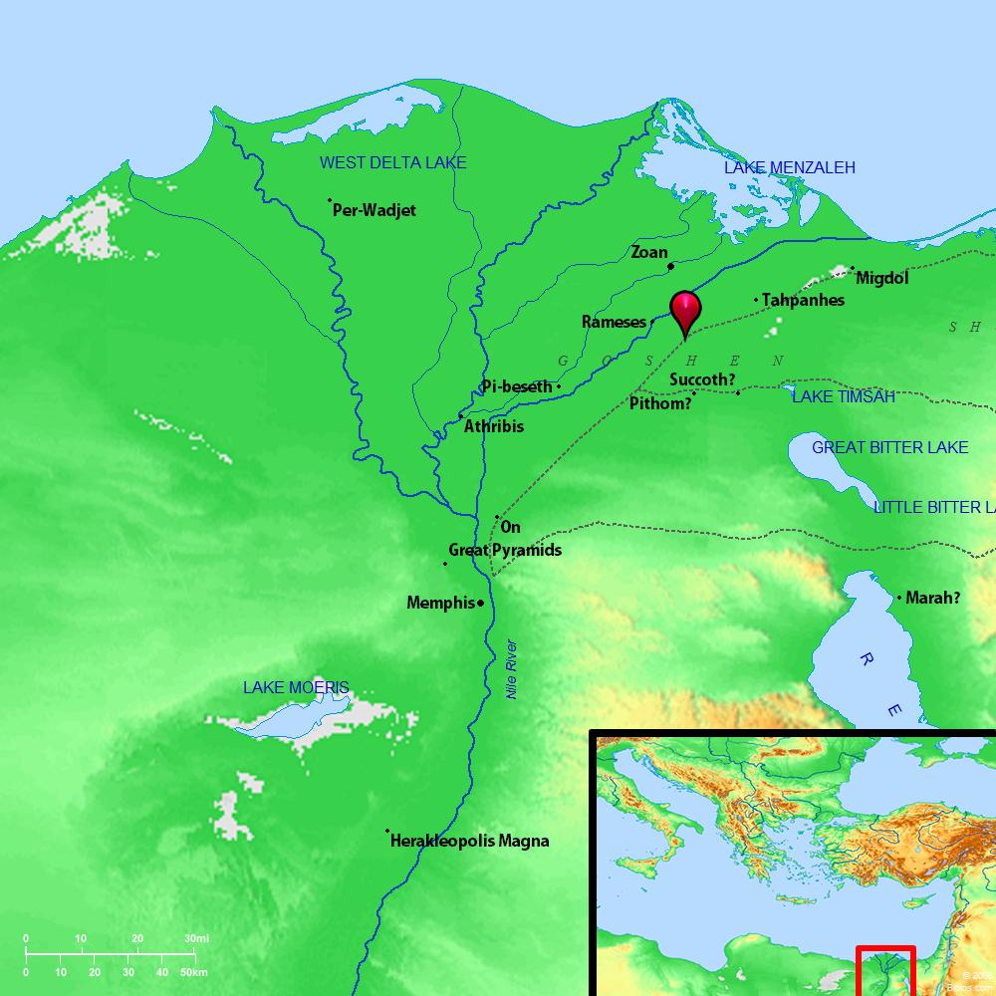
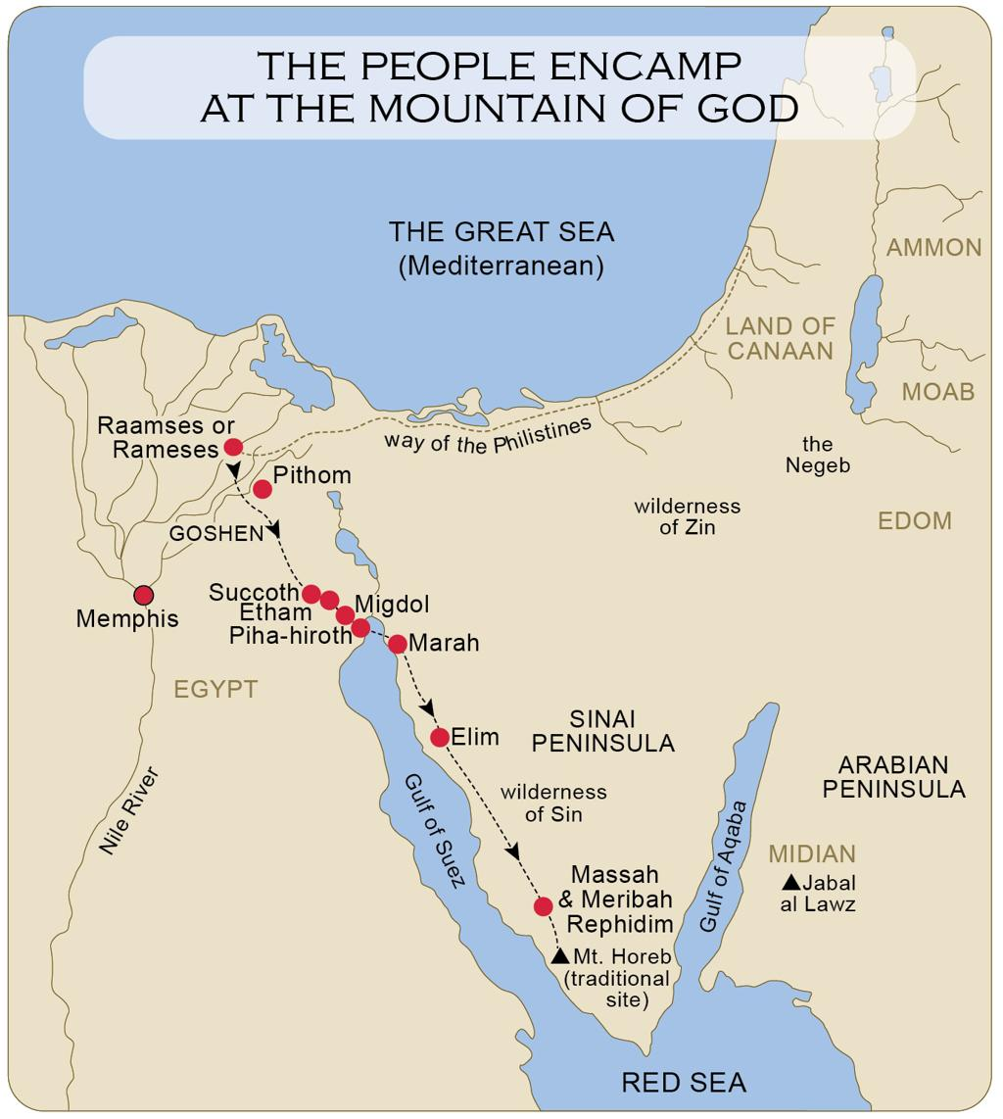
7
1. Egypt
Egypt is the dominant geographical setting of Exodus 1–15.
But Egypt has a dual role.
Egypt in Genesis
Egypt was a place of:
- famine relief
- preservation
- prosperity
- Joseph's administration
Egypt in Exodus
Egypt becomes:
- oppression
- forced labor
- genocide
- idolatrous empire
- the land from which God delivers Israel
Thus the same Egypt that once preserved Jacob's family becomes the house of bondage.

XVII. GOSHEN
Genesis 47:1–6; Exodus 8:22; 9:26
The Israelites reside in the region associated with Goshen.
It appears to be located in the northeastern Nile Delta.
Goshen represents Israel's initial place of settlement in Egypt.

XVIII. RAMESES / RAAMSES
Exodus 1:11; 12:37
The Israelites build store cities associated with:
- Pithom
- Rameses
The identification of the biblical Rameses has been central to discussions about the historical setting of Exodus. The name has strong connections with the Ramesside period, although dating the Exodus remains debated.

XIX. PITHOM
Exodus 1:11
One of the store cities constructed under Egyptian oppression.
The name's exact archaeological identification remains debated.
Its importance in the narrative is clearer:
Israel's forced labor becomes a symbol of imperial oppression.

XX. SUCCOTH
Exodus 12:37; 13:20
Israel leaves Rameses and camps at Succoth.
Succoth marks the transition:
Egypt → wilderness

XXI. ETHAM
Exodus 13:20
Israel camps at the edge of the wilderness.
The geographical description shows that Israel is moving away from Egypt but has not yet reached the deeper wilderness.

XXII. PI-HAHIROTH
Exodus 14:2
God deliberately directs Israel toward a location where Pharaoh will think Israel is trapped.
This is a crucial theological principle:
Israel's apparent geographical disaster becomes the stage for God's greatest deliverance.

XXIII. THE RED SEA / SEA OF REEDS
Exodus 14–15
Hebrew:
Yam Suph
Traditionally translated “Red Sea.”
The exact geographical identification is debated.
What is absolutely central to Exodus is not simply the geography but the theological event:
God opens a way where Israel has no way.
The sea becomes:
- judgment for Egypt
- salvation for Israel
- proof of God's power
- foundation for Israel's worship

XXIV. MARAH
Exodus 15:22–26
Israel finds bitter water.
God makes the water drinkable.
The name means “bitter.”
This is Israel's first major wilderness water crisis.
The sequence is important:
Red Sea victory → wilderness test → bitter water
Deliverance does not eliminate testing.

XXV. ELIM
Exodus 15:27
Elim has:
- twelve springs
- seventy palm trees
The numbers invite comparison with Israel's twelve tribes and the seventy elders/nations elsewhere in biblical tradition.
At minimum, Elim represents God's provision after Marah.

XXVI. WILDERNESS OF SIN
Exodus 16:1
Here Israel complains about food.
God responds with:
- manna
- quail
The wilderness becomes God's classroom.
Israel learns:
God can sustain a people who have no visible agricultural system.

XXVII. REPHIDIM
Exodus 17:1–16
Three major events occur here:
- water from the rock
- Amalek attacks
- Joshua appears prominently
Moses' raised hands become associated with Israel's victory.
Aaron and Hur support Moses.

XXVIII. MOUNT SINAI

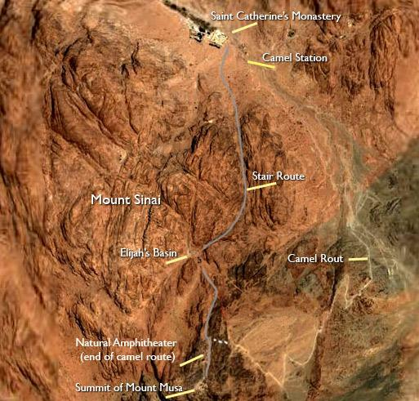
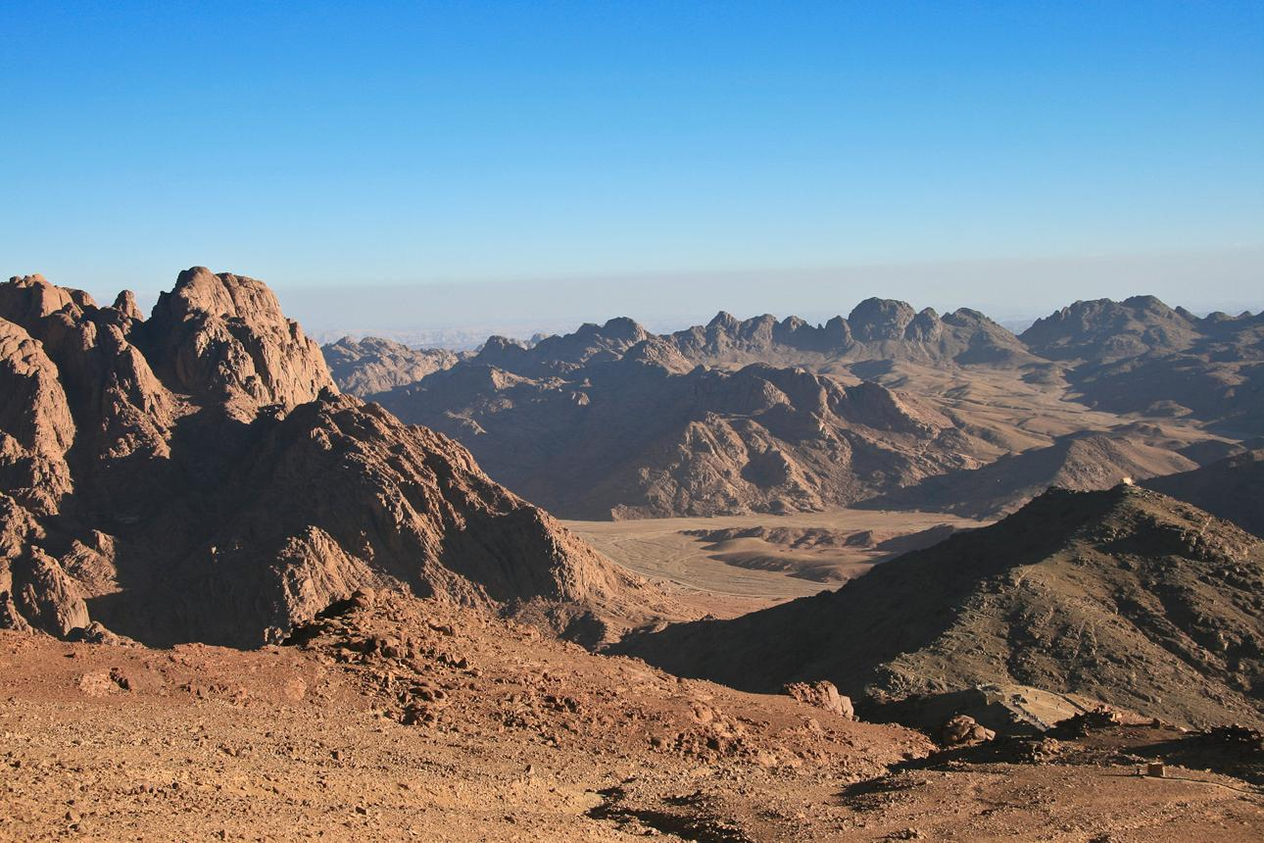
7
Mount Sinai is the theological center of Exodus 19–40.
Here Israel receives:
- covenant
- Ten Commandments
- laws
- instructions for worship
- Tabernacle instructions
The precise historical location of Mount Sinai remains debated. Jebel Musa is traditionally prominent, while other proposed locations exist, including proposals outside the Sinai Peninsula.

XXIX. MIDIAN
Midian is especially important in Exodus 2–4.
Moses flees Egypt and arrives in Midian.
There he encounters:
- Reuel/Jethro
- Zipporah
- shepherd life
Midian therefore becomes the place where Moses moves from:
prince-like Egyptian environment → fugitive → shepherd → prophet

XXX. THE WILDERNESS
The wilderness is not merely empty geography.
It is a theological environment.
Israel learns:
- dependence
- obedience
- trust
- covenant
- worship
- God's presence
Egypt was the place of slavery.
Canaan will eventually be the place of inheritance.
The wilderness is the place of formation.

XXXI. THINGS IN EXODUS
Now we move from people and places to the objects, institutions, symbols, rituals, and physical things that dominate the book.

XXXII. THE BASKET / ARK OF MOSES
Exodus 2:3
Hebrew:
tevah
The same unusual Hebrew word is used for Noah's ark.
That creates a striking literary connection:
Noah
Water threatens humanity → an ark preserves Noah.
Moses
Water threatens Moses → a “little ark” preserves Moses.
Both stories involve:
water + judgment + deliverance + God's preservation

XXXIII. THE BURNING BUSH
Exodus 3:2–4
A bush burns without being consumed.
The bush becomes the place where Moses encounters God.
Its significance includes:
- divine presence
- holiness
- mystery
- God's call
- revelation
God commands:
“Do not come near; take your sandals off your feet.”
Why?
Because:
“the place on which you are standing is holy ground.”

XXXIV. MOSES' STAFF
The staff becomes one of the most recognizable objects in Exodus.
It is associated with:
- God's calling
- signs
- judgment
- Red Sea deliverance
- water from the rock
- victory over Amalek
Yet Moses' staff is not magical.
God says:
“Take in your hand this staff, with which you shall do the signs.”
The power belongs to God.

XXXV. THE TEN PLAGUES
The plagues are not random disasters.
They are signs of divine judgment and revelation.
Traditional sequence
- Water becomes blood
- Frogs
- Gnats/lice
- Flies
- Livestock disease
- Boils
- Hail
- Locusts
- Darkness
- Death of the firstborn
The stated purpose is repeatedly connected with God's identity:
“that you may know that I am the LORD.”

XXXVI. THE FIRSTBORN
The tenth plague is fundamentally connected to the firstborn.
Egypt's firstborn are judged.
Israel's firstborn are spared through Passover.
This introduces the concept of:
substitutionary protection through sacrificial blood.

XXXVII. PASSOVER
Exodus 12
Passover is one of the most important institutions in the entire Bible.
Major elements include:
- lamb
- blood
- household
- unleavened bread
- bitter herbs
- urgency
- remembrance
The blood marks the houses.
The event becomes an annual memorial.

XXXVIII. THE PASSOVER LAMB
The lamb becomes central to Israel's understanding of redemption.
The New Testament later develops a direct Christological connection:
Christ → Passover Lamb
Especially:
- John 1:29
- John 19:36
- 1 Corinthians 5:7
- 1 Peter 1:18–19
- Revelation 5

XXXIX. UNLEAVENED BREAD
Exodus 12–13
Israel leaves in haste.
There is no time for ordinary bread preparation.
Unleavened bread therefore becomes an enduring memorial of the Exodus.

XL. MANNA
Exodus 16
Manna represents God's daily provision.
Israel cannot simply store it indefinitely.
The principle is:
daily dependence.
Jesus later draws on this imagery in John 6.

XLI. QUAIL
Exodus 16:13
God supplies meat for Israel.
Again, the wilderness reveals that Israel's survival depends upon divine provision.

XLII. THE ROCK
Exodus 17:1–7
Israel has no water.
Moses strikes the rock.
Water comes forth.
Paul later interprets the wilderness rock typologically:
“the Rock was Christ.”
1 Corinthians 10:4
This becomes one of the clearest New Testament Christological readings of an Exodus event.

XLIII. THE TEN COMMANDMENTS
Exodus 20
The Ten Commandments form the central summary of covenant obligations.
They concern:
Relationship with God
- no other gods
- no idols
- God's name
- Sabbath
Relationship with humanity
- honor parents
- do not murder
- do not commit adultery
- do not steal
- do not bear false witness
- do not covet
The commandments do not begin with:
“Obey me so I will rescue you.”
They come after redemption.
The pattern is:
Redemption → Covenant → Obedience

XLIV. THE SABBATH
The Sabbath is a major Exodus institution.
It is connected with:
- creation
- covenant
- holiness
- rest
- dependence upon God
Exodus 31:17 explicitly connects Sabbath with God's creation pattern.

XLV. THE COVENANT
Exodus 19–24
Israel becomes God's covenant people.
God declares:
“You shall be my treasured possession among all peoples.”
Israel is called:
“a kingdom of priests and a holy nation.”
This is one of the most important identity statements in the Old Testament.

XLVI. BLOOD OF THE COVENANT
Exodus 24:3–8
Moses sprinkles blood and declares:
“Behold the blood of the covenant…”
This becomes enormously important for New Testament theology.
Jesus uses covenant-blood language at the Last Supper:
- Matthew 26:28
- Mark 14:24
- Luke 22:20
Hebrews develops the connection extensively.

XLVII. THE TABERNACLE
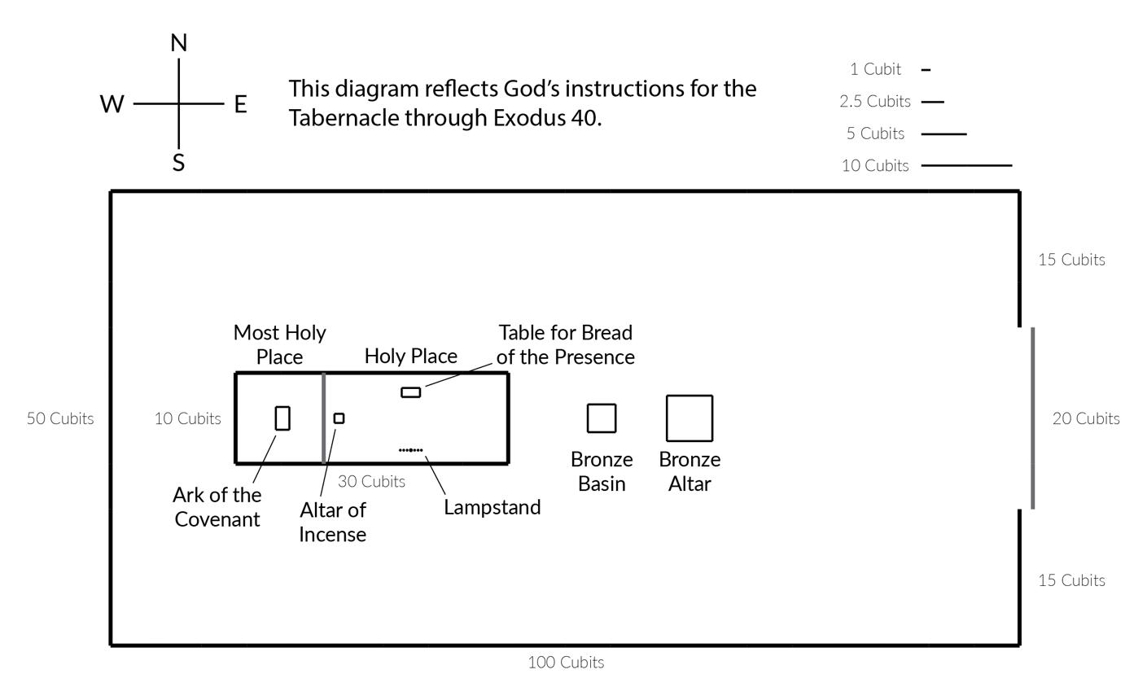
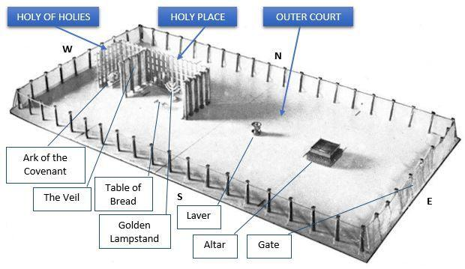
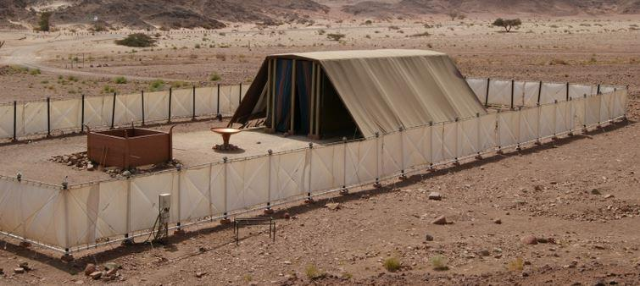
6
The Tabernacle dominates Exodus 25–40.
The Hebrew concept is associated with dwelling.
This is the climax of the book.
Why?
Because God's goal was not merely:
Get Israel out of Egypt.
It was:
Get Egypt out of Israel and dwell among them.
Exodus ends with God's glory filling the Tabernacle.

XLVIII. THE ARK OF THE COVENANT
Exodus 25:10–22
The Ark contains the testimony/covenant tablets.
It is associated with:
- God's throne/presence
- covenant
- holiness
- atonement
- divine speech
God says:
“There I will meet with you.”

XLIX. THE MERCY SEAT
Exodus 25:17–22
The mercy seat is positioned above the Ark.
The Hebrew concept is connected with atonement.
The cherubim face toward it.
God's presence is associated with this sacred location.

L. CHERUBIM
Cherubim appear on the Ark and sanctuary furnishings.
They are not cute baby angels.
Biblical cherubim are powerful heavenly beings associated with God's presence and holiness.
Compare:
- Genesis 3:24
- Exodus 25
- Ezekiel 1
- Ezekiel 10

LI. THE GOLDEN ALTAR OF INCENSE
Exodus 30:1–10
Incense is associated with worship and God's presence.
Later biblical theology connects incense with prayer:
- Psalm 141:2
- Revelation 5:8
- Revelation 8:3–4

LII. THE BRONZE ALTAR
Exodus 27
This is the altar for sacrifices.
The Tabernacle therefore has movement toward God:
courtyard → altar → laver → Holy Place → Most Holy Place

LIII. THE BRONZE BASIN
Exodus 30:17–21
The priests wash before ministering.
It represents ritual cleansing and preparation for holy service.

LIV. THE GOLDEN LAMPSTAND
Exodus 25:31–40
The menorah provides light in the Holy Place.
Its seven-branched structure becomes one of the most recognizable symbols of biblical Israel.

LV. THE TABLE OF BREAD
Exodus 25:23–30
The table holds the bread of the Presence.
It signifies continual presentation before God.

LVI. PRIESTLY GARMENTS
Exodus 28
The high priest wears:
- ephod
- breastpiece
- robe
- tunic
- sash
- turban
The breastpiece contains twelve stones representing the twelve tribes.
Thus the priest carries Israel symbolically before God.

LVII. URIM AND THUMMIM
Exodus 28:30
Associated with the high priest's breastpiece.
They appear to have functioned in discerning God's decision, though the precise mechanics are not explained.

LVIII. ANOINTING OIL
Exodus 30:22–33
Used in consecration.
The concept of anointing becomes foundational for later biblical categories:
priest + prophet + king → anointed
Ultimately this contributes to the biblical concept of Messiah / Christ, “the Anointed One.”

LIX. HOLY INCENSE
Exodus 30:34–38
A special mixture designated for worship.
Israel is not permitted to treat sacred things casually.
The sacred is differentiated from ordinary life.

LX. THE GOLDEN CALF
Exodus 32
Perhaps the most tragic “thing” in Exodus.
While Moses is on Sinai receiving covenant revelation, Israel makes an idol.
Aaron declares:
“These are your gods, O Israel…”
The golden calf represents:
- idolatry
- impatience
- distorted worship
- covenant violation
- human desire to control divine presence

LXI. THE TABLETS OF STONE
Exodus 24; 31–34
God gives tablets containing the covenant testimony.
Moses breaks the first tablets after seeing Israel's idolatry.
God later provides replacement tablets.
This symbolizes:
covenant broken → intercession → covenant renewed

LXII. THE CLOUD
The cloud is one of Exodus' major symbols of God's presence.
It appears:
- at the Red Sea
- on Sinai
- above the Tabernacle
The cloud signifies God's guidance and presence.

LXIII. THE FIRE
Fire represents:
- God's presence
- holiness
- revelation
- protection
- guidance
At Sinai, God's presence is associated with fire, smoke, thunder, and trembling.

LXIV. THE GLORY OF GOD
The Hebrew concept kavod carries the idea of glory, weight, honor, splendor.
The climax comes in Exodus 40:
“Then the cloud covered the tent of meeting, and the glory of the LORD filled the tabernacle.”
The book ends not merely with Israel free.
It ends with:
God dwelling among His people.

LXV. MAJOR THEMES IN EXODUS
1. Redemption
God delivers slaves.
This becomes the foundation for biblical redemption theology.

2. God's Name
Exodus asks:
Who is YHWH?
The answer unfolds through:
- signs
- plagues
- deliverance
- covenant
- holiness
- mercy
- presence

3. God's Presence
The movement is:
God sees Israel → God comes down → God leads Israel → God dwells among Israel.

4. Covenant
Israel is transformed from:
slaves of Pharaoh
into:
servants/covenant people of YHWH.

5. Holiness
Exodus repeatedly asks:
How can sinful humanity live near a holy God?
The answer involves:
- covenant
- sacrifice
- priesthood
- cleansing
- sanctuary
- atonement

LXVI. EXODUS AS A PATTERN OF SALVATION
One of the most important discoveries in biblical theology is that Exodus becomes a pattern repeatedly reused throughout Scripture.
Exodus pattern
Bondage → Cry → Divine intervention → Judgment → Redemption → Water → Wilderness → Covenant → Presence → Inheritance
This pattern appears repeatedly in later Scripture.
Prophets
Isaiah, Jeremiah, Ezekiel, Hosea and others repeatedly use Exodus imagery.
Hosea, for example, explicitly recalls the Exodus, wilderness, covenant, rebellion and restoration themes.

LXVII. EXODUS AND JESUS CHRIST
Exodus is foundational for New Testament Christology.
Moses ↔ Christ
Moses:
- delivers Israel from slavery
- mediates covenant
- gives God's law
- intercedes for Israel
Jesus:
- delivers from sin
- mediates the new covenant
- fulfills the Law
- intercedes for His people

Passover Lamb ↔ Christ
Exodus 12
The lamb's blood protects Israel.
John 1:29
Jesus is identified as the Lamb of God.
1 Corinthians 5:7
Paul explicitly connects Christ with Passover.

Manna ↔ Christ
Exodus 16
God provides bread from heaven.
John 6
Jesus identifies Himself as the true bread from heaven.

Water from the Rock ↔ Christ
Exodus 17
Water comes from the rock.
1 Corinthians 10:4
Paul connects the wilderness rock with Christ.

Tabernacle ↔ Christ
Exodus ends with God's dwelling presence.
John 1:14 says the Word:
“dwelt among us”
The Greek verb carries the sense of tabernacling/dwelling.
The theological movement is:
Tabernacle → Temple → Christ → Church → New Creation

LXVIII. EXODUS AND REVELATION
The connections between Exodus and Revelation are extraordinarily important.
Exodus | Revelation
Plagues | Final judgments
Passover | Lamb
Pharaoh | Beast-like oppressive power
Deliverance | Final salvation
Sea | Judgment/deliverance imagery
Tabernacle | God's dwelling
Glory | God's manifest presence
Covenant | New covenant fulfillment
Song of Moses | Song of Moses
Wilderness | Eschatological journey
Lamb | Christ the Lamb
Revelation 15 explicitly uses the song of Moses alongside the song of the Lamb.
This shows that Exodus is not merely ancient history in biblical theology.
It becomes a template for God's ultimate victory.

LXIX. EXODUS AND THE REST OF THE BIBLE
Genesis
Family becomes nation.
Exodus
Nation becomes covenant people.
Leviticus
Covenant people learn holiness and worship.
Numbers
Covenant people travel through wilderness.
Deuteronomy
Covenant people prepare to enter the land.
Joshua
Covenant people enter inheritance.
Thus:
Genesis → family
Exodus → redemption
Leviticus → holiness
Numbers → wilderness
Deuteronomy → covenant renewal
Joshua → inheritance

LXX. THE MOST IMPORTANT PEOPLE
Primary
- Moses
- Aaron
- Pharaoh
- Miriam
- Jochebed
- Amram
- Pharaoh's daughter
- Zipporah
- Jethro/Reuel
- Joshua
Supporting
- Shiphrah
- Puah
- Israel's elders
- Egyptian taskmasters
- Israelite leaders
- Hur
Divine
- YHWH
- Angel of the LORD

LXXI. THE MOST IMPORTANT PLACES
- Egypt
- Goshen
- Rameses
- Pithom
- Succoth
- Etham
- Pi-hahiroth
- Red Sea / Yam Suph
- Marah
- Elim
- Wilderness of Sin
- Rephidim
- Sinai
- Mount Sinai
- Midian

LXXII. THE MOST IMPORTANT THINGS
- Burning bush
- Moses' staff
- Basket/ark
- Passover lamb
- Blood
- Unleavened bread
- Manna
- Rock
- Ten Commandments
- Stone tablets
- Covenant
- Tabernacle
- Ark of the Covenant
- Mercy seat
- Cherubim
- Menorah
- Table of Presence
- Bronze altar
- Bronze basin
- Incense altar
- Priestly garments
- Anointing oil
- Holy incense
- Golden calf
- Cloud
- Fire
- Glory

LXXIII. THE CENTRAL MESSAGE OF EXODUS
If Genesis answers:
“Where did Israel come from?”
Exodus answers:
“How did Israel become God's redeemed covenant people?”
And the deepest answer is:
Israel did not save itself.
God:
- heard their cry
- remembered His covenant
- saw their suffering
- knew their condition
- came down
- confronted Pharaoh
- judged Egypt
- redeemed Israel
- led Israel
- fed Israel
- gave Israel His covenant
- established His worship
- forgave Israel
- and finally dwelt among Israel.
That is why Exodus is foundational to the entire biblical story. Modern scholarship continues to debate the precise historical reconstruction of the Exodus, including chronology, route, archaeological evidence, and the scale of the migration; there is no direct Egyptian record confirming the biblical event, while scholars differ sharply over how the archaeological and textual evidence should be interpreted.
The grand Exodus formula
SLAVERY → CRY → COVENANT → MOSES → PLAGUES → PASSOVER → REDEMPTION → RED SEA → WILDERNESS → MANNA → SINAI → LAW → COVENANT → TABERNACLE → GLORY
And the ultimate destination of the story is not merely:
“Israel got out of Egypt.”
It is:
“I will take you to be my people, and I will be your God.” — Exodus 6:7
That statement is arguably the theological heart of the entire book. Yale's study guide similarly identifies God's rescue of Israel from Egypt as the foundation of Israel's relationship with God. .
This document was created by doulos777 with the help of AI.

