Isaiah — Chapter-by-Chapter Very Deep Bible Research
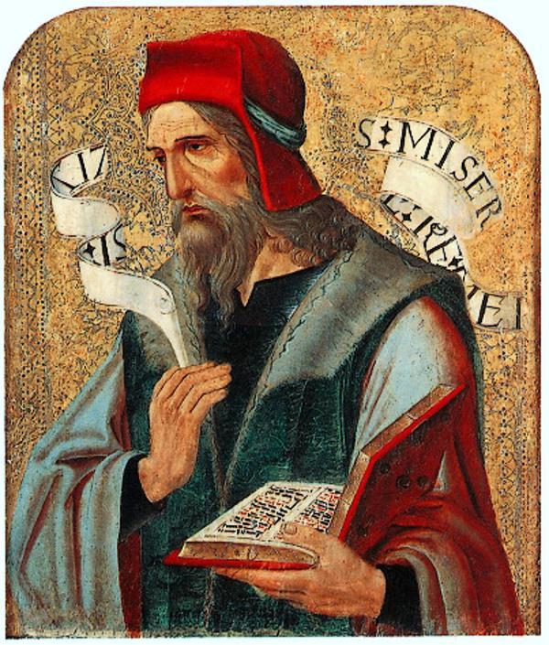
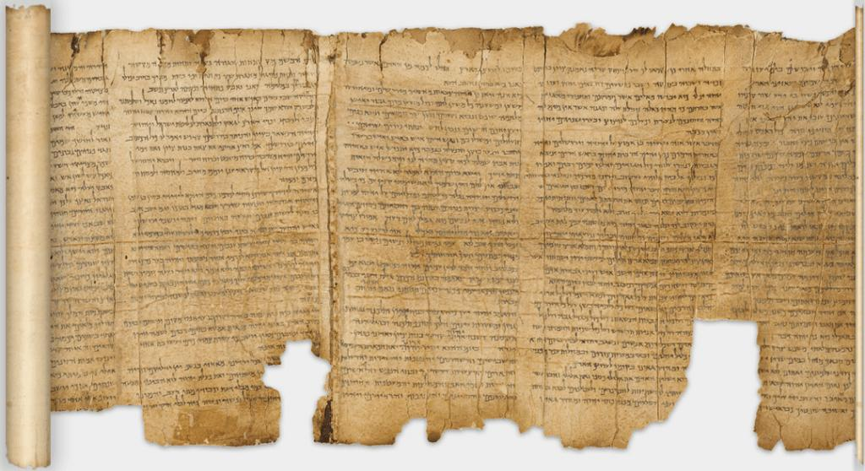
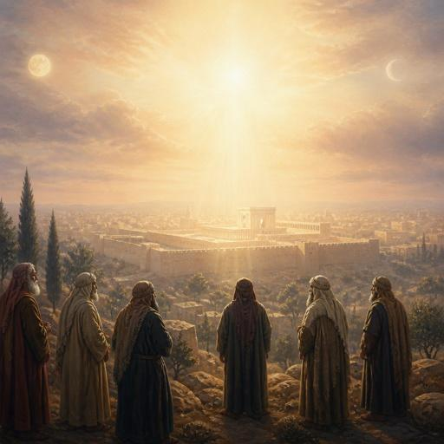
6
The Book of Isaiah contains 66 chapters and is one of the richest books in Scripture for studying God’s holiness, judgment, covenant, salvation, the remnant of Israel, the Messiah, the nations, Jerusalem, the kingdom of God, and the new heavens and new earth.
A genuinely deep study of Isaiah should examine each chapter through several layers:
- Historical setting
- Literary structure
- Verse-by-verse meaning
- Hebrew words and concepts
- People
- Places
- Nations
- Political and historical events
- Covenant theology
- Prophecy and fulfillment
- Messianic/Christological connections
- Connections to the New Testament
- Connections to the rest of the Old Testament
- Theology of God
- Theology of salvation
- Judgment and restoration
- Israel and the nations
- Zion/Jerusalem
- The kingdom
- Eschatology
- Major themes and repeated vocabulary
- Practical theological lessons

I. THE BOOK OF ISAIAH AT A GLANCE
1. Author
Isaiah son of Amoz
Isaiah identifies himself in:
- Isaiah 1:1
- Isaiah 2:1
- Isaiah 7:3
- Isaiah 13:1
- Isaiah 20:2
- Isaiah 37:2
- Isaiah 38:1
- Isaiah 39:3
His name, יְשַׁעְיָהוּ — Yəšaʿyāhû, means essentially:
“YHWH is salvation.”
That name is extraordinarily appropriate because salvation is one of Isaiah's dominant themes.

II. HISTORICAL SETTING
Isaiah ministered during the reigns of:
- Uzziah
- Jotham
- Ahaz
- Hezekiah
Isaiah 1:1 specifically places his ministry in their reigns.
His prophetic ministry therefore occurred during a tremendously important period of Judah's history.
Major international powers
Isaiah's world included:
- Assyria
- Babylon
- Egypt
- Syria/Aram
- Israel/Ephraim
- Judah
- Philistia
- Moab
- Edom
- Cush
- Tyre
- Sidon
Assyria became the dominant imperial threat.

III. MAJOR DIVISIONS OF ISAIAH
A useful chapter-by-chapter framework is:
Isaiah 1–12
Judgment upon Judah and the promise of the Davidic/Messianic King
Isaiah 13–23
Oracles concerning the nations
Isaiah 24–27
Universal judgment and eschatological salvation
Isaiah 28–35
Woes, Assyria, Jerusalem, trust in God, and future restoration
Isaiah 36–39
Historical narrative: Hezekiah, Assyria, Babylon
Isaiah 40–48
Comfort, restoration, God's sovereignty, Cyrus, and the fall of Babylon
Isaiah 49–55
The Servant, redemption, suffering, salvation
Isaiah 56–66
Restoration, righteousness, worship, Zion, judgment, and new creation

IV. ISAIAH CHAPTER-BY-CHAPTER RESEARCH MAP
ISAIAH 1 — Judah's Rebellion and God's Call to Repentance
Major themes
- Covenant rebellion
- Spiritual blindness
- Empty worship
- God's holiness
- Repentance
- Justice
- Redemption
- Restoration
Isaiah begins not with a flattering description of Judah but with an accusation.
Israel has become like a rebellious child.
Major passage
Isaiah 1:2–3
God describes His relationship with Israel using the language of a father and children.
The tragedy is that:
the ox knows its owner,
but Israel does not know its God.
Isaiah 1:10–15
God rejects religious activity when it is separated from righteousness.
This becomes one of Isaiah's major theological principles:
God does not desire ritual divorced from obedience.
Isaiah 1:16–17
The solution is:
- wash
- make yourselves clean
- cease evil
- learn good
- seek justice
- correct oppression
- defend the fatherless
- plead for the widow
Isaiah 1:18
One of the Bible's greatest invitations:
“Come now, and let us reason together…”
The chapter moves from sin → judgment → repentance → cleansing → restoration.
Messianic connection
Isaiah's promise of cleansing anticipates the larger biblical theology of forgiveness and redemption fulfilled in Christ.

ISAIAH 2 — The Mountain of the LORD
Major themes
- Zion
- nations
- God's kingdom
- peace
- judgment
- idolatry
- the Day of the LORD
Isaiah 2:2–4
The nations stream toward the mountain of the LORD.
This passage describes:
- God's instruction going forth
- nations learning His ways
- international peace
- weapons being transformed into agricultural tools
The ultimate vision is:
God's kingdom replacing human warfare.
Isaiah 2:11–17
Human pride is brought low.
One of Isaiah's recurring contrasts appears:
human exaltation vs. divine exaltation.

ISAIAH 3 — Judgment on Jerusalem and Judah
God removes:
- leadership
- security
- military strength
- economic stability
The chapter also condemns social oppression.
Isaiah 3:10–11
The distinction between:
- righteous
- wicked
remains important.
Isaiah does not merely condemn society generally; he distinguishes moral outcomes.

ISAIAH 4 — The Branch and the Cleansing of Zion
This short chapter contains major prophetic imagery.
Isaiah 4:2
“the branch of the LORD”
The Branch becomes an important Messianic concept throughout Scripture.
Compare:
- Isaiah 11:1
- Jeremiah 23:5
- Jeremiah 33:15
- Zechariah 3:8
- Zechariah 6:12
Major themes
- Branch
- holiness
- cleansing
- Zion
- God's presence
- glory
- protection

ISAIAH 5 — The Song of the Vineyard
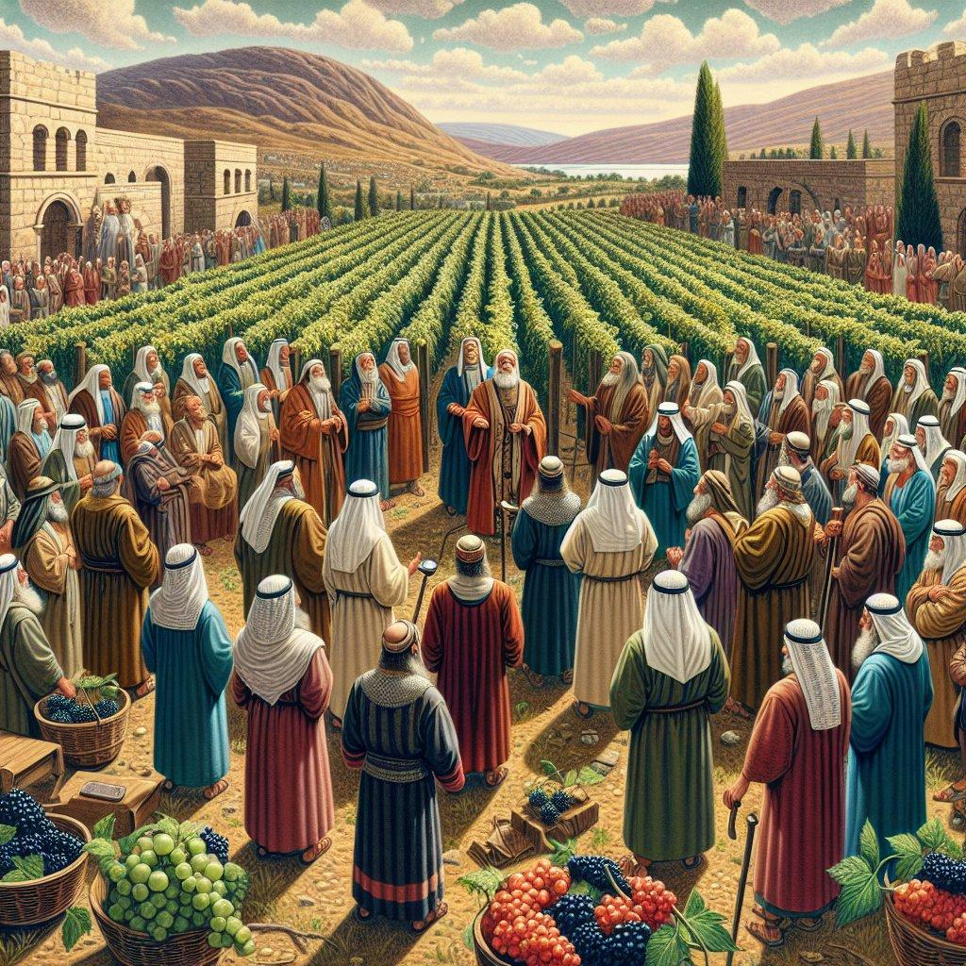
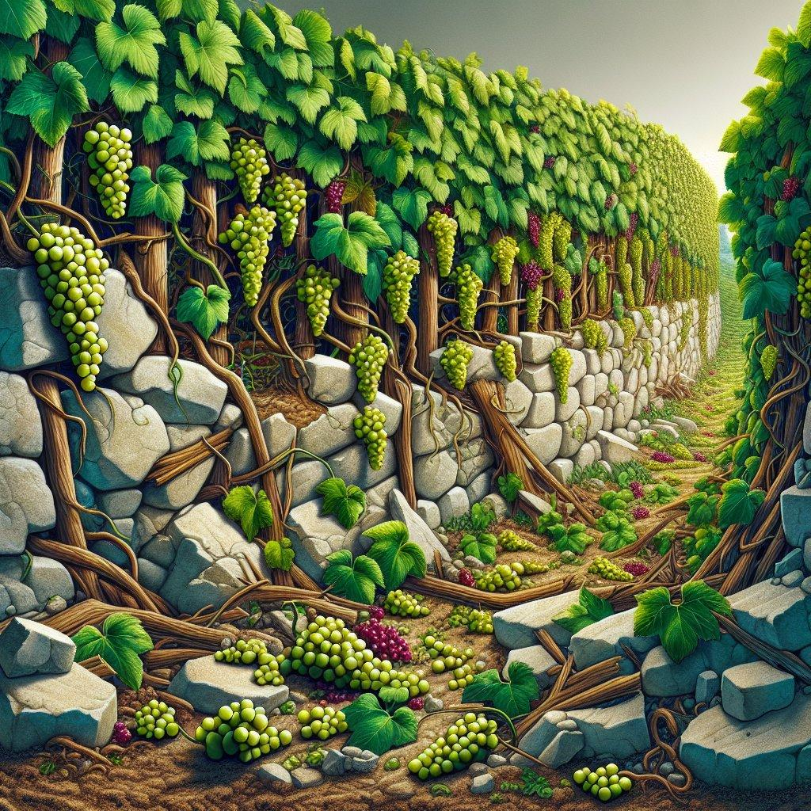
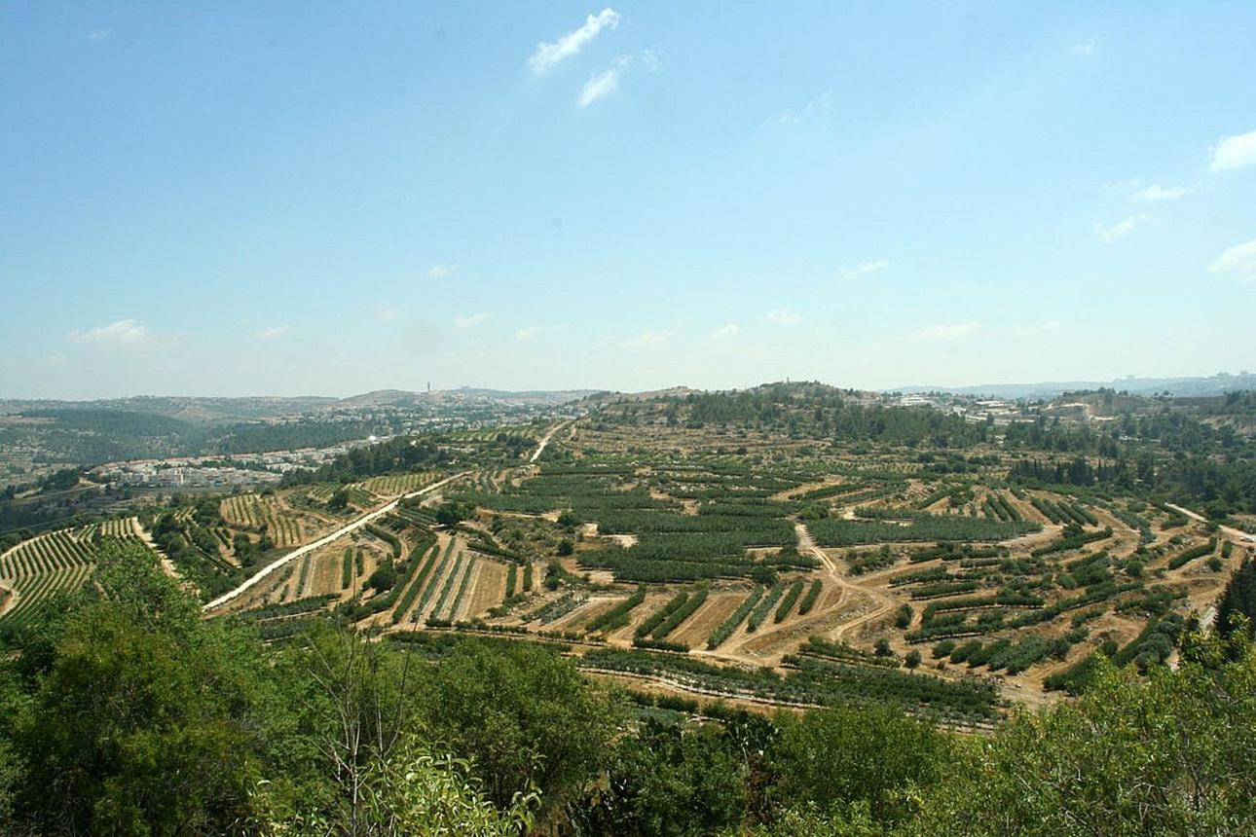
4
God portrays Israel as His vineyard.
Isaiah 5:1–7
The vineyard received:
- a fertile location
- protection
- cultivation
- expectation of fruit
But instead it produced wild grapes.
Isaiah explains:
“the vineyard of the LORD of hosts is the house of Israel.”
Six Woes
The chapter condemns:
- greed
- drunkenness
- moral corruption
- arrogance
- calling evil good
- injustice
Isaiah 5:20
One of the most important moral statements in Isaiah:
“Woe unto them that call evil good, and good evil…”

ISAIAH 6 — Isaiah's Vision of the Holy LORD
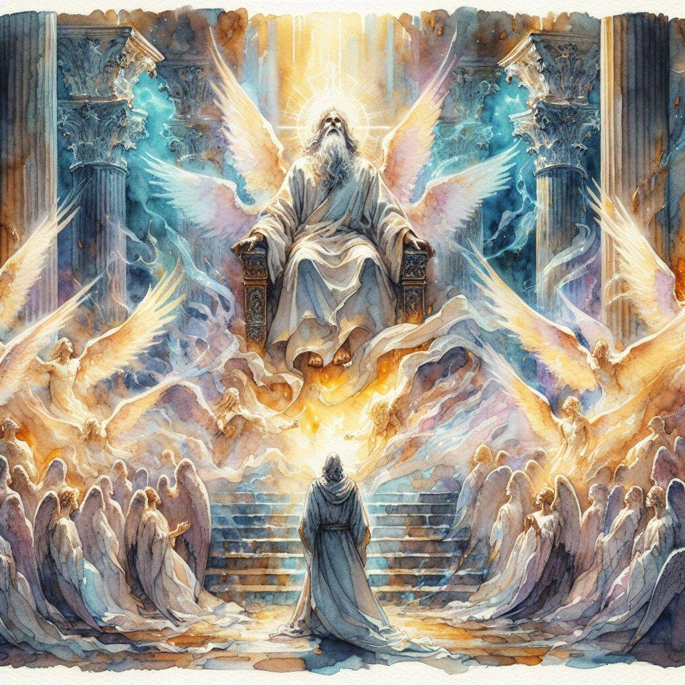
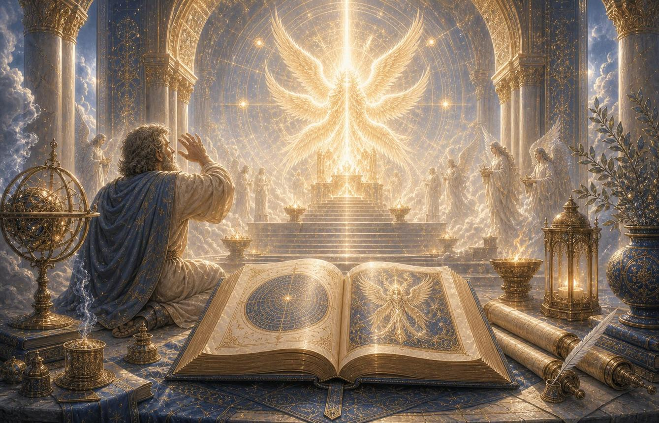
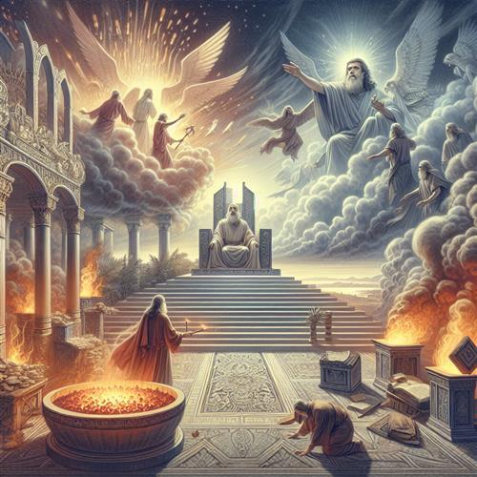
6
This is foundational to understanding Isaiah.
Isaiah 6:1
Isaiah sees:
“the Lord sitting upon a throne, high and lifted up”
The throne represents divine kingship.
Seraphim
The heavenly beings proclaim:
“Holy, holy, holy”
The Hebrew concept of holiness involves God's absolute uniqueness, purity, and separation from evil.
Isaiah 6:5
Isaiah's response:
“Woe is me!”
Why?
Because seeing God's holiness reveals Isaiah's own uncleanness.
Isaiah 6:6–7
A burning coal touches Isaiah's lips.
His guilt is taken away.
Isaiah 6:8
Then comes:
“Whom shall I send, and who will go for us?”
Isaiah answers:
“Here am I; send me.”
New Testament connection
Isaiah 6 becomes enormously important in John 12.
John connects Isaiah's vision with the glory of Christ.

ISAIAH 7 — Immanuel
This chapter enters the Syro-Ephraimite crisis.
Historical situation
Judah faces:
- Aram/Syria
- Israel/Ephraim
King Ahaz is frightened.
God tells Ahaz to trust Him.
Isaiah 7:14
The famous sign:
“Behold, a virgin shall conceive, and bear a son, and shall call his name Immanuel.”
Immanuel = “God with us.”
Major theological significance
The passage becomes explicitly associated with Jesus' birth in:
Matthew 1:22–23

ISAIAH 8 — Immanuel and the Coming Assyrian Flood
Major themes
- Assyria
- judgment
- Immanuel
- fear of God
- prophecy
- darkness
- waiting on God
Isaiah contrasts:
fear of the LORD
with
fear of political powers.
Isaiah 8:14
The LORD becomes:
- sanctuary
- stone of stumbling
- rock of offense
The New Testament applies this imagery to Christ.
Compare:
- Romans 9:33
- 1 Peter 2:6–8

ISAIAH 9 — The Child-King
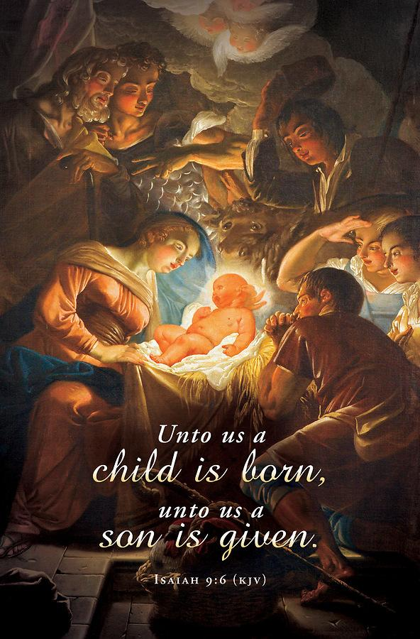
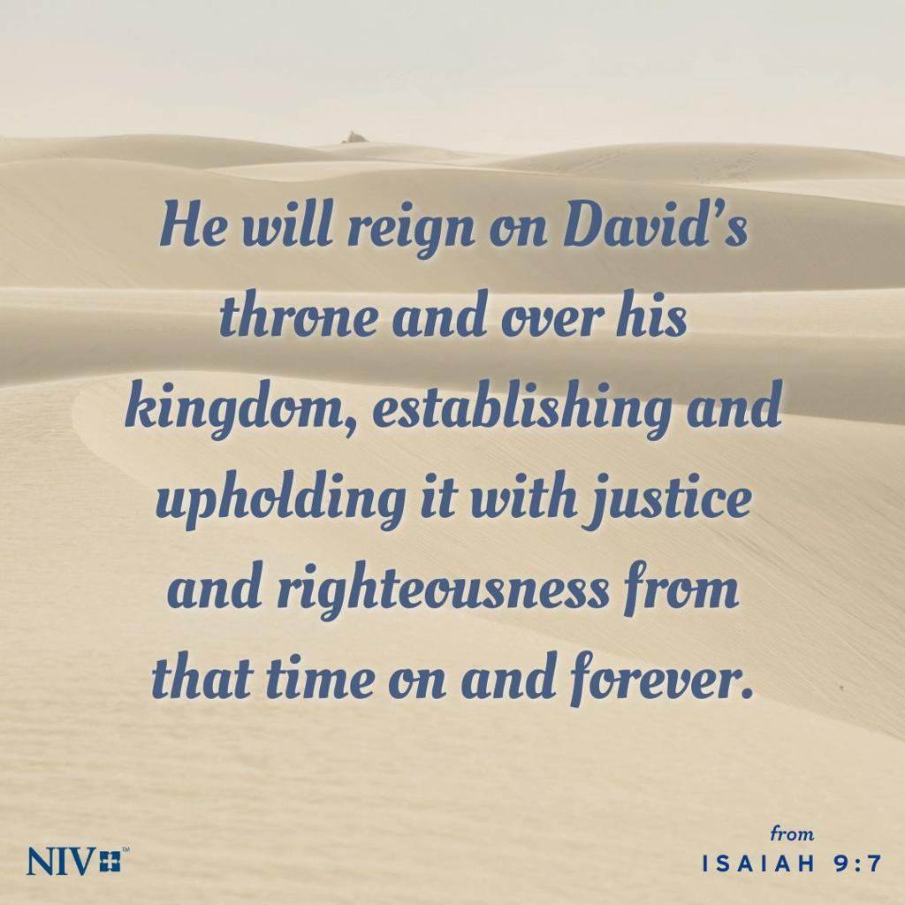
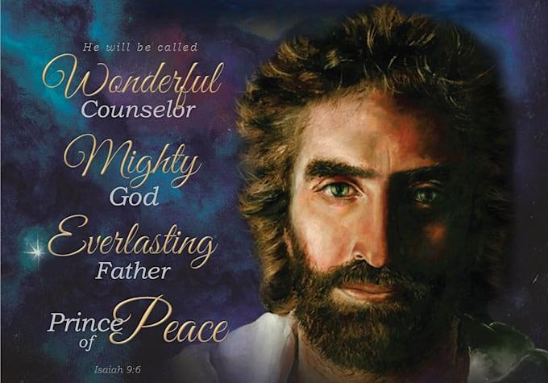
5
One of the most important Messianic chapters.
Isaiah 9:2
“The people that walked in darkness have seen a great light.”
Isaiah 9:6
The promised child is described with extraordinary titles:
- Wonderful Counselor
- Mighty God
- Everlasting Father
- Prince of Peace
Isaiah 9:7
His kingdom is characterized by:
- David's throne
- justice
- righteousness
- endless increase
- divine zeal
New Testament
Matthew 4:14–16 connects the Galilean ministry of Jesus with Isaiah 9.

ISAIAH 10 — Assyria as God's Instrument
Assyria is described as an instrument God uses to judge Judah.
But Assyria itself becomes guilty because of its arrogance.
This establishes an important biblical principle:
God can sovereignly use a nation without approving that nation's wickedness.
Isaiah 10:20–22
A remnant survives.
The remnant theme becomes central throughout Isaiah.

ISAIAH 11 — The Branch from Jesse
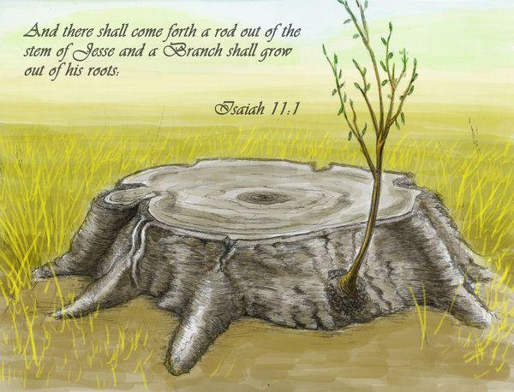
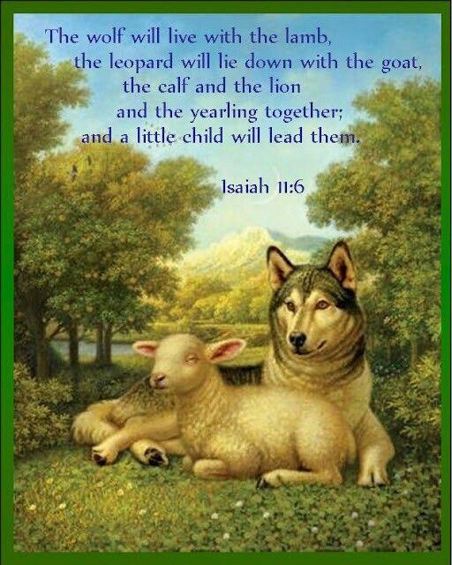
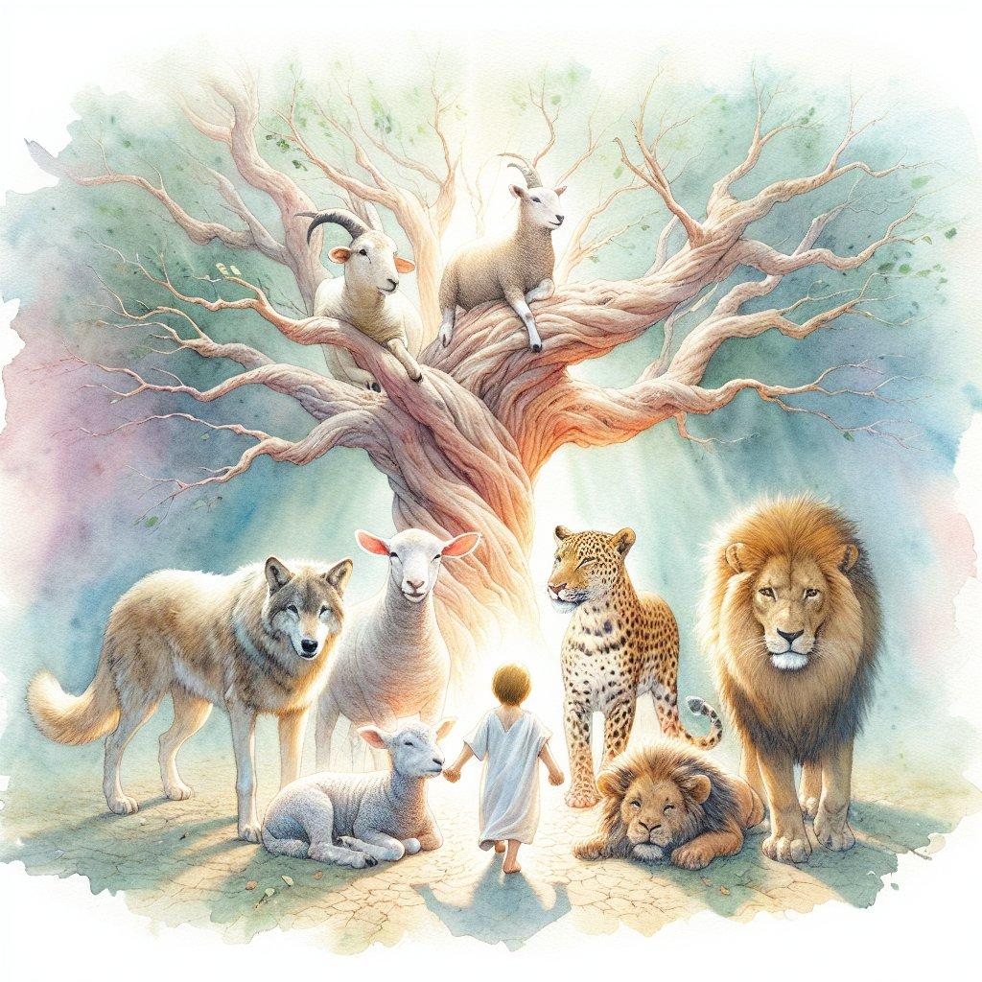
5
Isaiah 11:1
“There shall come forth a rod out of the stem of Jesse…”
The Messiah is connected directly to:
Jesse → David → Davidic king.
Isaiah 11:2
The Spirit rests upon Him:
- Spirit of the LORD
- wisdom
- understanding
- counsel
- might
- knowledge
- fear of the LORD
Isaiah 11:6–9
The famous kingdom imagery:
- wolf with lamb
- leopard with young goat
- lion
- child
- knowledge of the LORD filling the earth
Major theme
The Messiah does not merely save individuals.
He establishes a righteous kingdom.

ISAIAH 12 — The Song of Salvation
A short worship chapter.
Major themes:
- salvation
- trust
- joy
- praise
- God's greatness
- proclamation to the nations
Isaiah 12:2
“God is my salvation; I will trust, and not be afraid.”
Isaiah's own name—YHWH is salvation—is reflected throughout the book.

ISAIAH 13 — Judgment on Babylon
Babylon becomes a symbol of arrogant human empire.
Themes:
- Day of the LORD
- cosmic imagery
- judgment
- pride
- Babylon's fall
The prophecy becomes important when studying the relationship between:
historical Babylon → prophetic Babylon → Revelation.

ISAIAH 14 — The Fall of the King of Babylon
This chapter contains:
- judgment on Babylon
- the taunt against the king
- cosmic pride imagery
- the fall of the oppressor
Isaiah 14:12
“How art thou fallen from heaven, O Lucifer…”
The Hebrew expression refers to the morning star/day star.
The immediate context concerns the king of Babylon.
The passage has also been historically interpreted in Christian theology in connection with Satan's pride and fall, especially when compared with passages such as Luke 10:18 and Revelation 12.
A careful study should distinguish:
original historical context
from
later theological application.

ISAIAH 15 — Oracle Against Moab
Moab's cities and population experience devastation.
Important for studying:
- Moabite history
- Israel-Moab relations
- divine judgment
- prophetic lament

ISAIAH 16 — Moab and the Throne of David
The chapter continues the Moab oracle but introduces significant Davidic imagery.
Isaiah 16:5
A throne is established in steadfast love.
This connects:
Davidic kingship + righteousness + justice + covenant mercy.

ISAIAH 17 — Damascus and Israel
Judgment comes upon:
- Damascus
- Syria
- Israel
The chapter emphasizes the tragedy of forgetting the God of salvation.

ISAIAH 18 — Cush
Cush becomes the focus.
The chapter demonstrates that Isaiah's prophetic horizon extends far beyond Judah.
God is sovereign over international politics.

ISAIAH 19 — Egypt
Major themes
- Egypt's judgment
- idols
- political instability
- economic collapse
- God's intervention
- eventual blessing
One of the most remarkable statements appears near the end.
Isaiah 19:23–25
Egypt, Assyria, and Israel are pictured together under God's blessing.
This is astonishing because these nations were frequently enemies.
The theological message is:
God's salvation ultimately reaches the nations.

ISAIAH 20 — Isaiah as a Sign
Isaiah performs an unusual prophetic sign involving his clothing.
The prophetic messenger's life becomes part of the message.

ISAIAH 21 — Babylon, Edom, Arabia
Several nations are addressed.
Major themes
- watchman
- Babylon
- coming judgment
- uncertainty
- waiting
Isaiah 21:6
The watchman becomes an important prophetic image.

ISAIAH 22 — Jerusalem's Valley of Vision
Jerusalem's leadership is condemned for misplaced confidence.
Shebna
Shebna is judged for pride.
Eliakim
Eliakim receives authority.
Isaiah 22:22
“the key of the house of David”
This imagery later becomes important in:
Revelation 3:7

ISAIAH 23 — Tyre
Tyre, the wealthy Phoenician commercial center, is judged.
Major themes:
- commerce
- wealth
- pride
- international trade
- God's sovereignty

ISAIAH 24 — Universal Judgment
The focus expands from individual nations to the entire earth.
This is sometimes called Isaiah's “Little Apocalypse.”
Major themes:
- universal judgment
- earth's defilement
- human rebellion
- cosmic disturbance
- God's reign

ISAIAH 25 — Feast on God's Mountain
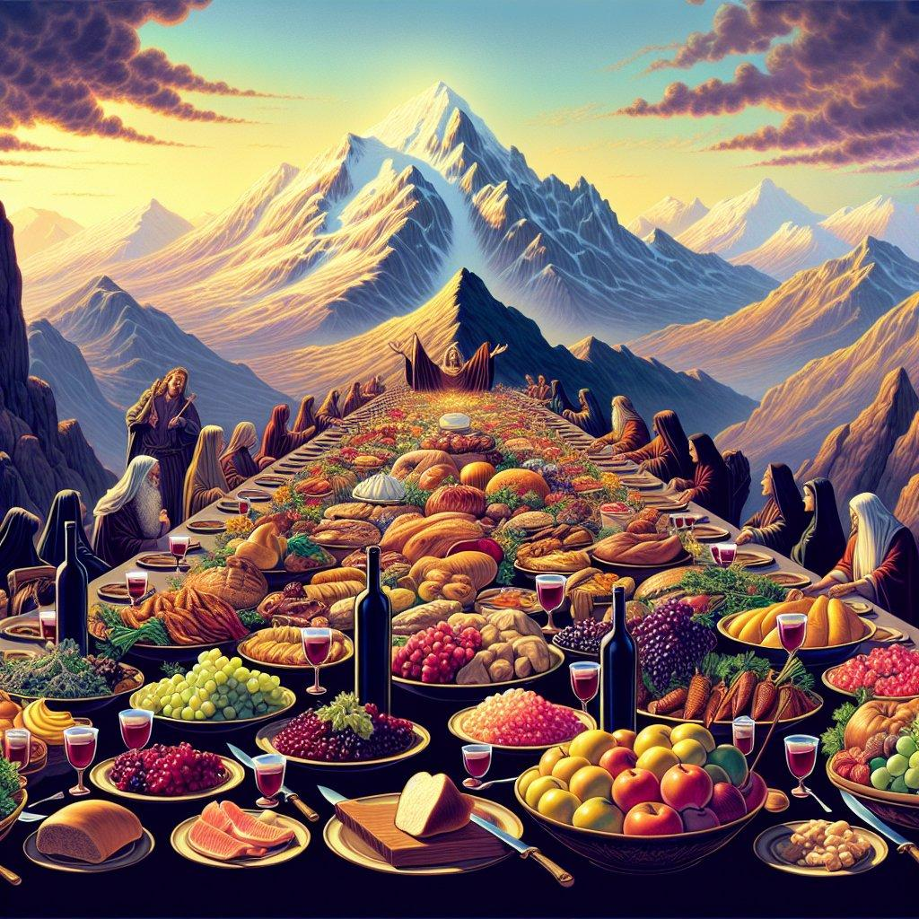
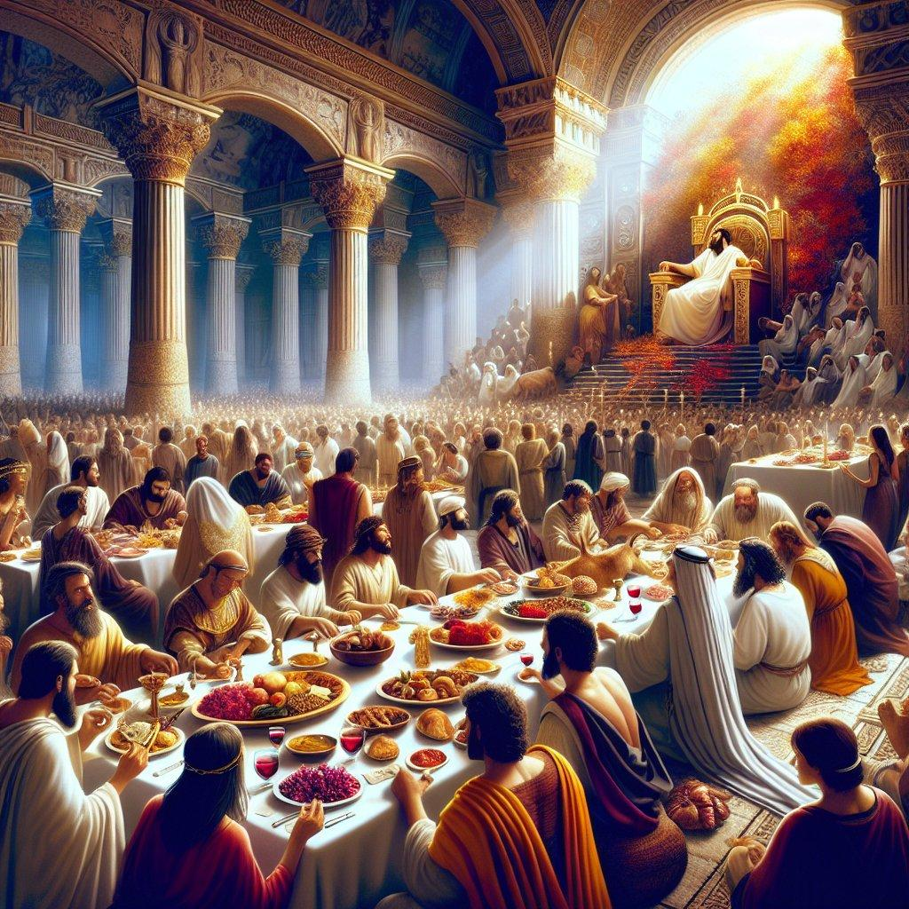
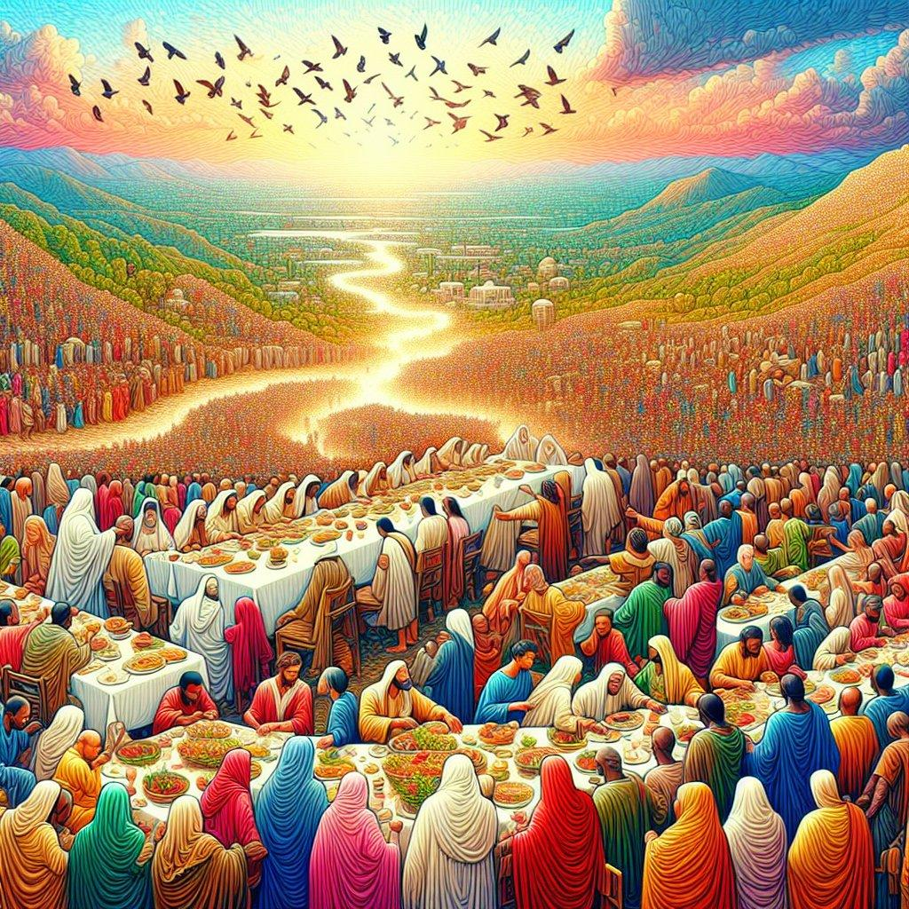
4
A magnificent salvation chapter.
Isaiah 25:6
God prepares a feast for the nations.
Isaiah 25:7
The veil covering the nations is removed.
Isaiah 25:8
One of Scripture's great promises:
“He will swallow up death in victory…”
This becomes especially important in:
1 Corinthians 15:54.

ISAIAH 26 — The Song of Salvation
Themes:
- trust
- resurrection
- peace
- righteousness
- waiting for God
- God's sovereignty
Isaiah 26:19
“Thy dead men shall live…”
One of Isaiah's important resurrection passages.

ISAIAH 27 — Leviathan and Restoration
The chapter combines:
- cosmic imagery
- judgment
- Leviathan
- vineyard imagery
- Israel's restoration
- gathering of God's people
Isaiah 27:6
Israel eventually flourishes and fills the world with fruit.

ISAIAH 28 — The Cornerstone
Judgment is pronounced against Ephraim and Jerusalem's false confidence.
Isaiah 28:16
God lays:
“a stone, a tried stone, a precious cornerstone…”
This becomes a major Messianic text.
New Testament connections include:
- Romans 9:33
- Romans 10:11
- 1 Peter 2:6

ISAIAH 29 — Jerusalem and Spiritual Blindness
Jerusalem is called Ariel.
Major themes:
- religious hypocrisy
- blindness
- sealed revelation
- human traditions
- God's unexpected intervention
New Testament
Jesus uses Isaiah 29:13 when confronting religious hypocrisy:
Matthew 15:7–9.

ISAIAH 30 — Woe to Those Who Trust Egypt
Judah seeks political security from Egypt rather than God.
Major theological principle:
Political alliances cannot substitute for faith in God.
Isaiah 30:15
“In returning and rest shall ye be saved; in quietness and in confidence shall be your strength…”

ISAIAH 31 — Egypt Cannot Save
The message continues.
Egypt has horses and chariots.
God has something greater:
His own presence and power.

ISAIAH 32 — The Righteous King
A righteous king will reign.
The chapter moves toward:
- justice
- righteousness
- peace
- Spirit
- restoration
Isaiah 32:17
The result of righteousness is:
“peace”

ISAIAH 33 — The LORD as King
Assyria is confronted.
Jerusalem looks to God.
Isaiah 33:22
“For the LORD is our judge, the LORD is our lawgiver, the LORD is our king…”
This is an extraordinarily concentrated statement of God's authority.

ISAIAH 34 — Judgment on the Nations
Edom receives particular attention.
The chapter portrays cosmic judgment.
Themes:
- wrath
- justice
- desolation
- divine vengeance

ISAIAH 35 — The Highway of Holiness
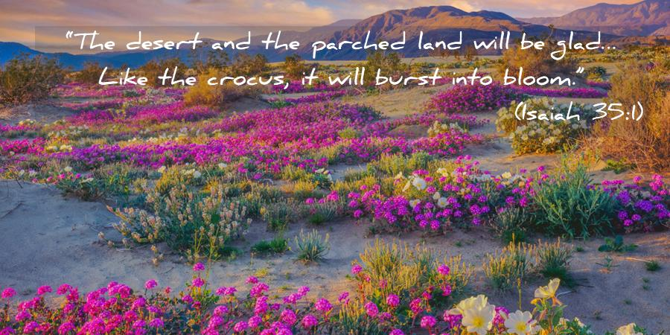
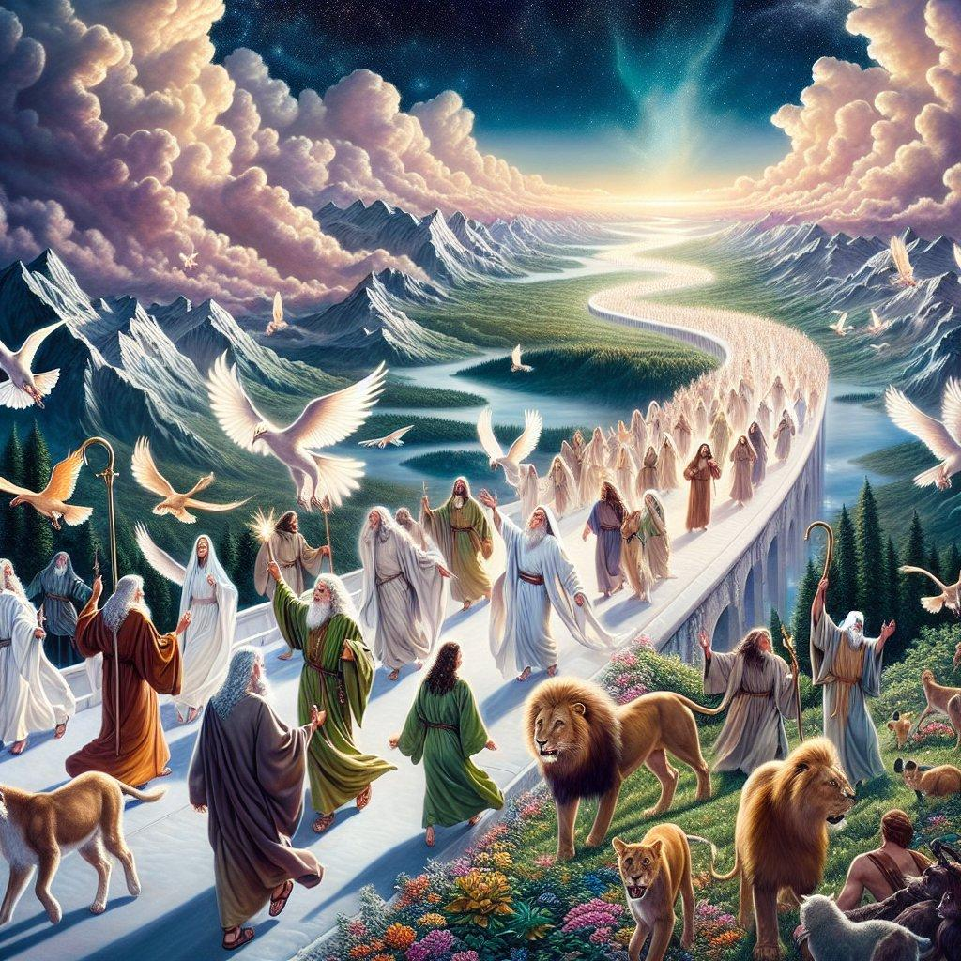
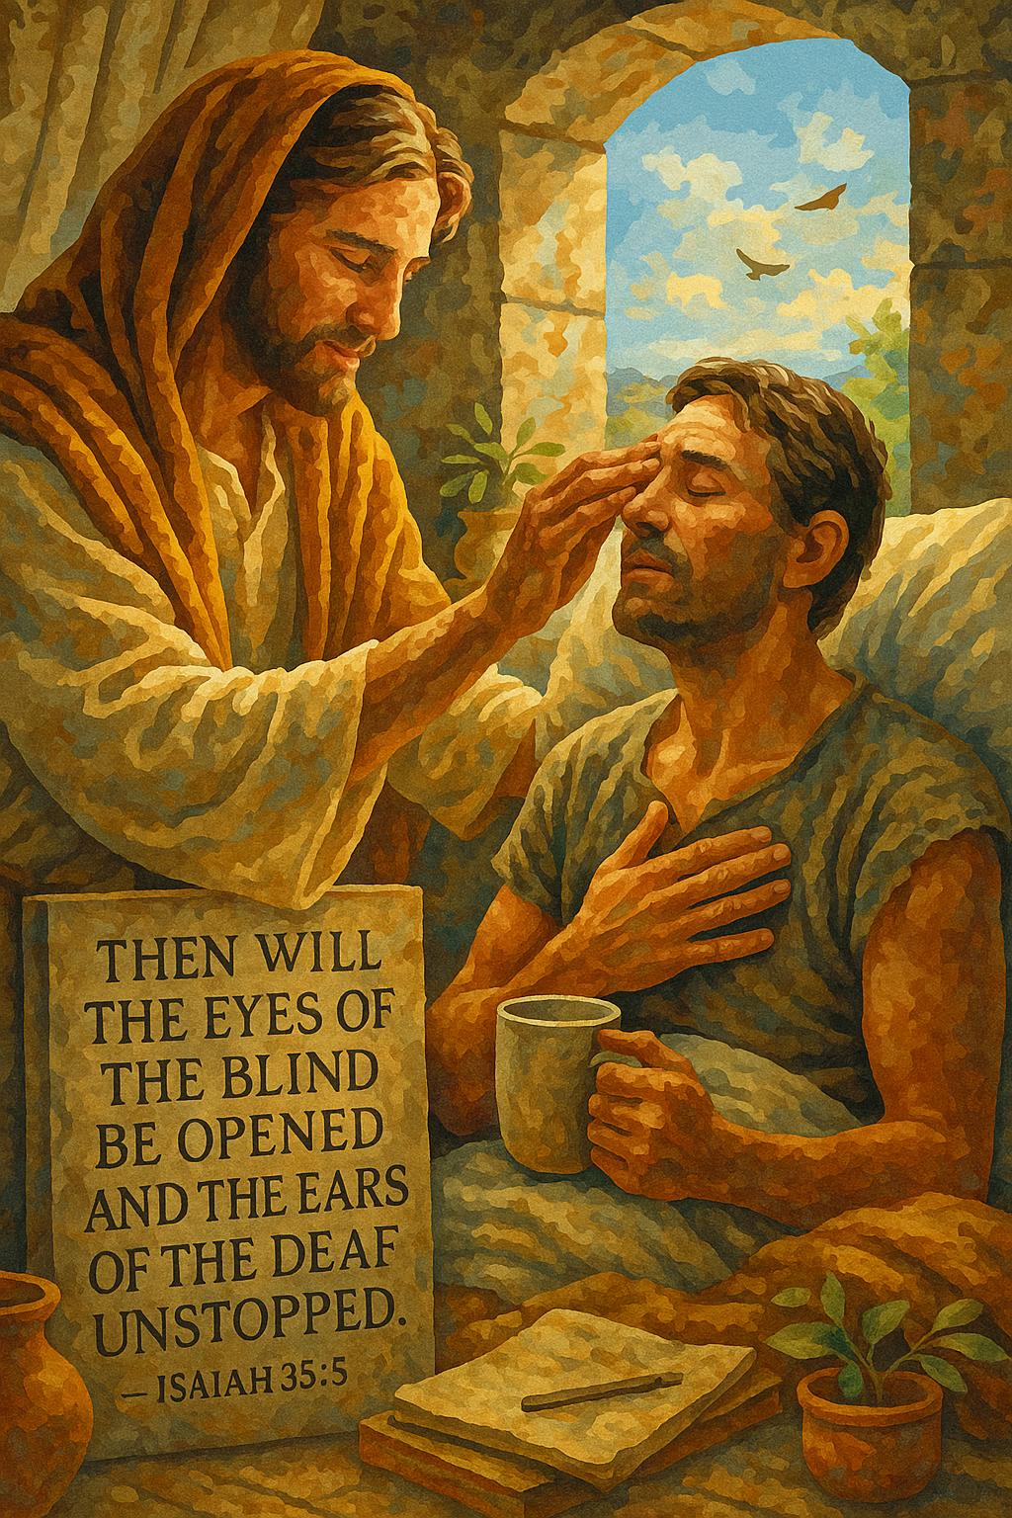
6
One of Isaiah's great restoration chapters.
The wilderness blossoms.
The blind see.
The deaf hear.
The lame leap.
The redeemed return.
Isaiah 35:8
“And an highway shall be there, and a way, and it shall be called The way of holiness…”
The chapter anticipates God's dramatic restoration.

ISAIAH 36 — Assyria Threatens Jerusalem
The prophetic section transitions into historical narrative.
Sennacherib's forces threaten Jerusalem.
The Rabshakeh attempts psychological warfare.

ISAIAH 37 — Hezekiah Prays
Hezekiah responds to Assyria by seeking God.
Isaiah delivers God's answer.
Major theme
Prayer in the face of impossible circumstances.
God delivers Jerusalem.

ISAIAH 38 — Hezekiah's Illness
Hezekiah becomes sick.
He prays.
God grants additional years.
Major themes:
- mortality
- prayer
- healing
- gratitude
- God's sovereignty

ISAIAH 39 — Babylonian Envoys
Hezekiah displays his treasures to Babylonian representatives.
Isaiah announces future Babylonian captivity.
This chapter serves as a bridge to Isaiah 40–66.

ISAIAH 40 — Comfort My People
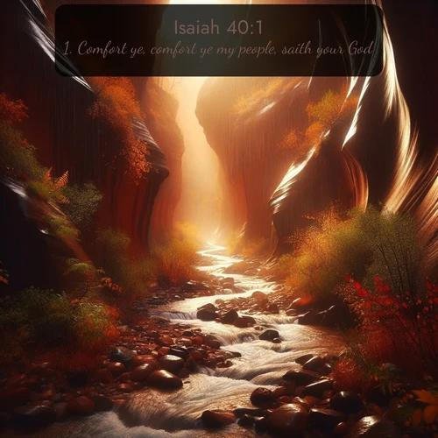
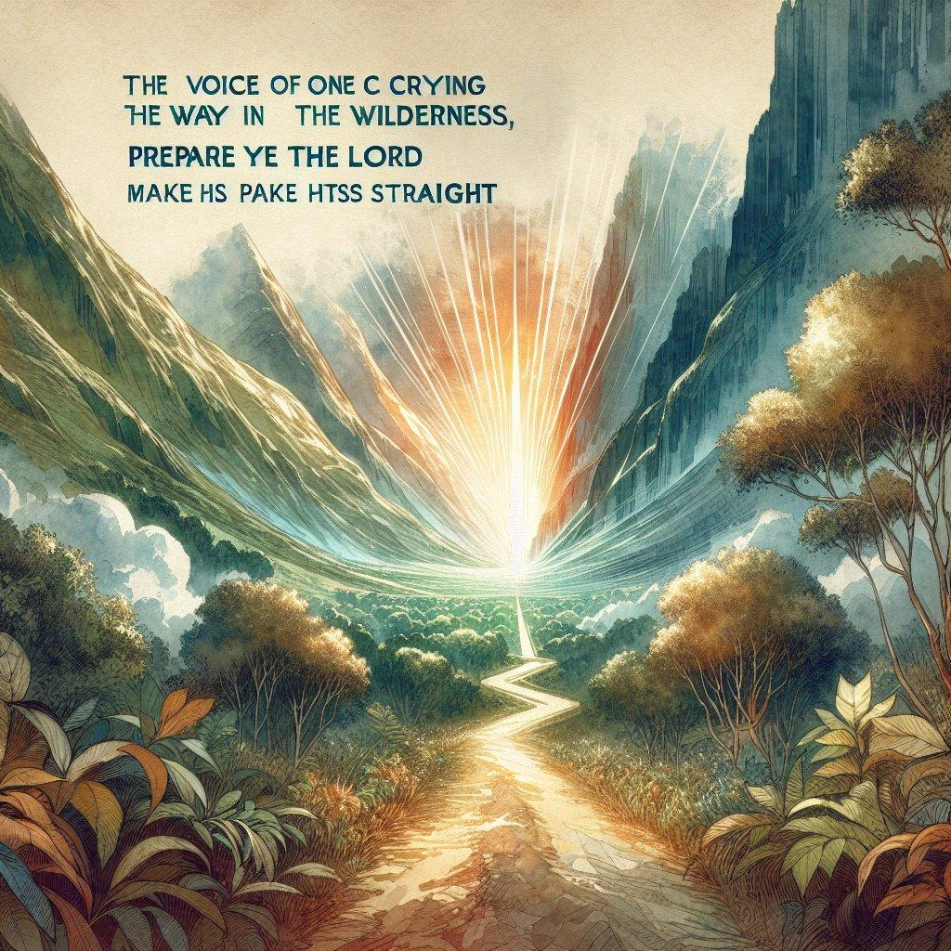
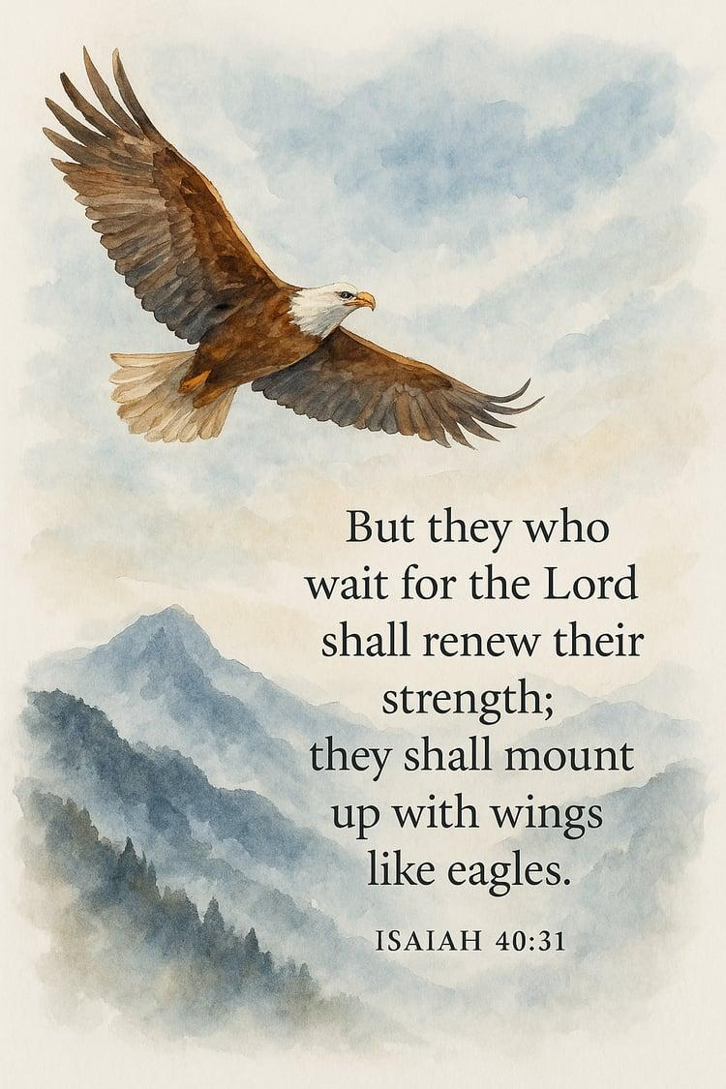
6
A dramatic transition occurs.
Isaiah 40:1
“Comfort ye, comfort ye my people…”
Isaiah 40:3
“The voice of him that crieth in the wilderness…”
The New Testament applies this to John the Baptist.
Isaiah 40:31
Those who wait upon the LORD:
- renew strength
- mount up with wings
- run
- walk
- do not faint

ISAIAH 41 — “Fear Thou Not”
God repeatedly reassures His people.
Major themes
- election
- Abraham
- Israel
- God's sovereignty
- idols
- fear
- divine help
Isaiah 41:10
“Fear thou not; for I am with thee…”

ISAIAH 42 — The Servant of the LORD
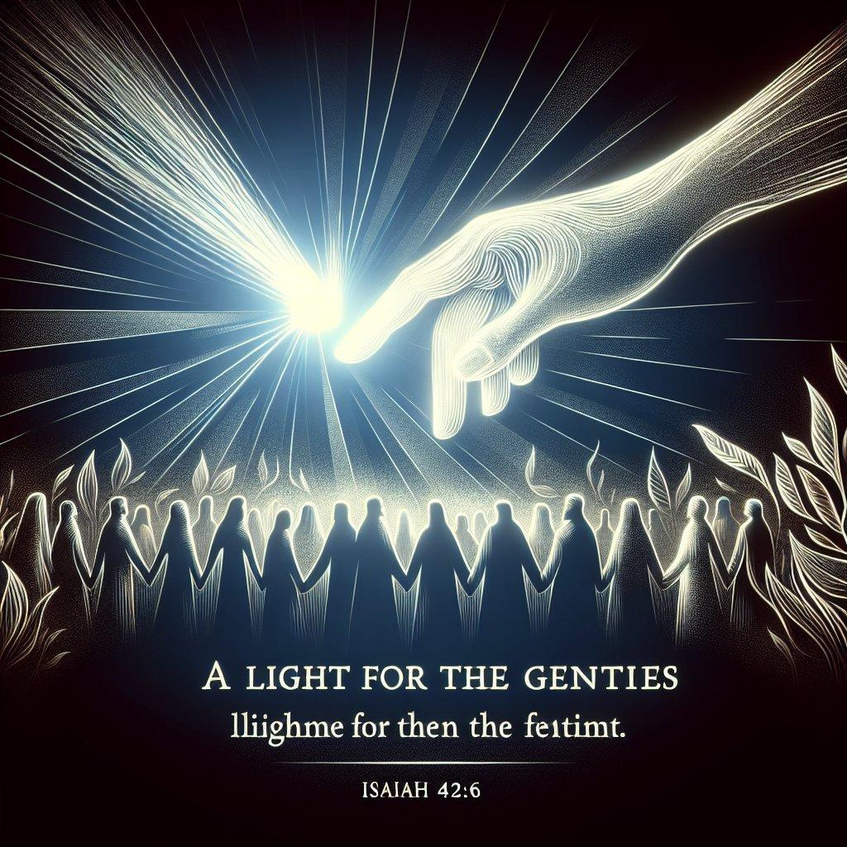
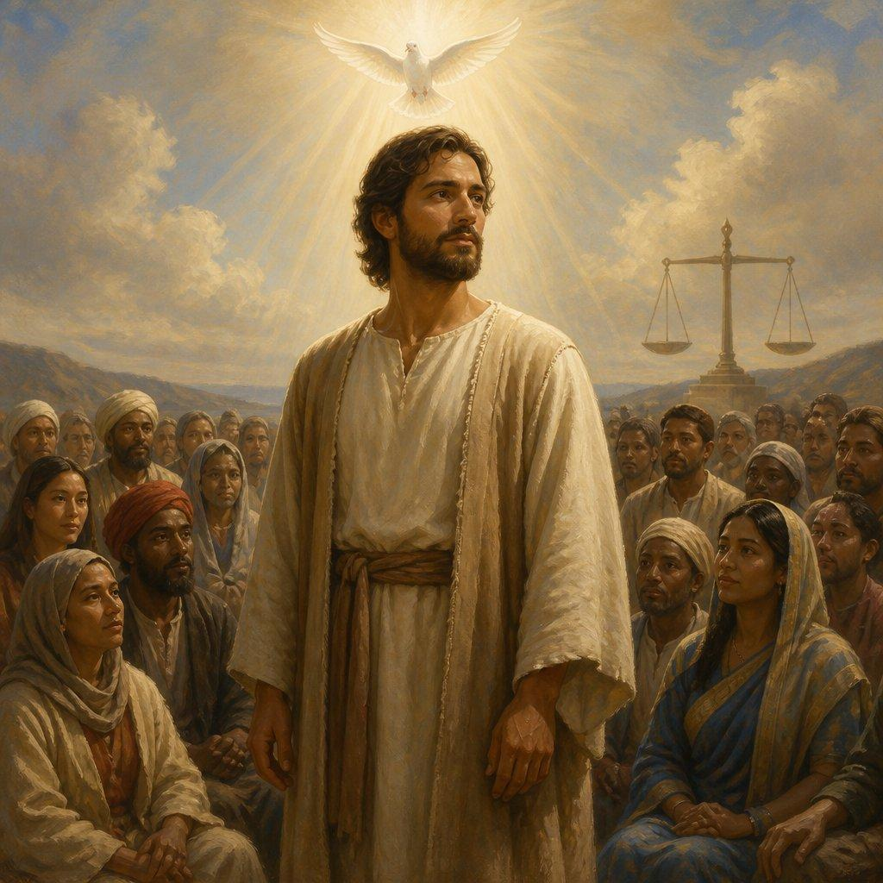
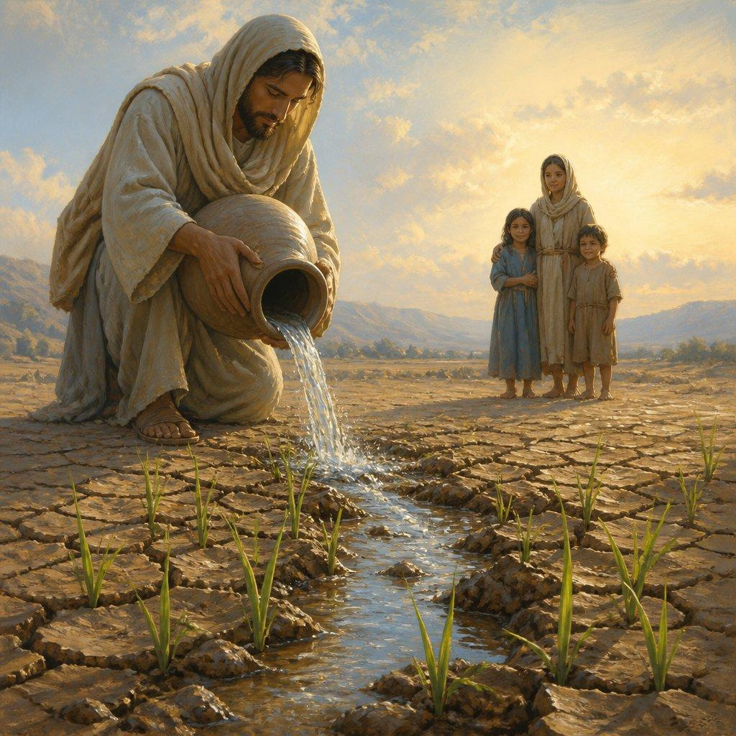
One of the great Servant Songs.
Isaiah 42:1
“Behold my servant…”
The Servant:
- receives God's Spirit
- brings justice
- does not crush the weak
- becomes a light to the nations
New Testament
Matthew 12:17–21 explicitly connects Jesus with Isaiah 42.

ISAIAH 43 — “I Have Redeemed You”
God tells Israel:
“Fear not: for I have redeemed thee…”
Major themes:
- creation
- redemption
- witness
- God's uniqueness
- forgiveness
- restoration
Isaiah 43:10
Israel is God's witness.
Isaiah 43:25
God blots out transgressions.

ISAIAH 44 — The One True God
The chapter contrasts:
YHWH
with
manufactured idols.
The famous idol-making passage demonstrates the absurdity of worshiping something humans themselves construct.
Isaiah 44:28
Cyrus is named.
This is one of Isaiah's most striking prophetic references.

ISAIAH 45 — Cyrus and God's Sovereignty
Cyrus is explicitly called God's:
“anointed”
Hebrew:
מָשִׁיחַ — māšîaḥ
This is the Hebrew word associated with anointed one.
Cyrus is not the Messiah in the ultimate Christian sense, but Isaiah uses royal/anointed terminology for him because God appoints him for a specific historical purpose.
Major theme
God controls history even through pagan rulers.

ISAIAH 46 — Babylon's Gods Cannot Save
Bel and Nebo are contrasted with YHWH.
Idols must be carried.
God carries His people.
That contrast is central:
Humans carry idols; God carries humans.

ISAIAH 47 — The Fall of Babylon
Babylon's pride is exposed.
She thinks:
“I am, and there is none beside me.”
But God's judgment comes.

ISAIAH 48 — Refined for God's Glory
Israel is confronted for stubbornness.
God explains His purpose:
His glory and His name.
The chapter closes the first major restoration section.

ISAIAH 49 — The Servant and the Nations
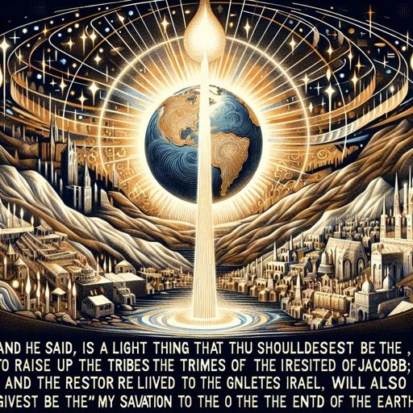
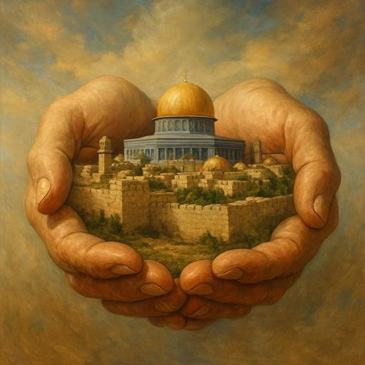
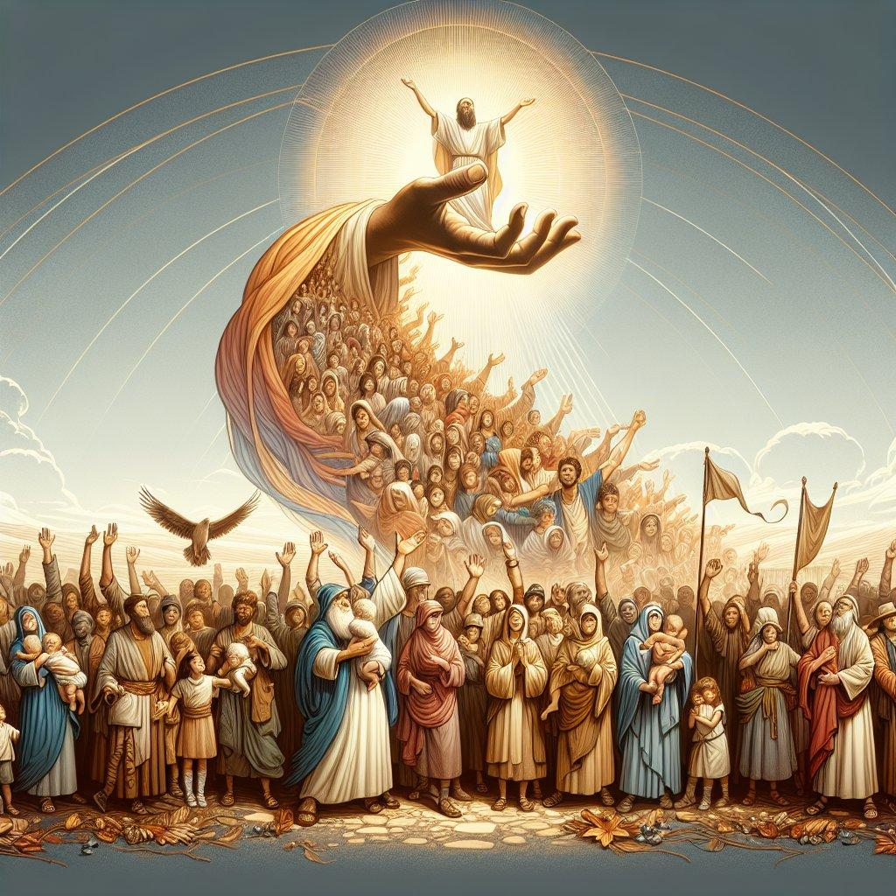
5
Another major Servant passage.
Isaiah 49:6
The Servant becomes:
“a light to the Gentiles”
The mission is not restricted to Israel.
Major theological progression
Israel → Servant → nations → salvation to the ends of the earth

ISAIAH 50 — The Obedient Servant
The Servant speaks of:
- obedience
- suffering
- rejection
- trust in God
Isaiah 50:6
The Servant willingly suffers humiliation.
This prepares the reader for Isaiah 53.

ISAIAH 51 — Listen to Me
God calls His people to remember:
- Abraham
- Sarah
- God's promises
- His righteousness
Zion will be restored.

ISAIAH 52 — Good News and the Suffering Servant Begins
Isaiah 52:7
“How beautiful upon the mountains are the feet of him that bringeth good tidings…”
Paul later uses this passage in:
Romans 10:15.
Isaiah 52:13–15
The final Servant Song begins.
It introduces a Servant who will be:
- exalted
- marred
- rejected
- astonishing to nations

ISAIAH 53 — The Suffering Servant
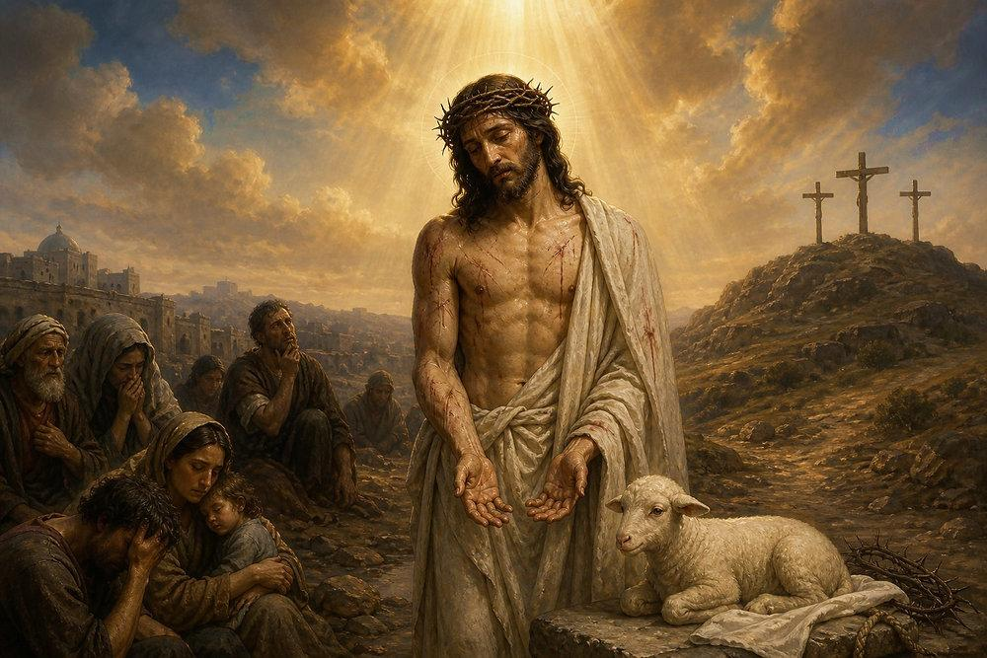
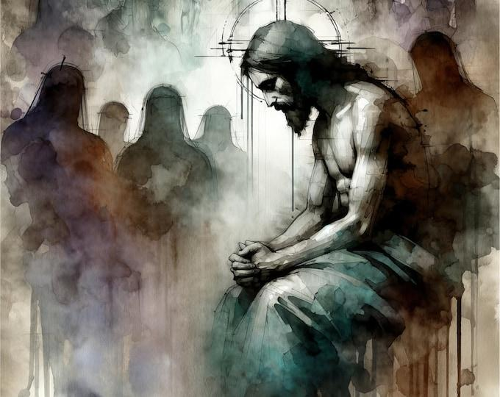
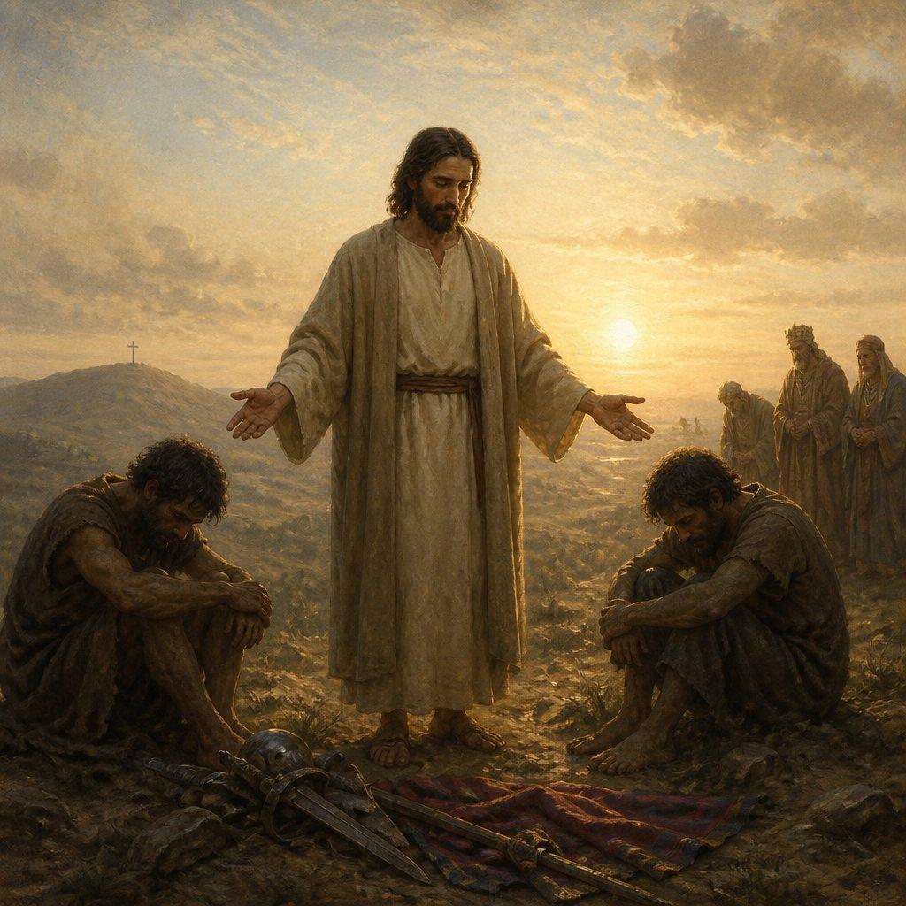
5
This is arguably the most famous Messianic passage in Isaiah.
Isaiah 53:3
The Servant is:
despised and rejected
Isaiah 53:4
He bears:
- griefs
- sorrows
Isaiah 53:5
He is wounded for:
“our transgressions”
and bruised for:
“our iniquities.”
Isaiah 53:6
The central substitutionary image:
“the LORD hath laid on him the iniquity of us all.”
Isaiah 53:7
The Servant is compared to:
a lamb led to slaughter.
Isaiah 53:9
His burial is mentioned.
Isaiah 53:10–12
The Servant:
- suffers
- makes an offering
- sees offspring
- is ultimately vindicated
- bears sin
- intercedes for transgressors
New Testament connections
Isaiah 53 is repeatedly connected with Jesus:
- Matthew 8:17
- Luke 22:37
- John 12:38
- Acts 8:32–35
- Romans 10:16
- 1 Peter 2:22–25

ISAIAH 54 — Zion Restored
After the Servant's suffering comes restoration.
Major themes:
- covenant
- compassion
- restoration
- Jerusalem
- God's faithfulness

ISAIAH 55 — Come, Everyone Who Thirsts
One of Scripture's greatest invitations.
Isaiah 55:1
“Ho, every one that thirsteth, come ye to the waters…”
God offers freely:
- water
- bread
- covenant
- mercy
- forgiveness
Isaiah 55:8–9
God's thoughts and ways exceed human understanding.
Isaiah 55:11
God's word accomplishes His purpose.

ISAIAH 56 — Salvation for the Nations
A major expansion occurs.
The foreigner and eunuch who trust God are welcomed.
Isaiah 56:7
God's house is called:
“an house of prayer for all people.”
Jesus quotes this in:
Matthew 21:13; Mark 11:17; Luke 19:46.

ISAIAH 57 — Idolatry and Healing
The chapter exposes:
- idolatry
- spiritual adultery
- false worship
But it ends with God's willingness to revive the humble.
Isaiah 57:15
God dwells with:
“him also that is of a contrite and humble spirit.”

ISAIAH 58 — True Fasting
Israel practices religious fasting but neglects justice.
God describes true fasting as:
- releasing oppression
- feeding the hungry
- helping the poor
- clothing the naked
- caring for one's neighbor
This chapter powerfully connects:
worship + justice + compassion.

ISAIAH 59 — Sin Separates
Isaiah 59:2
“your iniquities have separated between you and your God…”
The chapter describes:
- sin
- injustice
- lies
- bloodshed
- spiritual darkness
Then God Himself acts as Redeemer.
Isaiah 59:20
“the Redeemer shall come to Zion…”
Paul later quotes this in:
Romans 11:26–27.

ISAIAH 60 — Arise, Shine
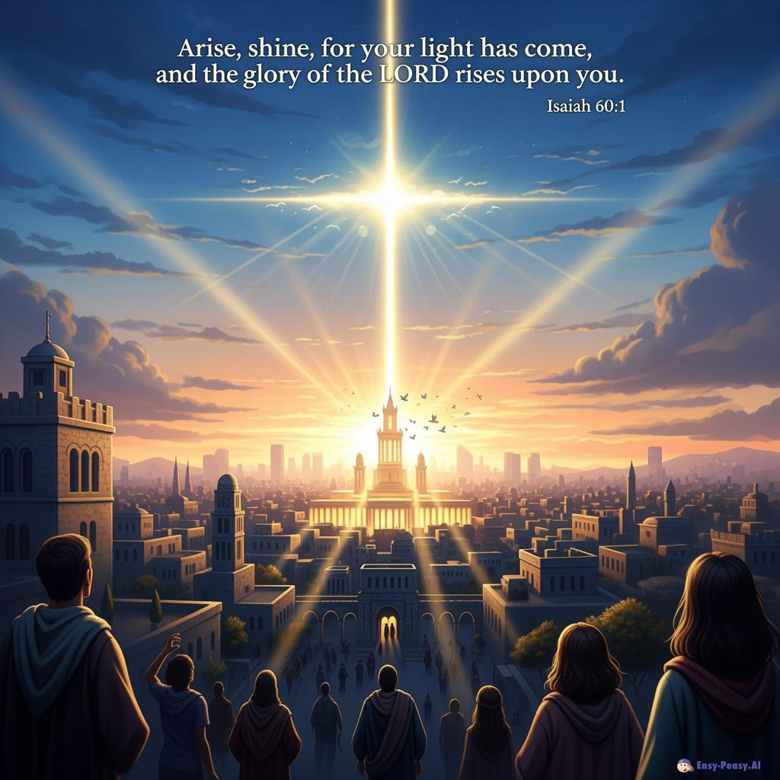
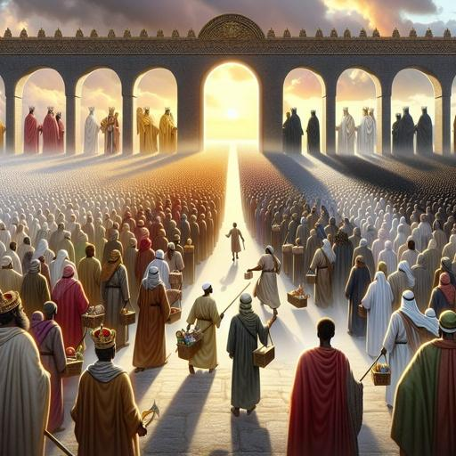
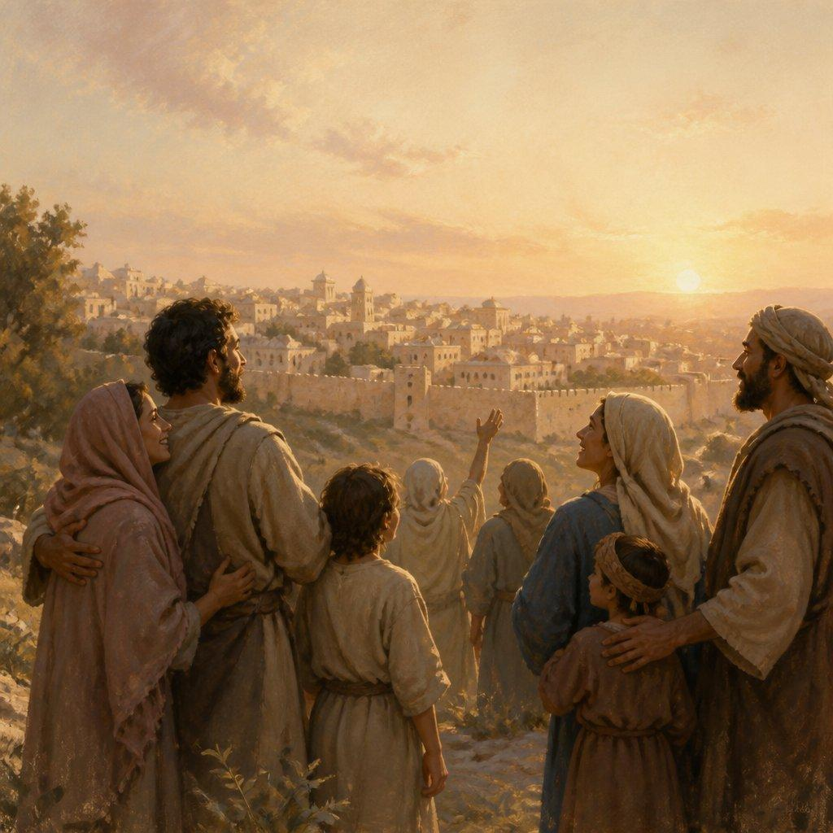
4
Isaiah 60:1
“Arise, shine; for thy light is come…”
Zion becomes radiant.
The nations come toward God's light.
Major themes:
- glory
- Zion
- nations
- wealth
- light
- restoration
- God's presence

ISAIAH 61 — The Anointed One
One of the most important Messianic passages.
Isaiah 61:1
“The Spirit of the Lord GOD is upon me…”
The Anointed One is sent to:
- preach good news
- heal the brokenhearted
- proclaim liberty
- comfort mourners
- proclaim God's favor
Luke 4:16–21
Jesus reads Isaiah 61 in the synagogue and declares its fulfillment.
This makes Isaiah 61 one of the clearest explicit connections between Isaiah's prophecy and Jesus' ministry.

ISAIAH 62 — Zion's New Name
God refuses to abandon Zion.
Themes:
- righteousness
- salvation
- new identity
- God's delight
- watchmen
- restoration
The imagery points toward God's restored relationship with His people.

ISAIAH 63 — The Divine Warrior
The chapter opens with a mysterious figure coming from Edom.
Major themes:
- vengeance
- redemption
- judgment
- salvation
- God's mercy
- Israel's history
The chapter then turns into prayer and remembrance.

ISAIAH 64 — “Oh That Thou Wouldest Rend the Heavens”
A prayer for God's dramatic intervention.
Major themes
- human sin
- divine holiness
- repentance
- God's fatherhood
- clay and potter
- longing for God's presence

ISAIAH 65 — New Heavens and New Earth

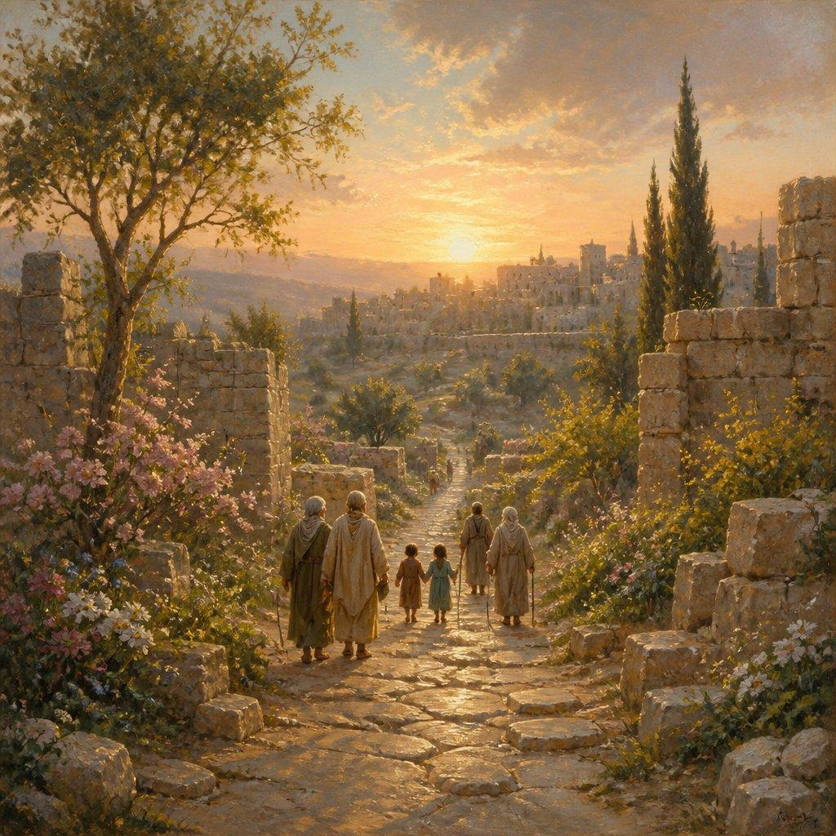
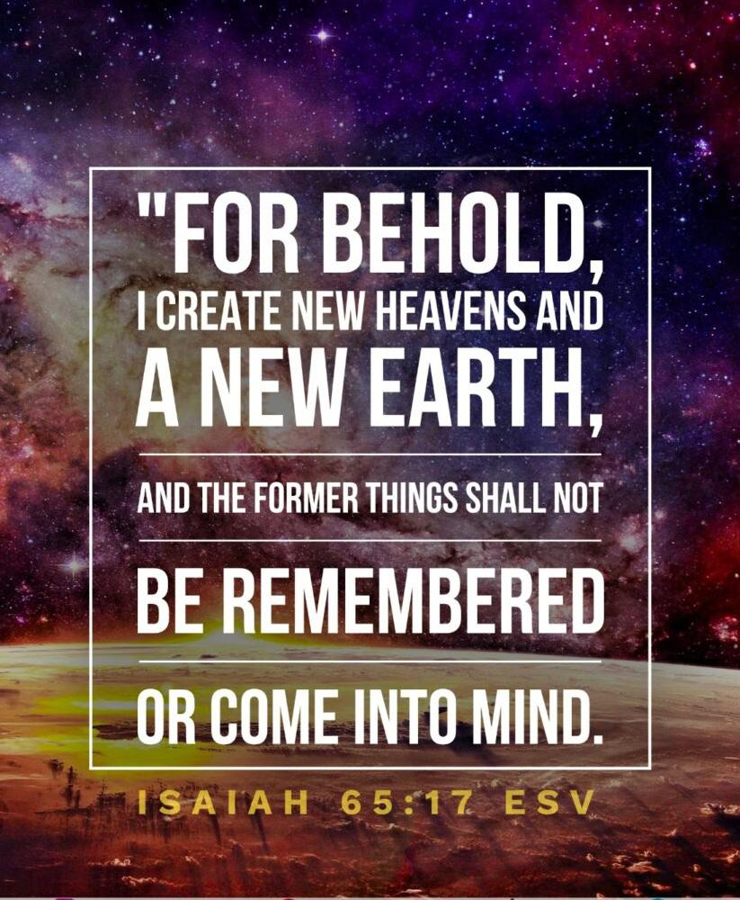
6
A major eschatological chapter.
Isaiah 65:17
“I create new heavens and a new earth…”
This is foundational for biblical study of the new creation.
Compare:
- Isaiah 66:22
- 2 Peter 3:13
- Revelation 21:1

ISAIAH 66 — Final Judgment and New Creation
The book concludes with:
- God's throne
- true worship
- judgment
- Jerusalem's restoration
- worldwide proclamation
- new heavens
- new earth
Isaiah 66:22
“the new heavens and the new earth, which I will make…”
Isaiah's final vision
The nations come to worship God.
The book therefore ends where its universal vision has been heading:
God's glory among the nations.

V. THE GREAT THEMES OF ISAIAH
1. The Holiness of God
Isaiah's God is repeatedly presented as:
“the Holy One of Israel.”
This title occurs throughout the book.
God's holiness produces:
conviction → judgment → purification → worship.

2. God as King
Isaiah repeatedly portrays God as:
- King
- Judge
- Creator
- Redeemer
- Shepherd
- Warrior
- Father
- Sovereign

3. The Holy One of Israel
This is one of the distinctive theological expressions of Isaiah.
It joins:
God's holiness
with
God's covenant relationship with Israel.

4. The Remnant
A remnant survives judgment.
Important passages include:
- Isaiah 6:13
- Isaiah 10:20–22
- Isaiah 11:11
- Isaiah 37:31–32
The remnant theme connects Isaiah with:
- Romans 9
- Romans 11

5. Zion
Zion is simultaneously associated with:
- Jerusalem
- Davidic kingship
- God's presence
- worship
- judgment
- restoration
- worldwide salvation

6. The Servant
The Servant passages are central:
- Isaiah 42
- Isaiah 49
- Isaiah 50
- Isaiah 52:13–53:12
The Servant's mission progresses from:
Israel → restoration → nations → suffering → redemption → exaltation.

7. The Messiah
Major Messianic passages include:
Isaiah | Major Messianic Theme
Isaiah 4:2 | Branch
Isaiah 7:14 | Immanuel
Isaiah 9:1–7 | Divine/Davidic King
Isaiah 11:1–10 | Branch of Jesse
Isaiah 28:16 | Cornerstone
Isaiah 42:1–9 | Servant
Isaiah 49:1–7 | Servant/light to nations
Isaiah 50:4–9 | Obedient suffering Servant
Isaiah 52:13–53:12 | Suffering Servant
Isaiah 59:20 | Redeemer
Isaiah 61:1–3 | Anointed One

8. Salvation
Isaiah's name itself means:
YHWH is salvation.
The book repeatedly asks the reader to stop trusting:
- idols
- military power
- Egypt
- Assyria
- political alliances
- human wisdom
and trust:
God alone.

9. The Nations
Isaiah is not merely a book about Judah.
It contains a vast theology of the nations.
Eventually:
Egypt + Assyria + Israel
can be blessed together.
The nations become recipients of God's salvation.

10. Judgment
Isaiah contains some of the Bible's strongest judgment passages.
Judgment falls because of:
- idolatry
- pride
- oppression
- injustice
- unbelief
- political arrogance
- rejection of God
But judgment is never Isaiah's final word.

11. Restoration
The pattern repeatedly becomes:
sin → judgment → remnant → redemption → restoration → glory.

12. The Day of the LORD
The Day of the LORD includes:
- historical judgment
- national judgment
- cosmic judgment
- ultimate divine intervention
Isaiah therefore helps establish biblical eschatology later developed in:
- Daniel
- Joel
- Zechariah
- Matthew
- 1 Thessalonians
- 2 Peter
- Revelation

VI. ISAIAH AND JESUS CHRIST
Isaiah is extraordinarily important for understanding Jesus.
Jesus as Immanuel
Isaiah 7:14 → Matthew 1:23
Jesus as Light
Isaiah 9:1–2 → Matthew 4:14–16
Jesus as Davidic King
Isaiah 9:6–7; 11:1–10
Jesus as Servant
Isaiah 42 → Matthew 12:17–21
Jesus as suffering Servant
Isaiah 53 → Acts 8:32–35; 1 Peter 2:24–25
Jesus as the Cornerstone
Isaiah 28:16 → Romans 9:33; 1 Peter 2:6
Jesus as Redeemer
Isaiah 59:20 → Romans 11:26
Jesus as Spirit-anointed Messiah
Isaiah 61:1–2 → Luke 4:18–21

VII. ISAIAH AND REVELATION
Isaiah is also essential for understanding Revelation.
Isaiah | Revelation
Isaiah 11 | Revelation 19–20
Isaiah 25:8 | Revelation 21:4
Isaiah 35 | Revelation 21–22
Isaiah 60 | Revelation 21
Isaiah 65:17 | Revelation 21:1
Isaiah 66:22 | Revelation 21:1
Isaiah 66:23 | Revelation 21–22
Isaiah's vision of:
new heavens + new earth + restored Jerusalem + nations + God's glory
provides major Old Testament background for Revelation 21–22.

VIII. ISAIAH'S CENTRAL MESSAGE
If the entire book had to be reduced to one theological progression, it would look like this:
The Holy God
↓
Judges human sin
↓
Preserves a remnant
↓
Promises a Davidic King
↓
Sends His Servant
↓
The Servant suffers for sinners
↓
God brings salvation
↓
The nations receive His light
↓
Zion is restored
↓
God establishes His righteous kingdom
↓
New heavens and new earth
↓
God's glory fills the world

IX. THE 66-CHAPTER MASTER STUDY
For a truly very deep chapter-by-chapter study, Isaiah can be worked through in this sequence:
Isaiah 1–12 — Judah, Immanuel, and the Davidic Messiah
1. Rebellious Judah
2. Mountain of the LORD
3. Judgment on Jerusalem
4. Branch and holy Zion
5. Vineyard and six woes
6. Isaiah's calling
7. Immanuel
8. Assyria and the stone
9. Child-King
10. Assyria and the remnant
11. Branch of Jesse
12. Song of salvation
Isaiah 13–23 — Nations Under God's Sovereignty
13. Babylon
14. Babylon's king and pride
15. Moab
16. Moab and Davidic justice
17. Damascus and Israel
18. Cush
19. Egypt
20. Isaiah's sign
21. Babylon, Edom, Arabia
22. Jerusalem and Shebna
23. Tyre
Isaiah 24–35 — Universal Judgment and Restoration
24. Judgment on the earth
25. Feast and victory over death
26. Resurrection and trust
27. Leviathan and restoration
28. Cornerstone
29. Jerusalem's blindness
30. Trust versus Egypt
31. Egypt cannot save
32. Righteous King
33. LORD as King
34. Judgment on nations
35. Highway of holiness
Isaiah 36–39 — Hezekiah Historical Section
36. Assyria attacks
37. Hezekiah prays
38. Hezekiah's sickness
39. Babylonian envoys
Isaiah 40–48 — Comfort, Cyrus, and God's Sovereignty
40. Comfort and God's greatness
41. Fear not
42. Servant of the LORD
43. Redeemed Israel
44. Idols versus God
45. Cyrus
46. Babylon's idols
47. Babylon's humiliation
48. Refined for God's glory
Isaiah 49–55 — The Servant and Salvation
49. Servant and nations
50. Obedient Servant
51. Comfort Zion
52. Good news and Servant
53. Suffering Servant
54. Restored Zion
55. Invitation to salvation
Isaiah 56–66 — Restoration and New Creation
56. Salvation for foreigners
57. Idolatry and healing
58. True fasting
59. Sin and Redeemer
60. Arise and shine
61. Anointed One
62. Zion's new name
63. Divine Warrior
64. Prayer for God's intervention
65. New heavens and new earth
66. Final judgment and new creation

X. THE BIGGEST QUESTIONS TO ASK IN EVERY ISAIAH CHAPTER
For your very deep research method, each chapter should be examined through these questions:
Historical
- Who is speaking?
- Who is being addressed?
- What king is reigning?
- What nations are involved?
- What historical crisis is present?
- What Assyrian, Babylonian, Egyptian, or Judean event is relevant?
Literary
- What is the chapter's structure?
- Is it prophecy, narrative, poetry, prayer, oracle, song, or vision?
- What words are repeated?
- What contrasts are used?
- What images dominate?
Theological
- What does this chapter reveal about God?
- What does it reveal about sin?
- What does it reveal about salvation?
- What does it teach about covenant?
- What does it teach about judgment?
- What does it teach about worship?
Messianic
- Is there a Davidic promise?
- Is there a Branch?
- Is there a Servant?
- Is there a King?
- Is there a Redeemer?
- Is there a light to the nations?
- Is there a suffering figure?
- Is there a kingdom?
Biblical cross-reference
- Where does this passage appear elsewhere in Scripture?
- Does Jesus quote it?
- Does Paul quote it?
- Does Peter quote it?
- Does Hebrews use it?
- Does Revelation echo it?
Eschatological
- Does this concern Israel's immediate future?
- Judah's restoration?
- the nations?
- Messiah's kingdom?
- resurrection?
- final judgment?
- new creation?

XI. THE GRAND THEOLOGICAL PICTURE OF ISAIAH
Isaiah begins with a rebellious people and ends with a vision of new creation.
It begins with:
sin
and moves toward:
salvation.
It begins with:
Jerusalem under judgment
and ends with:
Jerusalem restored.
It begins with:
human rebellion
and ends with:
God's glory among the nations.
It begins with:
unclean lips
and leads toward:
holy worship.
It begins with:
darkness
and repeatedly announces:
light.
It introduces:
Immanuel
and ultimately presents the Servant, Redeemer, King, and Anointed One through whom God's salvation reaches the nations.
The central theological movement is:
HOLINESS → SIN → JUDGMENT → REMNANT → SERVANT → REDEMPTION → MESSIAH → KINGDOM → RESTORATION → NEW CREATION.
That is the grand biblical architecture of Isaiah.

