Revelation — Chapter-by-Chapter Very Deep Bible Research
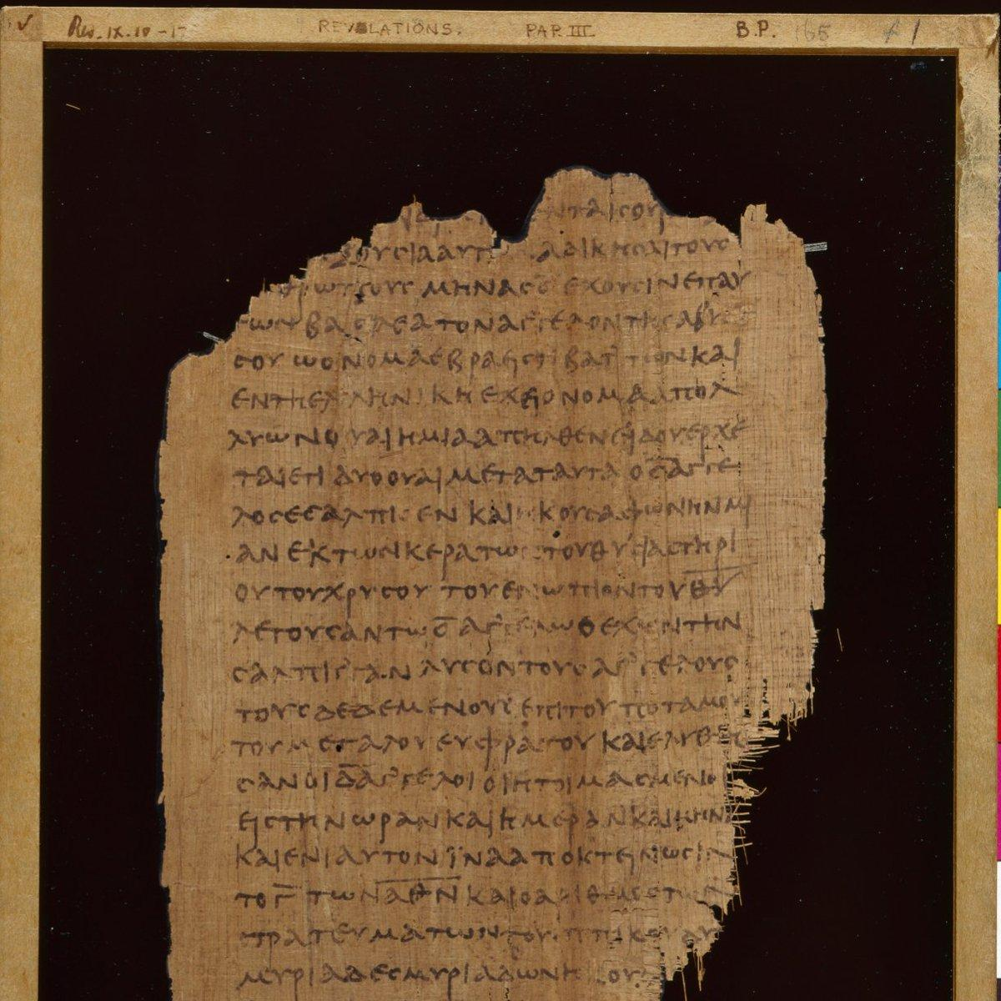
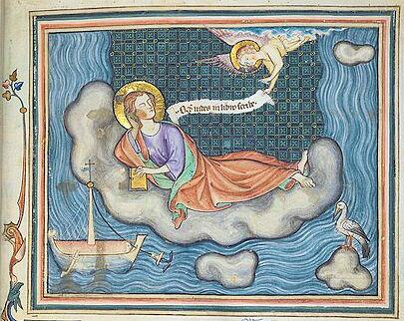
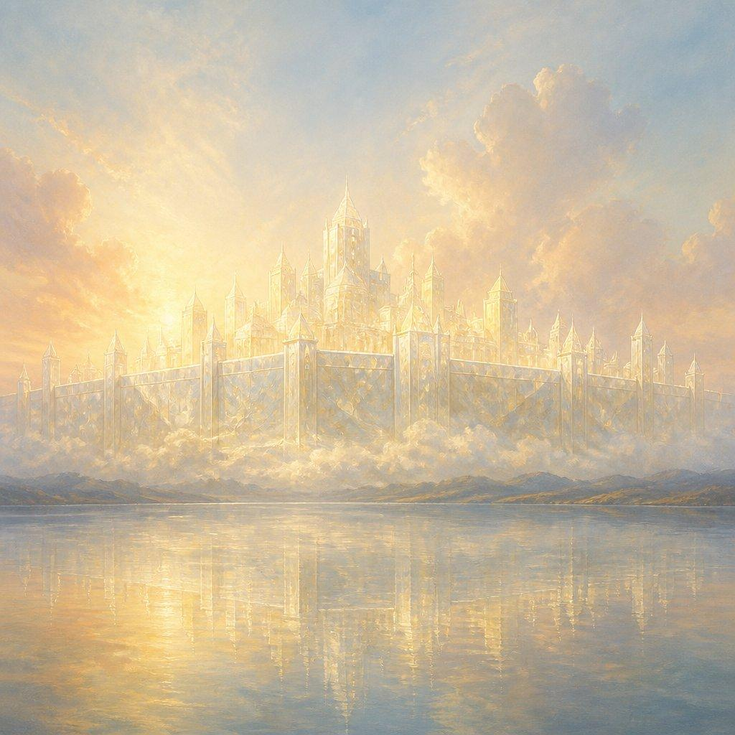
7
The Book of Revelation is the climactic book of the Bible. It brings together themes from Genesis through the Prophets, the Gospels, and the Apostolic writings: creation, fall, covenant, Exodus, temple, kingship, judgment, Babylon, Messiah, resurrection, Satan's defeat, the restoration of creation, and the dwelling of God with His people.
A useful way to study Revelation is not merely as a prediction chart, but as a theological unveiling of Jesus Christ and God's purposes for history.
Central message: Jesus Christ is the victorious Lamb and King. Evil may appear dominant for a time, but God will judge evil, vindicate His people, defeat Satan, raise the dead, and establish His eternal kingdom in a renewed creation where God dwells with His people.

I. BIG-PICTURE STRUCTURE OF REVELATION
Section | Chapters | Major Subject
Introduction | 1 | Christ revealed; commission to John
Seven Churches | 2–3 | Christ's message to His churches
Throne Room | 4–5 | God enthroned; the Lamb receives the scroll
Seven Seals | 6–8:1 | Judgment and the unfolding of God's purposes
Seven Trumpets | 8–11 | Escalating judgments and witness
Cosmic Conflict | 12–14 | Woman, dragon, beasts, Lamb, final harvest
Seven Bowls | 15–16 | Final plagues and judgment
Babylon | 17–18 | Fall of the great prostitute/city
Return of Christ | 19 | Christ the conquering King
Millennium / Final Judgment | 20 | Satan defeated; resurrection and judgment
New Creation | 21–22 | New heaven, new earth, New Jerusalem

II. REVELATION'S CENTRAL THEMES
1. Jesus Christ
Revelation is fundamentally Christ-centered.
Jesus appears as:
- Son of Man
- Faithful Witness
- Firstborn from the dead
- Ruler of earthly kings
- Son of God
- Lion of Judah
- Root of David
- Lamb
- Lord of lords
- King of kings
- Word of God
- Alpha and Omega
- First and Last
- Beginning and End
- Morning Star
The paradox is crucial:
The One who conquers is the Lamb who was slain.

III. CHAPTER-BY-CHAPTER VERY DEEP RESEARCH
REVELATION 1 — CHRIST AMONG THE SEVEN CHURCHES
Main text
Revelation 1:1–20
Central theme
Jesus Christ is revealed as the risen, glorified Lord who walks among His churches.
1:1 — "The Revelation of Jesus Christ"
The Greek word apokalypsis means unveiling, disclosure, revelation.
The book is therefore not primarily "the revelation of end-times events."
It is:
the revelation of Jesus Christ.
The events matter because they reveal:
- Christ's authority
- Christ's judgment
- Christ's kingdom
- Christ's victory
- Christ's glory
1:3 — The first beatitude
"Blessed is he that readeth..."
Revelation is intended to be:
- read,
- heard,
- obeyed.
Biblical prophecy is therefore not merely information.
It demands faithful living.
1:4–6 — The Trinity
John describes:
- the Father — "him which is, and which was, and which is to come"
- the seven Spirits before God's throne
- Jesus Christ
Jesus is called:
- faithful witness
- firstborn of the dead
- ruler of kings
1:5 — Christ's blood
Jesus:
- loves His people,
- releases them from sins,
- establishes them as a kingdom,
- makes them priests.
This connects Revelation to:
Exodus 19:5–6
Israel was called a kingdom of priests.
Revelation applies kingdom-priest language to Christ's redeemed people.
1:7 — Christ's return
"Behold, he cometh with clouds..."
Major Old Testament background:
- Daniel 7:13
- Zechariah 12:10
- Matthew 24:30
- Matthew 26:64
- Acts 1:9–11
Daniel 7's "Son of Man" imagery becomes central.
1:8 — Alpha and Omega
God declares Himself:
- beginning
- end
- eternal
The same language later appears in Revelation 21–22.
The entire story of history exists within God's sovereignty.
1:9 — Patmos
John is on the island of Patmos because of his testimony concerning Jesus.
He describes himself as a:
- brother
- companion
- fellow participant in tribulation
- fellow participant in the kingdom
- fellow participant in patient endurance.
1:12–16 — The glorified Christ
John sees:
- seven golden lampstands
- one like the Son of Man
- robe
- golden sash
- white hair
- eyes like fire
- feet like burning bronze
- voice like many waters
- seven stars
- sword from His mouth
- face like the sun
1:16 — Sword from His mouth
The sword represents Christ's authoritative word of judgment.
Compare:
- Isaiah 11:4
- Isaiah 49:2
- Ephesians 6:17
- Hebrews 4:12
- Revelation 19:15
1:18 — Jesus has the keys
"I am he that liveth, and was dead; and, behold, I am alive for evermore..."
Christ possesses:
the keys of death and Hades.
Death does not control Christ.
Christ controls death.
1:20
The seven lampstands are:
the seven churches.
The seven stars are:
the angels/messengers of the seven churches.
Major theological lesson
The first chapter establishes the lens through which the entire book must be read:
Jesus is Lord over the churches, history, death, judgment, and the future.

REVELATION 2 — FOUR CHURCHES
Revelation 2 contains messages to:
- Ephesus
- Smyrna
- Pergamum
- Thyatira

Revelation 2:1–7 — Ephesus
Commendation
Ephesus:
- worked hard
- endured
- rejected false apostles
- hated Nicolaitan practices
Problem
"Thou hast left thy first love."
The church had:
orthodoxy without sufficient love.
Jesus does not regard correct doctrine as sufficient if love has disappeared.
Command
- Remember.
- Repent.
- Return.
Promise
The overcomer receives access to:
the tree of life.
This takes us directly back to:
Genesis 2–3.
Revelation ends where Genesis began—but in a redeemed and restored condition.

Revelation 2:8–11 — Smyrna
Smyrna receives no condemnation.
It is:
- afflicted
- poor materially
- rich spiritually
2:10
"Be thou faithful unto death..."
Christ promises:
the crown of life.
Major theme
Faithfulness is measured not by comfort but by loyalty to Christ.
Connection
The church may experience death.
But Christ says:
"I will give thee a crown of life."

Revelation 2:12–17 — Pergamum
Pergamum is located where:
"Satan's seat [throne] is."
The church remained faithful even when Antipas was killed.
Problem
Some tolerated:
- Balaam-like compromise
- idolatry
- sexual immorality
- Nicolaitan teaching
Old Testament connection
Balaam appears in:
- Numbers 22–25
- Numbers 31:16
Balaam represents the strategy of corrupting God's people rather than merely attacking them externally.
Promise
The overcomer receives:
- hidden manna
- a white stone
- a new name

Revelation 2:18–29 — Thyatira
Commendation
Thyatira had:
- love
- faith
- service
- patience
- increasing works
Problem
They tolerated "Jezebel."
This evokes:
1 Kings 16–21
Jezebel represents:
- idolatrous influence
- spiritual compromise
- corruption
- persecution of God's servants
Promise
The faithful receive:
authority over the nations
and
the morning star.
The morning star is associated with Christ Himself in Revelation 22:16.

REVELATION 3 — THREE CHURCHES
Sardis — Revelation 3:1–6
Sardis had:
"a name that thou livest, and art dead."
This is one of Revelation's strongest warnings against spiritual reputation without spiritual reality.
Command
"Be watchful, and strengthen the things which remain."
Promise
The faithful receive:
- white garments
- their names confessed before the Father
- recognition before God's angels

Philadelphia — Revelation 3:7–13
Philadelphia receives no condemnation.
Jesus is:
"he that is holy, he that is true"
and possesses:
the key of David.
Isaiah connection
Isaiah 22:22 speaks of:
the key of David.
Revelation applies Davidic royal authority to Christ.
Open door
Christ places before them:
an open door that no one can shut.
Promise
The overcomer becomes:
a pillar in the temple of God.
The final chapters will show something even greater:
there is no temple building in the New Jerusalem because God and the Lamb are its temple.

Laodicea — Revelation 3:14–22
Laodicea is:
lukewarm.
Neither hot nor cold.
Major problem
They think they are:
- rich
- prosperous
- needing nothing.
Jesus says they are actually:
- wretched
- miserable
- poor
- blind
- naked
Christ's counsel
Buy from Him:
- gold refined by fire
- white garments
- eye salve
3:20
"Behold, I stand at the door, and knock..."
The immediate context concerns Christ's relationship with a church, not merely an evangelistic invitation to unbelievers.
3:21
The ultimate promise:
sit with Christ on His throne.
The church's destiny is participation in Christ's victorious reign.

REVELATION 4 — THE THRONE OF GOD
The scene shifts from earth to heaven.
John sees:
God's throne.
This is foundational.
Before Revelation shows the chaos of earth, it shows:
God's throne.
Four living creatures
They resemble imagery from:
- Ezekiel 1
- Ezekiel 10
- Isaiah 6
Their worship
"Holy, holy, holy..."
This connects Revelation with Isaiah's throne vision.
Twenty-four elders
They represent heavenly worship and/or the fullness of God's covenant people.
Interpretations differ, but the symbolic connection to God's redeemed people is significant.
Central theological message
History is not uncontrolled.
The throne is occupied.

REVELATION 5 — THE LAMB AND THE SEALED SCROLL
This is one of the most important chapters in the Bible.
John sees a scroll sealed with seven seals.
No one is worthy to open it.
John weeps.
Then:
"Behold, the Lion of the tribe of Juda..."
But when John looks, he sees:
a Lamb as though it had been slain.
The great paradox
John hears:
Lion.
John sees:
Lamb.
Christ conquers as the slain Lamb.
5:9
The Lamb was slain and redeemed people from:
- every kindred
- tongue
- people
- nation.
This is the universal scope of salvation.
5:10
The redeemed become:
a kingdom and priests.
5:13
Every creature worships:
- God
- the Lamb
This is enormously important for Christology.
Revelation places the Lamb within heavenly worship.

REVELATION 6 — THE FIRST SIX SEALS
First Seal — White Horse
A rider goes forth conquering.
Interpretations include:
- conquest
- imperial domination
- Antichrist-like deception
- symbolic conquest
The text should be interpreted in relation to the later horse imagery.

Second Seal — Red Horse
The rider takes peace from the earth.
Result:
war.

Third Seal — Black Horse
The scales signify:
economic scarcity and famine.

Fourth Seal — Pale Horse
The rider is called:
Death.
Hades follows.
Death receives authority over a significant portion of humanity.

Fifth Seal — Martyrs
John sees souls under the altar.
They ask:
"How long, O Lord?"
This is the language of the Psalms.
God's people are not forgotten.

Sixth Seal — Cosmic Disturbance
There is:
- earthquake
- darkened sun
- moon becoming bloodlike
- stars falling
- heaven departing
- mountains and islands moved
This draws heavily on prophetic judgment imagery:
- Isaiah 13
- Isaiah 34
- Joel 2
- Joel 3
- Haggai 2
Humanity recognizes:
the great day of divine wrath has come.

REVELATION 7 — THE SEALED SERVANTS AND GREAT MULTITUDE
Chapter 7 interrupts the seals.
This is significant.
Before further judgment:
God identifies and protects His servants.
144,000
The number is highly symbolic.
It is:
12 × 12 × 1,000.
Possible symbolism:
- 12 tribes
- 12 apostles
- fullness/completeness
- multiplied covenant people
Interpretations differ concerning whether the 144,000 are:
- literal Israelites
- symbolic Israel
- the entire redeemed people
- a specially designated group
The text must be handled carefully rather than assuming one interpretation automatically.

Great Multitude
John sees:
"a great multitude, which no man could number"
from:
every nation, tribe, people, and language.
They stand before:
- God
- the Lamb
Their robes
They are white because they have been washed in:
the blood of the Lamb.
This is a profound biblical paradox:
blood makes garments white.

REVELATION 8 — SEVENTH SEAL AND FOUR TRUMPETS
Seventh Seal
Silence occurs in heaven for approximately half an hour.
The dramatic silence emphasizes the seriousness of what follows.
Seven angels
They receive seven trumpets.

Trumpet 1
Hail and fire mixed with blood.
A third of the earth is affected.

Trumpet 2
Something like a great mountain burning with fire falls into the sea.
A third of the sea becomes bloodlike.

Trumpet 3
A great star called:
Wormwood
falls upon the waters.
The waters become bitter.

Trumpet 4
A third of:
- sun
- moon
- stars
is struck.
Repeated fraction
The recurring one-third judgments may indicate severe but still limited judgment.
God is judging but the final consummation has not yet occurred.

REVELATION 9 — FIFTH AND SIXTH TRUMPETS
Fifth Trumpet — The Abyss
A star falls and receives the key to:
the bottomless pit / abyss.
Locust-like creatures emerge.
Their king is called:
Abaddon / Apollyon
meaning roughly:
Destroyer.
Important point
These are not ordinary locusts.
They are supernatural judgment imagery.

Sixth Trumpet
Four angels are released.
A vast mounted force brings further destruction.
9:20–21
The terrifying statement is that those who survive:
still do not repent.
This is one of Revelation's recurring themes.
Judgment alone does not necessarily produce repentance.

REVELATION 10 — THE LITTLE SCROLL
John sees:
a mighty angel
holding a little scroll.
The angel swears by God.
John is told:
"Seal up those things..."
Then John eats the scroll.
It is:
sweet as honey
in his mouth,
but:
bitter in his stomach.
Meaning
God's word can be:
- sweet because it is God's truth,
- bitter because proclaiming judgment brings suffering.
Compare:
Ezekiel 2–3
Ezekiel also eats a scroll.

REVELATION 11 — TWO WITNESSES AND SEVENTH TRUMPET
The Temple
John measures the temple.
This evokes prophetic measuring imagery.
Possible interpretations include:
- literal future temple
- symbolic people of God
- temple-centered prophetic symbolism

The Two Witnesses
They prophesy for:
1,260 days.
They are described with imagery connected to:
- Moses
- Elijah
- Zechariah's lampstands
They have authority to:
- shut heaven
- turn waters to blood
- strike earth with plagues
Their death
The beast kills them.
Their bodies lie in:
the great city
called symbolically:
- Sodom
- Egypt
where their Lord was crucified.
This is an extraordinarily dense symbolic statement.

Resurrection
After three and a half days:
the breath of life from God enters them.
They stand.
Then ascend to heaven.
The message
The world can kill God's witnesses.
It cannot ultimately defeat God's testimony.

Seventh Trumpet
Heaven declares:
"The kingdoms of this world are become the kingdoms of our Lord, and of his Christ."
The seventh trumpet points toward:
the final establishment of God's kingdom.

REVELATION 12 — THE WOMAN, CHILD, AND DRAGON
This chapter takes us behind the visible events of history into the cosmic conflict.
Woman
She is clothed with:
- sun
- moon under her feet
- crown of twelve stars
Interpretations include:
- Israel
- God's covenant people
- Mary in a specific Christological dimension
- the people of God across salvation history
The imagery echoes Genesis 37.

The Male Child
The child is destined:
"to rule all nations with a rod of iron."
This clearly connects with:
Psalm 2.
The child is caught up to God and His throne.
The Messianic identity is unmistakable.

The Dragon
The dragon is explicitly identified as:
- serpent
- devil
- Satan
- deceiver of the whole world
This takes us back to:
Genesis 3.
The Bible begins with:
the serpent.
Revelation brings the serpent's story to its conclusion.

War in Heaven
Michael and his angels fight the dragon.
Satan is cast down.
12:11
God's people overcome:
"by the blood of the Lamb"
and
"by the word of their testimony."
The victory of Christians is rooted in:
Christ's sacrificial death and faithful witness.

REVELATION 13 — THE TWO BEASTS
Beast from the Sea
The beast represents oppressive anti-God political power.
The imagery combines:
- Daniel 7
- imperial power
- blasphemy
- persecution
- counterfeit authority
Seven heads / ten horns
These connect strongly with Daniel's beasts.

The Number 666
Revelation 13:18:
"the number of the beast"
is:
666.
Possible approaches include:
- gematria
- symbolic imperfection
- human/anti-divine counterfeit
- Nero-related interpretation
The number is intentionally enigmatic.
666 versus 777
Seven often represents fullness/completeness.
Six falls short.
Thus 666 can communicate:
humanity attempting divine authority but repeatedly falling short.

Beast from the Earth
Later called:
the false prophet
in Revelation.
He exercises religious/deceptive power.
He causes people to worship the first beast.
Mark of the Beast
The mark is connected with:
- worship
- allegiance
- economic participation
- identity
The crucial issue is not merely the physical mark.
The deeper issue is:
Whom do you worship?

REVELATION 14 — THE LAMB AND FINAL HARVEST
The Lamb stands on:
Mount Zion.
With Him are the 144,000.
They have His name and His Father's name.

Three Angels
First angel
Proclaims:
the everlasting gospel
and calls humanity to:
- fear God
- glorify Him
- worship the Creator
Second angel
Announces:
Babylon is fallen.
Third angel
Warns against:
worshiping the beast and receiving his mark.

Two Harvests
Grain harvest
Represents one aspect of final gathering.
Grape harvest
The grapes are thrown into:
the great winepress of God's wrath.
This imagery comes especially from:
- Joel 3
- Isaiah 63

REVELATION 15 — SEVEN ANGELS WITH SEVEN PLAGUES
This is the shortest chapter in the book.
The redeemed stand beside:
the sea of glass mixed with fire.
They sing:
the song of Moses and the song of the Lamb.
This is extremely important.
The Exodus story has not disappeared.
The final salvation of God's people is portrayed as a new Exodus.
Egypt → Babylon → final evil system
Pharaoh → Satan/beast
Exodus → final deliverance
Moses' song → Lamb's song

REVELATION 16 — SEVEN BOWLS
The seven bowls represent the final series of plagues.
Bowl 1
Painful sores on those who bear the beast's mark.
Bowl 2
The sea becomes blood.
Bowl 3
Rivers and springs become blood.
The angel declares God's judgment righteous.
Bowl 4
The sun scorches humanity.
Bowl 5
The beast's kingdom becomes dark.
Bowl 6
The Euphrates is dried up.
Three unclean spirits gather kings for:
Armageddon.
Bowl 7
A voice declares:
"It is done."
There is:
- lightning
- thunder
- earthquake
- hail
"It is done"
Compare:
John 19:30 — "It is finished."
The cross accomplished redemption.
Revelation 16:17 announces:
the completion of judgment.

REVELATION 17 — THE GREAT PROSTITUTE AND BABYLON
John sees a woman sitting on:
a scarlet beast.
She is called:
Babylon the Great.
She represents an anti-God civilization/system characterized by:
- immorality
- luxury
- political power
- economic exploitation
- persecution
- idolatry

Babylon
Babylon has enormous biblical significance.
The story begins in:
Genesis 11 — Babel.
Babylon becomes a major enemy of God's people.
In Revelation it becomes the symbolic climax of human civilization organized against God.
Babylon's characteristics
She offers:
wealth without God, power without righteousness, pleasure without holiness, religion without truth.

REVELATION 18 — THE FALL OF BABYLON
Babylon collapses.
The chapter contains repeated:
"Woe, woe..."
Those who benefited economically from Babylon mourn.
Kings mourn.
Merchants mourn.
Shipmasters mourn.
Why?
Not primarily because they repent.
They mourn because:
their economic system has collapsed.
Major theological lesson
Revelation strongly warns against:
loving wealth, luxury, exploitation, and worldly power.

REVELATION 19 — THE RETURN OF CHRIST
Heaven erupts in praise.
"Hallelujah"
appears repeatedly.
Then John sees:
heaven opened.
A white horse appears.
Its rider is:
Faithful and True.

The Rider's Names
He is called:
- Faithful
- True
- Word of God
- King of kings
- Lord of lords
Eyes like fire
He sees and judges perfectly.
Sword from His mouth
His authority is His word.
Robe dipped in blood
This imagery has connections to:
Isaiah 63.
The Rider is the divine warrior who brings final judgment.

Christ's Victory
The beast and false prophet are defeated.
The powers of evil collapse before Christ.
The chapter presents Jesus not merely as:
Suffering Servant
but also:
Conquering King.
Yet the King is still the Lamb.

REVELATION 20 — THE THOUSAND YEARS AND FINAL JUDGMENT
This is one of the most debated chapters in the Bible.
Satan Bound
An angel binds Satan for:
1,000 years.
Interpretations include:
Premillennial
Christ returns before a future earthly millennium.
Amillennial
The millennium symbolizes Christ's present reign between His first and second coming.
Postmillennial
Christ's kingdom progressively triumphs in history before His final return.
Each interpretation attempts to account for the text and its relationship to the rest of Scripture.

Satan Released
After the thousand years, Satan is released briefly.
He deceives the nations.
They surround:
the camp of the saints.
Fire comes from heaven.
Satan is finally cast into:
the lake of fire.
The final destiny of Satan
His defeat is permanent.

Great White Throne
The dead stand before God.
Books are opened.
Another book is opened:
the Book of Life.
The dead are judged according to their works.
Death and Hades
They are cast into:
the lake of fire.
Then:
"death and hell were cast into the lake of fire."
The last enemy is destroyed.
This connects with:
1 Corinthians 15:26
"The last enemy that shall be destroyed is death."

REVELATION 21 — NEW HEAVEN, NEW EARTH, NEW JERUSALEM
This is the climax of biblical history.
John sees:
a new heaven and a new earth.
This is not merely escape from creation.
It is:
creation renewed.

"No More Sea"
Revelation 21:1 says:
"there was no more sea."
The sea in Revelation frequently represents:
- chaos
- danger
- rebellious forces
- separation
The symbolism communicates the removal of everything associated with chaos and rebellion.

New Jerusalem
The holy city descends:
from heaven from God.
Notice:
Humanity does not escape upward forever.
Instead:
God's dwelling comes down.

21:3 — The Goal of Redemption
"Behold, the tabernacle of God is with men..."
This fulfills the great biblical theme:
God dwelling with humanity.
Compare:
- Genesis 3
- Exodus 25:8
- Leviticus 26:11–12
- Ezekiel 37:27
- John 1:14
- 1 Corinthians 3:16
- Revelation 21:3
The story reaches its goal:
God and humanity together.

21:4 — No More
There will be:
- no death
- no sorrow
- no crying
- no pain
Everything associated with the curse is removed.

21:5
God says:
"Behold, I make all things new."
Not merely:
I make all new things.
The emphasis is on renewal/restoration.

21:22 — No Temple
John sees:
"no temple therein"
Why?
Because:
God Almighty and the Lamb are the temple.
The entire creation has become sacred space.

21:23 — No Sun or Moon
The city does not need sun or moon because:
the glory of God gives it light.
And:
the Lamb is its light.

21:25 — No Night
Night is associated with:
- darkness
- danger
- evil
- death
The New Jerusalem is permanently illuminated by God's glory.

21:27 — Nothing Unclean
Only those written in:
the Lamb's Book of Life
enter.
Holiness is restored.

REVELATION 22 — THE RIVER, TREE OF LIFE, AND CHRIST'S RETURN
The final chapter deliberately takes us back to:
Genesis 1–3.

22:1 — River of Life
A pure river flows:
from the throne of God and of the Lamb.
Compare:
- Genesis 2
- Ezekiel 47
- Zechariah 14
- John 7

22:2 — Tree of Life
The tree of life appears again.
Compare:
Genesis 2:9
and
Genesis 3:22–24.
Genesis:
humanity loses access to the tree.
Revelation:
access is restored.

Healing of the Nations
The leaves of the tree are:
"for the healing of the nations."
The nations are not erased.
The redeemed diversity of humanity remains.

22:3 — No More Curse
This is perhaps one of the most important lines in the entire Bible:
"there shall be no more curse."
Genesis 3 introduced the curse.
Revelation 22 removes it.
Biblical story:
Genesis 1–2: Creation
↓
Genesis 3: Fall and curse
↓
Old Testament: Promise and covenant
↓
Gospels: Christ comes
↓
Cross: Redemption accomplished
↓
Resurrection: Death defeated
↓
Acts: Gospel to nations
↓
Revelation: Evil judged
↓
Revelation 21–22: Creation restored

22:4 — They Shall See His Face
"And they shall see his face..."
This is extraordinary.
In the Old Testament, God's holiness makes seeing God a terrifying reality.
Compare:
Exodus 33:20
Yet in the final state:
God's people see His face.
The goal of salvation is not merely:
- streets of gold
- mansions
- freedom from suffering
The ultimate blessing is:
the presence of God Himself.

22:5 — They Reign Forever
God's servants:
"shall reign for ever and ever."
Humanity's intended royal vocation from Genesis is restored.
Compare:
Genesis 1:26–28
Human beings were created to exercise righteous dominion.
Revelation ends with redeemed humanity reigning with God.

22:6–21 — THE FINAL WORDS
The book closes with repeated emphasis on:
Christ's coming.
22:7
"Behold, I come quickly."
22:12
"Behold, I come quickly."
22:20
"Surely I come quickly."
John responds:
"Even so, come, Lord Jesus."
This is the final prayer of the Bible.

IV. MAJOR PEOPLE IN REVELATION
Jesus Christ
The central Person of the book.
John
The prophetic witness who receives the revelation.
God the Father
The One enthroned and sovereign over history.
Holy Spirit
Symbolized in the "seven Spirits" before the throne and active throughout the visions.
Twenty-four Elders
Heavenly representatives of worship and covenantal fullness.
Four Living Creatures
Heavenly throne-room beings associated with worship.
Michael
The archangel who leads the heavenly conflict against the dragon.
The Woman
A symbolic figure connected with God's covenant people and the birth of the Messiah.
The Male Child
The Messiah, Jesus Christ.
Satan
The dragon, ancient serpent, devil, deceiver, and adversary.
Beast from the Sea
Anti-God political/imperial power.
Beast from the Earth
Religious/deceptive power later associated with the false prophet.
Two Witnesses
Prophetic witnesses who testify, suffer, die, rise, and ascend.
Babylon
Symbol of the rebellious world system.

V. MAJOR PLACES IN REVELATION
Patmos
Place where John receives the revelation.
Seven Churches
- Ephesus
- Smyrna
- Pergamum
- Thyatira
- Sardis
- Philadelphia
- Laodicea
Heaven
The throne-room setting of God's sovereignty.
Abyss
Realm associated with demonic imprisonment/judgment.
Armageddon
Location/name associated with the final gathering of rebellious powers.
Babylon
Symbolic center of corrupt worldly civilization.
Mount Zion
Associated with the Lamb and His people.
New Jerusalem
The eternal dwelling of God's redeemed people.
New Heaven and New Earth
The final renewed creation.

VI. MAJOR SYMBOLS
Symbol | Major Meaning
Lamb | Jesus Christ's sacrificial victory
Lion | Messianic kingship
Dragon | Satan
Beast | Anti-God political power
False Prophet | Deceptive religious power
Babylon | Rebellious world system
Woman | God's covenant people / symbolic community
White garments | Purity and victory
Crown | Royal authority/victory
Trumpets | Proclamation and judgment
Bowls | Final divine wrath
Seals | Unfolding of God's purposes/judgment
Sword | Christ's judging word
666 | Beast's number / counterfeit human authority
144,000 | Symbolic fullness of God's servants or a particular sealed group
New Jerusalem | God's perfected dwelling with His people
Tree of Life | Restored life and fellowship
River of Life | God's life-giving presence
Book of Life | Those belonging to God
Lake of Fire | Final judgment

VII. OLD TESTAMENT BOOKS BEHIND REVELATION
Revelation contains an enormous amount of Old Testament imagery.
Daniel
Especially important:
- Daniel 2
- Daniel 7
- Daniel 8
- Daniel 9
- Daniel 10–12
Daniel's:
- beasts
- horns
- Son of Man
- Ancient of Days
- kingdoms
- judgment
- resurrection
are foundational for Revelation.

Ezekiel
Especially:
- Ezekiel 1
- Ezekiel 10
- Ezekiel 37
- Ezekiel 40–48
Connections include:
- throne creatures
- temple
- measuring
- river of life
- restoration
- God's glory

Isaiah
Major connections:
- Isaiah 6
- Isaiah 11
- Isaiah 13
- Isaiah 25
- Isaiah 34
- Isaiah 63
- Isaiah 65–66
Isaiah's:
new heavens and new earth
are especially important for Revelation 21.

Exodus
Revelation repeatedly presents salvation as a new Exodus.
Connections include:
- plagues
- Passover/Lamb
- Moses
- song
- deliverance
- judgment on oppressive powers

Psalms
Especially:
- Psalm 2
- Psalm 22
- Psalm 23
- Psalm 46
- Psalm 72
- Psalm 110
- Psalm 118
Psalm 2 is especially important for Christ's rule over the nations.

Zechariah
Major Revelation connections include:
- lampstands
- olive trees
- horses
- Jerusalem
- Messiah
- final conflict
- living waters

Joel
Important for:
- cosmic signs
- Day of the Lord
- judgment of nations
- harvest imagery

Genesis
Revelation's final chapters deliberately reverse Genesis 3.
Genesis | Revelation
Serpent | Dragon defeated
Curse | No more curse
Death enters | Death eliminated
Tree lost | Tree restored
God's presence disrupted | God's presence permanently established
Garden | New Jerusalem
Marriage | Bride of the Lamb
River | River of life
Humanity banished | God's servants reign

VIII. JESUS CHRIST THROUGH ALL 22 CHAPTERS
Chapter | Christological Focus
1 | Glorified Son of Man
2 | Lord of the churches
3 | Holy and True; Davidic King
4 | Worthy God enthroned
5 | Lamb who was slain
6 | Sovereign judge
7 | Shepherd of the redeemed
8 | Lord whose purposes unfold
9 | Judge over demonic powers
10 | Lord of prophetic revelation
11 | Coming King
12 | Messianic Son
13 | Counterfeit kingdom opposed to Christ
14 | Lamb on Mount Zion
15 | Lamb of the new Exodus
16 | Lord of final judgment
17 | Judge of Babylon
18 | Victor over Babylon
19 | King of kings and Lord of lords
20 | Judge and conqueror of Satan
21 | Lamb as temple and light
22 | Alpha and Omega; coming Lord

IX. THE "LAMB" THEME
The word Lamb is one of the most important Christological images in Revelation.
The Lamb is:
- slain
- resurrected
- worshiped
- enthroned
- victorious
- judge
- bridegroom
- light
- temple
- king
The Lamb connects Revelation to:
Passover
Exodus 12
Isaiah's suffering servant
Isaiah 53
John the Baptist
John 1:29
Christ's death
Gospels
Heavenly worship
Revelation 5
The central theological paradox is:
Jesus conquers not by abandoning sacrifice, but through sacrificial faithfulness.

X. THE GREAT BIBLICAL REVERSALS
Revelation is filled with reversals.
Death → Life
Curse → Blessing
Babylon → New Jerusalem
Dragon → Defeated
Beast → Destroyed
Harlot → Bride
Darkness → Light
Exile → Home
Temple → God's immediate presence
Separation → Communion
Tears → No tears
Suffering → Glory
Martyrdom → Resurrection
Satan's kingdom → Christ's kingdom

XI. THE TWO WOMEN
One of Revelation's most powerful contrasts is:
Babylon — Revelation 17
A corrupt woman.
She represents:
- immorality
- luxury
- worldly power
- spiritual adultery
New Jerusalem — Revelation 21
The bride.
She represents:
- holiness
- beauty
- covenant faithfulness
- God's dwelling
Thus Revelation contrasts:
the prostitute and the bride.
Humanity ultimately belongs to one of two communities:
Babylon
or
the Bride of the Lamb.

XII. THE TWO CITIES
Babylon
Characterized by:
- human glory
- wealth
- exploitation
- immorality
- political power
- persecution
- temporary greatness
New Jerusalem
Characterized by:
- God's glory
- holiness
- life
- righteousness
- healing
- God's presence
- eternal permanence
Babylon says:
"I will glorify myself."
New Jerusalem exists because:
God's glory fills it.

XIII. THE TWO KINGDOMS
Throughout Revelation there is a conflict between:
Kingdom of the Beast
and
Kingdom of the Lamb.
The beast demands:
worship.
The Lamb receives:
worship.
The beast marks his followers.
God seals His servants.
The beast promises worldly power.
Christ gives eternal life.
The beast's kingdom ends.
Christ's kingdom endures forever.

XIV. REVELATION AND THE EXODUS
The Exodus pattern is extremely important.
Exodus
Pharaoh oppresses God's people.
Revelation
The beast oppresses God's people.
Exodus
God sends plagues.
Revelation
God sends plagues.
Exodus
Passover lamb.
Revelation
Lamb of God.
Exodus
Israel passes through the sea.
Revelation
God's people stand before the sea of glass.
Exodus
Moses sings.
Revelation
The redeemed sing the song of Moses and the Lamb.
Exodus
God dwells among Israel.
Revelation
God dwells permanently among humanity.
Thus Revelation can be understood partly as:
the final Exodus.

XV. REVELATION AND GENESIS
This may be the most important whole-Bible connection.
Genesis 1
Creation.
Genesis 3
Fall.
Genesis 3
Serpent.
Genesis 3
Curse.
Genesis 3
Death.
Genesis 3
Tree of Life inaccessible.
Revelation 20
Serpent defeated.
Revelation 21
New creation.
Revelation 21
Curse removed.
Revelation 21
Death destroyed.
Revelation 22
Tree of Life restored.
The Bible begins in a garden.
It ends in a garden-city.
The story does not merely return to Eden.
It moves beyond Eden into:
the perfected dwelling of God with redeemed humanity.

XVI. REVELATION'S VIEW OF THE CHURCH
The church is:
- lampstand
- kingdom
- priesthood
- witness
- bride
- conqueror
- suffering community
- worshiping community
- future reigning community
The church's calling is not simply to predict the end.
It is to:
remain faithful to Jesus until the end.

XVII. REVELATION'S VIEW OF SUFFERING
Revelation does not promise that faithful believers will avoid suffering.
Instead, it teaches:
suffering does not mean Christ has lost.
The martyrs appear defeated from earth's perspective.
Heaven sees them as:
victorious witnesses.
This produces one of Revelation's central reversals:
apparent defeat becomes eternal victory.

XVIII. REVELATION'S VIEW OF WORSHIP
The great question of Revelation is:
"Who is worthy?"
Revelation repeatedly contrasts:
worship God and the Lamb
with:
worship the beast and his image.
Therefore Revelation is not merely about:
What will happen?
It is about:
Whom will you worship?

XIX. REVELATION'S VIEW OF JUDGMENT
Divine judgment has several purposes:
- expose evil,
- punish rebellion,
- vindicate God's people,
- reveal God's righteousness,
- defeat Satan,
- remove evil from creation,
- establish God's kingdom.
Judgment is therefore connected with:
the restoration of justice.

XX. REVELATION'S VIEW OF THE NATIONS
Revelation does not portray God's final purpose as destroying human diversity.
Instead:
"every nation, and kindred, and people, and tongue"
appears before the Lamb.
The redeemed nations ultimately belong to God.
This connects with the promise to Abraham:
Genesis 12:3
"in thee shall all families of the earth be blessed."

XXI. THE FINAL DESTINY OF HISTORY
Revelation's final vision is not merely:
souls floating in heaven.
It is:
God dwelling with humanity in renewed creation.
The final picture includes:
- new heaven
- new earth
- New Jerusalem
- resurrection
- God's presence
- Lamb's presence
- river of life
- tree of life
- nations
- healing
- worship
- holiness
- reigning
- no death
- no curse
- no darkness

XXII. THE GRAND BIBLICAL STORY IN REVELATION
The entire Bible can be traced through Revelation:
Creation
→ Fall
→ Promise
→ Abraham
→ Israel
→ Exodus
→ Covenant
→ Davidic Kingdom
→ Prophets
→ Exile
→ Return
→ Messiah
→ Cross
→ Resurrection
→ Church
→ Gospel to nations
→ Tribulation and witness
→ Return of Christ
→ Final judgment
→ Resurrection
→ New Creation
→ God dwelling with humanity forever

XXIII. THE CENTRAL MESSAGE OF EACH CHAPTER
Chapter | One-Sentence Message
1 | Jesus Christ is the glorified Lord who walks among His churches.
2 | Christ calls His churches to love, faithfulness, purity, and perseverance.
3 | Christ knows the true spiritual condition of His churches and calls them to overcome.
4 | God sits sovereignly upon His heavenly throne.
5 | The slain Lamb alone is worthy to execute God's purposes.
6 | Judgment begins to unfold as the seals are opened.
7 | God knows, seals, protects, and ultimately saves His people.
8 | God's judgments intensify as the trumpets begin.
9 | Demonic judgment is released, yet rebellious humanity refuses to repent.
10 | God's prophetic word is sweet to receive but bitter to proclaim.
11 | God's witnesses may be killed, but God vindicates them and establishes His kingdom.
12 | Satan wages cosmic war against God's Messiah and people but is ultimately defeated.
13 | The beast and false prophet counterfeit God's authority and demand worship.
14 | The Lamb stands victorious while God's final harvest approaches.
15 | The redeemed sing the song of Moses and the Lamb before final judgment.
16 | The seven bowls bring the final outpouring of God's wrath.
17 | Babylon is exposed as the great corrupt system opposed to God.
18 | Babylon falls, demonstrating the temporary nature of worldly power and wealth.
19 | Christ returns as King of kings and defeats the powers of evil.
20 | Satan is finally defeated, the dead are judged, and death enters final judgment.
21 | God creates a new heaven and earth and dwells with His people.
22 | The curse is gone, the tree and river of life are restored, and Jesus promises to come.

XXIV. THE LAST THREE VERSES OF THE BIBLE
Revelation 22:19–21 brings the Bible to its conclusion.
The final emphasis is not on:
"Figure out every prophetic timetable."
It is on:
faithfulness, holiness, Christ's coming, grace, and hope.
The final words are:
"Surely I come quickly."
And the Bible's final response is:
"Even so, come, Lord Jesus."
Then:
"The grace of our Lord Jesus Christ be with you all. Amen."

XXV. THE ULTIMATE THEOLOGICAL SUMMARY
The Book of Revelation teaches that:
God is on the throne.
Jesus is the Lamb who was slain.
The Lamb is also the conquering King.
Satan is a defeated enemy whose final judgment is certain.
The beast's kingdom is temporary.
Babylon's wealth and power are temporary.
God's people may suffer, but their suffering is not meaningless.
The dead in Christ will be vindicated.
Jesus will return.
Evil will be judged.
Death will be destroyed.
The curse will be removed.
Creation will be renewed.
God will dwell with His people.
The nations will be gathered to the Lamb.
The tree of life will be accessible again.
The river of life will flow from God's throne.
God's servants will see His face.
And God's people will reign with Him forever.
The Bible's final picture is therefore not defeat.
It is:
THE VICTORY OF THE LAMB.
And the final destination of the biblical story is not merely escape from earth.
It is:
GOD WITH HIS PEOPLE IN A RENEWED CREATION.
That is the great theological climax of Revelation—and of the entire Bible.

