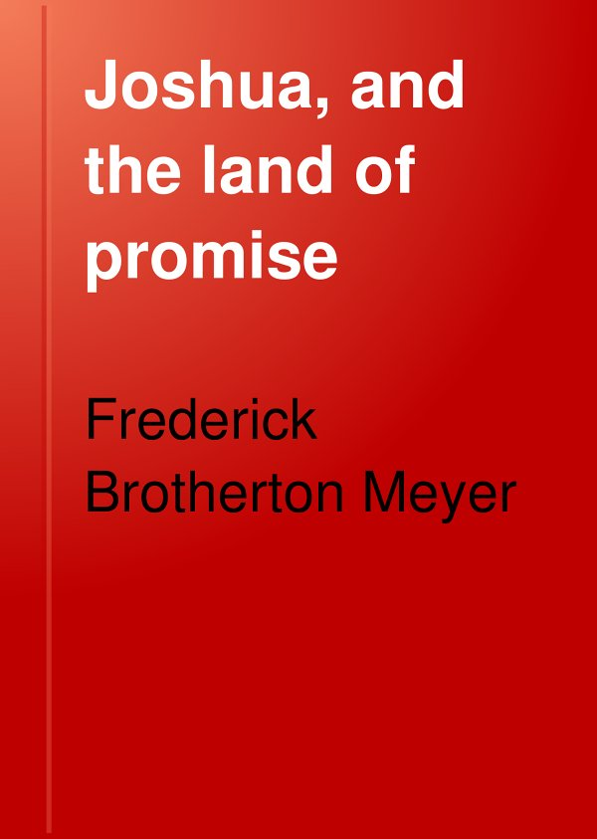 This is a digital copy of a book that was preserved for generations on library shelves before it was carefully scanned by Google as part of a project to make the world's books discoverable online. See the back of the book for detailed information.
   WORKS BY REV. F. B. MEYER

** Few books of recent years are better adapted to instruct and help Christians than those of this author."—D. L. Moody*

OLD TESTAMENT HEROES.

:raraii, cloth. Each $1.00

Joshua, and the Land of Promise.
Moses: The Servant of God.
Abraham; or, The Obedience of Faith.
Elijah, and the Secret of His Power.'
Israel: A Prince with God.
Joseph: Beloved, Hated, Exalted.

THE EXPOSITORY SERIES.

The Way into the Holiest: Expositions of
the Epistle to the Hebrews. I2mo, cloth, i.oo

The Life and Light of Men: Expositions of
John i: xii. I2tno, cloth i.oo

Tried by Fire: Expositions of the First Epis-
tle of Peter. I2mo, cloth i.oo

The Psalms: Notes and Readings. i8mo, cloth 60

THE CHRISTIAN LIFE SERIES.

i8mo, cloth. Each 50

White vellum cloth, silver tops. Each 60

The Future Tenses of the Blessed Life.

Christian Living.

The Present Tenses of the Blessed Life.

The Shepherd Psalm.

Envelope Series of Booklets.

No. I. 12 Tracts assorted net. .20

No. 2. 12 Tracts assorted net. .20

Choice Extracts from "The First Steps" and other Writings of Rev. F. B. Meyer, selected

by Rev. B. Fay Mills. 24mo, paper 05

Per dozen net. .35

:6mo, large paper edition 15

Fleming H. Revell Company

New York Chicago Toronto

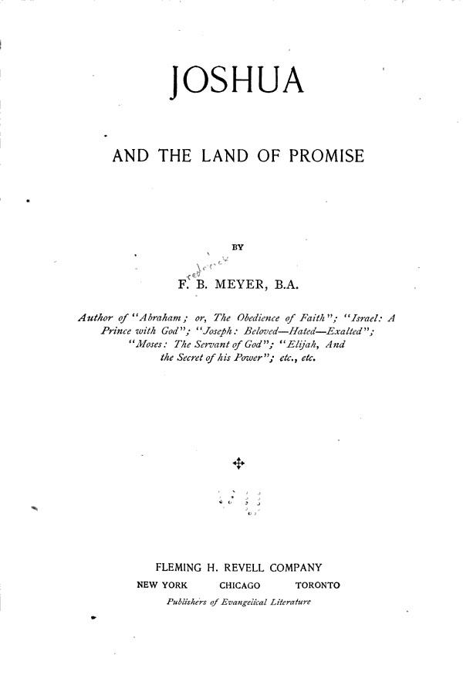  PREFACE.

THE best way to vindicate the Bible is to preach it. Each book contains within itself, sometimes in cypher, the autograph cf the Holy Spirit. Every page has the water-mark of Heaven. And a patient consideration of the contents of Scripture, as of the book before us, will leave a stronger impression of God's authority and authorship than any number of external evidences.

In addition to this, and altogether apart from the spiritual lessons that may be derived from a devout study of Old Testament Scriptures, there accrues to the thoughtful mind an ever-deepening conviction that, instrumentally, they date from the pens of contemporary historians. It is impossible to believe that a writer, after the return from exile, could have told the story with the vividness, the realism, the minute life-like touches, in which it is presented to us in the historical books of the Old Testament. In the perspective of time, many things that bulk largely to their contemporaries are dismissed as unworthy of notice, whilst general principles are discussed to the ignoring of details. But the reverse of these meets us in every paragraph of that wonderful series of books, of which the story of Joshua is one.

This study, in which the scenes of the conquest of Canaan are narrated again with such help as modern investigation affords, may thus confirm the wavering faith of some. But my main object has been to bring out the wonderful parallels between the story of this book and the experiences of the Church and the individual Christian—parallels so minute and precise as to establish with added force our faith in the Bible as one book, the production of one mind, which "at sundry times and in divers manners" has spoken to men.

In writing this book, I have, amongst other works, read Dean Stanley's "jewish Church"; "Joshua, His Life And Times," by Rev. W. J. Deane; "the Book Of Joshua," by H. F. Witherby; "The Fullness Of BlessIng," by S. F. Smiley; and other smaller books: to all of which I gladly confess my obligations.

F. B. MEYER.

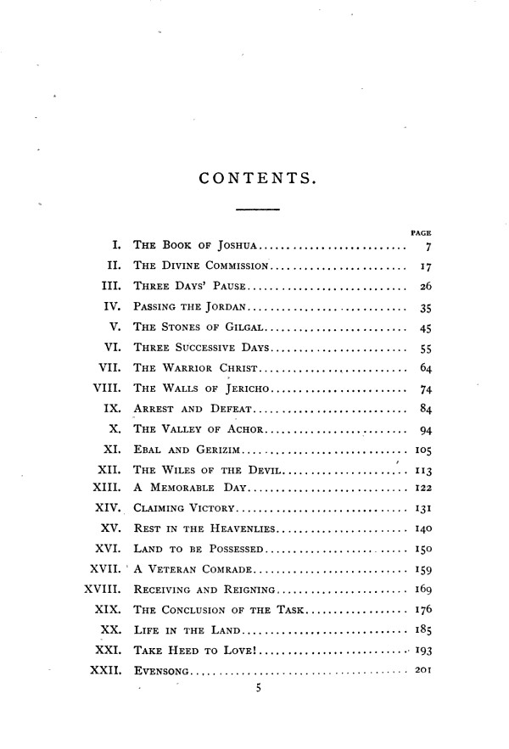
JOSHUA:

AND THE LAND OF PROMISE.

i.

®he Book of losljtta.

"What if Earth

Be but the shadow of Heaven,—and things therein
Each to other like, more than on earth is thought!"

Milton.

THE order of the books of the Old Testament is due to something more than human selection, or even the period of their composition. The same Spirit that originally inspired them has manifestly controlled their position in the sacred Book. Genesis begins with God, and leads us back to the origin of that divine grace which strives against human sin; loves man before ever there is aught in man to warrant it; and binds itself by a covenant, "ordered in all things and sure." Exodus tells the story of redemption; Leviticus, of worship; Numbers, of our position in the ordered ranks of God's army; Deuteronomy, of that more spiritual conception of the law of God which is produced by love and faith; and the Book of Joshua is an indispensable link in this chain of symbolical teaching. Finally, the history of the soul may be traced through the disorder of Judges to the royalty of the Kings,' and onward to the hallelujahs of the Psalms, and the prophetic visions of the following books.

There is, then, a special inner meaning in the Book of Joshua, which cannot be exhausted when we have learned from it the story of the extermination of the Canaanites; of the partition and settlement of Canaan; and of the noble simplicity and military exploits of Joshua. It is impossible to suppose that so much space should have been given to the record of these, unless there had been some deep and holy purpose—similar to that which has given such minute directions for Levitical sacrifice, each of which contained some deep spiritual truth required for the growth of holy souls throughout the ages. Of the Book of Joshua, as of the Paschal Lamb and the Passage of the Red Sea, it may be said, "All these things happened unto them for ensamples."

The clue to this inner meaning is given by the writer of the Epistle to the Hebrews, the third and fourth chapters of which are all-important in determining the drift of our interpretation; and it is to the clearer appreciation of the true meaning of these chapters that we must attribute the increasing interest with which the church of God turns to this record of the simple-minded, transparent, humble, and strong soldier, the Miles Standish of the Exodus. If the river Jordan stands for physical death, and Canaan for heaven, there seems to be no satisfactory interpretation for many items which are narrated with significant minuteness, ere we come to the conquest and partition of the land; and on this line of interpretation there would be some anomaly in associating fighting with the calm restfulness of the New Jerusalem.

A careful study of the chapters referred to shows us that "HEAVENLY PLACES IN CHRIST JESUS." 'g

though Canaan was not the rest of God—because he spoke of rest through an unknown temple singer, four hundred years after Canaan was occupied—yet it was a vivid type of that blessed Sabbath-keeping into which we may enter here and now. We are to fear lest we "should seem to come short" of the rest, even as they whose carcasses fell in the wilderness came short of the Land of Promise. "We which have believed do enter into that rest." Our Lord Jesus has entered into his rest, as God did into his; and has therefore received the ideal Land of Canaan, as the representative of his followers to whom he allots it as they believe. We are summoned to give diligence to enter into that rest, that "no man fall after the same example of disobedience."

All these references go to establish the spiritual significance of this wonderful story, which tells of that satisfaction of rest, wealth, and victory which may be enjoyed by those who have come to know the secret things which God hath prepared for them which love him, and which are revealed by his Spirit. Oh that that Spirit may use these 'chapters for the purpose of leading many of God's redeemed ones from the wilderness life into that rest! For that we have been redeemed; for that we have passed through the Red Sea; to convince us of our need of that we have been permitted to hunger and thirst in the desert waste; and our possession of that will alone convince the world that the Lord Jesus is the Christ of God. We were indeed brought out that we might be brought in; redeemed that we might be a purchased possession; justified that we might be sanctified and glorified.

There is another book in the New Testament in deep spiritual accord with the story told in the Book of Joshua, viz., the Epistle to the Ephesians; which rises above all its kin as the soaring cathedral tower rises above the maze of architecture beneath—on which it rests indeed, but which it crowns, and carries within its heart bells that ring out the wedding peal. Already in that epistle ₍we can detect notes which are to announce the consummation of creation in the marriage of the Lamb. The Book of Joshua is to the Old Testament what the Epistle to the Ephesians is to the New.

The characteristic word of the Ephesians is the heavenlies (i. 3, 20; ii. 6; iii. io; vi, 12). Of course it does not stand for heaven; but for that spiritual experience of oneness with the risen Saviour in his resurrection and exaltation which is the privilege of all the saints, to which, indeed, they have been called, and which is theirs in him. It may help us to a better comprehension of this analogy between the "heavenly places" and the land of Canaan, if we trace it in the following five particulars:

I. Each Was The Destined Goal To Which God's Purpose Led His People.—When in answer to the agony of his people's cry, and in remembrance of his covenant, the Lord appeared to Moses at the burning bush, in the first sentence he spoke he pledged himself, not only to deliver his people out of the land of the Egyptians, but to bring them up out of that land unto a good land and a large, unto a land flowing with milk and honey. Their emancipation from the thrall of Pharaoh was only preparatory to their settlement in the Land of Promise.

Some vision of this seems to have shone like a star before the march of the ransomed hosts; and on the shores of the Red Sea their triumphant strains passed from the destruction of their foes to the mountain of God's inheritance, whither he would bring them in and plant them.

"The place, O Lord, which thou hast mjdj''ftr thce to dwell in. The sanctuary, O Lord, which thy hands have established."

HOLINESS, VICTORY, AND POWER. n

The plagues of Egypt that struck the fetters from the wrists of an enslaved nation, the institution of the Passover and shedding of blood, the passage of the Red Sea and destruction of the hosts of Egypt—all must have been abortive had they not led on to, and been consummated in, the settlement of Israel in Canaan. Nor otherwise could the divine promise to Abraham have been fulfilled— "Lift up now thine eyes, and look from the place where thou art northward, and southward, and eastward, and westward: for all the land which thou seest, to thee will I give it, and to thy seed forever."

Similarly, though so many of the Lord's redeemed ones seem ignorant of it, all the wonderful facts that lie behind the history of the Church were intended to clear the ground, to level the hills, and fill up the vales, so as to prepare for the glad entrance of all who believe into the blessed life— into an experience like that which was enjoyed by the Master himself during his earthly ministry, joy that must forever be a song without words, peace that passeth understanding, love that passeth knowledge.

It is remarkable how constantly the Epistles point to this experience. The foundations of justification are massively and deeply laid, that they may carry the edifice of sanctification and blessedness. The apostles do not write their glowing paragraphs for the conversion of the world, or the awakening of the dead; but for the perfecting of the saints, and the unfolding of the true conditions of holiness, and victory, and power.

Let me here solemnly ask, Have you realized those conditions, and entered on those privileges? Are you still in the wilderness, or have you entered the Land of Promise? Do you occupy cities you never built; eat of vineyards and olive-yards you never planted; drink of cisterns filled from the everlasting hiBs which you have never hewed; and inhabit houses full of all good things which you never stored? Do you dwell in a land of corn and wine, while the heavens drop dew? Do you, as the beloved of the Lord, dwell between his shoulders? Do you tread down your enemies beneath shoes of iron or brass? Do you make your dwelling-place in the eternal God, whilst underneath are his everlasting arms? Test yourself by the promises made to Israel, which are types and shadows of eternal realities; and if they do not foreshadow facts in your spiritual experience, understand that you frustrate the purpose of God in your redemption. Leave those things which are behind to reach forth to the goodly land beyond the Jordan, apprehending that for which you were apprehended of Christ Jesus.

II. Each Was Impossible By The Means or Law.— "Now after the death of Moses the servant of the Lord, it came to pass, that the Lord spake unto Joshua the son of Nun, Moses' minister, saying, Moses my servant is dead; now therefore arise, go over this Jordan." "The law came by Moses," and in a very real sense found in him its representative. So it was befitting that, when he died, his eye should not be dim, nor his natural force abated. The law of God can never become decrepit, or show signs of weakness and decay. At the end of uncounted ages it is as strong, and fresh, and vigorous as that divine nature of which it is the expression.

But the law of God can never bring the soul of man into the Land of Promise; not because of any defect in it, but because of human infirmity and sin. In that marvelous piece of self-analysis given us in the Epistle to the Romans the Apostle repeatedly affirms that the law is holy, and righteous, and good; he insists that he delighted in it JOSHUA AND JESUS. 13

after the inward man, but he tells us that he finds another law in his members, warring against the law of his mind, and bringing him into captivity. It is the presence of this evil law in our members which makes obedience to the law of God impossible, filling us with disappointment and unrest, ceaseless striving and perpetual failure. We must, therefore, leave the law as an outward rule of life behind us, in that lonely valley over against Bethpeor, that the divine Joshua may lead us into the Land of Promise.

Not by vows, or resolutions, or covenants of consecration signed by blood fresh drawn from the veins; not by external rites or by ascetic abstinence from good and healthy things; not by days of fasting and nights of prayer; not even by obedience to the voice of conscience or the inner light—though attention to these is of prime importance—by none of these shall we enter the land of blessedness. They all become forms of legalism, when practiced with a view of obtaining the full rest and victory of Christian experience. Valuable many of them unquestionably are, when the river is crossed, and the land is entered; but they will not of themselves unlock its gates, or roll back its guardian river. Just as the forgiveness of sins and eternal life are the free gift of God's grace, to be received by faith —though their full enjoyment is determined by obedience and self-denial—so the fullness of the blessing of the Gospel of Christ is bestowed on those only who, in the absence of all merit and effort, receive it with open and empty hands. We do not work up to our rest-day, as the Jews did, but down from it.

III. EACH WAS INTRUSTED TO A REPRESENTATIVE. It

is a remarkable characteristic of the story of Joshua that God repeatedly addresses him for the people, and bestows on him what was destined for them. "Go over this Jordan, thou, and all this people. . . . There shall not any man be able to stand before thee." "See, I have given into thine hand Jericho, and the king thereof." And it was for him to apportion it. "Thou shalt cause this people to inherit the land which I sware unto their fathers to give them." All was put into the hands of Joshua, as the trustee of Israel, for him to administer as each of the tribes came near to appropriate it from his hands.

And in perfect keeping with this, we find it stated, at the close of the seven years' war, that "Joshua took the whole land, according to all that the Lord said unto Moses; and Joshua gave it for an inheritance unto Israel according to their divisions by their tribes" (Josh. xi. 23).

How perfectly is this type fulfilled in our blessed Lord! To him as the trustee and representative of his people has all spiritual blessing been given, and he holds it for us to claim. All power is given to him in heaven and on earth, that he might give us authority over all the power of the enemy. The Father has given him to have life in himself, that he might give us life more abundantly. He is full of grace and truth, that out of his fullness we all may receive. He received of the Father the promise of the Holy Ghost, that he might pour him forth in Pentecostal fullness. He hath received of the Father honor and glory, that we might be with him where he is.

Let us diligently comprehend all the fullness of our inheritance in Jesus; and then let us go forward to apprehend it by faith. Whatever he has is in trust for us. Let us claim it! Let us receive the abundance of his grace, that we may reign in this life through the one Man! Let us believe that we receive, and reckon on it, living in the power of what we may not feel, but know we have, so acting faith.

CONQUERED ADVERSARIES. 15

IV. Each Was Missed By Many.—Their carcasses fell in the wilderness, so that the generation who cried, " Would God that we had died in the wilderness!" did in fact die there. The Ninetieth Psalm tells the tale of those sad and dreary years, when an unceasing train of funerals passed out from the camp of Israel, and the mounds of the desert traced the course of the guilty and unbelieving race.

Such scenes are witnessed still. And the state of his Church must be a bitter sorrow to the heart of her Lord. Notwithstanding his agony and bloody sweat, his cross and passion; in spite of the earnest remonstrance of his Word and Spirit; though the fair land of Canaan lies within view —yet so few comparatively appear to have realized what he intended. All around, souls, redeemed by his blood, who have been numbered among his people, are perishing outside the land of blessedness in graves of worldliness, of self-indulgence, and masterful sin. We descry here and there a Joshua, a Caleb, or a tribe of Levites. But the majority seem to have come short. See to it, reader, that you are not one of them! "Let us also fear."

V. Each Was Infested By Many Adversaries.—The seven nations of Canaan held the land with strongholds and chariots of iron; though the Lord caused them to be to his people as bread which needs only to be eaten. They came against the invading hosts in all the pride of their vast battalions and the array of their warlike preparations; but at his rebuke they fled, at the voice of his thunder they hasted away.

The "heavenly places" also are not removed from the noise of conflict, or free from the presence of the foe. Those who are raised to sit there in Christ have to encounter the spiritual hosts of wickedness, principalities and powers of evil. They are conquered foes; but, nevertheless, are terrible to behold, and certain to overcome, unless we are abiding in our great Joshua, who has already vanquished them, and have taken to ourselves the whole armor of God.

Thus the land of Canaan and the heavenly places are one: and we may read into these ancient records the deepest thoughts of the New Testament, for God repeats himself in many ways.

.

y

(Eljc Oimnc (fommiscicm.

(joshua i. 7.)

"Only when thine arm
In sense of weakness reaches forth to God,
Wilt thou be strong to suffer and to do."

Plumptre.

AS Joshua stood on the threshold of his great work, he JT was repeatedly bidden to be strong and of a good courage. Some little time before the death of his predecessor, a great convocation of all Israel had been summoned, at which Moses had solemnly transferred his office to his successor, and had given him a charge, saying, "Be strong and of a good courage; for thou must go with this people unto ttre land." And now the voice of God reiterates the charge and repeats the injunction.

At first this startles us. What! must all they whom God uses be strong? Is it essential that there should be strength of limb and muscle in the physical and moral constitution of those who are called to do the divine biddings in the world? Because, if that be so, we who are like Ehud, left-handed; like Gideon, least in our father's house; or like Saul of Tarsus, painfully conscious of weakness, can never get beyond the rank and file in the army of the Lord.

And yet, may not this reiterated appeal indicate that the heart of Joshua misgave him, and that he was conscious of his utter inadequacy to fulfill the great commission that was thrust upon him? Probably he had never dreamt of so high an honor, so vast a responsibility. He had been content to be Moses' minister, satisfied to wait below while his master passed into the cloud to hold fellowship with God; staying in the tent to serve Moses if he were required, or in his absence to guard its contents; jealous for his master's honor, when Eldad and Medad prophesied; glad that all the glories of the conquest of Eastern Palestine decked with laurels the closing days of the great leader.

When Moses first received the sentence of death on the further side of Jordan, none could have been more deeply grieved than his faithful friend and attendant. But the thought of succeeding him never presented itself to his mind. Indeed, Moses himself does not appear to have thought of him in this direction; for we learn that he besought the Lord to appoint a man over the congregation, that they should not be as sheep without a shepherd (Num. xxvii. 17). In that prayer Joshua may have joined, thinking all <he while that Caleb, the lion-hearted, or Phinehas the priest, or one of the sons of Moses, might take his place; but not supposing that he would himself be called to it. His one aim had been to enhance the glory and lighten the cares of Moses; and he was too absorbed in his master's personality to be greatly conscious of his own.

When therefore the call came to him to assume the office which Moses was vacating, his heart failed him, and he needed every kind of encouragement and stimulus, both from God and man. "Be strong" means that he felt weak; "Be of good courage " means that he was affrighted; "Be not thou dismayed" means that he seriously considered whether he would not have to give up the task. He was a worm, and no man: how should he deliver Israel?

It is when men are in this condition that God approaches "BE STRONG!" 19

them with the summons to undertake vast and overwhelming responsibilities. Most of us are too strong for him to use; we are too full of our own schemes, and plans, and ways of doing things. He must empty us, and humble us, and bring us down to the dust of death, so low that we need every straw of encouragement, every leaf of help; and then he will raise us up, and make us as the rod of his strength. The world talks of the survival of the fittest; but God gives power to the faint, and increases might to them that have no strength; he perfects his strength in weakness, and uses things that are not to bring to naught things that are. If Ehud had been right-handed, he might never have judged Israel; if Gideon had been the greatest instead of the least in his father's house, he would never have vanquished Midian; if Paul had been as eloquent in his speech as he confesses himself to have been contemptible, he would never have preached the Gospel from Jerusalem round to Illyricum.

Let us consider the sources of Joshua's strength.

I. A Faithful Past.—"After the death of Moses the servant of the Lord, the Lord spake unto Joshua the son of Nun, Moses' minister." In his case, as always, the eternal rule held good, that faithfulness in a few things is the condition of rule over many things; and the loyalty of a servant is the stepping-stone to the royalty of the throne. Of the Highest it is said that he was obedient to death, even the death of the cross; and that, therefore, God highly exalted him, and gave him the Name above every name. We must learn obedience by the things that we suffer, ere we can be lifted from the dunghill to sit with princes.

The previous years of Joshua's past had been full of high and noble endeavor. For forty years, if Josephus be correct in his statement as to his age at the death of Moses, he shared the slavery and sorrows of a captive race. His childish eyes must have become accustomed to witnessing the brutality of the Egyptian taskmasters, even if his own shoulders were not torn by their cruel whips. As a scion of one of the leading families of Ephraim (Num. xiii.,8, 16), he may have taken some leading part in the marshaling of the Exodus, and there approved himself as worthy of all trust. His conflict with Amalek; his good report of the Land of Promise; his refusal to take any part in the disastrous attack on the Canaanites; his eagerness for the good name and fame of Moses; his patient endurance of the weary years of wandering—all prove that his was no common character. The aloe blooms but once in a hundred years; but every hour of all that century is needed to produce the delicate texture and resplendent beauty of the flower. The deed of a Grace Darling is not the sudden outburst of the moment that gives it birth, but the result of long years of self-discipline, courage, and ministry to others. And this summons of Joshua to the leader's place in Israel was the guerdon of more than eighty years of faithful service.

None of us can tell for what God is educating us. We fret and murmur at the narrow round and daily task of ordinary life, not realizing that it is only thus that we can be prepared for the high and holy office which awaits us. We must descend before we can ascend. We must suffer, if we would reign. We must take the via crucis (the way of the cross) submissively and patiently, if we would tread the via lucis (the way of light). We must endure the polishing, if we would be shafts in the quiver of Emmanuel. God's will comes to thee and me in daily circumstances, in little things equally as in great: meet them bravely; be at your best always, though the occasion be one of the JOSHUA'S TASK. 21

very least; dignify the smallest summons by the greatness of your response; so the call will come to thee as to Joshua the son of Nun, Moses' minister.

II. A Distinct Call.—"Arise, go over this Jordan, thou, and all this people, unto the land which I do give to them. ... Be strong and of a good courage, for thou shalt cause this people to inherit the land which I sware unto their fathers to give them." When a man knows that he has been called to do a certain work, he is invincible. He is not unconscious of his own deficiencies, whether they be natural or intellectual. He is not insensible of difficulty; none so Quick as he to see the great stones, the iron gates, the walled cities, the broad and flowing rivers; he is not invulnerable to the shafts of ridicule and adverse criticism: but for all these he looks steadily away to the declared purpose of God, and yields himself to be the channel through which it may operate.

Joshua's task was a very difficult one. The people of Canaan were well versed in the arts and sciences of the time, acquired from commerce with the Phoenicians on the north and the Egyptians on the south. One of the most interesting discoveries of recent years has shown that the Hittites were a great people, highly cultured, and of sufficient importance to rival Assyria and Egypt. It seemed preposterous to suppose that a nation of a few years' existence was so soon to dispossess nations that had gained the country by conquest and were prepared to fight for every inch of territory by the most approved methods of warfare. The Jewish legend says that when Joshua, appalled at the greatness of the task, rent his clothes and fell on his face, weeping to think of his incompetence, Moses lifted him up and comforted him with the assurance that God had foreseen and provided for all. Whether it were so or not, it is at least clear that the reiterated assurance of God to settle Israel by means of Joshua must have been a great source of strength to him.

The supreme inquiry for each of us, when summoned to a new work, is—not whether we possess sufficient strength or qualification for it, but—if we have been called to it of God; and when that is so there is no further cause for anxiety. If it is in his plan that we should march through a river, or attack a walled town, or turn to flight an army, we have simply to go forward. He will make the mountains a way. Rivers will dry up; walls will fall down; armies shall be scattered as snow in Salmon. There is no such thing as impossibility when God says, " Forward, soul: arise, go over this Jordan!"

III. The Sense Of The Presence Of God.—"As I was with Moses, so I will be with thee. I will not fail thee, nor forsake thee." There was one particular in which Joshua would always come far behind his great predecessor. Both were in necessary and constant communication with God; but Joshua had to seek counsel through the high-priest, whereas Moses-had enjoyed direct intercourse with God, "speaking unto him face to face, as a man speaketh unto his friend." Still, Joshua the son of Nun was equally sure of the personal companionship of his great Ally, though he lacked the direct vision.

There have been generals whose presence on the field of battle has been the presage and guarantee of victory. Not only have they inspired the soldiers with a sense of confidence in their leadership, but they have encouraged them by their personal prowess and bravery. There is a marvelous sense of security and courage when a Christiana, a Mr. Fearing, or a Miss Much-Afraid is assured of the presence of a Great-heart, who has never turned his back "/ WILL BE WITH THEE." 23

on a foe. And a lonely, trembling soul dares to step bravely across the margin of life into the unknown beyond: to go down unabashed into the chill waters of death, because it can sing, "Thou art with me; thy rod and thy staff they comfort me."

All through the arduous campaign that followed nothing could daunt Joshua's courage whilst that assurance was ever ringing its silver tones in the belfry of his memory, " I will be with thee." Ah, it is well when we can so encour age ourselves in God! The fire is heated seven times; but he is with me, and no smell of fire shall pass upon my flesh. The river is deep; but he is with me, and its waters shall not sweep me off my feet. Mine enemies are many, and they hate me with cruel hatred; but he is with me, and no weapon that is formed against me shall prosper, and every tongue that shall rise in judgment against me he will condemn. Who can wax faint-hearted whilst he holds the right hand, saying, "Fear not, I am with thee!" The Lord Jesus ever lives to save unto the uttermost, and is with us all the days, even unto the end of the age.

IV. The Indwelling Of The Word Of God.—" This book of the law shall not depart out of thy mouth; but thou shalt meditate therein day and night." Words pass on to men the heroic thoughts which thrilled the souls of those who spake them first. There are words, as there are strains of music, which cannot be uttered without nerving men to dare and do, to attempt and achieve. A woman will be strong to wait and suffer for long years in the strength of a sentence spoken by her lover as he parted from her. An army has before now forgotten sleepless nights and hungry marches in the stirring harangue of its general. And is not this what the prophet meant, when he said, "Thy words were found, and I did eat them; and thy word was unto me the joy and rejoicing of mine heart": and what Jesus meant when he said, "The words that I speak unto you, they are spirit, and they are life"?

We must meditate on the words of God, because it is through the Word of God that the Spirit of God comes in fullness to be the mighty occupant of our inner man. This, after all, is the secret of strength—to be possessed of the strong Son of God, strengthened by his indwelling might, and filled by his Spirit.

We can do all things when Christ is in us in un thwarted power. The only limit lies in our faith and capacity; or, in other words, in our absolute submission to his indwelling. Little children can overcome when there is within them a Stronger than their foes. Weaklings may do exploits when the Mighty Conqueror who travels in the greatness of his strength makes them the vehicle of his progress. Nobodies, nonentities, broken reeds, bleached jaw-bones, quills plucked from the wild-fowl, and arrows that a babe could snap, accomplish marvels, because they are the channels through which the mysterious current of divine power and Godhead flows forth to the world.

Our risen Lord is charged with power. It is stored in him as in a cistern for us. As the force of the brain is communicated to the members by the energy of the vital current flashing along the nerves, so does the power of Jesus come to us, his members, by the Holy Ghost. And if we would have that blessed Spirit, we must seek him, not only in the fervid meeting or in the great convocation, but through the Word, wherein his force is stored. Meditate on it day and night, till it yield to thee strength and good Courage, drawn from the nature of the glorified Redeemer. Thy God hath commanded thy strength: claim it from Jesus, through faith, by his Spirit, and in his Word.

Be strong in your weakness through the strengthening THE -WORD OF GOD. ²5

might of Christ. Take weakness, weariness, faint-heartedness, and difficulty, into his presence; they will melt as hoar-frost in sunbeams. Give yourself wholly up to him, to do or die, as he shall choose. Then anoint your head, and wash your face. You shall have your inheritance in Timnath-heres (the portion of the sun); you shall make your way prosperous, and have good success; and you shall lead a nation to inherit the Land of Promise.

III.

<£l)rcc Duns' Jimsc.

