In the Bible, the modern country Iran is mainly referred to as “Persia.”
Persia (Modern-day Iran)
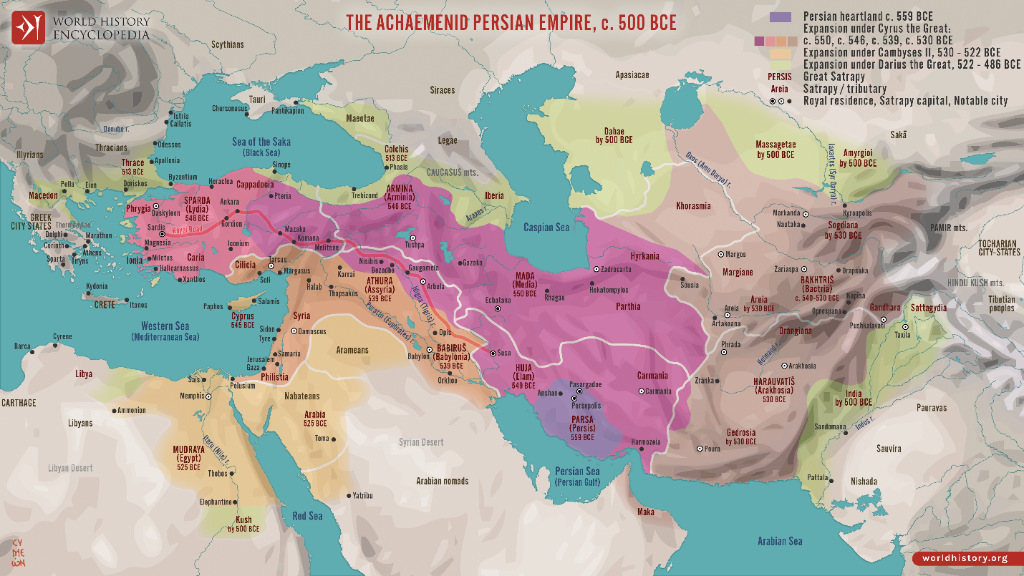
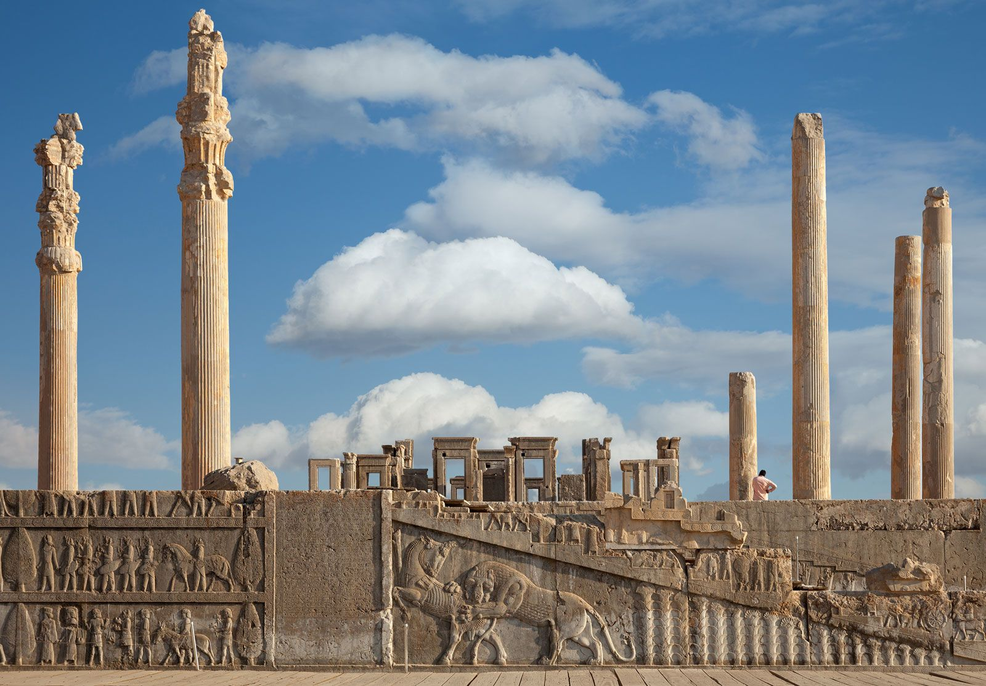
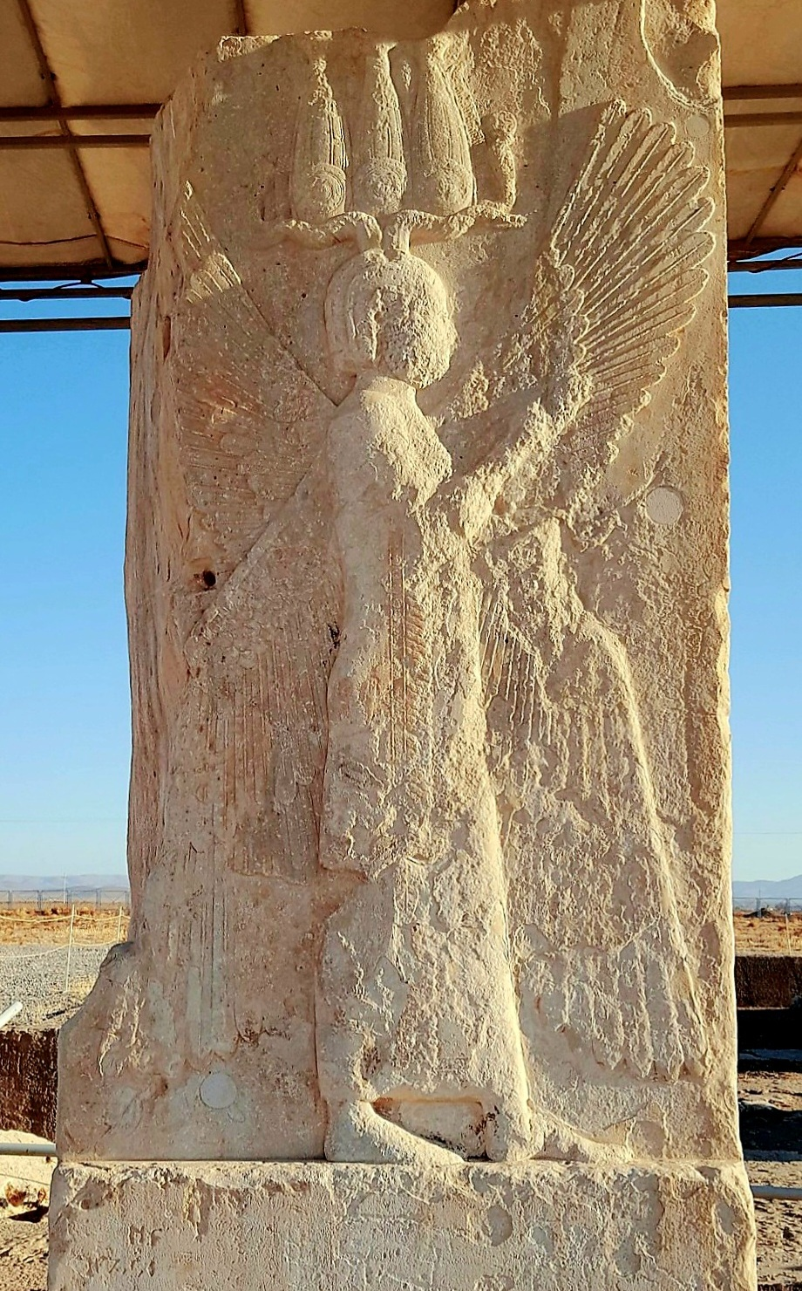
4
- The land we now call Iran was historically known as Persia.
- The name Iran only became the official international name in 1935; before that, the country was widely called Persia.
- In the Old Testament, Persia appears many times, especially in the books of Daniel, Ezra, Nehemiah, and Esther.
Important Persian figures in the Bible
- King Cyrus of Persia – allowed the Jews to return to Jerusalem and rebuild the temple (Ezra 1:1-3).
- King Darius – supported the rebuilding of the temple.
- King Ahasuerus (Xerxes) – the king in the story of Esther.
Other biblical names connected to Iran
Some regions in today’s Iran are also mentioned:
- Elam – an ancient kingdom in southwestern Iran (Genesis, Isaiah, Jeremiah).
- Media – part of the Persian-Median empire (Daniel).
- Persia and Media – often mentioned together as a powerful empire.
Example prophecy reference
In Ezekiel 38:5, Persia is listed among nations in a future prophecy.

✅ Summary:
- Iran = Persia in the Bible.
- Key biblical regions tied to Iran include Persia, Elam, and Media.
- Persian kings played major roles in Jewish history, especially in allowing the Jews to return from Babylonian exile.
A deep dive on Iran in the Bible requires understanding that the Bible never uses the modern name Iran. Instead it refers to the region mainly as Persia, and sometimes by older regional names like Elam and Media. These regions correspond largely to territory in modern Iran.
Below is a structured deep exploration: geography, history, key biblical passages, theology, and prophecy.

1. Ancient Iran in the Bible: Persia, Elam, and Media
The Bible refers to parts of modern Iran with three major names:
Biblical Name | Location Today | Role
Persia | Most of Iran | Major empire after Babylon
Elam | Southwestern Iran | Ancient kingdom east of Babylon
Media | Northwestern Iran | Allied with Persia to conquer Babylon
Elam was one of the earliest civilizations in the region and appears in the Table of Nations as a descendant of Shem (Genesis 10:22).
Media later united with Persia to form the Medo-Persian Empire, the power that replaced Babylon in the 6th century BC.

2. Iran’s Earliest Biblical Appearance (Patriarchal Era)
Genesis 14 – The King of Elam
One of the earliest references connected to Iran is Chedorlaomer, king of Elam.
- He led a coalition of kings that fought in Canaan during Abraham’s lifetime.
- Abraham defeated this coalition to rescue Lot.
This story places Elam (Iran region) as an established power even in the patriarchal period.
This indicates the Iranian plateau was already influential in Near Eastern politics.

3. The Medo-Persian Empire in Biblical History
The Medo-Persian Empire plays a huge role in the Bible.
Key Moment: Fall of Babylon (539 BC)
Persia conquered Babylon and allowed Jewish exiles to return to Israel.
Important Persian rulers mentioned
- Cyrus the Great
- Darius I
- Xerxes I
- Artaxerxes I
Cyrus the Great
Cyrus issued a decree allowing Jews to return and rebuild the Temple in Jerusalem.
This is recorded in:
- Ezra 1:1–4
- 2 Chronicles 36:22–23
Remarkably, the prophet Isaiah mentioned Cyrus by name about 150 years before he was born (Isaiah 44–45).
Isaiah 45:1 even calls Cyrus “the LORD’s anointed.”
That is extraordinary because he was a Gentile king.

4. Persia in Major Biblical Books
Book of Daniel
Much of Daniel takes place under Persian rule.
Key themes:
- Fall of Babylon to Medo-Persia (Daniel 5)
- Persian administration (Daniel 6)
- Visions predicting Medo-Persia (Daniel 8)
Daniel 8 symbolically describes the Medo-Persian empire as a ram with two horns (Media and Persia).

Book of Esther
The entire story takes place in the Persian capital Susa.
Key details:
- Jewish people lived across the Persian empire.
- The Persian king married the Jewish woman Esther.
- She prevented a genocide of Jews.
The Persian empire stretched from India to Ethiopia (Esther 1:1).

Ezra and Nehemiah
Persian kings financed the rebuilding of:
- Jerusalem
- The Temple
- The city walls
Without Persian support, the Jewish restoration after exile likely wouldn’t have happened.

5. People from Iran at Pentecost
Iranian regions are mentioned again in the New Testament.
Acts 2:9 lists people present when the Holy Spirit came:
- Parthians
- Medes
- Elamites
These groups were from the Iranian region.
So people from Iran likely heard the first Christian sermon at Pentecost.

6. Prophecies Related to Iran
Elam Prophecy
Jeremiah predicted judgment on Elam:
“I will break the bow of Elam… yet in the latter days I will restore Elam.”
— Jeremiah 49:35-39
This suggests both destruction and future restoration.
Some scholars interpret this historically (Persian conquest), others see future fulfillment.

Persia in Ezekiel’s End-Times Prophecy
In Ezekiel 38, Persia is listed among nations allied with Gog.
“Persia, Cush, and Put will be with them…” (Ezekiel 38:5)
Many modern interpreters connect this Persia with modern Iran, though interpretations differ.

7. Theological Significance of Persia
Persia is unique in the Bible because it is portrayed positively compared with most empires.
Examples:
- God used Persia to free Israel.
- Persian kings protected Jewish worship.
- Cyrus is called God’s shepherd (Isaiah 44:28).
Unlike Babylon or Assyria, Persia often appears as a tool of God’s restoration.

8. Timeline of Iran in Biblical History
Era | Biblical Event
~2000 BC | Elam appears in Genesis
~1800 BC | King of Elam fights Abraham
722 BC | Israelites exiled to cities of the Medes
539 BC | Persia conquers Babylon
538 BC | Cyrus allows Jews to return
480 BC | Story of Esther in Persia
33 AD | Parthians, Medes, Elamites at Pentecost

9. Key Takeaway
Modern Iran is deeply connected to the Bible.
It appears through three main identities:
- Elam – ancient Iranian civilization
- Media – northern Iranian kingdom
- Persia – the empire that freed the Jews
And historically, Persia was one of the most important nations in biblical history, playing a central role in Israel’s restoration after exile.

✅ In short:
Iran is one of the most frequently referenced regions outside Israel in the Bible, influencing events from Abraham to the early church.

A deep dive into Iran in Ezekiel 38–39 requires looking at the text, historical geography, Hebrew wording, prophetic context, and different interpretations. Iran appears in the prophecy under its ancient name Persia, which corresponds to modern Iran.
Below is a structured study you can use like a Bible study or research outline.

Iran (Persia) in Ezekiel 38–39 — Deep Dive
1. The Key Verse
The nation identified as Iran appears directly in the prophecy.
Ezekiel 38:5
“Persia, Cush, and Put are with them, all of them with shield and helmet.”
In Ezekiel’s time, Persia was a well-known kingdom east of Israel, corresponding geographically to modern Iran.
Unlike many prophetic nations that must be inferred, Persia is explicitly named, making it one of the easiest nations in the passage to identify.

2. Persia = Modern Iran
Historical background
- Persia was the dominant empire from 539–331 BC.
- The name Iran replaced Persia officially in 1935.
Therefore:
Biblical Name | Modern Nation
Persia | Iran
This makes Iran one of the few nations in Bible prophecy whose identity has remained geographically consistent for thousands of years.

3. Persia’s Role in the Gog Coalition
Ezekiel 38 describes a coalition of nations attacking Israel.
The coalition includes:
Nation in Ezekiel | Modern Location
Magog | Often linked with Russia/Scythian regions
Meshech | Turkey region
Tubal | Turkey region
Gomer | Turkey / Eastern Europe
Togarmah | Turkey / Armenia
Persia | Iran
Cush | Sudan / Ethiopia
Put | Libya
These nations form a large military alliance led by Gog.
Important point:
Persia is not the leader — but a major ally in the invasion.

4. Persia’s Military Role
The wording suggests Persia contributes armed forces to the coalition.
Ezekiel describes them as:
- Equipped with shield and helmet
- Participating in a massive multinational army
This implies:
- Military alliance
- Joint war campaign
- Organized coalition warfare

5. The Timing of the Prophecy
Ezekiel places the invasion in “the latter years”.
Ezekiel 38:8
“In the latter years you will go against the land restored from war…”
Key conditions:
- Israel restored as a nation
- Israel living securely
- Large northern coalition attacks
Many interpreters see this as future end-times prophecy.

6. Strategic Direction of the Invasion
The invasion comes from the north.
Ezekiel 38:15
“You will come from your place out of the far north…”
This is why Magog (often linked to northern regions) is the leader.
Persia/Iran comes from the east, joining the northern power.

7. Persia’s Relationship with Israel in Scripture
Interestingly, Persia historically helped Israel.
Key Persian rulers:
- Cyrus the Great — allowed Jews to return to Jerusalem (Ezra 1)
- Darius I — supported rebuilding the Temple
- Xerxes I — king during the story of Book of Esther
This creates a prophetic reversal:
Past | Future (Ezekiel)
Persia helped Israel | Persia joins invasion

8. God’s Judgment on the Coalition
The invasion fails.
God intervenes directly:
Ezekiel 38–39 describes:
- Earthquake
- Confusion among armies
- Pestilence
- Fire from heaven
- Massive destruction
Purpose:
“I will magnify Myself… and they shall know that I am the LORD.” (38:23)
The prophecy emphasizes God’s sovereignty over nations.

9. Possible Related Prophecies About Iran
Some scholars connect Ezekiel 38 with other prophecies involving Iran.
Jeremiah prophecy
- Book of Jeremiah 49:34–39 speaks about Elam (region in Iran).
Themes:
- Judgment
- Scattering
- Later restoration
Some interpreters think this occurs before or near the Gog invasion.

10. Major Interpretations
Scholars differ on how to interpret Persia in Ezekiel.
1. Futurist interpretation (most common)
- Ezekiel predicts a future alliance including Iran.
- Coalition attacks Israel in the end times.
2. Historical interpretation
Some believe the prophecy symbolically represents ancient enemies of Israel.
3. Apocalyptic symbolism
Others see it as symbolic of global rebellion against God.

11. Why Persia Is Important in the Prophecy
Persia is significant because:
- Explicitly named
- Historically powerful
- Geographically strategic
- Part of a multi-continental alliance
Persia represents the eastern flank of the coalition.

12. Key Observations From the Text
- Persia is not the leader (Gog is).
- Persia is militarily involved.
- The war occurs in the latter days.
- The invasion fails because of divine intervention.
- The purpose is global recognition of God’s power.

13. Summary
In Ezekiel 38–39:
- Persia = modern Iran
- Iran joins a coalition led by Gog
- The coalition attacks Israel in the latter days
- God supernaturally destroys the invading armies
- The event reveals God’s holiness to the nations

- A verse-by-verse breakdown of Ezekiel 38–39
- A map of all Gog-Magog nations
- The Hebrew word study of “Gog, Magog, Meshech, Tubal, Persia” (very interesting linguistically).

Map of the Gog-Magog Nations (Ezekiel 38–39)
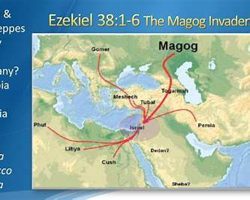
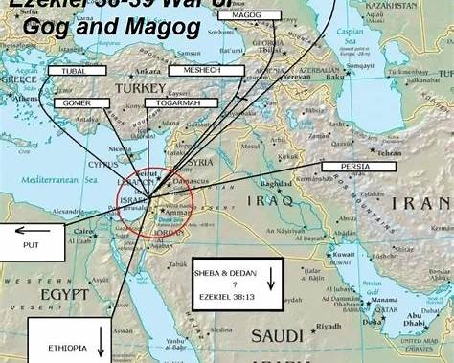
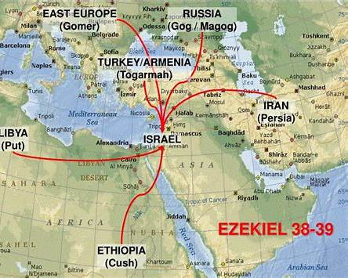
4
These maps show the coalition described in Ezekiel 38–39, where multiple regions converge on Israel. The nations named include Persia, Cush, Put, Gomer, Togarmah, Meshech, and Tubal.
Approximate modern locations often suggested by scholars:
Biblical Name | Likely Region Today
Persia | Iran
Cush | Sudan / Ethiopia
Put | Libya / North Africa
Meshech | Turkey region
Tubal | Turkey region
Gomer | Eastern Europe / Turkey
Togarmah | Armenia / Turkey
Magog | Northern Eurasia / Scythian region

Verse-by-Verse Breakdown
Ezekiel 38
Ezekiel 38:1–3 — The Leader Identified
God speaks to the prophet Ezekiel.
“Son of man, set your face against Gog of the land of Magog…”
Key elements:
- Gog = the leader of the invasion
- Magog = the territory he rules
- Gog is called “chief prince of Meshech and Tubal.”
Gog appears 11 times in chapters 38–39, emphasizing his role as leader.

Ezekiel 38:4 — God Draws the Army
God says He will:
“put hooks in your jaws and bring you out.”
Meaning:
- The invasion ultimately happens under God’s sovereignty.
- The coalition thinks it is acting on its own but God is directing history.

Ezekiel 38:5–6 — The Coalition Nations
This verse names the allies.
Persia, Cush, Put, Gomer, Togarmah
These represent east, south, and north of Israel, forming a massive alliance.
Important:
Persia (Iran) is one of the few nations named explicitly.

Ezekiel 38:7–9 — Massive Invasion
The army is described as:
- huge
- many nations
- like a storm covering the land
This imagery emphasizes overwhelming military force.

Ezekiel 38:10–12 — Motive of the Attack
The coalition attacks Israel for plunder.
“to seize spoil and carry off plunder”
Israel is described as:
- restored from war
- living securely

Ezekiel 38:13 — Nations Question the Attack
Other nations respond:
- Sheba
- Dedan
- Tarshish
They question the invasion but do not intervene.

Ezekiel 38:14–16 — The Invasion of Israel
Gog comes:
“from the far north”
The army moves against:
- the mountains of Israel
Purpose:
“I will magnify myself in the sight of many nations.”

Ezekiel 38:17 — Prophecy Fulfilled
God reminds Gog that earlier prophets predicted this conflict.

Ezekiel 38:18–23 — God Destroys the Army
God intervenes with:
- great earthquake
- confusion in armies
- sword against one another
- pestilence
- fire and brimstone
Purpose:
“The nations shall know that I am the LORD.”

Ezekiel 39
Ezekiel 39:1–6 — Gog Defeated
God repeats the judgment:
“I am against you, Gog.”
The invading armies fall on Israel’s mountains.

Ezekiel 39:7 — God’s Name Revealed
God declares:
“I will make my holy name known.”
This event reveals God's power to the nations.

Ezekiel 39:8 — Prophecy Fulfilled
God says:
“This is the day I have spoken of.”
Meaning the event was long foretold.

Ezekiel 39:9–10 — Weapons Burned for 7 Years
Israel burns the enemy’s weapons for seven years.
Interpretations include:
- literal weapon burning
- symbolic destruction of military power

Ezekiel 39:11–16 — Burial of the Dead
The dead are buried in a place called:
“Valley of Hamon-Gog”
It takes seven months to bury the bodies.

Ezekiel 39:17–20 — Birds and Beasts Feast
God invites:
- birds
- wild animals
to consume the fallen army.
This imagery appears again in Book of Revelation 19.

Ezekiel 39:21–24 — Israel Understands
Israel finally understands:
- their exile happened because of sin
- God is restoring them

Ezekiel 39:25–29 — Restoration of Israel
God promises:
- restoration
- forgiveness
- His Spirit poured out
This transitions into the future restoration of Israel.

Hebrew Word Study
Gog (גּוֹג)
Possible meanings:
- “high” or “exalted”
- possibly a title of a ruler
Some connect it to ancient rulers like Gyges of Lydia.
In Ezekiel it refers to:
a powerful leader of the invading coalition.

Magog (מָגוֹג)
First appears in Book of Genesis 10.
Magog was a son of Japheth, ancestor of northern tribes.
Historian Josephus connected Magog with the Scythians of Eurasia.

Meshech (מֶשֶׁךְ)
Ancient people located in:
- Anatolia
- modern Turkey
They often appear paired with Tubal in the Old Testament.

Tubal (תֻּבָל)
Ancient tribe known for:
- metal work
- trade
Located in Asia Minor (Turkey).

Persia (פָּרַס)
The Hebrew name for the Persian Empire.
Historically:
- rose to power in 539 BC
- ruled much of the Middle East
Modern equivalent:
Iran.

Big Picture of Ezekiel 38–39
The prophecy describes:
- A northern leader (Gog)
- A coalition of nations including Persia
- A massive invasion of Israel
- Supernatural destruction by God
- Global recognition of God's power

✅ Key takeaway
Ezekiel 38–39 describes a future event where a coalition of nations—including Persia (Iran)—attacks Israel but is defeated by divine intervention.

The Source: ChatGpt and compiled and arranged by dolous777.

