The Book of Exodus — A Deep Dive into People, Places & Things
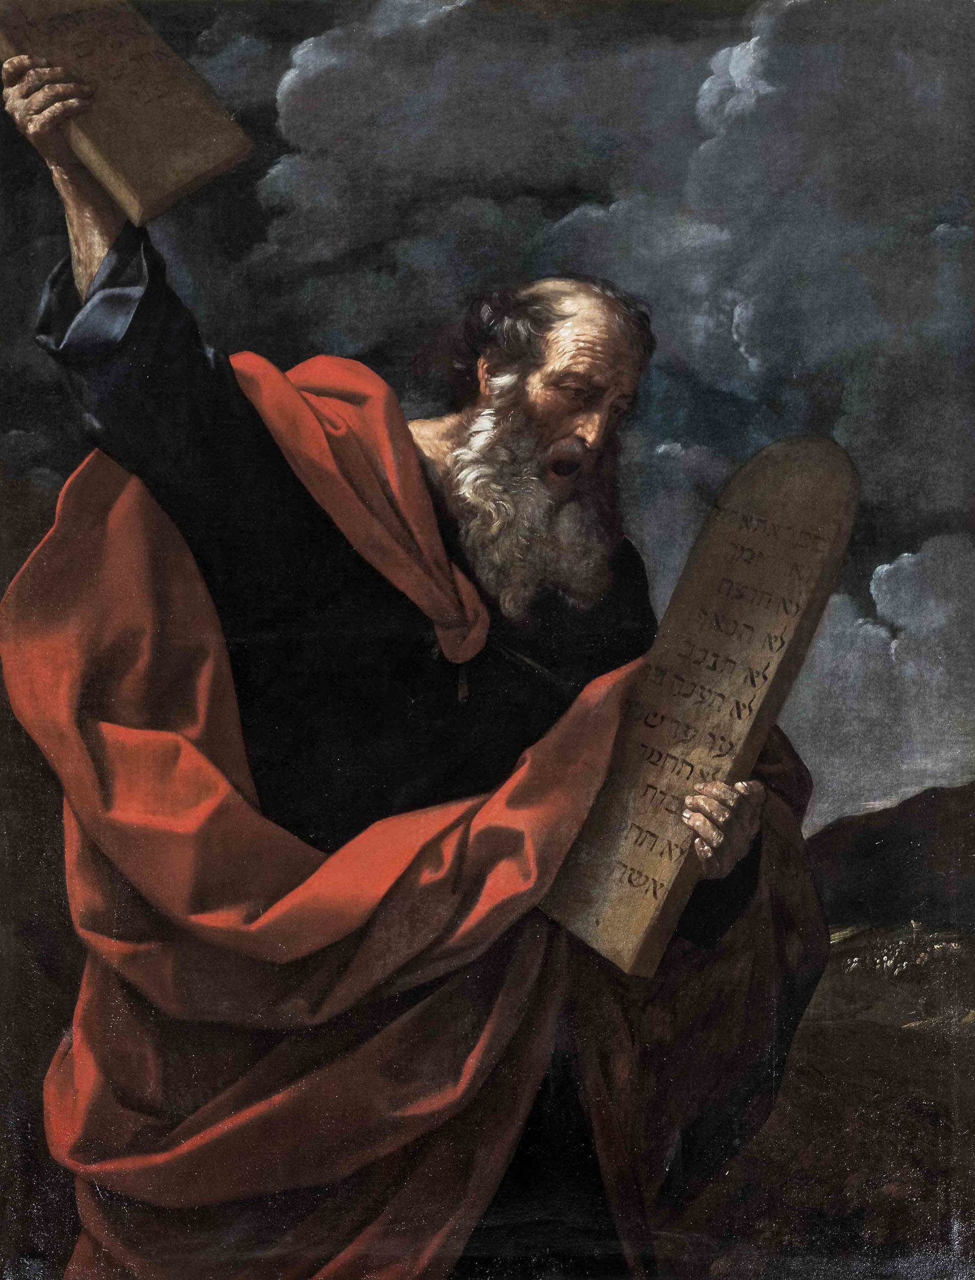
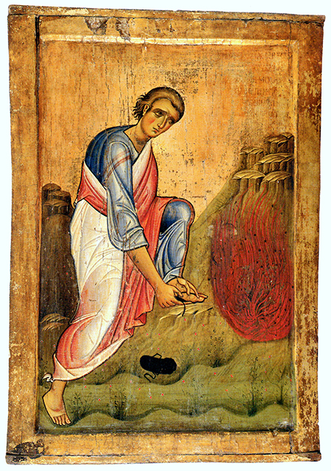
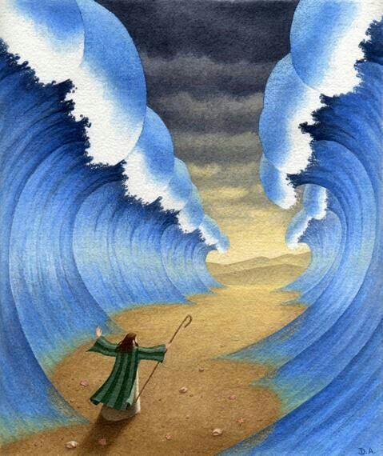
4
Exodus (the second book of the Bible) tells the story of Israel’s deliverance from slavery in Egypt and the formation of a covenant nation under God. It spans oppression, miracles, lawgiving, rebellion, and divine presence.

👥 Key People in Exodus
🔹 Moses
- Central leader and prophet.
- Raised in Pharaoh’s household, flees to Midian.
- Encounters God at the Burning Bush.
- Leads Israel out of Egypt.
- Receives the Law at Sinai.
🔹 Aaron
- Moses’ brother and spokesperson.
- First High Priest of Israel.
- Plays a role in the Golden Calf incident.
🔹 Miriam
- Prophetess and sister of Moses and Aaron.
- Leads women in worship after crossing the Red Sea.
🔹 Pharaoh
- The unnamed king of Egypt.
- Oppresses the Israelites.
- Refuses to release them despite the plagues.
🔹 Joshua
- Military leader.
- Fights Amalek.
- Later becomes Moses’ successor (in the next book).
🔹 Jethro
- Moses’ father-in-law.
- Advises Moses on leadership delegation.

📍 Major Places in Exodus
🏺 Egypt
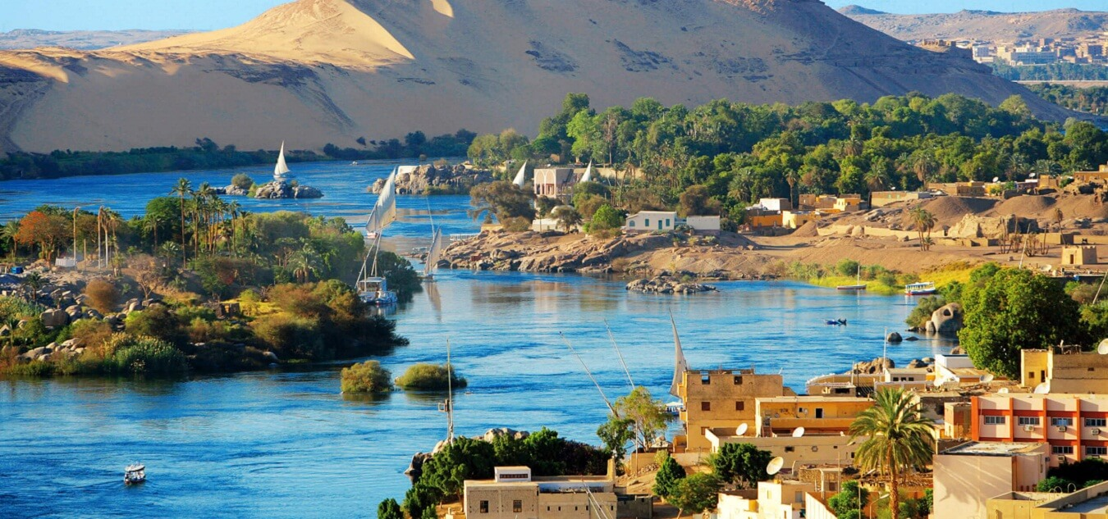
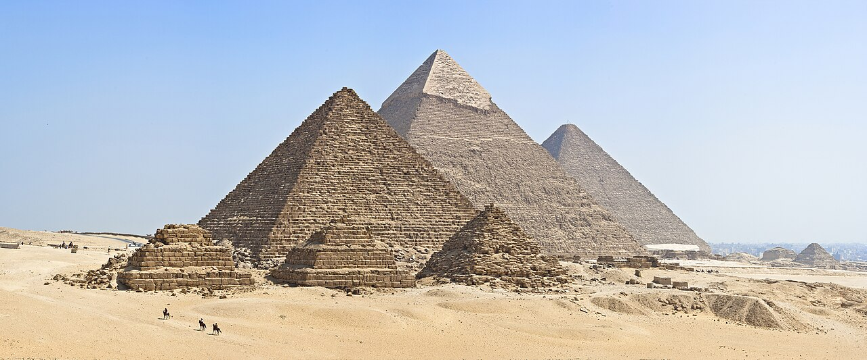
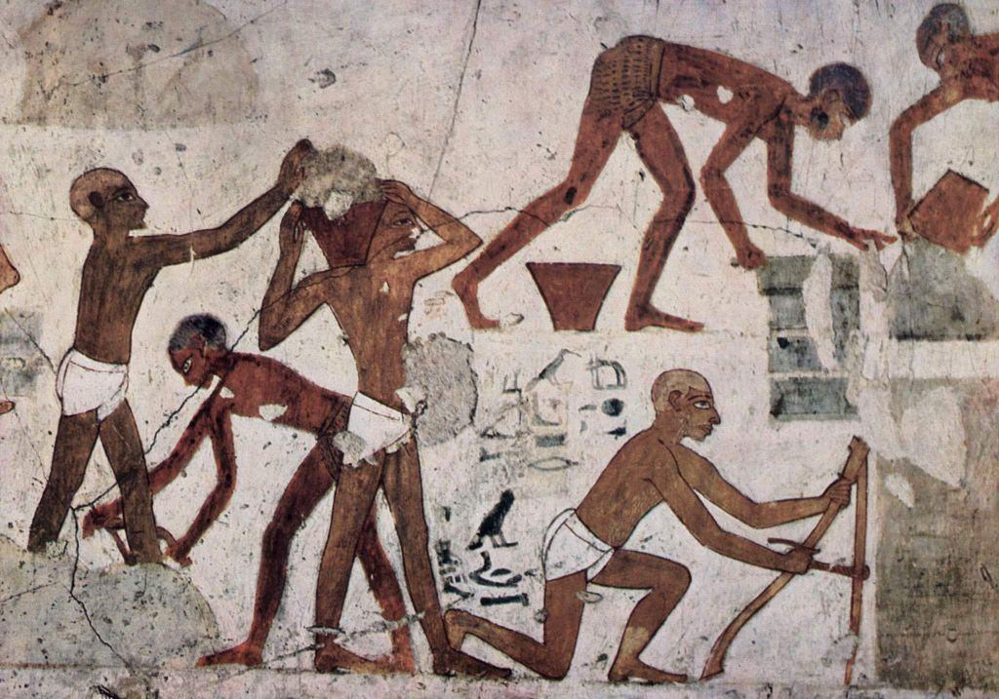
4
- Land of Israelite slavery.
- Site of the Ten Plagues.
- Represents oppression and worldly power.

🌊 Red Sea (Yam Suph)
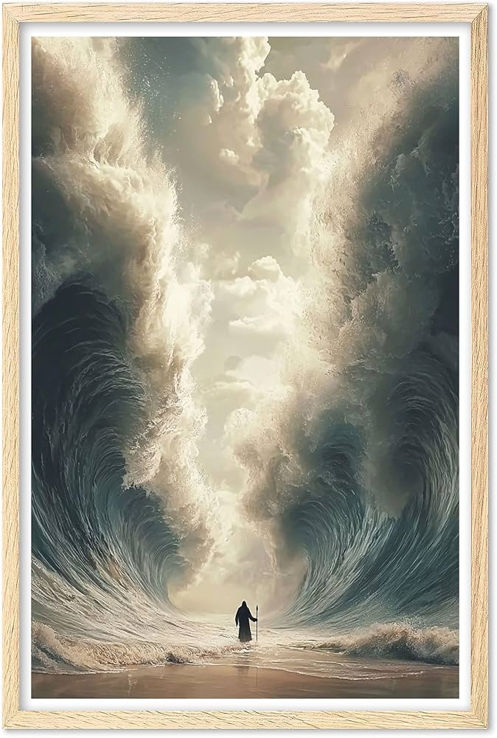
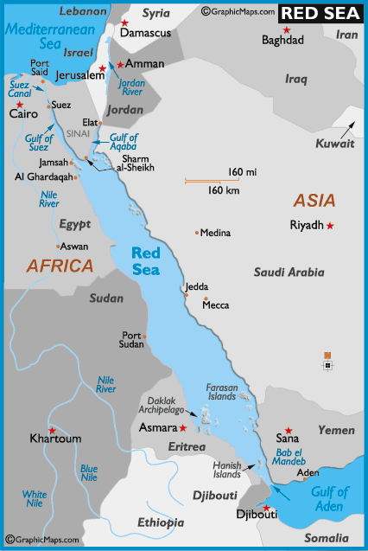
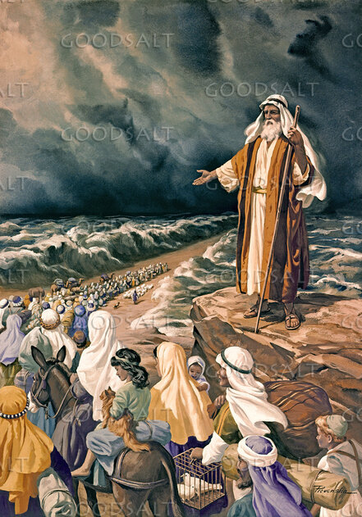
4
- Miraculous crossing.
- Egyptian army destroyed.
- Symbol of salvation and divine power.

⛰️ Mount Sinai (Horeb)

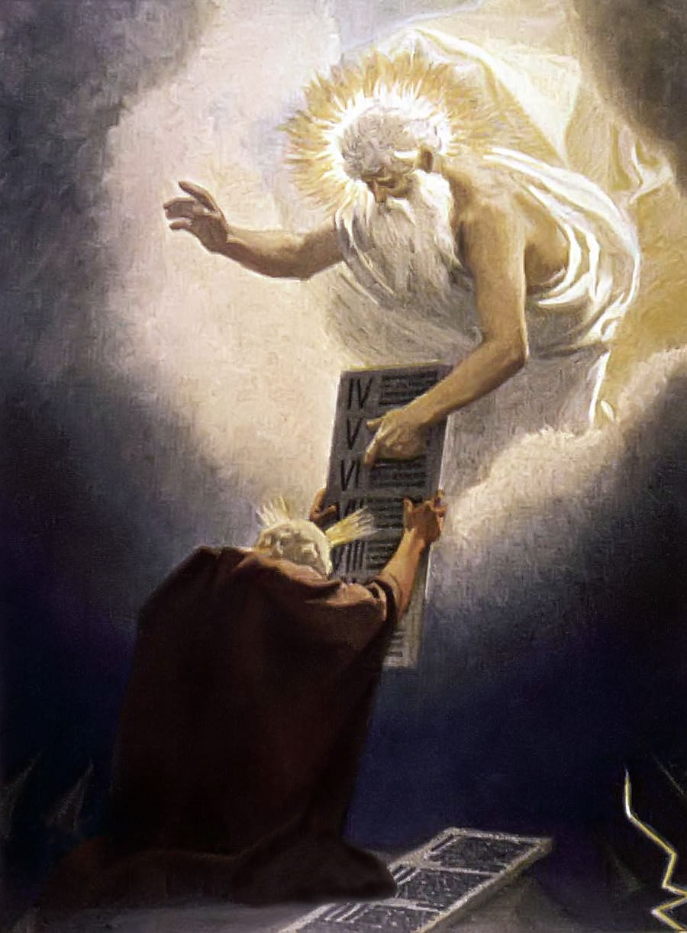
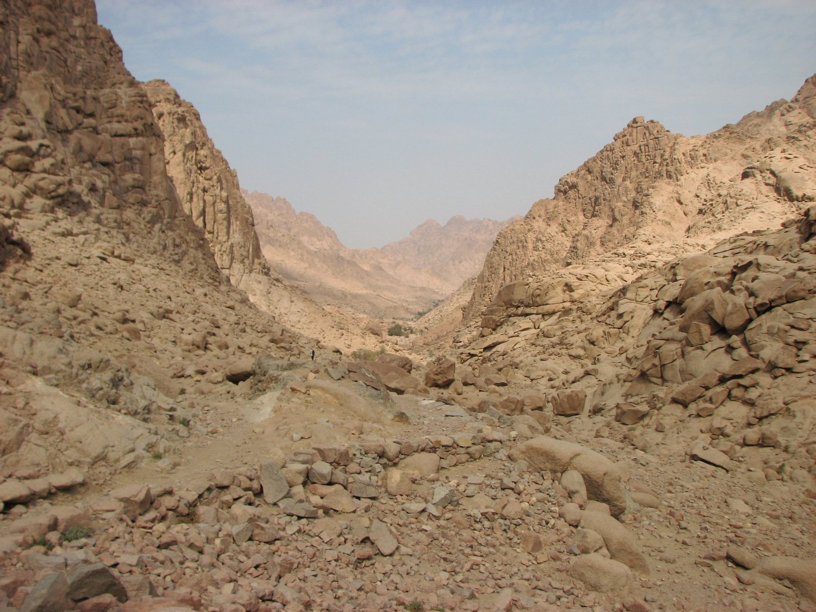
- Site of the Burning Bush.
- Location where the Ten Commandments are given.
- Israel enters covenant with God.

🏕️ Wilderness of Sinai
- Period of testing and formation.
- Manna and quail provided.
- Water from the rock.
- Complaints and rebellion episodes.

📦 Important Objects & Sacred Things
📜 The Ten Commandments
- Written on stone tablets.
- Foundation of covenant law.
- Moral and spiritual framework for Israel.
🏕️ The Tabernacle
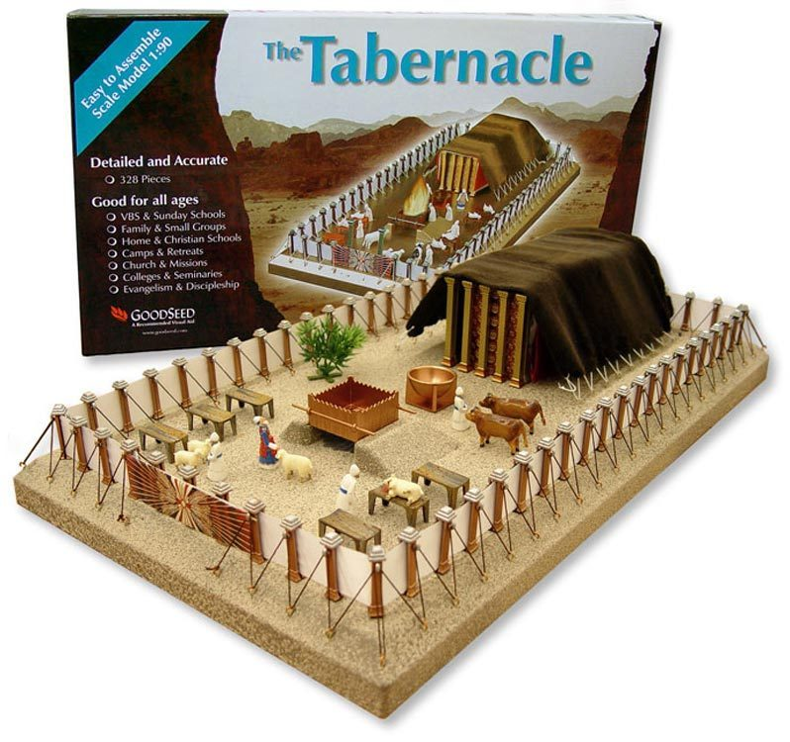
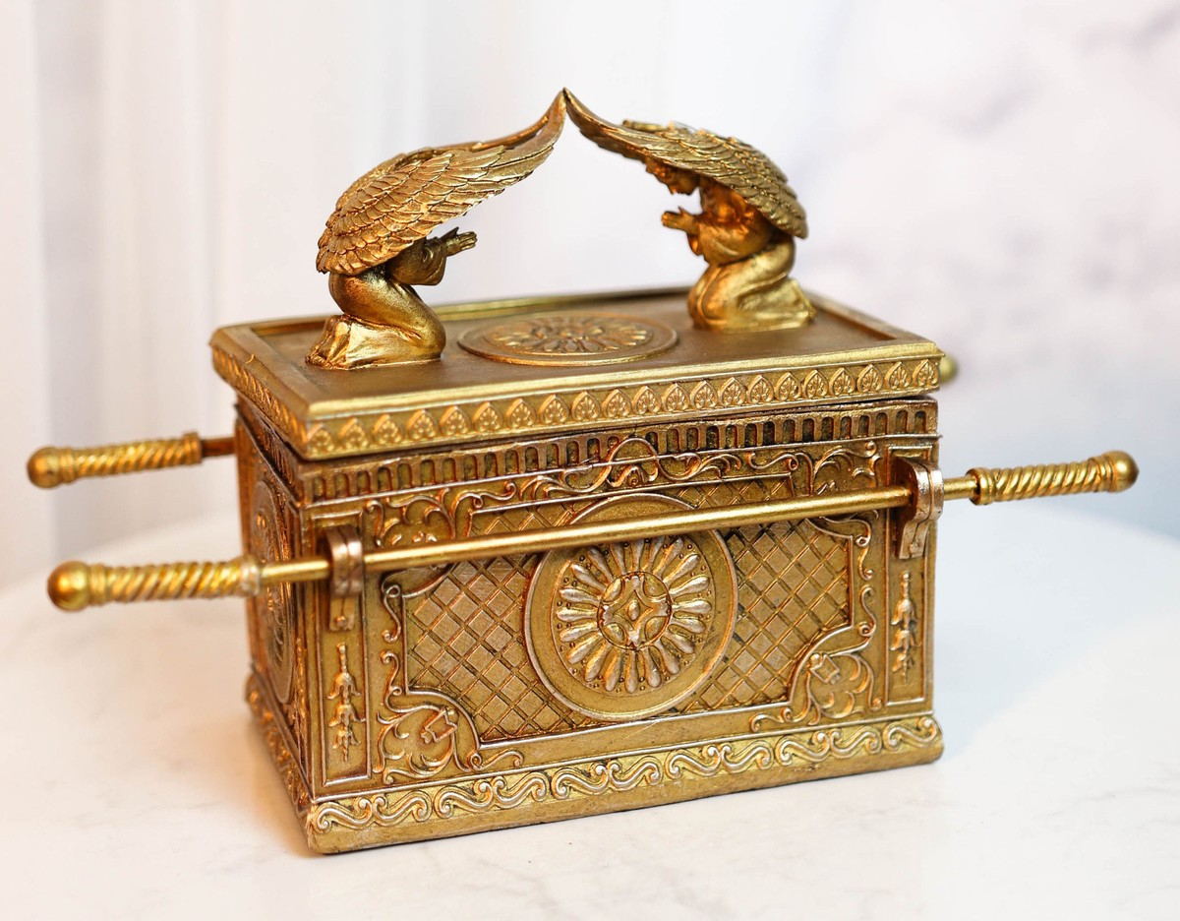
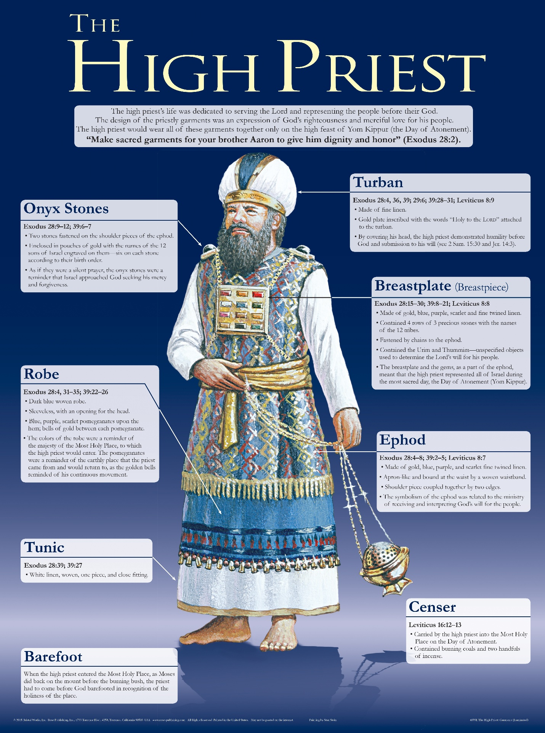
4
A portable sanctuary where God’s presence dwells.
Key elements:
- Ark of the Covenant
- Mercy Seat
- Bronze Altar
- Lampstand (Menorah)
- Priestly garments

🍞 Manna
- Miraculous bread from heaven.
- Daily dependence on God.
- Cannot be hoarded (except before Sabbath).

🔥 Major Themes in Exodus
- Deliverance & Redemption
- Covenant Relationship
- Law & Holiness
- God’s Presence
- Leadership & Obedience
- Freedom from Bondage

🧠 Structural Overview
Section | Chapters | Focus
Oppression in Egypt | Exodus 1–12 | Slavery & Plagues
The Exodus | Exodus 13–18 | Red Sea & Wilderness
Sinai Covenant | Exodus 19–24 | Law & Commandments
Tabernacle Instructions | Exodus 25–31 | Worship Design
Golden Calf Crisis | Exodus 32–34 | Rebellion & Mercy
Tabernacle Built | Exodus 35–40 | God Dwells with Israel

If you'd like, I can also provide:
- A symbolism deep dive
- A historical/archaeological analysis
- A Hebrew word study breakdown
- A theological comparison (Jewish vs Christian interpretation)
- Or a timeline map visualization
What direction do you want to explore next?

