The Project Gutenberg eBook of A Christmas Carol
This ebook is for the use of anyone anywhere in the United States and most other parts of the world at no cost and with almost no restrictions whatsoever. You may copy it, give it away or re-use it under the terms of the Project Gutenberg License included with this ebook or online at www.gutenberg.org. If you are not located in the United States, you will have to check the laws of the country where you are located before using this eBook.
Title: A Christmas Carol
Author: Charles Dickens
Illustrator: Arthur Rackham
Release date: December 24, 2007 [eBook #24022]
Most recently updated: August 9, 2019
Language: English
Original publication: Philadelphia and New York: J. B. Lippincott Company,, 1915
Credits: Produced by Suzanne Shell, Janet Blenkinship and the Online
Distributed Proofreading Team at http://www.pgdp.net
*** START OF THE PROJECT GUTENBERG EBOOK A CHRISTMAS CAROL ***
There are several editions of this ebook in the Project Gutenberg collection. Various characteristics of each ebook are listed to aid in selecting the preferred file.
Click on any of the filenumbers belowto quickly view each ebook.
46 | (Original First Edition Cover; 1843 Original Illustrations in Color by John Leech)
19337 | (Published in 1905; Illustrations in Black and White by G. A. Williams)
24022 | (Published in 1915; Illustrations in Black and White and Color by By Arthur Rackham)
30368 | (First edition with original hand written pages; Black and White illustrations.)

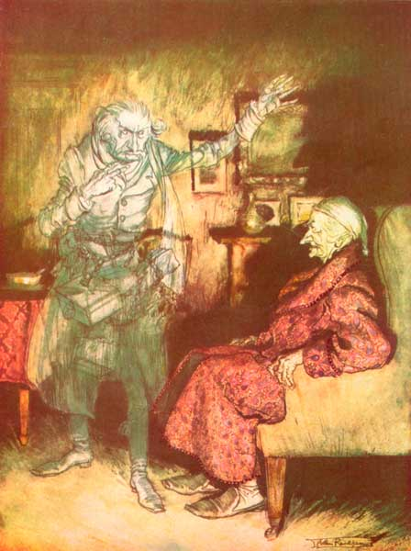 "How now?" said Scrooge, caustic and cold as ever.
"What do you want with me?"
A CHRISTMAS CAROL
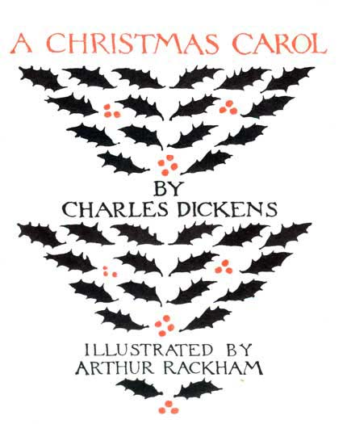
BY
CHARLES DICKENS
ILLUSTRATED BY ARTHUR RACKHAM
J. B. LIPPINCOTT COMPANY PHILADELPHIA AND NEW YORK
FIRST PUBLISHED 1915
ISBN: 0-397-00033-2
PRINTED IN GREAT BRITAIN

PREFACE
I have endeavoured in this Ghostly little book to raise the Ghost of an Idea which shall not put my readers out of humour with themselves, with each other, with the season, or with me. May it haunt their house pleasantly, and no one wish to lay it.
Their faithful Friend and Servant,
C. D.
December, 1843.
[Pg x]
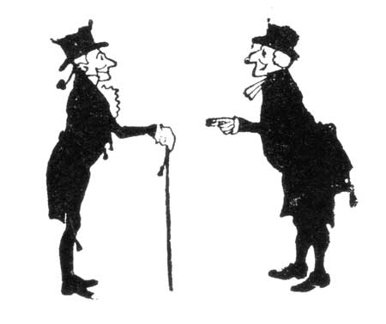

CHARACTERS
[Pg x]
Bob Cratchit, clerk to Ebenezer Scrooge.
Peter Cratchit, a son of the preceding.
Tim Cratchit ("Tiny Tim"), a cripple, youngest son of Bob Cratchit.
Mr. Fezziwig, a kind-hearted, jovial old merchant.
Fred, Scrooge's nephew.
Ghost of Christmas Past, a phantom showing things past.
Ghost of Christmas Present, a spirit of a kind, generous, and hearty nature.
Ghost of Christmas Yet to Come, an apparition showing the shadows of things which yet may happen.
Ghost of Jacob Marley, a spectre of Scrooge's former partner in business.
Joe, a marine-store dealer and receiver of stolen goods.
Ebenezer Scrooge, a grasping, covetous old man, the surviving partner of the firm of Scrooge and Marley.
Mr. Topper, a bachelor.
Dick Wilkins, a fellow apprentice of Scrooge's.
Belle, a comely matron, an old sweetheart of Scrooge's.
Caroline, wife of one of Scrooge's debtors.
Mrs. Cratchit, wife of Bob Cratchit.
Belinda and Martha Cratchit, daughters of the preceding.
Mrs. Dilber, a laundress.
Fan, the sister of Scrooge.
Mrs. Fezziwig, the worthy partner of Mr. Fezziwig.
[Pg viii]
CONTENTS
STAVE ONE—MARLEY'S GHOST | 3
STAVE TWO—THE FIRST OF THE THREE SPIRITS | 37
STAVE THREE—THE SECOND OF THE THREE SPIRITS | 69
STAVE FOUR—THE LAST OF THE SPIRITS | 111
STAVE FIVE—THE END OF IT | 137

LIST OF ILLUSTRATIONS
IN COLOUR
[Pg x]
"How now?" said Scrooge, caustic and cold as ever.  "What do you want with me?" | Frontispiece
Bob Cratchit went down a slide on Cornhill, at the end of a lane of boys, twenty times, in honour of its being Christmas Eve | 16
Nobody under the bed; nobody in the closet; nobody in his dressing-gown, which was hanging up in a suspicious attitude against the wall | 20
The air was filled with phantoms, wandering hither and thither in restless haste and moaning as they went | 32
Then old Fezziwig stood out to dance with Mrs. Fezziwig | 54
A flushed and boisterous group | 62
Laden with Christmas toys and presents | 64
The way he went after that plump sister in the lace tucker! | 100
"How are you?" said one.  "How are you?" returned the other.  "Well!" said the first. "Old Scratch has got his own at last, hey?" | 114
"What do you call this?" said Joe. "Bed-curtains!"  "Ah!" returned the woman, laughing.... "Bed-curtains!"  "You don't mean to say you took 'em down, rings and all, with him lying there?" said Joe.  "Yes, I do," replied the woman. "Why not?" | 120
"It's I, your uncle Scrooge. I have come to dinner. Will you let me in, Fred?" | 144
"Now, I'll tell you what, my friend," said Scrooge. "I am not going to stand this sort of thing any longer." | 146
[Pg x]
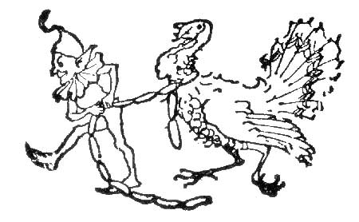
IN BLACK AND WHITE
Tailpiece | vi
Tailpiece to List of Coloured Illustrations | x
Tailpiece to List of Black and White Illustrations | xi
Heading to Stave One | 3
They were portly gentlemen, pleasant to behold | 12
On the wings of the wind | 28-29
Tailpiece to Stave One | 34
Heading to Stave Two | 37
He produced a decanter of curiously light wine and a block of curiously heavy cake | 50
She left him, and they parted | 60
Tailpiece to Stave Two | 65
Heading to Stave Three | 69
There was nothing very cheerful in the climate | 75
He had been Tim's blood-horse all the way from church | 84-85
With the pudding | 88
Heading to Stave Four | 111
Heading to Stave Five | 137
Tailpiece to Stave Five | 147
[Pg xi]
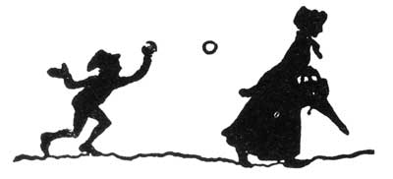

STAVE ONE
[Pg 3]

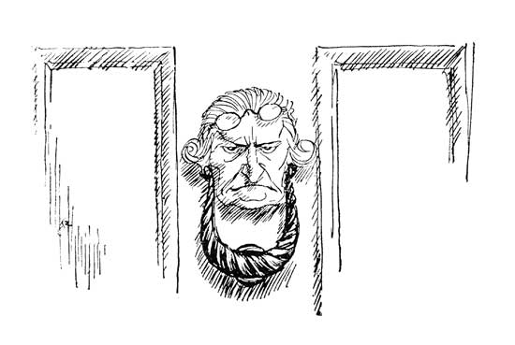
MARLEY'S GHOST
Marley was dead, to begin with. There is no doubt whatever about that. The register of his burial was signed by the clergyman, the clerk, the undertaker, and the chief mourner. Scrooge signed it. And Scrooge's name was good upon 'Change for anything he chose to put his hand to. Old Marley was as dead as a door-nail.
Mind! I don't mean to say that I know of my own knowledge, what there is particularly dead about a door-nail. I might have been inclined, myself, to regard a coffin-nail as the deadest piece of ironmongery[Pg 4] in the trade. But the wisdom of our ancestors is in the simile; and my unhallowed hands shall not disturb it, or the country's done for. You will, therefore, permit me to repeat, emphatically, that Marley was as dead as a door-nail.
Scrooge knew he was dead? Of course he did. How could it be otherwise? Scrooge and he were partners for I don't know how many years. Scrooge was his sole executor, his sole administrator, his sole assign, his sole residuary legatee, his sole friend, and sole mourner. And even Scrooge was not so dreadfully cut up by the sad event but that he was an excellent man of business on the very day of the funeral, and solemnised it with an undoubted bargain.
The mention of Marley's funeral brings me back to the point I started from. There is no doubt that Marley was dead. This must be distinctly understood, or nothing wonderful can come of the story I am going to relate. If we were not perfectly convinced that Hamlet's father died before the play began, there would be nothing more remarkable in his taking a stroll at night, in an easterly wind, upon his own ramparts, than there would be in any other middle-aged gentleman rashly turning out after dark in a breezy spot—say St. Paul's Churchyard, for instance—literally to astonish his son's weak mind.[Pg 5]
Scrooge never painted out Old Marley's name. There it stood, years afterwards, above the warehouse door: Scrooge and Marley. The firm was known as Scrooge and Marley. Sometimes people new to the business called Scrooge Scrooge, and sometimes Marley, but he answered to both names. It was all the same to him.
Oh! but he was a tight-fisted hand at the grindstone, Scrooge! a squeezing, wrenching, grasping, scraping, clutching, covetous old sinner! Hard and sharp as flint, from which no steel had ever struck out generous fire; secret, and self-contained, and solitary as an oyster. The cold within him froze his old features, nipped his pointed nose, shrivelled his cheek, stiffened his gait; made his eyes red, his thin lips blue; and spoke out shrewdly in his grating voice. A frosty rime was on his head, and on his eyebrows, and his wiry chin. He carried his own low temperature always about with him; he iced his office in the dog-days, and didn't thaw it one degree at Christmas.
External heat and cold had little influence on Scrooge. No warmth could warm, no wintry weather chill him. No wind that blew was bitterer than he, no falling snow was more intent upon its purpose, no pelting rain less open to entreaty. Foul weather didn't know where to have him. The heaviest rain, and snow, and hail, and sleet could boast of the advan[Pg 6]tage over him in only one respect. They often 'came down' handsomely, and Scrooge never did.
Nobody ever stopped him in the street to say, with gladsome looks, 'My dear Scrooge, how are you? When will you come to see me?' No beggars implored him to bestow a trifle, no children asked him what it was o'clock, no man or woman ever once in all his life inquired the way to such and such a place, of Scrooge. Even the blind men's dogs appeared to know him; and, when they saw him coming on, would tug their owners into doorways and up courts; and then would wag their tails as though they said, 'No eye at all is better than an evil eye, dark master!'
But what did Scrooge care? It was the very thing he liked. To edge his way along the crowded paths of life, warning all human sympathy to keep its distance, was what the knowing ones call 'nuts' to Scrooge.
Once upon a time—of all the good days in the year, on Christmas Eve—old Scrooge sat busy in his counting-house. It was cold, bleak, biting weather; foggy withal; and he could hear the people in the court outside go wheezing up and down, beating their hands upon their breasts, and stamping their feet upon the pavement stones to warm them. The City clocks had only just gone three, but it was quite dark already—it had not been light all day—and candles were flaring in[Pg 7] the windows of the neighbouring offices, like ruddy smears upon the palpable brown air. The fog came pouring in at every chink and keyhole, and was so dense without, that, although the court was of the narrowest, the houses opposite were mere phantoms. To see the dingy cloud come drooping down, obscuring everything, one might have thought that nature lived hard by, and was brewing on a large scale.
The door of Scrooge's counting-house was open, that he might keep his eye upon his clerk, who in a dismal little cell beyond, a sort of tank, was copying letters. Scrooge had a very small fire, but the clerk's fire was so very much smaller that it looked like one coal. But he couldn't replenish it, for Scrooge kept the coal-box in his own room; and so surely as the clerk came in with the shovel, the master predicted that it would be necessary for them to part. Wherefore the clerk put on his white comforter, and tried to warm himself at the candle; in which effort, not being a man of strong imagination, he failed.
'A merry Christmas, uncle! God save you!' cried a cheerful voice. It was the voice of Scrooge's nephew, who came upon him so quickly that this was the first intimation he had of his approach.
'Bah!' said Scrooge. 'Humbug!'
He had so heated himself with rapid walking in the fog and frost, this nephew of Scrooge's, that he was all[Pg 8] in a glow; his face was ruddy and handsome; his eyes sparkled, and his breath smoked again.
'Christmas a humbug, uncle!' said Scrooge's nephew. 'You don't mean that, I am sure?'
'I do,' said Scrooge. 'Merry Christmas! What right have you to be merry? What reason have you to be merry? You're poor enough.'
'Come, then,' returned the nephew gaily. 'What right have you to be dismal? What reason have you to be morose? You're rich enough.'
Scrooge, having no better answer ready on the spur of the moment, said, 'Bah!' again; and followed it up with 'Humbug!'
'Don't be cross, uncle!' said the nephew.
'What else can I be,' returned the uncle, 'when I live in such a world of fools as this? Merry Christmas! Out upon merry Christmas! What's Christmas-time to you but a time for paying bills without money; a time for finding yourself a year older, and not an hour richer; a time for balancing your books, and having every item in 'em through a round dozen of months presented dead against you? If I could work my will,' said Scrooge indignantly, 'every idiot who goes about with "Merry Christmas" on his lips should be boiled with his own pudding, and buried with a stake of holly through his heart. He should!'
'Uncle!' pleaded the nephew.[Pg 9]
'Nephew!' returned the uncle sternly, 'keep Christmas in your own way, and let me keep it in mine.'
'Keep it!' repeated Scrooge's nephew. 'But you don't keep it.'
'Let me leave it alone, then,' said Scrooge. 'Much good may it do you! Much good it has ever done you!'
'There are many things from which I might have derived good, by which I have not profited, I dare say,' returned the nephew; 'Christmas among the rest. But I am sure I have always thought of Christmas-time, when it has come round—apart from the veneration due to its sacred name and origin, if anything belonging to it can be apart from that—as a good time; a kind, forgiving, charitable, pleasant time; the only time I know of, in the long calendar of the year, when men and women seem by one consent to open their shut-up hearts freely, and to think of people below them as if they really were fellow-passengers to the grave, and not another race of creatures bound on other journeys. And therefore, uncle, though it has never put a scrap of gold or silver in my pocket, I believe that it has done me good and will do me good; and I say, God bless it!'
The clerk in the tank involuntarily applauded. Becoming immediately sensible of the impropriety, he[Pg 10] poked the fire, and extinguished the last frail spark for ever.
'Let me hear another sound from you,' said Scrooge, 'and you'll keep your Christmas by losing your situation! You're quite a powerful speaker, sir,' he added, turning to his nephew. 'I wonder you don't go into Parliament.'
'Don't be angry, uncle. Come! Dine with us to-morrow.'
Scrooge said that he would see him——Yes, indeed he did. He went the whole length of the expression, and said that he would see him in that extremity first.
'But why?' cried Scrooge's nephew. 'Why?'
'Why did you get married?' said Scrooge.
'Because I fell in love.'
'Because you fell in love!' growled Scrooge, as if that were the only one thing in the world more ridiculous than a merry Christmas. 'Good afternoon!'
'Nay, uncle, but you never came to see me before that happened. Why give it as a reason for not coming now?'
'Good afternoon,' said Scrooge.
'I want nothing from you; I ask nothing of you; why cannot we be friends?'
'Good afternoon!' said Scrooge.
'I am sorry, with all my heart, to find you so resolute. We have never had any quarrel to which I[Pg 11] have been a party. But I have made the trial in homage to Christmas, and I'll keep my Christmas humour to the last. So A Merry Christmas, uncle!'
'Good afternoon,' said Scrooge.
'And A Happy New Year!'
'Good afternoon!' said Scrooge.
His nephew left the room without an angry word, notwithstanding. He stopped at the outer door to bestow the greetings of the season on the clerk, who, cold as he was, was warmer than Scrooge; for he returned them cordially.
'There's another fellow,' muttered Scrooge, who overheard him: 'my clerk, with fifteen shillings a week, and a wife and family, talking about a merry Christmas. I'll retire to Bedlam.'
This lunatic, in letting Scrooge's nephew out, had let two other people in. They were portly gentlemen, pleasant to behold, and now stood, with their hats off, in Scrooge's office. They had books and papers in their hands, and bowed to him.
'Scrooge and Marley's, I believe,' said one of the gentlemen, referring to his list. 'Have I the pleasure of addressing Mr. Scrooge, or Mr. Marley?'
'Mr. Marley has been dead these seven years,' Scrooge replied. 'He died seven years ago, this very night.'
'We have no doubt his liberality is well represented[Pg 12] by his surviving partner,' said the gentleman, presenting his credentials.
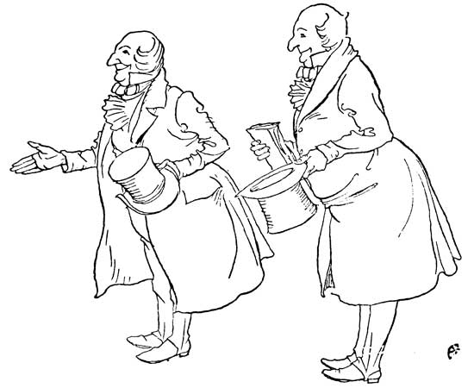 THEY WERE PORTLY GENTLEMEN, PLEASANT TO BEHOLD
It certainly was; for they had been two kindred spirits. At the ominous word 'liberality' Scrooge frowned, and shook his head, and handed the credentials back.
'At this festive season of the year, Mr. Scrooge,' said the gentleman, taking up a pen, 'it is more than usually desirable that we should make some slight[Pg 13] provision for the poor and destitute, who suffer greatly at the present time. Many thousands are in want of common necessaries; hundreds of thousands are in want of common comforts, sir.'
'Are there no prisons?' asked Scrooge.
'Plenty of prisons,' said the gentleman, laying down the pen again.
'And the Union workhouses?' demanded Scrooge. 'Are they still in operation?'
'They are. Still,' returned the gentleman, 'I wish I could say they were not.'
'The Treadmill and the Poor Law are in full vigour, then?' said Scrooge.
'Both very busy, sir.'
'Oh! I was afraid, from what you said at first, that something had occurred to stop them in their useful course,' said Scrooge. 'I am very glad to hear it.'
'Under the impression that they scarcely furnish Christian cheer of mind or body to the multitude,' returned the gentleman, 'a few of us are endeavouring to raise a fund to buy the Poor some meat and drink, and means of warmth. We choose this time, because it is a time, of all others, when Want is keenly felt, and Abundance rejoices. What shall I put you down for?'
'Nothing!' Scrooge replied.
'You wish to be anonymous?'[Pg 14]
'I wish to be left alone,' said Scrooge. 'Since you ask me what I wish, gentlemen, that is my answer. I don't make merry myself at Christmas, and I can't afford to make idle people merry. I help to support the establishments I have mentioned—they cost enough: and those who are badly off must go there.'
'Many can't go there; and many would rather die.'
'If they would rather die,' said Scrooge, 'they had better do it, and decrease the surplus population. Besides—excuse me—I don't know that.'
'But you might know it,' observed the gentleman.
'It's not my business,' Scrooge returned. 'It's enough for a man to understand his own business, and not to interfere with other people's. Mine occupies me constantly. Good afternoon, gentlemen!'
Seeing clearly that it would be useless to pursue their point, the gentlemen withdrew. Scrooge resumed his labours with an improved opinion of himself, and in a more facetious temper than was usual with him.
Meanwhile the fog and darkness thickened so, that people ran about with flaring links, proffering their services to go before horses in carriages, and conduct them on their way. The ancient tower of a church, whose gruff old bell was always peeping slyly down at Scrooge out of a Gothic window in the wall, became[Pg 15] invisible, and struck the hours and quarters in the clouds, with tremulous vibrations afterwards, as if its teeth were chattering in its frozen head up there. The cold became intense. In the main street, at the corner of the court, some labourers were repairing the gas-pipes, and had lighted a great fire in a brazier, round which a party of ragged men and boys were gathered: warming their hands and winking their eyes before the blaze in rapture. The water-plug being left in solitude, its overflowings suddenly congealed, and turned to misanthropic ice. The brightness of the shops, where holly sprigs and berries crackled in the lamp heat of the windows, made pale faces ruddy as they passed. Poulterers' and grocers' trades became a splendid joke: a glorious pageant, with which it was next to impossible to believe that such dull principles as bargain and sale had anything to do. The Lord Mayor, in the stronghold of the mighty Mansion House, gave orders to his fifty cooks and butlers to keep Christmas as a Lord Mayor's household should; and even the little tailor, whom he had fined five shillings on the previous Monday for being drunk and bloodthirsty in the streets, stirred up to-morrow's pudding in his garret, while his lean wife and the baby sallied out to buy the beef.
Foggier yet, and colder! Piercing, searching, biting cold. If the good St. Dunstan had but nipped the[Pg 16] Evil Spirit's nose with a touch of such weather as that, instead of using his familiar weapons, then indeed he would have roared to lusty purpose. The owner of one scant young nose, gnawed and mumbled by the hungry cold as bones are gnawed by dogs, stooped down at Scrooge's keyhole to regale him with a Christmas carol; but, at the first sound of
'God bless you, merry gentleman,
May nothing you dismay!'
Scrooge seized the ruler with such energy of action that the singer fled in terror, leaving the keyhole to the fog, and even more congenial frost.
At length the hour of shutting up the counting-house arrived. With an ill-will Scrooge dismounted from his stool, and tacitly admitted the fact to the expectant clerk in the tank, who instantly snuffed his candle out, and put on his hat.
'You'll want all day to-morrow, I suppose?' said Scrooge.
'If quite convenient, sir.'
'It's not convenient,' said Scrooge, 'and it's not fair. If I was to stop half-a-crown for it, you'd think yourself ill used, I'll be bound?'
The clerk smiled faintly.
'And yet,' said Scrooge, 'you don't think me ill used when I pay a day's wages for no work.'
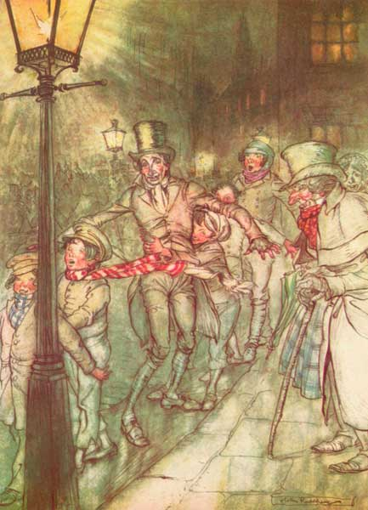 Bob Cratchit went down a slide on Cornhill,
at the end of a lane of boys, twenty times,
in honour of its being Christmas Eve
[Pg 17]
The clerk observed that it was only once a year.
'A poor excuse for picking a man's pocket every twenty-fifth of December!' said Scrooge, buttoning his greatcoat to the chin. 'But I suppose you must have the whole day. Be here all the earlier next morning.'
The clerk promised that he would; and Scrooge walked out with a growl. The office was closed in a twinkling, and the clerk, with the long ends of his white comforter dangling below his waist (for he boasted no greatcoat), went down a slide on Cornhill, at the end of a lane of boys, twenty times, in honour of its being Christmas Eve, and then ran home to Camden Town as hard as he could pelt, to play at blind man's-buff.
Scrooge took his melancholy dinner in his usual melancholy tavern; and having read all the newspapers, and beguiled the rest of the evening with his banker's book, went home to bed. He lived in chambers which had once belonged to his deceased partner. They were a gloomy suite of rooms, in a lowering pile of building up a yard, where it had so little business to be, that one could scarcely help fancying it must have run there when it was a young house, playing at hide-and-seek with other houses, and have forgotten the way out again. It was old enough now, and dreary enough; for nobody lived in it but[Pg 18] Scrooge, the other rooms being all let out as offices. The yard was so dark that even Scrooge, who knew its every stone, was fain to grope with his hands. The fog and frost so hung about the black old gateway of the house, that it seemed as if the Genius of the Weather sat in mournful meditation on the threshold.
Now, it is a fact that there was nothing at all particular about the knocker on the door, except that it was very large. It is also a fact that Scrooge had seen it, night and morning, during his whole residence in that place; also that Scrooge had as little of what is called fancy about him as any man in the City of London, even including—which is a bold word—the corporation, aldermen, and livery. Let it also be borne in mind that Scrooge had not bestowed one thought on Marley since his last mention of his seven-years'-dead partner that afternoon. And then let any man explain to me, if he can, how it happened that Scrooge, having his key in the lock of the door, saw in the knocker, without its undergoing any intermediate process of change—not a knocker, but Marley's face.
Marley's face. It was not in impenetrable shadow, as the other objects in the yard were, but had a dismal light about it, like a bad lobster in a dark cellar. It was not angry or ferocious, but looked at Scrooge as Marley used to look; with ghostly spectacles turned up on its ghostly forehead. The hair was curiously[Pg 19] stirred, as if by breath or hot air; and, though the eyes were wide open, they were perfectly motionless. That, and its livid colour, made it horrible; but its horror seemed to be in spite of the face, and beyond its control, rather than a part of its own expression.
As Scrooge looked fixedly at this phenomenon, it was a knocker again.
To say that he was not startled, or that his blood was not conscious of a terrible sensation to which it had been a stranger from infancy, would be untrue. But he put his hand upon the key he had relinquished, turned it sturdily, walked in, and lighted his candle.
He did pause, with a moment's irresolution, before he shut the door; and he did look cautiously behind it first, as if he half expected to be terrified with the sight of Marley's pigtail sticking out into the hall. But there was nothing on the back of the door, except the screws and nuts that held the knocker on, so he said, 'Pooh, pooh!' and closed it with a bang.
The sound resounded through the house like thunder. Every room above, and every cask in the wine-merchant's cellars below, appeared to have a separate peal of echoes of its own. Scrooge was not a man to be frightened by echoes. He fastened the door, and walked across the hall, and up the stairs: slowly, too: trimming his candle as he went.
You may talk vaguely about driving a coach and six[Pg 20] up a good old flight of stairs, or through a bad young Act of Parliament; but I mean to say you might have got a hearse up that staircase, and taken it broadwise, with the splinter-bar towards the wall, and the door towards the balustrades: and done it easy. There was plenty of width for that, and room to spare; which is perhaps the reason why Scrooge thought he saw a locomotive hearse going on before him in the gloom. Half-a-dozen gas-lamps out of the street wouldn't have lighted the entry too well, so you may suppose that it was pretty dark with Scrooge's dip.
Up Scrooge went, not caring a button for that. Darkness is cheap, and Scrooge liked it. But, before he shut his heavy door, he walked through his rooms to see that all was right. He had just enough recollection of the face to desire to do that.
Sitting-room, bedroom, lumber-room. All as they should be. Nobody under the table, nobody under the sofa; a small fire in the grate; spoon and basin ready; and the little saucepan of gruel (Scrooge had a cold in his head) upon the hob. Nobody under the bed; nobody in the closet; nobody in his dressing-gown, which was hanging up in a suspicious attitude against the wall. Lumber-room as usual. Old fire-guard, old shoes, two fish baskets, washing-stand on three legs, and a poker.
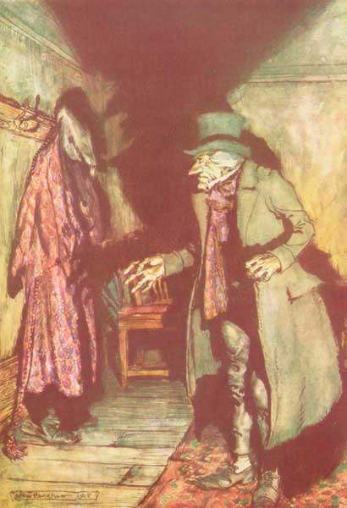 Nobody under the bed;
nobody in the closet; nobody in his dressing-gown,
which was hanging up in a suspicious attitude against the wall
Quite satisfied, he closed his door, and locked himself[Pg 21] in; double locked himself in, which was not his custom. Thus secured against surprise, he took off his cravat; put on his dressing-gown and slippers, and his nightcap; and sat down before the fire to take his gruel.
It was a very low fire indeed; nothing on such a bitter night. He was obliged to sit close to it, and brood over it, before he could extract the least sensation of warmth from such a handful of fuel. The fireplace was an old one, built by some Dutch merchant long ago, and paved all round with quaint Dutch tiles, designed to illustrate the Scriptures. There were Cains and Abels, Pharaoh's daughters, Queens of Sheba, Angelic messengers descending through the air on clouds like feather-beds, Abrahams, Belshazzars, Apostles putting off to sea in butter-boats, hundreds of figures to attract his thoughts; and yet that face of Marley, seven years dead, came like the ancient Prophet's rod, and swallowed up the whole. If each smooth tile had been a blank at first, with power to shape some picture on its surface from the disjointed fragments of his thoughts, there would have been a copy of old Marley's head on every one.
'Humbug!' said Scrooge; and walked across the room.
After several turns he sat down again. As he threw his head back in the chair, his glance happened to rest[Pg 22] upon a bell, a disused bell, that hung in the room, and communicated, for some purpose now forgotten, with a chamber in the highest storey of the building. It was with great astonishment, and with a strange, inexplicable dread, that, as he looked, he saw this bell begin to swing. It swung so softly in the outset that it scarcely made a sound; but soon it rang out loudly, and so did every bell in the house.
This might have lasted half a minute, or a minute, but it seemed an hour. The bells ceased, as they had begun, together. They were succeeded by a clanking noise deep down below as if some person were dragging a heavy chain over the casks in the wine-merchant's cellar. Scrooge then remembered to have heard that ghosts in haunted houses were described as dragging chains.
The cellar door flew open with a booming sound, and then he heard the noise much louder on the floors below; then coming up the stairs; then coming straight towards his door.
'It's humbug still!' said Scrooge. 'I won't believe it.'
His colour changed, though, when, without a pause, it came on through the heavy door and passed into the room before his eyes. Upon its coming in, the dying flame leaped up, as though it cried, 'I know him! Marley's Ghost!' and fell again.[Pg 23]
The same face: the very same. Marley in his pigtail, usual waistcoat, tights, and boots; the tassels on the latter bristling, like his pigtail, and his coat-skirts, and the hair upon his head. The chain he drew was clasped about his middle. It was long, and wound about him like a tail; and it was made (for Scrooge observed it closely) of cash-boxes, keys, padlocks, ledgers, deeds, and heavy purses wrought in steel. His body was transparent: so that Scrooge, observing him, and looking through his waistcoat, could see the two buttons on his coat behind.
Scrooge had often heard it said that Marley had no bowels, but he had never believed it until now.
No, nor did he believe it even now. Though he looked the phantom through and through, and saw it standing before him; though he felt the chilling influence of its death-cold eyes, and marked the very texture of the folded kerchief bound about its head and chin, which wrapper he had not observed before, he was still incredulous, and fought against his senses.
'How now!' said Scrooge, caustic and cold as ever. 'What do you want with me?'
'Much!'—Marley's voice; no doubt about it.
'Who are you?'
'Ask me who I was.'
'Who were you, then?' said Scrooge, raising his voice. 'You're particular, for a shade.' He was[Pg 24] going to say 'to a shade,' but substituted this, as more appropriate.
'In life I was your partner, Jacob Marley.'
'Can you—can you sit down?' asked Scrooge, looking doubtfully at him.
'I can.'
'Do it, then.'
Scrooge asked the question, because he didn't know whether a ghost so transparent might find himself in a condition to take a chair; and felt that in the event of its being impossible, it might involve the necessity of an embarrassing explanation. But the Ghost sat down on the opposite side of the fireplace, as if he were quite used to it.
'You don't believe in me,' observed the Ghost.
'I don't,' said Scrooge.
'What evidence would you have of my reality beyond that of your own senses?'
'I don't know,' said Scrooge.
'Why do you doubt your senses?'
'Because,' said Scrooge, 'a little thing affects them. A slight disorder of the stomach makes them cheats. You may be an undigested bit of beef, a blot of mustard, a crumb of cheese, a fragment of an underdone potato. There's more of gravy than of grave about you, whatever you are!'
Scrooge was not much in the habit of cracking jokes,[Pg 25] nor did he feel in his heart by any means waggish then. The truth is, that he tried to be smart, as a means of distracting his own attention, and keeping down his terror; for the spectre's voice disturbed the very marrow in his bones.
To sit staring at those fixed, glazed eyes in silence, for a moment, would play, Scrooge felt, the very deuce with him. There was something very awful, too, in the spectre's being provided with an infernal atmosphere of his own. Scrooge could not feel it himself, but this was clearly the case; for though the Ghost sat perfectly motionless, its hair, and skirts, and tassels were still agitated as by the hot vapour from an oven.
'You see this toothpick?' said Scrooge, returning quickly to the charge, for the reason just assigned; and wishing, though it were only for a second, to divert the vision's stony gaze from himself.
'I do,' replied the Ghost.
'You are not looking at it,' said Scrooge.
'But I see it,' said the Ghost, 'notwithstanding.'
'Well!' returned Scrooge, 'I have but to swallow this, and be for the rest of my days persecuted by a legion of goblins, all of my own creation. Humbug, I tell you: humbug!'
At this the spirit raised a frightful cry, and shook its chain with such a dismal and appalling noise, that[Pg 26] Scrooge held on tight to his chair, to save himself from falling in a swoon. But how much greater was his horror when the phantom, taking off the bandage round his head, as if it were too warm to wear indoors, its lower jaw dropped down upon its breast!
Scrooge fell upon his knees, and clasped his hands before his face.
'Mercy!' he said. 'Dreadful apparition, why do you trouble me?'
'Man of the worldly mind!' replied the Ghost, 'do you believe in me or not?'
'I do,' said Scrooge; 'I must. But why do spirits walk the earth, and why do they come to me?'
'It is required of every man,' the Ghost returned, 'that the spirit within him should walk abroad among his fellow-men, and travel far and wide; and, if that spirit goes not forth in life, it is condemned to do so after death. It is doomed to wander through the world—oh, woe is me!—and witness what it cannot share, but might have shared on earth, and turned to happiness!'
Again the spectre raised a cry, and shook its chain and wrung its shadowy hands.
'You are fettered,' said Scrooge, trembling. 'Tell me why?'
'I wear the chain I forged in life,' replied the Ghost. 'I made it link by link, and yard by yard; I girded it[Pg 27] on of my own free will, and of my own free will I wore it. Is its pattern strange to you?'
Scrooge trembled more and more.
'Or would you know,' pursued the Ghost, 'the weight and length of the strong coil you bear yourself? It was full as heavy and as long as this seven Christmas Eves ago. You have laboured on it since. It is a ponderous chain!'
Scrooge glanced about him on the floor, in the expectation of finding himself surrounded by some fifty or sixty fathoms of iron cable; but he could see nothing.
'Jacob!' he said imploringly. 'Old Jacob Marley, tell me more! Speak comfort to me, Jacob!'
'I have none to give,' the Ghost replied. 'It comes from other regions, Ebenezer Scrooge, and is conveyed by other ministers, to other kinds of men. Nor can I tell you what I would. A very little more is all permitted to me. I cannot rest, I cannot stay, I cannot linger anywhere. My spirit never walked beyond our counting-house—mark me;—in life my spirit never roved beyond the narrow limits of our money-changing hole; and weary journeys lie before me!'
It was a habit with Scrooge, whenever he became thoughtful, to put his hands in his breeches pockets. Pondering on what the Ghost had said, he did so now, but without lifting up his eyes, or getting off his knees.[Pg 28]
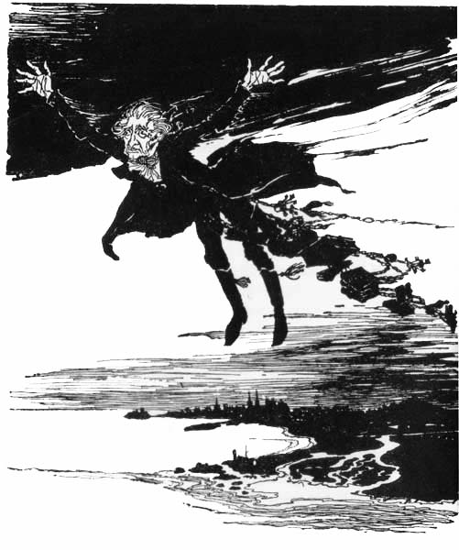 ON THE WINGS OF THE WIND
[Pg 29]
'You must have been very slow about it, Jacob,' Scrooge observed in a business-like manner, though with humility and deference.
'Slow!' the Ghost repeated.
'Seven years dead,' mused Scrooge. 'And travelling all the time?'
'The whole time,' said the Ghost. 'No rest, no peace. Incessant torture of remorse.'
'You travel fast?' said Scrooge.
'On the wings of the wind,' replied the Ghost.
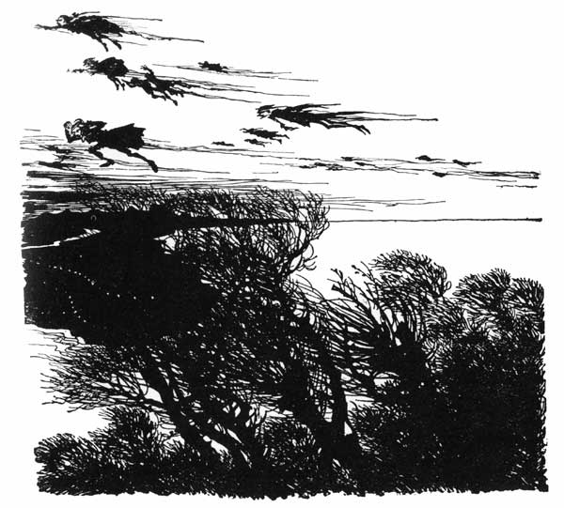
[Pg 30]
'You might have got over a great quantity of ground in seven years,' said Scrooge.
The Ghost, on hearing this, set up another cry, and clanked its chain so hideously in the dead silence of the night, that the Ward would have been justified in indicting it for a nuisance.
'Oh! captive, bound, and double-ironed,' cried the phantom, 'not to know that ages of incessant labour, by immortal creatures, for this earth must pass into eternity before the good of which it is susceptible is all developed! Not to know that any Christian spirit working kindly in its little sphere, whatever it may be, will find its mortal life too short for its vast means of usefulness! Not to know that no space of regret can make amends for one life's opportunities misused! Yet such was I! Oh, such was I!'
'But you were always a good man of business, Jacob,' faltered Scrooge, who now began to apply this to himself.
'Business!' cried the Ghost, wringing its hands again. 'Mankind was my business. The common welfare was my business; charity, mercy, forbearance, and benevolence were, all, my business. The dealings of my trade were but a drop of water in the comprehensive ocean of my business!'
It held up its chain at arm's-length, as if that were the cause of all its unavailing grief, and flung it heavily upon the ground again.[Pg 31]
'At this time of the rolling year,' the spectre said, 'I suffer most. Why did I walk through crowds of fellow-beings with my eyes turned down, and never raise them to that blessed Star which led the Wise Men to a poor abode? Were there no poor homes to which its light would have conducted me?'
Scrooge was very much dismayed to hear the spectre going on at this rate, and began to quake exceedingly.
'Hear me!' cried the Ghost. 'My time is nearly gone.'
'I will,' said Scrooge. 'But don't be hard upon me! Don't be flowery, Jacob! Pray!'
'How it is that I appear before you in a shape that you can see, I may not tell. I have sat invisible beside you many and many a day.'
It was not an agreeable idea. Scrooge shivered, and wiped the perspiration from his brow.
'That is no light part of my penance,' pursued the Ghost. 'I am here to-night to warn you that you have yet a chance and hope of escaping my fate. A chance and hope of my procuring, Ebenezer.'
'You were always a good friend to me,' said Scrooge. 'Thankee!'
'You will be haunted,' resumed the Ghost, 'by Three Spirits.'
Scrooge's countenance fell almost as low as the Ghost's had done.[Pg 32]
'Is that the chance and hope you mentioned, Jacob?' he demanded in a faltering voice.
'It is.'
'I—I think I'd rather not,' said Scrooge.
'Without their visits,' said the Ghost, 'you cannot hope to shun the path I tread. Expect the first to-morrow when the bell tolls One.'
'Couldn't I take 'em all at once, and have it over, Jacob?' hinted Scrooge.
'Expect the second on the next night at the same hour. The third, upon the next night when the last stroke of Twelve has ceased to vibrate. Look to see me no more; and look that, for your own sake, you remember what has passed between us!'
When it had said these words, the spectre took its wrapper from the table, and bound it round its head as before. Scrooge knew this by the smart sound its teeth made when the jaws were brought together by the bandage. He ventured to raise his eyes again, and found his supernatural visitor confronting him in an erect attitude, with its chain wound over and about its arm.
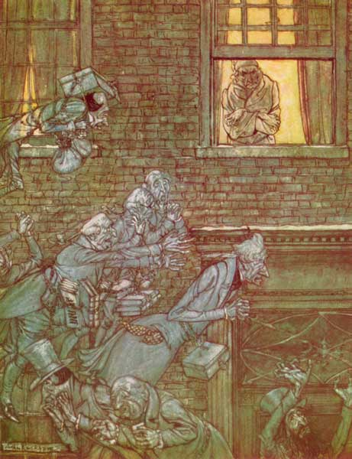 The air was filled with phantoms, wandering hither and thither in restless haste and moaning as they went
The apparition walked backward from him; and, at every step it took, the window raised itself a little, so that, when the spectre reached it, it was wide open. It beckoned Scrooge to approach, which he did. When they were within two paces of each other,[Pg 33] Marley's Ghost held up its hand, warning him to come no nearer. Scrooge stopped.
Not so much in obedience as in surprise and fear; for, on the raising of the hand, he became sensible of confused noises in the air; incoherent sounds of lamentation and regret; wailings inexpressibly sorrowful and self-accusatory. The spectre, after listening for a moment, joined in the mournful dirge; and floated out upon the bleak, dark night.
Scrooge followed to the window: desperate in his curiosity. He looked out.
The air was filled with phantoms, wandering hither and thither in restless haste, and moaning as they went. Every one of them wore chains like Marley's Ghost; some few (they might be guilty governments) were linked together; none were free. Many had been personally known to Scrooge in their lives. He had been quite familiar with one old ghost in a white waistcoat, with a monstrous iron safe attached to its ankle, who cried piteously at being unable to assist a wretched woman with an infant, whom it saw below upon a doorstep. The misery with them all was clearly, that they sought to interfere, for good, in human matters, and had lost the power for ever.
Whether these creatures faded into mist, or mist enshrouded them, he could not tell. But they and[Pg 34] their spirit voices faded together; and the night became as it had been when he walked home.
Scrooge closed the window, and examined the door by which the Ghost had entered. It was double locked, as he had locked it with his own hands, and the bolts were undisturbed. He tried to say 'Humbug!' but stopped at the first syllable. And being, from the emotions he had undergone, or the fatigues of the day, or his glimpse of the Invisible World, or the dull conversation of the Ghost, or the lateness of the hour, much in need of repose, went straight to bed without undressing, and fell asleep upon the instant.
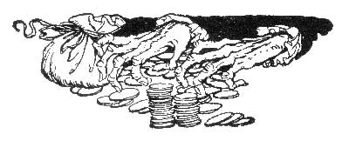
[Pg 35]
[Pg 36]

STAVE TWO
[Pg 37]

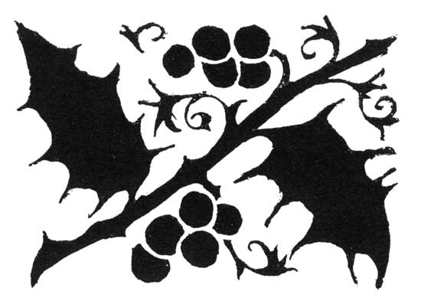
THE FIRST OF THE THREE SPIRITS
When Scrooge awoke it was so dark, that, looking out of bed, he could scarcely distinguish the transparent window from the opaque walls of his chamber. He was endeavouring to pierce the darkness with his ferret eyes, when the chimes of a neighbouring church struck the four quarters. So he listened for the hour.
To his great astonishment, the heavy bell went on from six to seven, and from seven to eight, and regularly up to twelve; then stopped. Twelve! It was past two when he went to bed. The clock was wrong. An icicle must have got into the works. Twelve!
He touched the spring of his repeater, to correct this most preposterous clock. Its rapid little pulse beat twelve, and stopped.[Pg 38]
'Why, it isn't possible,' said Scrooge, 'that I can have slept through a whole day and far into another night. It isn't possible that anything has happened to the sun, and this is twelve at noon!'
The idea being an alarming one, he scrambled out of bed, and groped his way to the window. He was obliged to rub the frost off with the sleeve of his dressing-gown before he could see anything; and could see very little then. All he could make out was, that it was still very foggy and extremely cold, and that there was no noise of people running to and fro, and making a great stir, as there unquestionably would have been if night had beaten off bright day, and taken possession of the world. This was a great relief, because 'Three days after sight of this First of Exchange pay to Mr. Ebenezer Scrooge or his order,' and so forth, would have become a mere United States security if there were no days to count by.
Scrooge went to bed again, and thought, and thought, and thought it over and over, and could make nothing of it. The more he thought, the more perplexed he was; and, the more he endeavoured not to think, the more he thought.
Marley's Ghost bothered him exceedingly. Every time he resolved within himself, after mature inquiry that it was all a dream, his mind flew back again, like a strong spring released, to its first position, and pre[Pg 39]sented the same problem to be worked all through, 'Was it a dream or not?'
Scrooge lay in this state until the chime had gone three-quarters more, when he remembered, on a sudden, that the Ghost had warned him of a visitation when the bell tolled one. He resolved to lie awake until the hour was passed; and, considering that he could no more go to sleep than go to heaven, this was, perhaps, the wisest resolution in his power.
The quarter was so long, that he was more than once convinced he must have sunk into a doze unconsciously, and missed the clock. At length it broke upon his listening ear.
'Ding, dong!'
'A quarter past,' said Scrooge, counting.
'Ding, dong!'
'Half past,' said Scrooge.
'Ding, dong!'
'A quarter to it.' said Scrooge.
'Ding, dong!'
'The hour itself,' said Scrooge triumphantly, 'and nothing else!'
He spoke before the hour bell sounded, which it now did with a deep, dull, hollow, melancholy One. Light flashed up in the room upon the instant, and the curtains of his bed were drawn.
The curtains of his bed were drawn aside, I tell you,[Pg 40] by a hand. Not the curtains at his feet, nor the curtains at his back, but those to which his face was addressed. The curtains of his bed were drawn aside; and Scrooge, starting up into a half-recumbent attitude, found himself face to face with the unearthly visitor who drew them: as close to it as I am now to you, and I am standing in the spirit at your elbow.
It was a strange figure—like a child; yet not so like a child as like an old man, viewed through some supernatural medium, which gave him the appearance of having receded from the view, and being diminished to a child's proportions. Its hair, which hung about its neck and down its back, was white, as if with age; and yet the face had not a wrinkle in it, and the tenderest bloom was on the skin. The arms were very long and muscular; the hands the same, as if its hold were of uncommon strength. Its legs and feet, most delicately formed, were, like those upper members, bare. It wore a tunic of the purest white; and round its waist was bound a lustrous belt, the sheen of which was beautiful. It held a branch of fresh green holly in its hand; and, in singular contradiction of that wintry emblem, had its dress trimmed with summer flowers. But the strangest thing about it was, that from the crown of its head there sprang a bright clear jet of light, by which all this was visible; and which was doubtless the occasion of its using, in its duller[Pg 41] moments, a great extinguisher for a cap, which it now held under its arm.
Even this, though, when Scrooge looked at it with increasing steadiness, was not its strangest quality. For, as its belt sparkled and glittered, now in one part and now in another, and what was light one instant at another time was dark, so the figure itself fluctuated in its distinctness; being now a thing with one arm, now with one leg, now with twenty legs, now a pair of legs without a head, now a head without a body: of which dissolving parts no outline would be visible in the dense gloom wherein they melted away. And, in the very wonder of this, it would be itself again; distinct and clear as ever.
'Are you the Spirit, sir, whose coming was foretold to me?' asked Scrooge.
'I am!'
The voice was soft and gentle. Singularly low, as if, instead of being so close behind him, it were at a distance.
'Who and what are you?' Scrooge demanded.
'I am the Ghost of Christmas Past.'
'Long Past?' inquired Scrooge, observant of its dwarfish stature.
'No. Your past.'
Perhaps Scrooge could not have told anybody why, if anybody could have asked him; but he had a special[Pg 42] desire to see the Spirit in his cap, and begged him to be covered.
'What!' exclaimed the Ghost, 'would you so soon put out, with worldly hands, the light I give? Is it not enough that you are one of those whose passions made this cap, and force me through whole trains of years to wear it low upon my brow?'
Scrooge reverently disclaimed all intention to offend or any knowledge of having wilfully 'bonneted' the Spirit at any period of his life. He then made bold to inquire what business brought him there.
'Your welfare!' said the Ghost.
Scrooge expressed himself much obliged, but could not help thinking that a night of unbroken rest would have been more conducive to that end. The Spirit must have heard him thinking, for it said immediately—
'Your reclamation, then. Take heed!'
It put out its strong hand as it spoke, and clasped him gently by the arm.
'Rise! and walk with me!'
It would have been in vain for Scrooge to plead that the weather and the hour were not adapted to pedestrian purposes; that bed was warm, and the thermometer a long way below freezing; that he was clad but lightly in his slippers, dressing-gown, and nightcap; and that he had a cold upon him at that time. The[Pg 43] grasp, though gentle as a woman's hand, was not to be resisted. He rose; but, finding that the Spirit made towards the window, clasped its robe in supplication.
'I am a mortal,' Scrooge remonstrated, 'and liable to fall.'
'Bear but a touch of my hand there,' said the Spirit, laying it upon his heart, 'and you shall be upheld in more than this!'
As the words were spoken, they passed through the wall, and stood upon an open country road, with fields on either hand. The city had entirely vanished. Not a vestige of it was to be seen. The darkness and the mist had vanished with it, for it was a clear, cold, winter day, with snow upon the ground.
'Good Heaven!' said Scrooge, clasping his hands together, as he looked about him. 'I was bred in this place. I was a boy here!'
The Spirit gazed upon him mildly. Its gentle touch, though it had been light and instantaneous, appeared still present to the old man's sense of feeling. He was conscious of a thousand odours floating in the air, each one connected with a thousand thoughts, and hopes, and joys, and cares long, long forgotten!
'Your lip is trembling,' said the Ghost. 'And what is that upon your cheek?'
Scrooge muttered, with an unusual catching in his[Pg 44] voice, that it was a pimple; and begged the Ghost to lead him where he would.
'You recollect the way?' inquired the Spirit.
'Remember it!' cried Scrooge with fervour; 'I could walk it blindfold.'
'Strange to have forgotten it for so many years!' observed the Ghost. 'Let us go on.'
They walked along the road, Scrooge recognising every gate, and post, and tree, until a little market-town appeared in the distance, with its bridge, its church, and winding river. Some shaggy ponies now were seen trotting towards them with boys upon their backs, who called to other boys in country gigs and carts, driven by farmers. All these boys were in great spirits, and shouted to each other, until the broad fields were so full of merry music, that the crisp air laughed to hear it.
'These are but shadows of the things that have been,' said the Ghost. 'They have no consciousness of us.'
The jocund travellers came on; and as they came, Scrooge knew and named them every one. Why was he rejoiced beyond all bounds to see them? Why did his cold eye glisten, and his heart leap up as they went past? Why was he filled with gladness when he heard them give each other Merry Christmas, as they parted at cross-roads and by-ways for their several homes?[Pg 45] What was merry Christmas to Scrooge? Out upon merry Christmas! What good had it ever done to him?
'The school is not quite deserted,' said the Ghost. 'A solitary child, neglected by his friends, is left there still.'
Scrooge said he knew it. And he sobbed.
They left the high-road by a well-remembered lane and soon approached a mansion of dull red brick, with a little weather-cock surmounted cupola on the roof, and a bell hanging in it. It was a large house, but one of broken fortunes; for the spacious offices were little used, their walls were damp and mossy, their windows broken, and their gates decayed. Fowls clucked and strutted in the stables; and the coach-houses and sheds were overrun with grass. Nor was it more retentive of its ancient state within; for, entering the dreary hall, and glancing through the open doors of many rooms, they found them poorly furnished, cold, and vast. There was an earthy savour in the air, a chilly bareness in the place, which associated itself somehow with too much getting up by candle light and not too much to eat.
They went, the Ghost and Scrooge, across the hall, to a door at the back of the house. It opened before them, and disclosed a long, bare, melancholy room, made barer still by lines of plain deal forms and desks. At one of these a lonely boy was reading near a feeble fire;[Pg 46] and Scrooge sat down upon a form, and wept to see his poor forgotten self as he had used to be.
Not a latent echo in the house, not a squeak and scuffle from the mice behind the panelling, not a drip from the half-thawed waterspout in the dull yard behind, not a sigh among the leafless boughs of one despondent poplar, not the idle swinging of an empty storehouse door, no, not a clicking in the fire, but fell upon the heart of Scrooge with softening influence, and gave a freer passage to his tears.
The Spirit touched him on the arm, and pointed to his younger self, intent upon his reading. Suddenly a man in foreign garments, wonderfully real and distinct to look at, stood outside the window, with an axe stuck in his belt, and leading by the bridle an ass laden with wood.
'Why, it's Ali Baba!' Scrooge exclaimed in ecstasy. 'It's dear old honest Ali Baba! Yes, yes, I know. One Christmas-time, when yonder solitary child was left here all alone, he did come, for the first time, just like that. Poor boy! And Valentine,' said Scrooge, 'and his wild brother, Orson; there they go! And what's his name, who was put down in his drawers, asleep, at the gate of Damascus; don't you see him? And the Sultan's Groom turned upside down by the Genii; there he is upon his head! Serve him right! I'm glad of it. What business had he to be married to the Princess?'[Pg 47]
To hear Scrooge expending all the earnestness of his nature on such subjects, in a most extraordinary voice between laughing and crying; and to see his heightened and excited face; would have been a surprise to his business friends in the City, indeed.
'There's the Parrot!' cried Scrooge. 'Green body and yellow tail, with a thing like a lettuce growing out of the top of his head; there he is! Poor Robin Crusoe he called him, when he came home again after sailing round the island. "Poor Robin Crusoe, where have you been, Robin Crusoe?" The man thought he was dreaming, but he wasn't. It was the Parrot, you know. There goes Friday, running for his life to the little creek! Halloa! Hoop! Halloo!'
Then, with a rapidity of transition very foreign to his usual character, he said, in pity for his former self, 'Poor boy!' and cried again.
'I wish,' Scrooge muttered, putting his hand in his pocket, and looking about him, after drying his eyes with his cuff; 'but it's too late now.'
'What is the matter?' asked the Spirit.
'Nothing,' said Scrooge. 'Nothing. There was a boy singing a Christmas carol at my door last night. I should like to have given him something: that's all.'
The Ghost smiled thoughtfully, and waved its hand, saying as it did so, 'Let us see another Christmas!'[Pg 48]
Scrooge's former self grew larger at the words, and the room became a little darker and more dirty. The panels shrunk, the windows cracked; fragments of plaster fell out of the ceiling, and the naked laths were shown instead; but how all this was brought about Scrooge knew no more than you do. He only knew that it was quite correct; that everything had happened so; that there he was, alone again, when all the other boys had gone home for the jolly holidays.
He was not reading now, but walking up and down despairingly. Scrooge looked at the Ghost, and, with a mournful shaking of his head, glanced anxiously towards the door.
It opened; and a little girl, much younger than the boy, came darting in, and, putting her arms about his neck, and often kissing him, addressed him as her 'dear, dear brother.'
'I have come to bring you home, dear brother!' said the child, clapping her tiny hands, and bending down to laugh. 'To bring you home, home, home!'
'Home, little Fan?' returned the boy.
'Yes!' said the child, brimful of glee. 'Home for good and all. Home for ever and ever. Father is so much kinder than he used to be, that home's like heaven! He spoke so gently to me one dear night when I was going to bed, that I was not afraid to ask him once more if you might come home; and he said[Pg 49] Yes, you should; and sent me in a coach to bring you. And you're to be a man!' said the child, opening her eyes; 'and are never to come back here; but first we're to be together all the Christmas long, and have the merriest time in all the world.'
'You are quite a woman, little Fan!' exclaimed the boy.
She clapped her hands and laughed, and tried to touch his head; but, being too little laughed again, and stood on tiptoe to embrace him. Then she began to drag him, in her childish eagerness, towards the door; and he, nothing loath to go, accompanied her.
A terrible voice in the hall cried, 'Bring down Master Scrooge's box, there!' and in the hall appeared the schoolmaster himself, who glared on Master Scrooge with a ferocious condescension, and threw him into a dreadful state of mind by shaking hands with him. He then conveyed him and his sister into the veriest old well of a shivering best parlour that ever was seen, where the maps upon the wall, and the celestial and terrestrial globes in the windows, were waxy with cold. Here he produced a decanter of curiously light wine, and a block of curiously heavy cake, and administered instalments of those dainties to the young people; at the same time sending out a meagre servant to offer a glass of 'something' to the postboy, who answered that he thanked the gentleman, but, if it was the same tap as he had tasted before, he[Pg 50] had rather not. Master Scrooge's trunk being by this time tied on to the top of the chaise, the children bade the schoolmaster good-bye right willingly; and, getting into it, drove gaily down the garden sweep; the quick wheels dashing the hoar-frost and snow from off the dark leaves of the evergreens like spray.
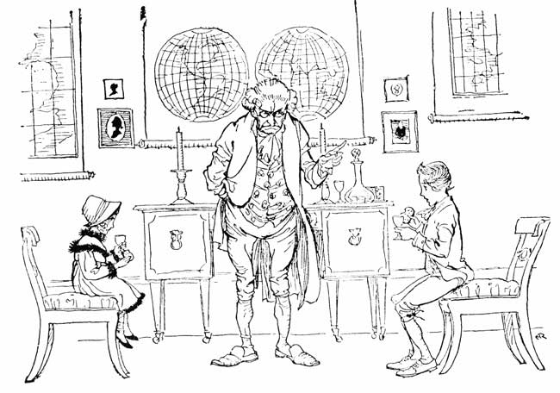 HE PRODUCED A DECANTER OF CURIOUSLY LIGHT WINE, AND A BLOCK OF CURIOUSLY HEAVY CAKE
'Always a delicate creature, whom a breath might[Pg 51] have withered,' said the Ghost. 'But she had a large heart!'
'So she had,' cried Scrooge. 'You're right. I will not gainsay it, Spirit. God forbid!'
'She died a woman,' said the Ghost, 'and had, as I think, children.'
'One child,' Scrooge returned.
'True,' said the Ghost. 'Your nephew!'
Scrooge seemed uneasy in his mind, and answered briefly, 'Yes.'
Although they had but that moment left the school behind them, they were now in the busy thoroughfares of a city, where shadowy passengers passed and re-passed; where shadowy carts and coaches battled for the way, and all the strife and tumult of a real city were. It was made plain enough, by the dressing of the shops, that here, too, it was Christmas-time again; but it was evening, and the streets were lighted up.
The Ghost stopped at a certain warehouse door, and asked Scrooge if he knew it.
'Know it!' said Scrooge. 'Was I apprenticed here?'
They went in. At sight of an old gentleman in a Welsh wig, sitting behind such a high desk, that if he had been two inches taller, he must have knocked his head against the ceiling, Scrooge cried in great excitement[Pg 52]—
'Why, it's old Fezziwig! Bless his heart, it's Fezziwig alive again!'
Old Fezziwig laid down his pen, and looked up at the clock, which pointed to the hour of seven. He rubbed his hands; adjusted his capacious waistcoat; laughed all over himself, from his shoes to his organ of benevolence; and called out, in a comfortable, oily, rich, fat, jovial voice—
'Yo ho, there! Ebenezer! Dick!'
Scrooge's former self, now grown a young man, came briskly in, accompanied by his fellow-'prentice.
'Dick Wilkins, to be sure!' said Scrooge to the Ghost. 'Bless me, yes. There he is. He was very much attached to me, was Dick. Poor Dick! Dear, dear!'
'Yo ho, my boys!' said Fezziwig. 'No more work to-night. Christmas Eve, Dick. Christmas, Ebenezer! Let's have the shutters up,' cried old Fezziwig, with a sharp clap of his hands, 'before a man can say Jack Robinson!'
You wouldn't believe how those two fellows went at it! They charged into the street with the shutters—one, two, three—had 'em up in their places—four, five, six—barred 'em and pinned 'em—seven, eight, nine—and came back before you could have got to twelve, panting like racehorses.
'Hilli-ho!' cried old Fezziwig, skipping down from[Pg 53] the high desk with wonderful agility. 'Clear away, my lads, and let's have lots of room here! Hilli-ho, Dick! Chirrup, Ebenezer!'
Clear away! There was nothing they wouldn't have cleared away, or couldn't have cleared away, with old Fezziwig looking on. It was done in a minute. Every movable was packed off, as if it were dismissed from public life for evermore; the floor was swept and watered, the lamps were trimmed, fuel was heaped upon the fire; and the warehouse was as snug, and warm, and dry, and bright a ball-room as you would desire to see upon a winter's night.
In came a fiddler with a music-book, and went up to the lofty desk, and made an orchestra of it, and tuned like fifty stomach-aches. In came Mrs. Fezziwig, one vast substantial smile. In came the three Miss Fezziwigs, beaming and lovable. In came the six young followers whose hearts they broke. In came all the young men and women employed in the business. In came the housemaid, with her cousin the baker. In came the cook with her brother's particular friend the milkman. In came the boy from over the way, who was suspected of not having board enough from his master; trying to hide himself behind the girl from next door but one, who was proved to have had her ears pulled by her mistress. In they all came, one after another; some shyly, some boldly, some grace[Pg 54]fully, some awkwardly, some pushing, some pulling; in they all came, any how and every how. Away they all went, twenty couple at once; hands half round and back again the other way; down the middle and up again; round and round in various stages of affectionate grouping; old top couple always turning up in the wrong place; new top couple starting off again as soon as they got there; all top couples at last, and not a bottom one to help them! When this result was brought about, old Fezziwig, clapping his hands to stop the dance, cried out, 'Well done!' and the fiddler plunged his hot face into a pot of porter, especially provided for that purpose. But, scorning rest upon his reappearance, he instantly began again, though there were no dancers yet, as if the other fiddler had been carried home, exhausted, on a shutter, and he were a bran-new man resolved to beat him out of sight, or perish.
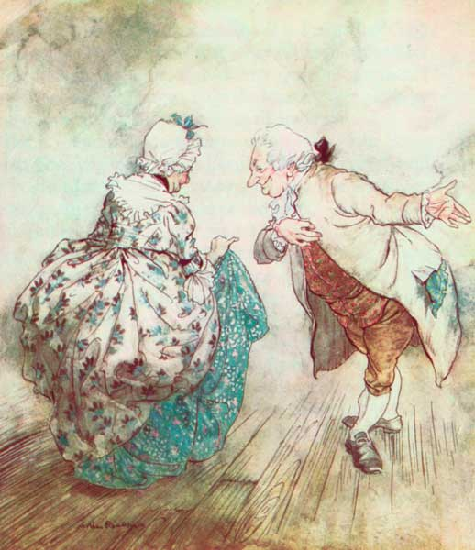 Then old Fezziwig stood out to dance with Mrs. Fezziwig
There were more dances, and there were forfeits, and more dances, and there was cake, and there was negus, and there was a great piece of Cold Roast, and there was a great piece of Cold Boiled, and there were mince-pies, and plenty of beer. But the great effect of the evening came after the Roast and Boiled, when the fiddler (an artful dog, mind! The sort of man who knew his business better than you or I could have told it him!) struck up 'Sir Roger de Coverley.' Then old[Pg 55] Fezziwig stood out to dance with Mrs. Fezziwig. Top couple, too; with a good stiff piece of work cut out for them; three or four and twenty pair of partners; people who were not to be trifled with; people who would dance, and had no notion of walking.
But if they had been twice as many—ah! four times—old Fezziwig would have been a match for them, and so would Mrs. Fezziwig. As to her, she was worthy to be his partner in every sense of the term. If that's not high praise, tell me higher, and I'll use it. A positive light appeared to issue from Fezziwig's calves. They shone in every part of the dance like moons. You couldn't have predicted, at any given time, what would become of them next. And when old Fezziwig and Mrs. Fezziwig had gone all through the dance; advance and retire, both hands to your partner, bow and curtsy, cork-screw, thread-the-needle, and back again to your place: Fezziwig 'cut'—cut so deftly, that he appeared to wink with his legs, and came upon his feet again without a stagger.
When the clock struck eleven, this domestic ball broke up. Mr. and Mrs. Fezziwig took their stations, one on either side the door, and, shaking hands with every person individually as he or she went out, wished him or her a Merry Christmas. When everybody had retired but the two 'prentices, they did the same to them; and thus the cheerful voices died away, and the[Pg 56] lads were left to their beds; which were under a counter in the back-shop.
During the whole of this time Scrooge had acted like a man out of his wits. His heart and soul were in the scene, and with his former self. He corroborated everything, remembered everything, enjoyed everything, and underwent the strangest agitation. It was not until now, when the bright faces of his former self and Dick were turned from them, that he remembered the Ghost, and became conscious that it was looking full upon him, while the light upon its head burnt very clear.
'A small matter,' said the Ghost, 'to make these silly folks so full of gratitude.'
'Small!' echoed Scrooge.
The Spirit signed to him to listen to the two apprentices, who were pouring out their hearts in praise of Fezziwig; and when he had done so, said:
'Why! Is it not? He has spent but a few pounds of your mortal money: three or four, perhaps. Is that so much that he deserves this praise?'
'It isn't that,' said Scrooge, heated by the remark, and speaking unconsciously like his former, not his latter self. 'It isn't that, Spirit. He has the power to render us happy or unhappy; to make our service light or burdensome; a pleasure or a toil. Say that his power lies in words and looks; in things so slight[Pg 57] and insignificant that it is impossible to add and count 'em up: what then? The happiness he gives is quite as great as if it cost a fortune.'
He felt the Spirit's glance, and stopped.
'What is the matter?' asked the Ghost.
'Nothing particular,' said Scrooge.
'Something, I think?' the Ghost insisted.
'No,' said Scrooge, 'no. I should like to be able to say a word or two to my clerk just now. That's all.'
His former self turned down the lamps as he gave utterance to the wish; and Scrooge and the Ghost again stood side by side in the open air.
'My time grows short,' observed the Spirit. 'Quick!'
This was not addressed to Scrooge, or to any one whom he could see, but it produced an immediate effect. For again Scrooge saw himself. He was older now; a man in the prime of life. His face had not the harsh and rigid lines of later years; but it had begun to wear the signs of care and avarice. There was an eager, greedy, restless motion in the eye, which showed the passion that had taken root, and where the shadow of the growing tree would fall.
He was not alone, but sat by the side of a fair young girl in a mourning dress: in whose eyes there were tears, which sparkled in the light that shone out of the Ghost of Christmas Past.[Pg 58]
'It matters little,' she said softly. 'To you, very little. Another idol has displaced me; and, if it can cheer and comfort you in time to come as I would have tried to do, I have no just cause to grieve.'
'What Idol has displaced you?' he rejoined.
'A golden one.'
'This is the even-handed dealing of the world!' he said. 'There is nothing on which it is so hard as poverty; and there is nothing it professes to condemn with such severity as the pursuit of wealth!'
'You fear the world too much,' she answered gently. 'All your other hopes have merged into the hope of being beyond the chance of its sordid reproach. I have seen your nobler aspirations fall off one by one, until the master passion, Gain, engrosses you. Have I not?'
'What then?' he retorted. 'Even if I have grown so much wiser, what then? I am not changed towards you.'
She shook her head.
'Am I?'
'Our contract is an old one. It was made when we were both poor, and content to be so, until, in good season, we could improve our worldly fortune by our patient industry. You are changed. When it was made you were another man.'
'I was a boy,' he said impatiently.[Pg 59]
'Your own feeling tells you that you were not what you are,' she returned. 'I am. That which promised happiness when we were one in heart is fraught with misery now that we are two. How often and how keenly I have thought of this I will not say. It is enough that I have thought of it, and can release you.'
'Have I ever sought release?'
'In words. No. Never.'
'In what, then?'
'In a changed nature; in an altered spirit; in another atmosphere of life; another Hope as its great end. In everything that made my love of any worth or value in your sight. If this had never been between us,' said the girl, looking mildly, but with steadiness, upon him; 'tell me, would you seek me out and try to win me now? Ah, no!'
He seemed to yield to the justice of this supposition in spite of himself. But he said, with a struggle, 'You think not.'
'I would gladly think otherwise if I could,' she answered. 'Heaven knows! When I have learned a Truth like this, I know how strong and irresistible it must be. But if you were free to-day, to-morrow, yesterday, can even I believe that you would choose a dowerless girl—you who, in your very confidence with her, weigh everything by Gain: or, choosing her, if for a moment you were false enough to your one[Pg 60] guiding principle to do so, do I not know that your repentance and regret would surely follow? I do; and I release you. With a full heart, for the love of him you once were.'
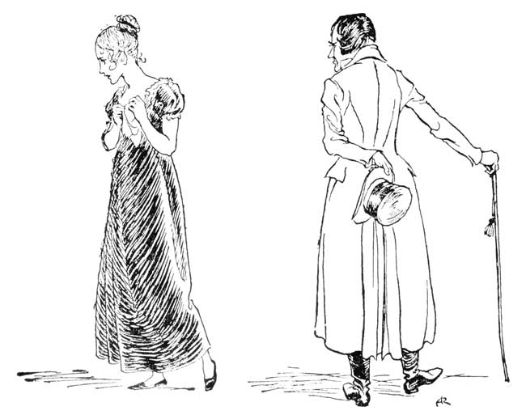 SHE LEFT HIM, AND THEY PARTED
He was about to speak; but, with her head turned from him, she resumed:
'You may—the memory of what is past half makes me hope you will—have pain in this. A very, very brief time, and you will dismiss the recollection of[Pg 61] it gladly, as an unprofitable dream, from which it happened well that you awoke. May you be happy in the life you have chosen!'
She left him, and they parted.
'Spirit!' said Scrooge, 'show me no more! Conduct me home. Why do you delight to torture me?'
'One shadow more!' exclaimed the Ghost.
'No more!' cried Scrooge. 'No more! I don't wish to see it. Show me no more!'
But the relentless Ghost pinioned him in both his arms, and forced him to observe what happened next.
They were in another scene and place; a room, not very large or handsome, but full of comfort. Near to the winter fire sat a beautiful young girl, so like that last that Scrooge believed it was the same, until he saw her, now a comely matron, sitting opposite her daughter. The noise in this room was perfectly tumultuous, for there were more children there than Scrooge in his agitated state of mind could count; and, unlike the celebrated herd in the poem, they were not forty children conducting themselves like one, but every child was conducting itself like forty. The consequences were uproarious beyond belief; but no one seemed to care; on the contrary, the mother and daughter laughed heartily, and enjoyed it very much; and the latter, soon beginning to mingle in the sports, got pillaged by the young brigands most ruthlessly.[Pg 62] What would I not have given to be one of them! Though I never could have been so rude, no, no! I wouldn't for the wealth of all the world have crushed that braided hair, and torn it down; and for the precious little shoe, I wouldn't have plucked it off, God bless my soul! to save my life. As to measuring her waist in sport, as they did, bold young brood, I couldn't have done it; I should have expected my arm to have grown round it for a punishment, and never come straight again. And yet I should have dearly liked, I own, to have touched her lips; to have questioned her, that she might have opened them; to have looked upon the lashes of her downcast eyes, and never raised a blush; to have let loose waves of hair, an inch of which would be a keepsake beyond price: in short, I should have liked, I do confess, to have had the lightest license of a child, and yet to have been man enough to know its value.
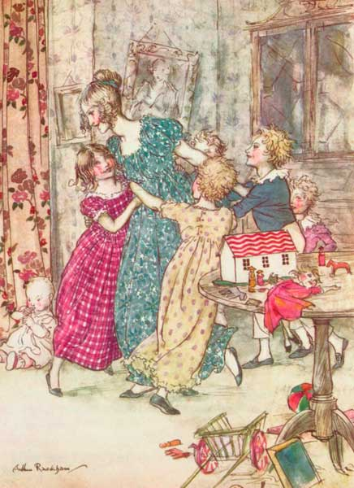 A flushed and boisterous group
But now a knocking at the door was heard, and such a rush immediately ensued that she, with laughing face and plundered dress, was borne towards it the centre of a flushed and boisterous group, just in time to greet the father, who came home attended by a man laden with Christmas toys and presents. Then the shouting and the struggling, and the onslaught that was made on the defenceless porter! The scaling him, with chairs for ladders, to dive into his pockets, despoil him of[Pg 63] brown-paper parcels, hold on tight by his cravat, hug him round his neck, pummel his back, and kick his legs in irrepressible affection! The shouts of wonder and delight with which the development of every package was received! The terrible announcement that the baby had been taken in the act of putting a doll's frying pan into his mouth, and was more than suspected of having swallowed a fictitious turkey, glued on a wooden platter! The immense relief of finding this a false alarm! The joy, and gratitude, and ecstasy! They are all indescribable alike. It is enough that, by degrees, the children and their emotions got out of the parlour, and, by one stair at a time, up to the top of the house, where they went to bed, and so subsided.
And now Scrooge looked on more attentively than ever, when the master of the house, having his daughter leaning fondly on him, sat down with her and her mother at his own fireside; and when he thought that such another creature, quite as graceful and as full of promise, might have called him father, and been a spring-time in the haggard winter of his life, his sight grew very dim indeed.
'Belle,' said the husband, turning to his wife with a smile, 'I saw an old friend of yours this afternoon.'
'Who was it?'
'Guess!'
'How can I? Tut, don't I know?' she added in[Pg 64] the same breath, laughing as he laughed. 'Mr. Scrooge.'
'Mr. Scrooge it was. I passed his office window; and as it was not shut up, and he had a candle inside, I could scarcely help seeing him. His partner lies upon the point of death, I hear; and there he sat alone. Quite alone in the world, I do believe.'
'Spirit!' said Scrooge in a broken voice, 'remove me from this place.'
'I told you these were shadows of the things that have been,' said the Ghost. 'That they are what they are do not blame me!'
'Remove me!' Scrooge exclaimed, 'I cannot bear it!'
He turned upon the Ghost, and seeing that it looked upon him with a face, in which in some strange way there were fragments of all the faces it had shown him, wrestled with it.
'Leave me! Take me back. Haunt me no longer!'
In the struggle, if that can be called a struggle in which the Ghost with no visible resistance on its own part was undisturbed by any effort of its adversary, Scrooge observed that its light was burning high and bright; and dimly connecting that with its influence over him, he seized the extinguisher-cap, and by a sudden action pressed it down upon its head.
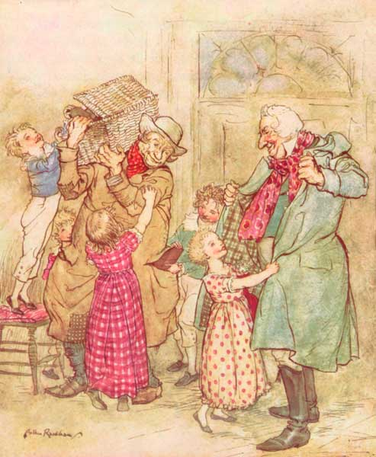 Laden with Christmas toys and presents
[Pg 65]
The Spirit dropped beneath it, so that the extinguisher covered its whole form; but though Scrooge pressed it down with all his force, he could not hide the light, which streamed from under it, in an unbroken flood upon the ground.
He was conscious of being exhausted, and overcome by an irresistible drowsiness; and, further, of being in his own bedroom. He gave the cap a parting squeeze, in which his hand relaxed; and had barely time to reel to bed, before he sank into a heavy sleep.
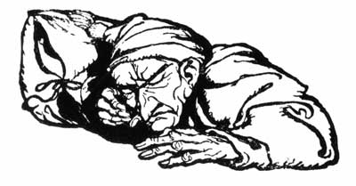
[Pg 66]
[Pg 67]

[Pg 68]
STAVE THREE
[Pg 69]

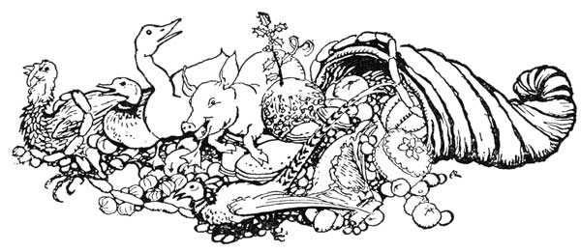
THE SECOND OF THE THREE SPIRITS
Awaking in the middle of a prodigiously tough snore, and sitting up in bed to get his thoughts together, Scrooge had no occasion to be told that the bell was again upon the stroke of One. He felt that he was restored to consciousness in the right nick of time, for the especial purpose of holding a conference with the second messenger despatched to him through Jacob Marley's intervention. But finding that he turned uncomfortably cold when he began to wonder which of his curtains this new spectre would draw back, he put them every one aside with his own hands, and, lying down again, established a sharp look-out all round the bed. For he wished to challenge the Spirit on the moment of its appearance, and did not wish to be taken by surprise and made nervous.[Pg 70]
Gentlemen of the free-and-easy sort, who plume themselves on being acquainted with a move or two, and being usually equal to the time of day, express the wide range of their capacity for adventure by observing that they are good for anything from pitch-and-toss to manslaughter; between which opposite extremes, no doubt, there lies a tolerably wide and comprehensive range of subjects. Without venturing for Scrooge quite as hardily as this, I don't mind calling on you to believe that he was ready for a good broad field of strange appearances, and that nothing between a baby and a rhinoceros would have astonished him very much.
Now, being prepared for almost anything, he was not by any means prepared for nothing; and consequently, when the bell struck One, and no shape appeared, he was taken with a violent fit of trembling. Five minutes, ten minutes, a quarter of an hour went by, yet nothing came. All this time he lay upon his bed, the very core and centre of a blaze of ruddy light, which streamed upon it when the clock proclaimed the hour; and which, being only light, was more alarming than a dozen ghosts, as he was powerless to make out what it meant, or would be at; and was sometimes apprehensive that he might be at that very moment an interesting case of spontaneous combustion, without having the consolation of knowing it. At last,[Pg 71] however, he began to think—as you or I would have thought at first; for it is always the person not in the predicament who knows what ought to have been done in it, and would unquestionably have done it too—at last, I say, he began to think that the source and secret of this ghostly light might be in the adjoining room, from whence, on further tracing it, it seemed to shine. This idea taking full possession of his mind, he got up softly, and shuffled in his slippers to the door.
The moment Scrooge's hand was on the lock a strange voice called him by his name, and bade him enter. He obeyed.
It was his own room. There was no doubt about that. But it had undergone a surprising transformation. The walls and ceiling were so hung with living green, that it looked a perfect grove; from every part of which bright gleaming berries glistened. The crisp leaves of holly, mistletoe, and ivy reflected back the light, as if so many little mirrors had been scattered there; and such a mighty blaze went roaring up the chimney as that dull petrification of a hearth had never known in Scrooge's time, or Marley's, or for many and many a winter season gone. Heaped up on the floor, to form a kind of throne, were turkeys, geese, game, poultry, brawn, great joints of meat, sucking-pigs, long wreaths of sausages, mince-pies, plum-puddings, barrels of oysters, red-hot chestnuts, cherry-cheeked[Pg 72] apples, juicy oranges, luscious pears, immense twelfth-cakes, and seething bowls of punch, that made the chamber dim with their delicious steam. In easy state upon this couch there sat a jolly Giant, glorious to see; who bore a glowing torch, in shape not unlike Plenty's horn, and held it up, high up, to shed its light on Scrooge as he came peeping round the door.
'Come in!' exclaimed the Ghost. 'Come in! and know me better, man!'
Scrooge entered timidly, and hung his head before this Spirit. He was not the dogged Scrooge he had been; and though the Spirit's eyes were clear and kind, he did not like to meet them.
'I am the Ghost of Christmas Present,' said the Spirit. 'Look upon me!'
Scrooge reverently did so. It was clothed in one simple deep green robe, or mantle, bordered with white fur. This garment hung so loosely on the figure, that its capacious breast was bare, as if disdaining to be warded or concealed by any artifice. Its feet, observable beneath the ample folds of the garment, were also bare; and on its head it wore no other covering than a holly wreath, set here and there with shining icicles. Its dark-brown curls were long and free; free as its genial face, its sparkling eye, its open hand, its cheery voice, its unconstrained demeanour, and its joyful air. Girded round its middle was an antique scabbard:[Pg 73] but no sword was in it, and the ancient sheath was eaten up with rust.
'You have never seen the like of me before!' exclaimed the Spirit.
'Never,' Scrooge made answer to it.
'Have never walked forth with the younger members of my family; meaning (for I am very young) my elder brothers born in these later years?' pursued the Phantom.
'I don't think I have,' said Scrooge. 'I am afraid I have not. Have you had many brothers, Spirit?'
'More than eighteen hundred,' said the Ghost.
'A tremendous family to provide for,' muttered Scrooge.
The Ghost of Christmas Present rose.
'Spirit,' said Scrooge submissively, 'conduct me where you will. I went forth last night on compulsion, and I learned a lesson which is working now. To-night if you have aught to teach me, let me profit by it.'
'Touch my robe!'
Scrooge did as he was told, and held it fast.
Holly, mistletoe, red berries, ivy, turkeys, geese, game, poultry, brawn, meat, pigs, sausages, oysters, pies, puddings, fruit, and punch, all vanished instantly. So did the room, the fire, the ruddy glow, the hour of night, and they stood in the city streets on Christmas[Pg 74] morning, where (for the weather was severe) the people made a rough, but brisk and not unpleasant kind of music, in scraping the snow from the pavement in front of their dwellings, and from the tops of their houses, whence it was mad delight to the boys to see it come plumping down into the road below, and splitting into artificial little snowstorms.
The house-fronts looked black enough, and the windows blacker, contrasting with the smooth white sheet of snow upon the roofs, and with the dirtier snow upon the ground; which last deposit had been ploughed up in deep furrows by the heavy wheels of carts and waggons: furrows that crossed and recrossed each other hundreds of times where the great streets branched off; and made intricate channels, hard to trace in the thick yellow mud and icy water. The sky was gloomy, and the shortest streets were choked up with a dingy mist, half thawed, half frozen, whose heavier particles descended in a shower of sooty atoms, as if all the chimneys in Great Britain had, by one consent, caught fire, and were blazing away to their dear heart's content. There was nothing very cheerful in the climate or the town, and yet was there an air of cheerfulness abroad that the clearest summer air and brightest summer sun might have endeavoured to diffuse in vain.
[Pg 75]
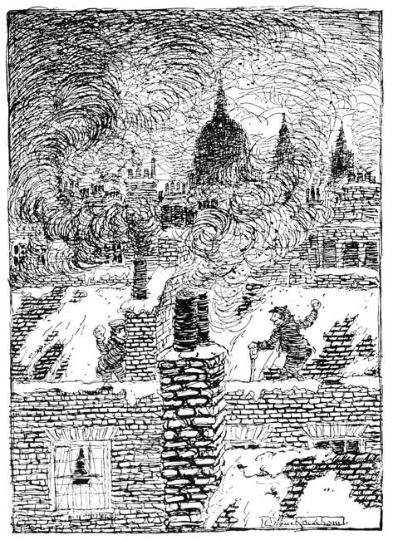 THERE WAS NOTHING VERY CHEERFUL IN THE CLIMATE
For the people who were shovelling away on the[Pg 76] house-tops were jovial and full of glee; calling out to one another from the parapets, and now and then exchanging a facetious snowball—better-natured missile far than many a wordy jest—laughing heartily if it went right, and not less heartily if it went wrong. The poulterers' shops were still half open, and the fruiterers' were radiant in their glory. There were great, round, pot-bellied baskets of chestnuts, shaped like the waistcoats of jolly old gentlemen, lolling at the doors, and tumbling out into the street in their apoplectic opulence: There were ruddy, brown-faced, broad-girthed Spanish onions, shining in the fatness of their growth like Spanish friars, and winking from their shelves in wanton slyness at the girls as they went by, and glanced demurely at the hung-up mistletoe. There were pears and apples clustered high in blooming pyramids; there were bunches of grapes, made, in the shopkeepers' benevolence, to dangle from conspicuous hooks that people's mouths might water gratis as they passed; there were piles of filberts, mossy and brown, recalling, in their fragrance, ancient walks among the woods, and pleasant shufflings ankle deep through withered leaves; there were Norfolk Biffins, squab and swarthy, setting off the yellow of the oranges and lemons, and, in the great compactness of their juicy persons, urgently entreating and beseeching to be carried home in paper bags and eaten after dinner.[Pg 77] The very gold and silver fish, set forth among these choice fruits in a bowl, though members of a dull and stagnant-blooded race, appeared to know that there was something going on; and, to a fish, went gasping round and round their little world in slow and passionless excitement.
The Grocers'! oh, the Grocers'! nearly closed, with perhaps two shutters down, or one; but through those gaps such glimpses! It was not alone that the scales descending on the counter made a merry sound, or that the twine and roller parted company so briskly, or that the canisters were rattled up and down like juggling tricks, or even that the blended scents of tea and coffee were so grateful to the nose, or even that the raisins were so plentiful and rare, the almonds so extremely white, the sticks of cinnamon so long and straight, the other spices so delicious, the candied fruits so caked and spotted with molten sugar as to make the coldest lookers-on feel faint, and subsequently bilious. Nor was it that the figs were moist and pulpy, or that the French plums blushed in modest tartness from their highly-decorated boxes, or that everything was good to eat and in its Christmas dress; but the customers were all so hurried and so eager in the hopeful promise of the day, that they tumbled up against each other at the door, crashing their wicker baskets wildly, and left their purchases upon the counter, and came running[Pg 78] back to fetch them, and committed hundreds of the like mistakes, in the best humour possible; while the grocer and his people were so frank and fresh, that the polished hearts with which they fastened their aprons behind might have been their own, worn outside for general inspection, and for Christmas daws to peck at if they chose.
But soon the steeples called good people all to church and chapel, and away they came, flocking through the streets in their best clothes and with their gayest faces. And at the same time there emerged, from scores of by-streets, lanes, and nameless turnings, innumerable people, carrying their dinners to the bakers' shops. The sight of these poor revellers appeared to interest the Spirit very much, for he stood with Scrooge beside him in a baker's doorway, and, taking off the covers as their bearers passed, sprinkled incense on their dinners from his torch. And it was a very uncommon kind of torch, for once or twice, when there were angry words between some dinner-carriers who had jostled each other, he shed a few drops of water on them from it, and their good-humour was restored directly. For they said, it was a shame to quarrel upon Christmas Day. And so it was! God love it, so it was!
In time the bells ceased, and the bakers were shut up; and yet there was a genial shadowing forth of all these dinners, and the progress of their cooking, in the[Pg 79] thawed blotch of wet above each baker's oven, where the pavement smoked as if its stones were cooking too.
'Is there a peculiar flavour in what you sprinkle from your torch?' asked Scrooge.
'There is. My own.'
'Would it apply to any kind of dinner on this day?' asked Scrooge.
'To any kindly given. To a poor one most.'
'Why to a poor one most?' asked Scrooge.
'Because it needs it most.'
'Spirit!' said Scrooge, after a moment's thought, 'I wonder you, of all the beings in the many worlds about us, should desire to cramp these people's opportunities of innocent enjoyment.
'I!' cried the Spirit.
'You would deprive them of their means of dining every seventh day, often the only day on which they can be said to dine at all,' said Scrooge; 'wouldn't you?'
'I!' cried the Spirit.
'You seek to close these places on the Seventh Day,' said Scrooge. 'And it comes to the same thing.'
'I seek!' exclaimed the Spirit.
'Forgive me if I am wrong. It has been done in your name, or at least in that of your family,' said Scrooge.
'There are some upon this earth of yours,' returned[Pg 80] the Spirit, 'who lay claim to know us, and who do their deeds of passion, pride, ill-will, hatred, envy, bigotry, and selfishness in our name, who are as strange to us, and all our kith and kin, as if they had never lived. Remember that, and charge their doings on themselves, not us.'
Scrooge promised that he would; and they went on, invisible, as they had been before, into the suburbs of the town. It was a remarkable quality of the Ghost (which Scrooge had observed at the baker's), that notwithstanding his gigantic size, he could accommodate himself to any place with ease; and that he stood beneath a low roof quite as gracefully and like a supernatural creature as it was possible he could have done in any lofty hall.
And perhaps it was the pleasure the good Spirit had in showing off this power of his, or else it was his own kind, generous, hearty nature, and his sympathy with all poor men, that led him straight to Scrooge's clerk's; for there he went, and took Scrooge with him, holding to his robe; and on the threshold of the door the Spirit smiled, and stopped to bless Bob Cratchit's dwelling with the sprinklings of his torch. Think of that! Bob had but fifteen 'Bob' a week himself; he pocketed on Saturdays but fifteen copies of his Christian name; and yet the Ghost of Christmas Present blessed his four-roomed house![Pg 81]
Then up rose Mrs. Cratchit, Cratchit's wife, dressed out but poorly in a twice-turned gown, but brave in ribbons, which are cheap, and make a goodly show for sixpence; and she laid the cloth, assisted by Belinda Cratchit, second of her daughters, also brave in ribbons; while Master Peter Cratchit plunged a fork into the saucepan of potatoes, and getting the corners of his monstrous shirt-collar (Bob's private property, conferred upon his son and heir in honour of the day,) into his mouth, rejoiced to find himself so gallantly attired, and yearned to show his linen in the fashionable Parks. And now two smaller Cratchits, boy and girl, came tearing in, screaming that outside the baker's they had smelt the goose, and known it for their own; and basking in luxurious thoughts of sage and onion, these young Cratchits danced about the table, and exalted Master Peter Cratchit to the skies, while he (not proud, although his collars nearly choked him) blew the fire, until the slow potatoes, bubbling up, knocked loudly at the saucepan-lid to be let out and peeled.
'What has ever got your precious father, then?' said Mrs. Cratchit. 'And your brother, Tiny Tim? And Martha warn't as late last Christmas Day by half an hour!'
'Here's Martha, mother!' said a girl, appearing as she spoke.[Pg 82]
'Here's Martha, mother!' cried the two young Cratchits. 'Hurrah! There's such a goose, Martha!'
'Why, bless your heart alive, my dear, how late you are!' said Mrs. Cratchit, kissing her a dozen times, and taking off her shawl and bonnet for her with officious zeal.
'We'd a deal of work to finish up last night,' replied the girl, 'and had to clear away this morning, mother!'
'Well! never mind so long as you are come,' said Mrs. Cratchit. 'Sit ye down before the fire, my dear, and have a warm, Lord bless ye!'
'No, no! There's father coming,' cried the two young Cratchits, who were everywhere at once. 'Hide, Martha, hide!'
So Martha hid herself, and in came little Bob, the father, with at least three feet of comforter, exclusive of the fringe, hanging down before him, and his threadbare clothes darned up and brushed to look seasonable, and Tiny Tim upon his shoulder. Alas for Tiny Tim, he bore a little crutch, and had his limbs supported by an iron frame!
'Why, where's our Martha?' cried Bob Cratchit, looking round.
'Not coming,' said Mrs. Cratchit.
'Not coming!' said Bob, with a sudden declension in his high spirits; for he had been Tim's blood-horse[Pg 83] all the way from church, and had come home rampant. 'Not coming upon Christmas Day!'
Martha didn't like to see him disappointed, if it were only in joke; so she came out prematurely from behind the closet door, and ran into his arms, while the two young Cratchits hustled Tiny Tim, and bore him off into the wash-house, that he might hear the pudding singing in the copper.
'And how did little Tim behave?' asked Mrs. Cratchit when she had rallied Bob on his credulity, and Bob had hugged his daughter to his heart's content.
'As good as gold,' said Bob, 'and better. Somehow, he gets thoughtful, sitting by himself so much, and thinks the strangest things you ever heard. He told me, coming home, that he hoped the people saw him in the church, because he was a cripple, and it might be pleasant to them to remember upon Christmas Day who made lame beggars walk and blind men see.'
Bob's voice was tremulous when he told them this, and trembled more when he said that Tiny Tim was growing strong and hearty.
His active little crutch was heard upon the floor, and back came Tiny Tim before another word was spoken, escorted by his brother and sister to his stool beside the fire; and while Bob, turning up his cuffs—as if, poor fellow, they were capable of being made[Pg 84] more shabby—compounded some hot mixture in a jug with gin and lemons, and stirred it round and round, and put it on the hob to simmer, Master Peter and the two ubiquitous young Cratchits went to fetch the goose, with which they soon returned in high procession.
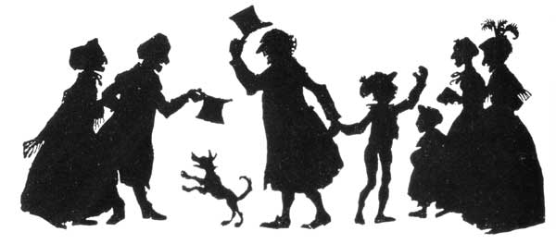
Such a bustle ensued that you might have thought a goose the rarest of all birds; a feathered phenomenon, to which a black swan was a matter of course—and, in truth, it was something very like it in that house. Mrs. Cratchit made the gravy (ready beforehand in a little saucepan) hissing hot; Master Peter mashed the potatoes with incredible vigour; Miss Belinda sweetened up the apple sauce; Martha dusted the hot plates; Bob took Tiny Tim beside him in a tiny corner at the table; the two young Cratchits set[Pg 85] chairs for everybody, not forgetting themselves, and, mounting guard upon their posts, crammed spoons into their mouths, lest they should shriek for goose before[Pg 86] their turn came to be helped. At last the dishes were set on, and grace was said. It was succeeded by a breathless pause, as Mrs. Cratchit, looking slowly all along the carving-knife, prepared to plunge it in the breast; but when she did, and when the long-expected gush of stuffing issued forth, one murmur of delight arose all round the board, and even Tiny Tim, excited by the two young Cratchits, beat on the table with the handle of his knife and feebly cried Hurrah!
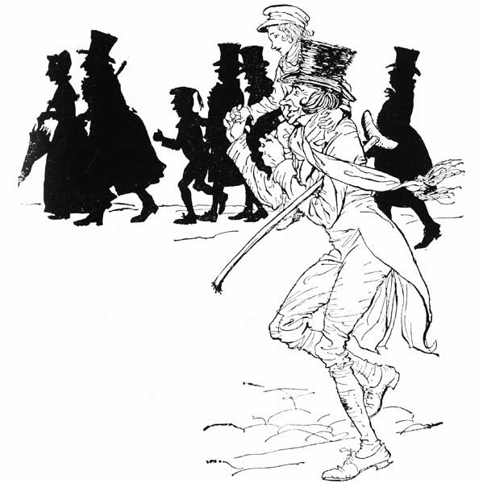 HE HAD BEEN TIM'S BLOOD-HORSE ALL THE WAY FROM CHURCH
There never was such a goose. Bob said he didn't believe there ever was such a goose cooked. Its tenderness and flavour, size and cheapness, were the themes of universal admiration. Eked out by apple sauce and mashed potatoes, it was a sufficient dinner for the whole family; indeed, as Mrs. Cratchit said with great delight (surveying one small atom of a bone upon the dish), they hadn't ate it all at last! Yet every one had had enough, and the youngest Cratchits, in particular, were steeped in sage and onion to the eyebrows! But now, the plates being changed by Miss Belinda, Mrs. Cratchit left the room alone—too nervous to bear witnesses—to take the pudding up, and bring it in.
Suppose it should not be done enough! Suppose it should break in turning out! Suppose somebody should have got over the wall of the back-yard and stolen it, while they were merry with the goose—a[Pg 87] supposition at which the two young Cratchits became livid! All sorts of horrors were supposed.
Hallo! A great deal of steam! The pudding was out of the copper. A smell like a washing-day! That was the cloth. A smell like an eating-house and a pastry-cook's next door to each other, with a laundress's next door to that! That was the pudding! In half a minute Mrs. Cratchit entered—flushed, but smiling proudly—with the pudding, like a speckled cannon-ball, so hard and firm, blazing in half of half-a-quartern of ignited brandy, and bedight with Christmas holly stuck into the top.
Oh, a wonderful pudding! Bob Cratchit said, and calmly too, that he regarded it as the greatest success achieved by Mrs. Cratchit since their marriage. Mrs. Cratchit said that, now the weight was off her mind, she would confess she had her doubts about the quantity of flour. Everybody had something to say about it, but nobody said or thought it was at all a small pudding for a large family. It would have been flat heresy to do so. Any Cratchit would have blushed to hint at such a thing.
[Pg 88]
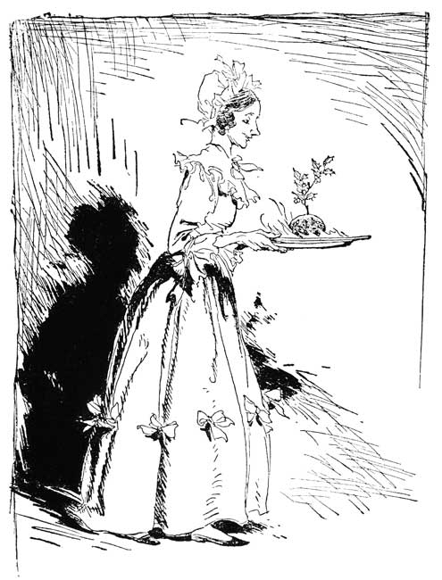 WITH THE PUDDING
At last the dinner was all done, the cloth was cleared, the hearth swept, and the fire made up. The compound in the jug being tasted and considered perfect, apples and oranges were put upon the table, and a shovel full of chestnuts on the fire. Then all the[Pg 89] Cratchit family drew round the hearth in what Bob Cratchit called a circle, meaning half a one; and at Bob Cratchit's elbow stood the family display of glass. Two tumblers and a custard cup without a handle.
These held the hot stuff from the jug, however, as well as golden goblets would have done; and Bob served it out with beaming looks, while the chestnuts on the fire sputtered and cracked noisily. Then Bob proposed:
'A merry Christmas to us all, my dears. God bless us!'
Which all the family re-echoed.
'God bless us every one!' said Tiny Tim, the last of all.
He sat very close to his father's side, upon his little stool. Bob held his withered little hand to his, as if he loved the child, and wished to keep him by his side, and dreaded that he might be taken from him.
'Spirit,' said Scrooge, with an interest he had never felt before, 'tell me if Tiny Tim will live.'
'I see a vacant seat,' replied the Ghost, 'in the poor chimney corner, and a crutch without an owner, carefully preserved. If these shadows remain unaltered by the Future, the child will die.'
'No, no,' said Scrooge. 'Oh no, kind Spirit! say he will be spared.'[Pg 90]
'If these shadows remain unaltered by the Future none other of my race,' returned the Ghost, 'will find him here. What then? If he be like to die, he had better do it, and decrease the surplus population.'
Scrooge hung his head to hear his own words quoted by the Spirit, and was overcome with penitence and grief.
'Man,' said the Ghost, 'if man you be in heart, not adamant, forbear that wicked cant until you have discovered what the surplus is, and where it is. Will you decide what men shall live, what men shall die? It may be that, in the sight of Heaven, you are more worthless and less fit to live than millions like this poor man's child. O God! to hear the insect on the leaf pronouncing on the too much life among his hungry brothers in the dust!'
Scrooge bent before the Ghost's rebuke, and, trembling, cast his eyes upon the ground. But he raised them speedily on hearing his own name.
'Mr. Scrooge!' said Bob. 'I'll give you Mr. Scrooge, the Founder of the Feast!'
'The Founder of the Feast, indeed!' cried Mrs. Cratchit, reddening. 'I wish I had him here. I'd give him a piece of my mind to feast upon, and I hope he'd have a good appetite for it.'
'My dear,' said Bob, 'the children! Christmas Day.'[Pg 91]
'It should be Christmas Day, I am sure,' said she, 'on which one drinks the health of such an odious, stingy, hard, unfeeling man as Mr. Scrooge. You know he is, Robert! Nobody knows it better than you do, poor fellow!'
'My dear!' was Bob's mild answer. 'Christmas Day.'
'I'll drink his health for your sake and the Day's,' said Mrs. Cratchit, 'not for his. Long life to him! A merry Christmas and a happy New Year! He'll be very merry and very happy, I have no doubt!'
The children drank the toast after her. It was the first of their proceedings which had no heartiness in it. Tiny Tim drank it last of all, but he didn't care twopence for it. Scrooge was the Ogre of the family. The mention of his name cast a dark shadow on the party, which was not dispelled for full five minutes.
After it had passed away they were ten times merrier than before, from the mere relief of Scrooge the Baleful being done with. Bob Cratchit told them how he had a situation in his eye for Master Peter, which would bring in, if obtained, full five-and-sixpence weekly. The two young Cratchits laughed tremendously at the idea of Peter's being a man of business; and Peter himself looked thoughtfully at the fire from between his collars, as if he were deliberating what particular investments he should favour[Pg 92] when he came into the receipt of that bewildering income. Martha, who was a poor apprentice at a milliner's, then told them what kind of work she had to do, and how many hours she worked at a stretch and how she meant to lie abed to-morrow morning for a good long rest; to-morrow being a holiday she passed at home. Also how she had seen a countess and a lord some days before, and how the lord 'was much about as tall as Peter'; at which Peter pulled up his collar so high that you couldn't have seen his head if you had been there. All this time the chestnuts and the jug went round and round; and by-and-by they had a song, about a lost child travelling in the snow, from Tiny Tim, who had a plaintive little voice, and sang it very well indeed.
There was nothing of high mark in this. They were not a handsome family; they were not well dressed; their shoes were far from being waterproof; their clothes were scanty; and Peter might have known, and very likely did, the inside of a pawnbroker's. But they were happy, grateful, pleased with one another, and contented with the time; and when they faded, and looked happier yet in the bright sprinklings of the Spirit's torch at parting, Scrooge had his eye upon them, and especially on Tiny Tim, until the last.
By this time it was getting dark, and snowing pretty heavily; and as Scrooge and the Spirit went along the[Pg 93] streets, the brightness of the roaring fires in kitchens, parlours, and all sorts of rooms was wonderful. Here, the flickering of the blaze showed preparations for a cosy dinner, with hot plates baking through and through before the fire, and deep red curtains, ready to be drawn to shut out cold and darkness. There, all the children of the house were running out into the snow to meet their married sisters, brothers, cousins, uncles, aunts, and be the first to greet them. Here, again, were shadows on the window-blinds of guests assembling; and there a group of handsome girls, all hooded and fur-booted, and all chattering at once, tripped lightly off to some near neighbour's house; where, woe upon the single man who saw them enter—artful witches, well they knew it—in a glow!
But, if you had judged from the numbers of people on their way to friendly gatherings, you might have thought that no one was at home to give them welcome when they got there, instead of every house expecting company, and piling up its fires half-chimney high. Blessings on it, how the Ghost exulted! How it bared its breadth of breast, and opened its capacious palm, and floated on, outpouring with a generous hand its bright and harmless mirth on everything within its reach! The very lamplighter, who ran on before, dotting the dusky street with specks of light, and who was dressed to spend the evening somewhere, laughed[Pg 94] out loudly as the Spirit passed, though little kenned the lamplighter that he had any company but Christmas.
And now, without a word of warning from the Ghost, they stood upon a bleak and desert moor, where monstrous masses of rude stone were cast about, as though it were the burial-place of giants; and water spread itself wheresoever it listed; or would have done so, but for the frost that held it prisoner; and nothing grew but moss and furze, and coarse, rank grass. Down in the west the setting sun had left a streak of fiery red, which glared upon the desolation for an instant, like a sullen eye, and frowning lower, lower, lower yet, was lost in the thick gloom of darkest night.
'What place is this?' asked Scrooge.
'A place where miners live, who labour in the bowels of the earth,' returned the Spirit. 'But they know me. See!'
A light shone from the window of a hut, and swiftly they advanced towards it. Passing through the wall of mud and stone, they found a cheerful company assembled round a glowing fire. An old, old man and woman, with their children and their children's children, and another generation beyond that, all decked out gaily in their holiday attire. The old man, in a voice that seldom rose above the howling of the wind upon the barren waste, was singing them a[Pg 95] Christmas song; it had been a very old song when he was a boy; and from time to time they all joined in the chorus. So surely as they raised their voices, the old man got quite blithe and loud; and so surely as they stopped, his vigour sank again.
The Spirit did not tarry here, but bade Scrooge hold his robe, and, passing on above the moor, sped whither? Not to sea? To sea. To Scrooge's horror, looking back, he saw the last of the land, a frightful range of rocks, behind them; and his ears were deafened by the thundering of water, as it rolled and roared, and raged among the dreadful caverns it had worn, and fiercely tried to undermine the earth.
Built upon a dismal reef of sunken rocks, some league or so from shore, on which the waters chafed and dashed, the wild year through, there stood a solitary lighthouse. Great heaps of seaweed clung to its base, and storm-birds—born of the wind, one might suppose, as seaweed of the water—rose and fell about it, like the waves they skimmed.
But, even here, two men who watched the light had made a fire, that through the loophole in the thick stone wall shed out a ray of brightness on the awful sea. Joining their horny hands over the rough table at which they sat, they wished each other Merry Christmas in their can of grog; and one of them—the elder too, with his face all damaged and scarred with hard[Pg 96] weather, as the figure-head of an old ship might be—struck up a sturdy song that was like a gale in itself.
Again the Ghost sped on, above the black and heaving sea—on, on—until being far away, as he told Scrooge, from any shore, they lighted on a ship. They stood beside the helmsman at the wheel, the look-out in the bow, the officers who had the watch; dark, ghostly figures in their several stations; but every man among them hummed a Christmas tune, or had a Christmas thought, or spoke below his breath to his companion of some bygone Christmas Day, with homeward hopes belonging to it. And every man on board, waking or sleeping, good or bad, had had a kinder word for one another on that day than on any day in the year; and had shared to some extent in its festivities; and had remembered those he cared for at a distance, and had known that they delighted to remember him.
It was a great surprise to Scrooge, while listening to the moaning of the wind, and thinking what a solemn thing it was to move on through the lonely darkness over an unknown abyss, whose depths were secrets as profound as death: it was a great surprise to Scrooge, while thus engaged, to hear a hearty laugh. It was a much greater surprise to Scrooge to recognise it as his own nephew's and to find himself in a bright, dry,[Pg 97] gleaming room, with the Spirit standing smiling by his side, and looking at that same nephew with approving affability!
'Ha, ha!' laughed Scrooge's nephew. 'Ha, ha, ha!'
If you should happen, by any unlikely chance, to know a man more blessed in a laugh than Scrooge's nephew, all I can say is, I should like to know him too. Introduce him to me, and I'll cultivate his acquaintance.
It is a fair, even-handed, noble adjustment of things, that while there is infection in disease and sorrow, there is nothing in the world so irresistibly contagious as laughter and good-humour. When Scrooge's nephew laughed in this way—holding his sides, rolling his head, and twisting his face into the most extravagant contortions—Scrooge's niece, by marriage, laughed as heartily as he. And their assembled friends, being not a bit behindhand, roared out lustily.
'Ha, ha! Ha, ha, ha, ha!'
'He said that Christmas was a humbug, as I live!' cried Scrooge's nephew. 'He believed it, too!'
'More shame for him, Fred!' said Scrooge's niece indignantly. Bless those women! they never do anything by halves. They are always in earnest.
She was very pretty; exceedingly pretty. With a dimpled, surprised-looking, capital face; a ripe little mouth, that seemed made to be kissed—as no doubt it[Pg 98] was; all kinds of good little dots about her chin, that melted into one another when she laughed; and the sunniest pair of eyes you ever saw in any little creature's head. Altogether she was what you would have called provoking, you know; but satisfactory, too. Oh, perfectly satisfactory!
'He's a comical old fellow,' said Scrooge's nephew, 'that's the truth; and not so pleasant as he might be. However, his offences carry their own punishment, and I have nothing to say against him.'
'I'm sure he is very rich, Fred,' hinted Scrooge's niece. 'At least, you always tell me so.'
'What of that, my dear?' said Scrooge's nephew. 'His wealth is of no use to him. He don't do any good with it. He don't make himself comfortable with it. He hasn't the satisfaction of thinking—ha, ha, ha!—that he is ever going to benefit Us with it.'
'I have no patience with him,' observed Scrooge's niece. Scrooge's niece's sisters, and all the other ladies, expressed the same opinion.
'Oh, I have!' said Scrooge's nephew. 'I am sorry for him; I couldn't be angry with him if I tried. Who suffers by his ill whims? Himself always. Here he takes it into his head to dislike us, and he won't come and dine with us. What's the consequence? He don't lose much of a dinner.'
'Indeed, I think he loses a very good dinner,' inter[Pg 99]rupted Scrooge's niece. Everybody else said the same, and they must be allowed to have been competent judges, because they had just had dinner; and with the dessert upon the table, were clustered round the fire, by lamplight.
'Well! I am very glad to hear it,' said Scrooge's nephew, 'because I haven't any great faith in these young housekeepers. What do you say, Topper?'
Topper had clearly got his eye upon one of Scrooge's niece's sisters, for he answered that a bachelor was a wretched outcast, who had no right to express an opinion on the subject. Whereat Scrooge's niece's sister—the plump one with the lace tucker: not the one with the roses—blushed.
'Do go on, Fred,' said Scrooge's niece, clapping her hands. 'He never finishes what he begins to say! He is such a ridiculous fellow!'
Scrooge's nephew revelled in another laugh, and as it was impossible to keep the infection off, though the plump sister tried hard to do it with aromatic vinegar, his example was unanimously followed.
'I was only going to say,' said Scrooge's nephew, 'that the consequence of his taking a dislike to us, and not making merry with us, is, as I think, that he loses some pleasant moments, which could do him no harm. I am sure he loses pleasanter companions than he can find in his own thoughts, either in his mouldy old office[Pg 100] or his dusty chambers. I mean to give him the same chance every year, whether he likes it or not, for I pity him. He may rail at Christmas till he dies, but he can't help thinking better of it—I defy him—if he finds me going there, in good temper, year after year, and saying, "Uncle Scrooge, how are you?" If it only put him in the vein to leave his poor clerk fifty pounds, that's something; and I think I shook him yesterday.'
It was their turn to laugh now, at the notion of his shaking Scrooge. But being thoroughly good-natured, and not much caring what they laughed at, so that they laughed at any rate, he encouraged them in their merriment, and passed the bottle, joyously.
After tea they had some music. For they were a musical family, and knew what they were about when they sung a Glee or Catch, I can assure you: especially Topper, who could growl away in the bass like a good one, and never swell the large veins in his forehead, or get red in the face over it. Scrooge's niece played well upon the harp; and played, among other tunes, a simple little air (a mere nothing: you might learn to whistle it in two minutes) which had been familiar to the child who fetched Scrooge from the boarding-school, as he had been reminded by the Ghost of Christmas Past. When this strain of music sounded, all the things that Ghost had shown him came upon his mind; he softened more and more; and thought that[Pg 101] if he could have listened to it often, years ago, he might have cultivated the kindnesses of life for his own happiness with his own hands, without resorting to the sexton's spade that buried Jacob Marley.
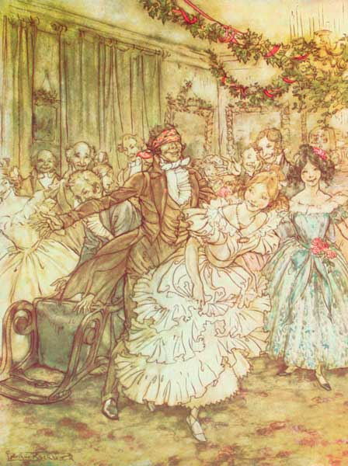 The way he went after that plump sister in the lace tucker!
But they didn't devote the whole evening to music. After a while they played at forfeits; for it is good to be children sometimes, and never better than at Christmas, when its mighty Founder was a child himself. Stop! There was first a game at blind man's-buff. Of course there was. And I no more believe Topper was really blind than I believe he had eyes in his boots. My opinion is, that it was a done thing between him and Scrooge's nephew; and that the Ghost of Christmas Present knew it. The way he went after that plump sister in the lace tucker was an outrage on the credulity of human nature. Knocking down the fire-irons, tumbling over the chairs, bumping up against the piano, smothering himself amongst the curtains, wherever she went, there went he! He always knew where the plump sister was. He wouldn't catch anybody else. If you had fallen up against him (as some of them did) on purpose, he would have made a feint of endeavouring to seize you, which would have been an affront to your understanding, and would instantly have sidled off in the direction of the plump sister. She often cried out that it wasn't fair; and it really was not. But when, at last, he caught her;[Pg 102] when, in spite of all her silken rustlings, and her rapid flutterings past him, he got her into a corner whence there was no escape; then his conduct was the most execrable. For his pretending not to know her; his pretending that it was necessary to touch her head-dress, and further to assure himself of her identity by pressing a certain ring upon her finger, and a certain chain about her neck; was vile, monstrous! No doubt she told him her opinion of it when, another blind man being in office, they were so very confidential together behind the curtains.
Scrooge's niece was not one of the blind man's-buff party, but was made comfortable with a large chair and a footstool, in a snug corner where the Ghost and Scrooge were close behind her. But she joined in the forfeits, and loved her love to admiration with all the letters of the alphabet. Likewise at the game of How, When, and Where, she was very great, and, to the secret joy of Scrooge's nephew, beat her sisters hollow; though they were sharp girls too, as Topper could have told you. There might have been twenty people there, young and old, but they all played, and so did Scrooge; for wholly forgetting, in the interest he had in what was going on, that his voice made no sound in their ears, he sometimes came out with his guess quite loud, and very often guessed right, too; for the sharpest needle, best Whitechapel, warranted not to cut in the[Pg 103] eye, was not sharper than Scrooge, blunt as he took it in his head to be.
The Ghost was greatly pleased to find him in this mood, and looked upon him with such favour that he begged like a boy to be allowed to stay until the guests departed. But this the Spirit said could not be done.
'Here is a new game,' said Scrooge. 'One half-hour, Spirit, only one!'
It was a game called Yes and No, where Scrooge's nephew had to think of something, and the rest must find out what, he only answering to their questions yes or no, as the case was. The brisk fire of questioning to which he was exposed elicited from him that he was thinking of an animal, a live animal, rather a disagreeable animal, a savage animal, an animal that growled and grunted sometimes, and talked sometimes and lived in London, and walked about the streets, and wasn't made a show of, and wasn't led by anybody, and didn't live in a menagerie, and was never killed in a market, and was not a horse, or an ass, or a cow, or a bull, or a tiger, or a dog, or a pig, or a cat, or a bear. At every fresh question that was put to him, this nephew burst into a fresh roar of laughter; and was so inexpressibly tickled, that he was obliged to get up off the sofa and stamp. At last the plump sister, falling into a similar state, cried out:[Pg 104]
'I have found it out! I know what it is, Fred! I know what it is!'
'What is it?' cried Fred.
'It's your uncle Scro-o-o-o-oge.'
Which it certainly was. Admiration was the universal sentiment, though some objected that the reply to 'Is it a bear?' ought to have been 'Yes'; inasmuch as an answer in the negative was sufficient to have diverted their thoughts from Mr. Scrooge, supposing they had ever had any tendency that way.
'He has given us plenty of merriment, I am sure,' said Fred, 'and it would be ungrateful not to drink his health. Here is a glass of mulled wine ready to our hand at the moment; and I say, "Uncle Scrooge!"'
'Well! Uncle Scrooge!' they cried.
'A merry Christmas and a happy New Year to the old man, whatever he is!' said Scrooge's nephew. 'He wouldn't take it from me, but may he have it, nevertheless. Uncle Scrooge!'
Uncle Scrooge had imperceptibly become so gay and light of heart, that he would have pledged the unconscious company in return, and thanked them in an inaudible speech, if the Ghost had given him time. But the whole scene passed off in the breath of the last word spoken by his nephew; and he and the Spirit were again upon their travels.
Much they saw, and far they went, and many homes[Pg 105] they visited, but always with a happy end. The Spirit stood beside sick-beds, and they were cheerful; on foreign lands, and they were close at home; by struggling men, and they were patient in their greater hope; by poverty, and it was rich. In almshouse, hospital, and gaol, in misery's every refuge, where vain man in his little brief authority had not made fast the door, and barred the Spirit out, he left his blessing and taught Scrooge his precepts.
It was a long night, if it were only a night; but Scrooge had his doubts of this, because the Christmas holidays appeared to be condensed into the space of time they passed together. It was strange, too, that, while Scrooge remained unaltered in his outward form, the Ghost grew older, clearly older. Scrooge had observed this change, but never spoke of it until they left a children's Twelfth-Night party, when, looking at the Spirit as they stood together in an open place, he noticed that its hair was grey.
'Are spirits' lives so short?' asked Scrooge.
'My life upon this globe is very brief,' replied the Ghost. 'It ends to-night.'
'To-night!' cried Scrooge.
'To-night at midnight. Hark! The time is drawing near.'
The chimes were ringing the three-quarters past eleven at that moment.[Pg 106]
'Forgive me if I am not justified in what I ask,' said Scrooge, looking intently at the Spirit's robe, 'but I see something strange, and not belonging to yourself, protruding from your skirts. Is it a foot or a claw?'
'It might be a claw, for the flesh there is upon it,' was the Spirit's sorrowful reply. 'Look here!'
From the foldings of its robe it brought two children, wretched, abject, frightful, hideous, miserable. They knelt down at its feet, and clung upon the outside of its garment.
'O Man! look here! Look, look down here!' exclaimed the Ghost.
They were a boy and girl. Yellow, meagre, ragged, scowling, wolfish, but prostrate, too, in their humility. Where graceful youth should have filled their features out, and touched them with its freshest tints, a stale and shrivelled hand, like that of age, had pinched and twisted them, and pulled them into shreds. Where angels might have sat enthroned, devils lurked, and glared out menacing. No change, no degradation, no perversion of humanity in any grade, through all the mysteries of wonderful creation, has monsters half so horrible and dread.
Scrooge started back, appalled. Having them shown to him in this way, he tried to say they were fine children, but the words choked themselves, rather than be parties to a lie of such enormous magnitude.[Pg 107]
'Spirit! are they yours?' Scrooge could say no more.
'They are Man's,' said the Spirit, looking down upon them. 'And they cling to me, appealing from their fathers. This boy is Ignorance. This girl is Want. Beware of them both, and all of their degree, but most of all beware this boy, for on his brow I see that written which is Doom, unless the writing be erased. Deny it!' cried the Spirit, stretching out his hand towards the city. 'Slander those who tell it ye! Admit it for your factious purposes, and make it worse! And bide the end!'
'Have they no refuge or resource?' cried Scrooge.
'Are there no prisons?' said the Spirit, turning on him for the last time with his own words. 'Are there no workhouses?'[Pg 108]
The bell struck Twelve.
Scrooge looked about him for the Ghost, and saw it not. As the last stroke ceased to vibrate, he remembered the prediction of old Jacob Marley, and, lifting up his eyes, beheld a solemn Phantom, draped and hooded, coming like a mist along the ground towards him.[Pg 109]
[Pg 110]

STAVE FOUR
[Pg 111]

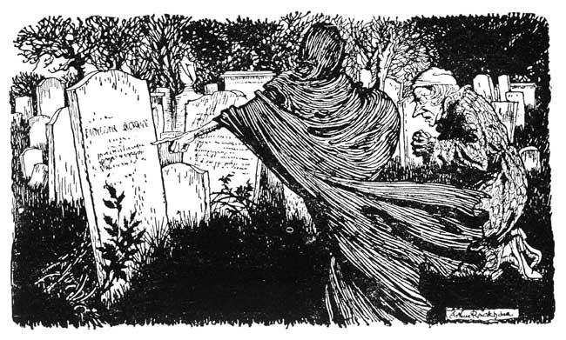
THE LAST OF THE SPIRITS
The Phantom slowly, gravely, silently approached. When it came near him, Scrooge bent down upon his knee; for in the very air through which this Spirit moved it seemed to scatter gloom and mystery.
It was shrouded in a deep black garment, which concealed its head, its face, its form, and left nothing of it visible, save one outstretched hand. But for this, it would have been difficult to detach its figure from the night, and separate it from the darkness by which it was surrounded.[Pg 112]
He felt that it was tall and stately when it came beside him, and that its mysterious presence filled him with a solemn dread. He knew no more, for the Spirit neither spoke nor moved.
'I am in the presence of the Ghost of Christmas Yet to Come?' said Scrooge.
The Spirit answered not, but pointed onward with its hand.
'You are about to show me shadows of the things that have not happened, but will happen in the time before us,' Scrooge pursued. 'Is that so, Spirit?'
The upper portion of the garment was contracted for an instant in its folds, as if the Spirit had inclined its head. That was the only answer he received.
Although well used to ghostly company by this time, Scrooge feared the silent shape so much that his legs trembled beneath him, and he found that he could hardly stand when he prepared to follow it. The Spirit paused a moment, as observing his condition, and giving him time to recover.
But Scrooge was all the worse for this. It thrilled him with a vague, uncertain horror to know that, behind the dusky shroud, there were ghostly eyes intently fixed upon him, while he, though he stretched his own to the utmost, could see nothing but a spectral hand and one great heap of black.
'Ghost of the Future!' he exclaimed, 'I fear you[Pg 113] more than any spectre I have seen. But as I know your purpose is to do me good, and as I hope to live to be another man from what I was, I am prepared to bear your company, and do it with a thankful heart. Will you not speak to me?'
It gave him no reply. The hand was pointed straight before them.
'Lead on!' said Scrooge. 'Lead on! The night is waning fast, and it is precious time to me, I know. Lead on, Spirit!'
The Phantom moved away as it had come towards him. Scrooge followed in the shadow of its dress, which bore him up, he thought, and carried him along.
They scarcely seemed to enter the City; for the City rather seemed to spring up about them, and encompass them of its own act. But there they were in the heart of it; on 'Change, amongst the merchants, who hurried up and down, and chinked the money in their pockets, and conversed in groups, and looked at their watches, and trifled thoughtfully with their great gold seals, and so forth, as Scrooge had seen them often.
The Spirit stopped beside one little knot of business men. Observing that the hand was pointed to them, Scrooge advanced to listen to their talk.
'No,' said a great fat man with a monstrous chin, 'I don't know much about it either way. I only know he's dead.'[Pg 114]
'When did he die?' inquired another.
'Last night, I believe.'
'Why, what was the matter with him?' asked a third, taking a vast quantity of snuff out of a very large snuff-box. 'I thought he'd never die.'
'God knows,' said the first, with a yawn.
'What has he done with his money?' asked a red-faced gentleman with a pendulous excrescence on the end of his nose, that shook like the gills of a turkey-cock.
'I haven't heard,' said the man with the large chin, yawning again. 'Left it to his company, perhaps. He hasn't left it to me. That's all I know.'
This pleasantry was received with a general laugh.
'It's likely to be a very cheap funeral,' said the same speaker; 'for, upon my life, I don't know of anybody to go to it. Suppose we make up a party, and volunteer?'
'I don't mind going if a lunch is provided,' observed the gentleman with the excrescence on his nose. 'But I must be fed if I make one.'
Another laugh.
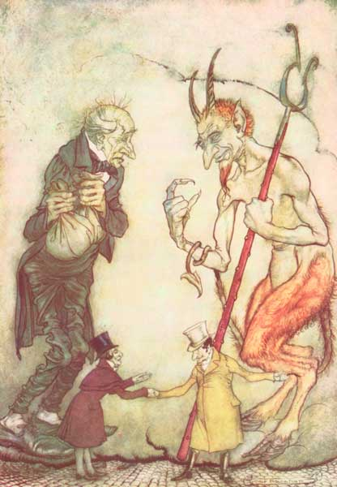 "How are you?" said one.
"How are you?" returned the other.
"Well!" said the first. "Old Scratch has got his own at last, hey?"
'Well, I am the most disinterested among you, after all,' said the first speaker, 'for I never wear black gloves, and I never eat lunch. But I'll offer to go if anybody else will. When I come to think[Pg 115] of it, I'm not at all sure that I wasn't his most particular friend; for we used to stop and speak whenever we met. Bye, bye!'
Speakers and listeners strolled away, and mixed with other groups. Scrooge knew the men, and looked towards the Spirit for an explanation.
The phantom glided on into a street. Its finger pointed to two persons meeting. Scrooge listened again, thinking that the explanation might lie here.
He knew these men, also, perfectly. They were men of business: very wealthy, and of great importance. He had made a point always of standing well in their esteem in a business point of view, that is; strictly in a business point of view.
'How are you?' said one.
'How are you?' returned the other.
'Well!' said the first, 'old Scratch has got his own at last, hey?'
'So I am told,' returned the second. 'Cold, isn't it?'
'Seasonable for Christmas-time. You are not a skater, I suppose?'
'No, no. Something else to think of. Good-morning!'
Not another word. That was their meeting, their conversation, and their parting.
Scrooge was at first inclined to be surprised that the[Pg 116] Spirit should attach importance to conversations apparently so trivial; but feeling assured that they must have some hidden purpose, he set himself to consider what it was likely to be. They could scarcely be supposed to have any bearing on the death of Jacob, his old partner, for that was Past, and this Ghost's province was the Future. Nor could he think of any one immediately connected with himself to whom he could apply them. But nothing doubting that, to whomsoever they applied, they had some latent moral for his own improvement, he resolved to treasure up every word he heard, and everything he saw; and especially to observe the shadow of himself when it appeared. For he had an expectation that the conduct of his future self would give him the clue he missed, and would render the solution of these riddles easy.
He looked about in that very place for his own image, but another man stood in his accustomed corner; and though the clock pointed to his usual time of day for being there, he saw no likeness of himself among the multitudes that poured in through the Porch. It gave him little surprise, however; for he had been revolving in his mind a change of life, and thought and hoped he saw his new-born resolutions carried out in this.
Quiet and dark, beside him stood the Phantom, with its outstretched hand. When he roused himself from[Pg 117] his thoughtful quest, he fancied, from the turn of the hand, and its situation in reference to himself, that the Unseen Eyes were looking at him keenly. It made him shudder, and feel very cold.
They left the busy scene, and went into an obscure part of the town, where Scrooge had never penetrated before, although he recognised its situation and its bad repute. The ways were foul and narrow; the shop and houses wretched; the people half naked, drunken, slipshod, ugly. Alleys and archways, like so many cesspools, disgorged their offences of smell and dirt, and life upon the straggling streets; and the whole quarter reeked with crime, with filth, and misery.
Far in this den of infamous resort, there was a low-browed, beetling shop, below a penthouse roof, where iron, old rags, bottles, bones, and greasy offal were bought. Upon the floor within were piled up heaps of rusty keys, nails, chains, hinges, files, scales, weights, and refuse iron of all kinds. Secrets that few would like to scrutinise were bred and hidden in mountains of unseemly rags, masses of corrupted fat, and sepulchres of bones. Sitting in among the wares he dealt in, by a charcoal stove made of old bricks, was a grey-haired rascal, nearly seventy years of age, who had screened himself from the cold air without by a frouzy curtaining of miscellaneous tatters hung upon a line[Pg 118] and smoked his pipe in all the luxury of calm retirement.
Scrooge and the Phantom came into the presence of this man, just as a woman with a heavy bundle slunk into the shop. But she had scarcely entered, when another woman, similarly laden, came in too; and she was closely followed by a man in faded black, who was no less startled by the sight of them than they had been upon the recognition of each other. After a short period of blank astonishment, in which the old man with the pipe had joined them, they all three burst into a laugh.
'Let the charwoman alone to be the first!' cried she who had entered first. 'Let the laundress alone to be the second; and let the undertaker's man alone to be the third. Look here, old Joe, here's a chance! If we haven't all three met here without meaning it!'
'You couldn't have met in a better place,' said old Joe, removing his pipe from his mouth. 'Come into the parlour. You were made free of it long ago, you know; and the other two an't strangers. Stop till I shut the door of the shop. Ah! how it skreeks! There an't such a rusty bit of metal in the place as its own hinges, I believe; and I'm sure there's no such old bones here as mine. Ha! ha! We're all suitable to our calling, we're well matched. Come into the parlour. Come into the parlour.'[Pg 119]
The parlour was the space behind the screen of rags. The old man raked the fire together with an old stair-rod, and having trimmed his smoky lamp (for it was night) with the stem of his pipe, put it into his mouth again.
While he did this, the woman who had already spoken threw her bundle on the floor, and sat down in a flaunting manner on a stool, crossing her elbows on her knees, and looking with a bold defiance at the other two.
'What odds, then? What odds, Mrs. Dilber?' said the woman. 'Every person has a right to take care of themselves. He always did!'
'That's true, indeed!' said the laundress. 'No man more so.'
'Why, then, don't stand staring as if you was afraid, woman! Who's the wiser? We're not going to pick holes in each other's coats, I suppose?'
'No, indeed!' said Mrs. Dilber and the man together. 'We should hope not.'
'Very well then!' cried the woman. 'That's enough. Who's the worse for the loss of a few things like these? Not a dead man, I suppose?'
'No, indeed,' said Mrs. Dilber, laughing.
'If he wanted to keep 'em after he was dead, a wicked old screw,' pursued the woman, 'why wasn't he natural in his lifetime? If he had been, he'd have[Pg 120] had somebody to look after him when he was struck with Death, instead of lying gasping out his last there, alone by himself.'
'It's the truest word that ever was spoke,' said Mrs. Dilber. 'It's a judgment on him.'
'I wish it was a little heavier judgment,' replied the woman: 'and it should have been, you may depend upon it, if I could have laid my hands on anything else. Open that bundle, old Joe, and let me know the value of it. Speak out plain. I'm not afraid to be the first, nor afraid for them to see it. We knew pretty well that we were helping ourselves before we met here, I believe. It's no sin. Open the bundle, Joe.'
But the gallantry of her friends would not allow of this; and the man in faded black, mounting the breach first, produced his plunder. It was not extensive. A seal or two, a pencil-case, a pair of sleeve-buttons, and a brooch of no great value, were all. They were severally examined and appraised by old Joe, who chalked the sums he was disposed to give for each upon the wall, and added them up into a total when he found that there was nothing more to come.
'That's your account,' said Joe, 'and I wouldn't give another sixpence, if I was to be boiled for not doing it. Who's next?'
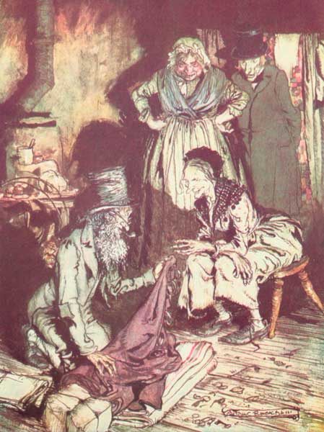 "What do you call this?" said Joe. "Bed-curtains."
Mrs. Dilber was next. Sheets and towels, a little wearing apparel, two old fashioned silver teaspoons, a[Pg 121] pair of sugar-tongs, and a few boots. Her account was stated on the wall in the same manner.
'I always give too much to ladies. It's a weakness of mine, and that's the way I ruin myself,' said old Joe. 'That's your account. If you asked me for another penny, and made it an open question, I'd repent of being so liberal, and knock off half-a-crown.'
'And now undo my bundle, Joe,' said the first woman.
Joe went down on his knees for the greater convenience of opening it, and, having unfastened a great many knots, dragged out a large heavy roll of some dark stuff.
'What do you call this?' said Joe. 'Bed-curtains?'
'Ah!' returned the woman, laughing and leaning forward on her crossed arms. 'Bed-curtains!'
'You don't mean to say you took 'em down, rings and all, with him lying there?' said Joe.
'Yes, I do,' replied the woman. 'Why not?'
'You were born to make your fortune,' said Joe, 'and you'll certainly do it.'
'I certainly shan't hold my hand, when I can get anything in it by reaching it out, for the sake of such a man as he was, I promise you, Joe,' returned the woman coolly. 'Don't drop that oil upon the blankets, now.'
'His blankets?' asked Joe.[Pg 122]
'Whose else's do you think?' replied the woman. 'He isn't likely to take cold without 'em, I dare say.'
'I hope he didn't die of anything catching? Eh?' said old Joe, stopping in his work, and looking up.
'Don't you be afraid of that,' returned the woman. 'I an't so fond of his company that I'd loiter about him for such things, if he did. Ah! you may look through that shirt till your eyes ache, but you won't find a hole in it, nor a threadbare place. It's the best he had, and a fine one too. They'd have wasted it, if it hadn't been for me.'
'What do you call wasting of it?' asked old Joe.
'Putting it on him to be buried in, to be sure,' replied the woman, with a laugh. 'Somebody was fool enough to do it, but I took it off again. If calico an't good enough for such a purpose, it isn't good enough for anything. It's quite as becoming to the body. He can't look uglier than he did in that one.'
Scrooge listened to this dialogue in horror. As they sat grouped about their spoil, in the scanty light afforded by the old man's lamp, he viewed them with a detestation and disgust which could hardly have been greater, though they had been obscene demons marketing the corpse itself.
'Ha, ha!' laughed the same woman when old Joe producing a flannel bag with money in it, told out their[Pg 123] several gains upon the ground. 'This is the end of it, you see! He frightened every one away from him when he was alive, to profit us when he was dead! Ha, ha, ha!'
'Spirit!' said Scrooge, shuddering from head to foot. 'I see, I see. The case of this unhappy man might be my own. My life tends that way now. Merciful heaven, what is this?'
He recoiled in terror, for the scene had changed, and now he almost touched a bed—a bare, uncurtained bed—on which, beneath a ragged sheet, there lay a something covered up, which, though it was dumb, announced itself in awful language.
The room was very dark, too dark to be observed with any accuracy, though Scrooge glanced round it in obedience to a secret impulse, anxious to know what kind of room it was. A pale light, rising in the outer air, fell straight upon the bed; and on it, plundered and bereft, unwatched, unwept, uncared for, was the body of this man.
Scrooge glanced towards the Phantom. Its steady hand was pointed to the head. The cover was so carelessly adjusted that the slightest raising of it, the motion of a finger upon Scrooge's part, would have disclosed the face. He thought of it, felt how easy it would be to do, and longed to do it; but he had no more power to withdraw the veil than to dismiss the spectre at his side.[Pg 124]
Oh, cold, cold, rigid, dreadful Death, set up thine altar here, and dress it with such terrors as thou hast at thy command; for this is thy dominion! But of the loved, revered, and honoured head thou canst not turn one hair to thy dread purposes, or make one feature odious. It is not that the hand is heavy, and will fall down when released; it is not that the heart and pulse are still; but that the hand was open, generous, and true; the heart brave, warm, and tender, and the pulse a man's. Strike, Shadow, strike! And see his good deeds springing from the wound, to sow the world with life immortal!
No voice pronounced these words in Scrooge's ears, and yet he heard them when he looked upon the bed. He thought, if this man could be raised up now, what would be his foremost thoughts? Avarice, hard dealing, griping cares? They have brought him to a rich end, truly!
He lay in the dark, empty house, with not a man, a woman, or a child to say he was kind to me in this or that, and for the memory of one kind word I will be kind to him. A cat was tearing at the door, and there was a sound of gnawing rats beneath the hearthstone. What they wanted in the room of death, and why they were so restless and disturbed, Scrooge did not dare to think.
'Spirit!' he said, 'this is a fearful place. In[Pg 125] leaving it, I shall not leave its lesson, trust me. Let us go!'
Still the Ghost pointed with an unmoved finger to the head.
'I understand you,' Scrooge returned, 'and I would do it if I could. But I have not the power, Spirit. I have not the power.'
Again it seemed to look upon him.
'If there is any person in the town who feels emotion caused by this man's death,' said Scrooge, quite agonised, 'show that person to me, Spirit, I beseech you!'
The Phantom spread its dark robe before him for a moment, like a wing; and, withdrawing it, revealed a room by daylight, where a mother and her children were.
She was expecting some one, and with anxious eagerness; for she walked up and down the room, started at every sound, looked out from the window, glanced at the clock, tried, but in vain, to work with her needle, and could hardly bear the voices of her children in their play.
At length the long-expected knock was heard. She hurried to the door, and met her husband; a man whose face was careworn and depressed, though he was young. There was a remarkable expression in it now, a kind of serious delight of which he felt ashamed, and which he struggled to repress.[Pg 126]
He sat down to the dinner that had been hoarding for him by the fire, and when she asked him faintly what news (which was not until after a long silence), he appeared embarrassed how to answer.
'Is it good,' she said, 'or bad?' to help him.
'Bad,' he answered.
'We are quite ruined?'
'No. There is hope yet, Caroline.'
'If he relents,' she said, amazed, 'there is! Nothing is past hope, if such a miracle has happened.'
'He is past relenting,' said her husband. 'He is dead.'
She was a mild and patient creature, if her face spoke truth; but she was thankful in her soul to hear it, and she said so with clasped hands. She prayed forgiveness the next moment, and was sorry; but the first was the emotion of her heart.
'What the half-drunken woman, whom I told you of last night, said to me when I tried to see him and obtain a week's delay—and what I thought was a mere excuse to avoid me—turns out to have been quite true. He was not only very ill, but dying, then.'
'To whom will our debt be transferred?'
'I don't know. But, before that time, we shall be ready with the money; and even though we were not, it would be bad fortune indeed to find so merciless a creditor in his successor. We may sleep to-night with light hearts, Caroline!'[Pg 127]
Yes. Soften it as they would, their hearts were lighter. The children's faces, hushed and clustered round to hear what they so little understood, were brighter; and it was a happier house for this man's death! The only emotion that the Ghost could show him, caused by the event, was one of pleasure.
'Let me see some tenderness connected with a death,' said Scrooge; 'or that dark chamber, Spirit, which we left just now, will be for ever present to me.'
The Ghost conducted him through several streets familiar to his feet; and as they went along, Scrooge looked here and there to find himself, but nowhere was he to be seen. They entered poor Bob Cratchit's house; the dwelling he had visited before; and found the mother and the children seated round the fire.
Quiet. Very quiet. The noisy little Cratchits were as still as statues in one corner, and sat looking up at Peter, who had a book before him. The mother and her daughters were engaged in sewing. But surely they were very quiet!
'"And he took a child, and set him in the midst of them."'
Where had Scrooge heard those words? He had not dreamed them. The boy must have read them out as he and the Spirit crossed the threshold. Why did he not go on?[Pg 128]
The mother laid her work upon the table, and put her hand up to her face.
'The colour hurts my eyes,' she said.
The colour? Ah, poor Tiny Tim!
'They're better now again,' said Cratchit's wife. 'It makes them weak by candle-light; and I wouldn't show weak eyes to your father when he comes home for the world. It must be near his time.'
'Past it rather,' Peter answered, shutting up his book. 'But I think he has walked a little slower than he used, these few last evenings, mother.'
They were very quiet again. At last she said, and in a steady, cheerful voice, that only faltered once:
'I have known him walk with—I have known him walk with Tiny Tim upon his shoulder very fast indeed.'
'And so have I,' cried Peter. 'Often.'
'And so have I,' exclaimed another. So had all.
'But he was very light to carry,' she resumed, intent upon her work, 'and his father loved him so, that it was no trouble, no trouble. And there is your father at the door!'
She hurried out to meet him; and little Bob in his comforter—he had need of it, poor fellow—came in. His tea was ready for him on the hob, and they all tried who should help him to it most. Then the two young Cratchits got upon his knees, and laid, each[Pg 129] child, a little cheek against his face, as if they said, 'Don't mind it, father. Don't be grieved!'
Bob was very cheerful with them, and spoke pleasantly to all the family. He looked at the work upon the table, and praised the industry and speed of Mrs. Cratchit and the girls. They would be done long before Sunday, he said.
'Sunday! You went to-day, then, Robert?' said his wife.
'Yes, my dear,' returned Bob. 'I wish you could have gone. It would have done you good to see how green a place it is. But you'll see it often. I promised him that I would walk there on a Sunday. My little, little child!' cried Bob. 'My little child!'
He broke down all at once. He couldn't help it. If he could have helped it, he and his child would have been farther apart, perhaps, than they were.
He left the room, and went upstairs into the room above, which was lighted cheerfully, and hung with Christmas. There was a chair set close beside the child, and there were signs of some one having been there lately. Poor Bob sat down in it, and when he had thought a little and composed himself, he kissed the little face. He was reconciled to what had happened, and went down again quite happy.
They drew about the fire, and talked, the girls and mother working still. Bob told them of the extra[Pg 130]ordinary kindness of Mr. Scrooge's nephew, whom he had scarcely seen but once, and who, meeting him in the street that day, and seeing that he looked a little—'just a little down, you know,' said Bob, inquired what had happened to distress him. 'On which,' said Bob, 'for he is the pleasantest-spoken gentleman you ever heard, I told him. "I am heartily sorry for it, Mr. Cratchit," he said, "and heartily sorry for your good wife." By-the-bye, how he ever knew that I don't know.'
'Knew what, my dear?'
'Why, that you were a good wife,' replied Bob.
'Everybody knows that,' said Peter.
'Very well observed, my boy!' cried Bob. 'I hope they do. "Heartily sorry," he said, "for your good wife. If I can be of service to you in any way," he said, giving me his card, "that's where I live. Pray come to me." Now, it wasn't,' cried Bob, 'for the sake of anything he might be able to do for us, so much as for his kind way, that this was quite delightful. It really seemed as if he had known our Tiny Tim, and felt with us.'
'I'm sure he's a good soul!' said Mrs. Cratchit.
'You would be sure of it, my dear,' returned Bob, 'if you saw and spoke to him. I shouldn't be at all surprised—mark what I say!—if he got Peter a better situation.'[Pg 131]
'Only hear that, Peter,' said Mrs. Cratchit.
'And then,' cried one of the girls, 'Peter will be keeping company with some one, and setting up for himself.'
'Get along with you!' retorted Peter, grinning.
'It's just as likely as not,' said Bob, 'one of these days; though there's plenty of time for that, my dear. But, however and whenever we part from one another, I am sure we shall none of us forget poor Tiny Tim—shall we—or this first parting that there was among us?'
'Never, father!' cried they all.
'And I know,' said Bob, 'I know, my dears, that when we recollect how patient and how mild he was; although he was a little, little child; we shall not quarrel easily among ourselves, and forget poor Tiny Tim in doing it.'
'No, never, father!' they all cried again.
'I am very happy,' said little Bob, 'I am very happy!'
Mrs. Cratchit kissed him, his daughters kissed him, the two young Cratchits kissed him, and Peter and himself shook hands. Spirit of Tiny Tim, thy childish essence was from God!
'Spectre,' said Scrooge, 'something informs me that our parting moment is at hand. I know it but I know not how. Tell me what man that was whom we saw lying dead?'[Pg 132]
The Ghost of Christmas Yet to Come conveyed him, as before—though at a different time, he thought: indeed there seemed no order in these latter visions, save that they were in the Future—into the resorts of business men, but showed him not himself. Indeed, the Spirit did not stay for anything, but went straight on, as to the end just now desired, until besought by Scrooge to tarry for a moment.
'This court,' said Scrooge, 'through which we hurry now, is where my place of occupation is, and has been for a length of time. I see the house. Let me behold what I shall be in days to come.'
The Spirit stopped; the hand was pointed elsewhere.
'The house is yonder,' Scrooge exclaimed. 'Why do you point away?'
The inexorable finger underwent no change.
Scrooge hastened to the window of his office, and looked in. It was an office still, but not his. The furniture was not the same, and the figure in the chair was not himself. The Phantom pointed as before.
He joined it once again, and, wondering why and whither he had gone, accompanied it until they reached an iron gate. He paused to look round before entering.
A churchyard. Here, then, the wretched man, whose name he had now to learn, lay underneath the[Pg 133] ground. It was a worthy place. Walled in by houses; overrun by grass and weeds, the growth of vegetation's death, not life; choked up with too much burying; fat with repleted appetite. A worthy place!
The Spirit stood among the graves, and pointed down to One. He advanced towards it trembling. The Phantom was exactly as it had been, but he dreaded that he saw new meaning in its solemn shape.
'Before I draw nearer to that stone to which you point,' said Scrooge, 'answer me one question. Are these the shadows of the things that Will be, or are they shadows of the things that May be only?'
Still the Ghost pointed downward to the grave by which it stood.
'Men's courses will foreshadow certain ends, to which, if persevered in, they must lead,' said Scrooge. 'But if the courses be departed from, the ends will change. Say it is thus with what you show me!'
The Spirit was immovable as ever.
Scrooge crept towards it, trembling as he went; and, following the finger, read upon the stone of the neglected grave his own name, Ebenezer Scrooge.
'Am I that man who lay upon the bed?' he cried upon his knees.
The finger pointed from the grave to him, and back again.
'No, Spirit! Oh no, no!'[Pg 134]
The finger still was there.
'Spirit!' he cried, tight clutching at its robe, 'hear me! I am not the man I was. I will not be the man I must have been but for this intercourse. Why show me this, if I am past all hope?'
For the first time the hand appeared to shake.
'Good Spirit,' he pursued, as down upon the ground he fell before it, 'your nature intercedes for me, and pities me. Assure me that I yet may change these shadows you have shown me by an altered life?'
The kind hand trembled.
'I will honour Christmas in my heart, and try to keep it all the year. I will live in the Past, the Present, and the Future. The Spirits of all Three shall strive within me. I will not shut out the lessons that they teach. Oh, tell me I may sponge away the writing on this stone!'
In his agony he caught the spectral hand. It sought to free itself, but he was strong in his entreaty, and detained it. The Spirit stronger yet, repulsed him.
Holding up his hands in a last prayer to have his fate reversed, he saw an alteration in the Phantom's hood and dress. It shrunk, collapsed, and dwindled down into a bedpost.[Pg 135]
[Pg 136]

STAVE FIVE
[Pg 137]

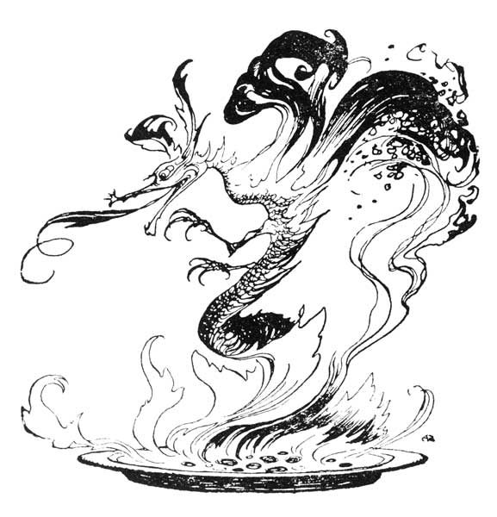
THE END OF IT
Yes! and the bedpost was his own. The bed was his own, the room was his own. Best and happiest of all, the Time before him was his own, to make amends in!
'I will live in the Past, the Present, and the Future!' Scrooge repeated as he scrambled out of bed. 'The Spirits of all Three shall strive within me. O Jacob Marley! Heaven and the Christmas Time be[Pg 138] praised for this! I say it on my knees, old Jacob; on my knees!'
He was so fluttered and so glowing with his good intentions, that his broken voice would scarcely answer to his call. He had been sobbing violently in his conflict with the Spirit, and his face was wet with tears.
'They are not torn down,' cried Scrooge, folding one of his bed-curtains in his arms, 'They are not torn down, rings and all. They are here—I am here—the shadows of the things that would have been may be dispelled. They will be. I know they will!'
His hands were busy with his garments all this time: turning them inside out, putting them on upside down, tearing them, mislaying them, making them parties to every kind of extravagance.
'I don't know what to do!' cried Scrooge, laughing and crying in the same breath, and making a perfect Laocoon of himself with his stockings. 'I am as light as a feather, I am as happy as an angel, I am as merry as a schoolboy, I am as giddy as a drunken man. A merry Christmas to everybody! A happy New Year to all the world! Hallo here! Whoop! Hallo!'
He had frisked into the sitting-room, and was now standing there, perfectly winded.
'There's the saucepan that the gruel was in!' cried Scrooge, starting off again, and going round the fireplace. 'There's the door by which the Ghost of Jacob[Pg 139] Marley entered! There's the corner where the Ghost of Christmas Present sat! There's the window where I saw the wandering Spirits! It's all right, it's all true, it all happened. Ha, ha, ha!'
Really, for a man who had been out of practice for so many years, it was a splendid laugh, a most illustrious laugh. The father of a long, long line of brilliant laughs!
'I don't know what day of the month it is,' said Scrooge. 'I don't know how long I have been among the Spirits. I don't know anything. I'm quite a baby. Never mind. I don't care. I'd rather be a baby. Hallo! Whoop! Hallo here!'
He was checked in his transports by the churches ringing out the lustiest peals he had ever heard. Clash, clash, hammer; ding, dong, bell! Bell, dong, ding; hammer, clash, clash! Oh, glorious, glorious!
Running to the window, he opened it, and put out his head. No fog, no mist; clear, bright, jovial, stirring, cold; cold, piping for the blood to dance to; golden sunlight; heavenly sky; sweet fresh air; merry bells. Oh, glorious! Glorious!
'What's to-day?' cried Scrooge, calling downward to a boy in Sunday clothes, who perhaps had loitered in to look about him.
'Eh?' returned the boy with all his might of wonder.[Pg 140]
'What's to-day, my fine fellow?' said Scrooge.
'To-day!' replied the boy. 'Why, Christmas Day.'
'It's Christmas Day!' said Scrooge to himself. 'I haven't missed it. The Spirits have done it all in one night. They can do anything they like. Of course they can. Of course they can. Hallo, my fine fellow!'
'Hallo!' returned the boy.
'Do you know the poulterer's in the next street but one, at the corner?' Scrooge inquired.
'I should hope I did,' replied the lad.
'An intelligent boy!' said Scrooge. 'A remarkable boy! Do you know whether they've sold the prize turkey that was hanging up there?—Not the little prize turkey: the big one?'
'What! the one as big as me?' returned the boy.
'What a delightful boy!' said Scrooge. 'It's a pleasure to talk to him. Yes, my buck!'
'It's hanging there now,' replied the boy.
'Is it?' said Scrooge. 'Go and buy it.'
'Walk-er!' exclaimed the boy.
'No, no,' said Scrooge. 'I am in earnest. Go and buy it, and tell 'em to bring it here, that I may give them the directions where to take it. Come back with the man, and I'll give you a shilling. Come back with him in less than five minutes, and I'll give you half-a-crown!'[Pg 141]
The boy was off like a shot. He must have had a steady hand at a trigger who could have got a shot off half as fast.
'I'll send it to Bob Cratchit's,' whispered Scrooge, rubbing his hands, and splitting with a laugh. 'He shan't know who sends it. It's twice the size of Tiny Tim. Joe Miller never made such a joke as sending it to Bob's will be!'
The hand in which he wrote the address was not a steady one; but write it he did, somehow, and went downstairs to open the street-door, ready for the coming of the poulterer's man. As he stood there, waiting his arrival, the knocker caught his eye.
'I shall love it as long as I live!' cried Scrooge, patting it with his hand. 'I scarcely ever looked at it before. What an honest expression it has in its face! It's a wonderful knocker!—Here's the turkey. Hallo! Whoop! How are you! Merry Christmas!'
It was a turkey! He never could have stood upon his legs, that bird. He would have snapped 'em short off in a minute, like sticks of sealing-wax.
'Why, it's impossible to carry that to Camden Town,' said Scrooge. 'You must have a cab.'
The chuckle with which he said this, and the chuckle with which he paid for the turkey, and the chuckle with which he paid for the cab, and the chuckle with which he recompensed the boy, were only to be exceeded by[Pg 142] the chuckle with which he sat down breathless in his chair again, and chuckled till he cried.
Shaving was not an easy task, for his hand continued to shake very much; and shaving requires attention, even when you don't dance while you are at it. But if he had cut the end of his nose off, he would have put a piece of sticking-plaster over it, and been quite satisfied.
He dressed himself 'all in his best,' and at last got out into the streets. The people were by this time pouring forth, as he had seen them with the Ghost of Christmas Present; and, walking with his hands behind him, Scrooge regarded every one with a delighted smile. He looked so irresistibly pleasant, in a word, that three or four good-humoured fellows said, 'Good-morning, sir! A merry Christmas to you!' And Scrooge said often afterwards that, of all the blithe sounds he had ever heard, those were the blithest in his ears.
He had not gone far when, coming on towards him, he beheld the portly gentleman who had walked into his counting-house the day before, and said, 'Scrooge and Marley's, I believe?' It sent a pang across his heart to think how this old gentleman would look upon him when they met; but he knew what path lay straight before him, and he took it.
'My dear sir,' said Scrooge, quickening his pace, and[Pg 143] taking the old gentleman by both his hands, 'how do you do? I hope you succeeded yesterday. It was very kind of you. A merry Christmas to you, sir!'
'Mr. Scrooge?'
'Yes,' said Scrooge. 'That is my name, and I fear it may not be pleasant to you. Allow me to ask your pardon. And will you have the goodness——' Here Scrooge whispered in his ear.
'Lord bless me!' cried the gentleman, as if his breath were taken away. 'My dear Mr. Scrooge, are you serious?'
'If you please,' said Scrooge. 'Not a farthing less. A great many back-payments are included in it, I assure you. Will you do me that favour?'
'My dear sir,' said the other, shaking hands with him, 'I don't know what to say to such munifi——'
'Don't say anything, please,' retorted Scrooge. 'Come and see me. Will you come and see me?'
'I will!' cried the old gentleman. And it was clear he meant to do it.
'Thankee,' said Scrooge. 'I am much obliged to you. I thank you fifty times. Bless you!'
He went to church, and walked about the streets, and watched the people hurrying to and fro, and patted the children on the head, and questioned beggars, and looked down into the kitchens of houses, and up to the windows; and found that everything could yield him[Pg 144] pleasure. He had never dreamed that any walk—that anything—could give him so much happiness. In the afternoon he turned his steps towards his nephew's house.
He passed the door a dozen times before he had the courage to go up and knock. But he made a dash and did it.
'Is your master at home, my dear?' said Scrooge to the girl. 'Nice girl! Very.'
'Yes, sir.'
'Where is he, my love?' said Scrooge.
'He's in the dining-room, sir, along with mistress. I'll show you upstairs, if you please.'
'Thankee. He knows me,' said Scrooge, with his hand already on the dining-room lock. 'I'll go in here, my dear.'
He turned it gently, and sidled his face in round the door. They were looking at the table (which was spread out in great array); for these young housekeepers are always nervous on such points, and like to see that everything is right.
'Fred!' said Scrooge.
Dear heart alive, how his niece by marriage started! Scrooge had forgotten, for the moment, about her sitting in the corner with the footstool, or he wouldn't have done it on any account.
'Why, bless my soul!' cried Fred, 'who's that?'
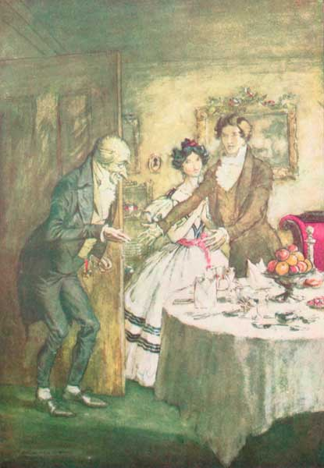 "It's I, your uncle Scrooge. I have come to dinner. Will you let me in, Fred?"
[Pg 145]
'It's I. Your uncle Scrooge. I have come to dinner. Will you let me in, Fred?'
Let him in! It is a mercy he didn't shake his arm off. He was at home in five minutes. Nothing could be heartier. His niece looked just the same. So did Topper when he came. So did the plump sister when she came. So did every one when they came. Wonderful party, wonderful games, wonderful unanimity, won-der-ful happiness!
But he was early at the office next morning. Oh, he was early there! If he could only be there first, and catch Bob Cratchit coming late! That was the thing he had set his heart upon.
And he did it; yes, he did! The clock struck nine. No Bob. A quarter past. No Bob. He was full eighteen minutes and a half behind his time. Scrooge sat with his door wide open, that he might see him come into the tank.
His hat was off before he opened the door; his comforter too. He was on his stool in a jiffy, driving away with his pen, as if he were trying to overtake nine o'clock.
'Hallo!' growled Scrooge in his accustomed voice as near as he could feign it. 'What do you mean by coming here at this time of day?'
'I am very sorry, sir,' said Bob. 'I am behind my time.'[Pg 146]
'You are!' repeated Scrooge. 'Yes, I think you are. Step this way, sir, if you please.'
'It's only once a year, sir,' pleaded Bob, appearing from the tank. 'It shall not be repeated. I was making rather merry yesterday, sir.'
'Now, I'll tell you what, my friend,' said Scrooge. 'I am not going to stand this sort of thing any longer. And therefore,' he continued, leaping from his stool, and giving Bob such a dig in the waistcoat that he staggered back into the tank again—'and therefore I am about to raise your salary!'
Bob trembled, and got a little nearer to the ruler. He had a momentary idea of knocking Scrooge down with it, holding him, and calling to the people in the court for help and a strait-waistcoat.
'A merry Christmas, Bob!' said Scrooge, with an earnestness that could not be mistaken, as he clapped him on the back. 'A merrier Christmas, Bob, my good fellow, than I have given you for many a year! I'll raise your salary, and endeavour to assist your struggling family, and we will discuss your affairs this very afternoon, over a Christmas bowl of smoking bishop, Bob! Make up the fires and buy another coal-scuttle before you dot another i, Bob Cratchit!'
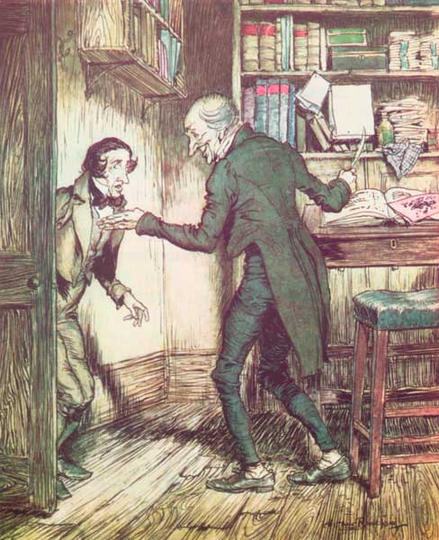 "Now, I'll tell you what, my friend," said Scrooge. "I am not going to stand this sort of thing any longer."
Scrooge was better than his word. He did it all, and infinitely more; and to Tiny Tim, who did NOT die, he was a second father. He became as good a friend, as[Pg 147] good a master, and as good a man as the good old City knew, or any other good old city, town, or borough in the good old world. Some people laughed to see the alteration in him, but he let them laugh, and little heeded them; for he was wise enough to know that nothing ever happened on this globe, for good, at which some people did not have their fill of laughter in the outset; and knowing that such as these would be blind anyway, he thought it quite as well that they should wrinkle up their eyes in grins as have the malady in less attractive forms. His own heart laughed, and that was quite enough for him.
He had no further intercourse with Spirits, but lived upon the Total-Abstinence Principle ever afterwards; and it was always said of him that he knew how to keep Christmas well, if any man alive possessed the knowledge. May that be truly said of us, and all of us! And so, as Tiny Tim observed, God bless Us, Every One!
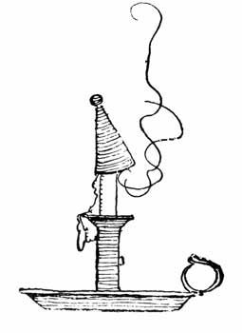
Transcriber's Note: The Table of Contents were added by the transcriber.
*** END OF THE PROJECT GUTENBERG EBOOK A CHRISTMAS CAROL ***
Updated editions will replace the previous one—the old editions will be renamed.
Creating the works from print editions not protected by U.S. copyright law means that no one owns a United States copyright in these works, so the Foundation (and you!) can copy and distribute it in the United States without permission and without paying copyright royalties. Special rules, set forth in the General Terms of Use part of this license, apply to copying and distributing Project Gutenberg™ electronic works to protect the PROJECT GUTENBERG™ concept and trademark. Project Gutenberg is a registered trademark, and may not be used if you charge for an eBook, except by following the terms of the trademark license, including paying royalties for use of the Project Gutenberg trademark. If you do not charge anything for copies of this eBook, complying with the trademark license is very easy. You may use this eBook for nearly any purpose such as creation of derivative works, reports, performances and research. Project Gutenberg eBooks may be modified and printed and given away—you may do practically ANYTHING in the United States with eBooks not protected by U.S. copyright law. Redistribution is subject to the trademark license, especially commercial redistribution.
START: FULL LICENSE
THE FULL PROJECT GUTENBERG LICENSE
PLEASE READ THIS BEFORE YOU DISTRIBUTE OR USE THIS WORK
To protect the Project Gutenberg™ mission of promoting the free distribution of electronic works, by using or distributing this work (or any other work associated in any way with the phrase “Project Gutenberg”), you agree to comply with all the terms of the Full Project Gutenberg™ License available with this file or online at www.gutenberg.org/license.
Section 1. General Terms of Use and Redistributing Project Gutenberg™ electronic works
1.A. By reading or using any part of this Project Gutenberg™ electronic work, you indicate that you have read, understand, agree to and accept all the terms of this license and intellectual property (trademark/copyright) agreement. If you do not agree to abide by all the terms of this agreement, you must cease using and return or destroy all copies of Project Gutenberg™ electronic works in your possession. If you paid a fee for obtaining a copy of or access to a Project Gutenberg™ electronic work and you do not agree to be bound by the terms of this agreement, you may obtain a refund from the person or entity to whom you paid the fee as set forth in paragraph 1.E.8.
1.B. “Project Gutenberg” is a registered trademark. It may only be used on or associated in any way with an electronic work by people who agree to be bound by the terms of this agreement. There are a few things that you can do with most Project Gutenberg™ electronic works even without complying with the full terms of this agreement. See paragraph 1.C below. There are a lot of things you can do with Project Gutenberg™ electronic works if you follow the terms of this agreement and help preserve free future access to Project Gutenberg™ electronic works. See paragraph 1.E below.
1.C. The Project Gutenberg Literary Archive Foundation (“the Foundation” or PGLAF), owns a compilation copyright in the collection of Project Gutenberg™ electronic works. Nearly all the individual works in the collection are in the public domain in the United States. If an individual work is unprotected by copyright law in the United States and you are located in the United States, we do not claim a right to prevent you from copying, distributing, performing, displaying or creating derivative works based on the work as long as all references to Project Gutenberg are removed. Of course, we hope that you will support the Project Gutenberg™ mission of promoting free access to electronic works by freely sharing Project Gutenberg™ works in compliance with the terms of this agreement for keeping the Project Gutenberg™ name associated with the work. You can easily comply with the terms of this agreement by keeping this work in the same format with its attached full Project Gutenberg™ License when you share it without charge with others.
1.D. The copyright laws of the place where you are located also govern what you can do with this work. Copyright laws in most countries are in a constant state of change. If you are outside the United States, check the laws of your country in addition to the terms of this agreement before downloading, copying, displaying, performing, distributing or creating derivative works based on this work or any other Project Gutenberg™ work. The Foundation makes no representations concerning the copyright status of any work in any country other than the United States.
1.E. Unless you have removed all references to Project Gutenberg:
1.E.1. The following sentence, with active links to, or other immediate access to, the full Project Gutenberg™ License must appear prominently whenever any copy of a Project Gutenberg™ work (any work on which the phrase “Project Gutenberg” appears, or with which the phrase “Project Gutenberg” is associated) is accessed, displayed, performed, viewed, copied or distributed:
This eBook is for the use of anyone anywhere in the United States and most other parts of the world at no cost and with almost no restrictions whatsoever. You may copy it, give it away or re-use it under the terms of the Project Gutenberg License included with this eBook or online at www.gutenberg.org. If you are not located in the United States, you will have to check the laws of the country where you are located before using this eBook.
1.E.2. If an individual Project Gutenberg™ electronic work is derived from texts not protected by U.S. copyright law (does not contain a notice indicating that it is posted with permission of the copyright holder), the work can be copied and distributed to anyone in the United States without paying any fees or charges. If you are redistributing or providing access to a work with the phrase “Project Gutenberg” associated with or appearing on the work, you must comply either with the requirements of paragraphs 1.E.1 through 1.E.7 or obtain permission for the use of the work and the Project Gutenberg™ trademark as set forth in paragraphs 1.E.8 or 1.E.9.
1.E.3. If an individual Project Gutenberg™ electronic work is posted with the permission of the copyright holder, your use and distribution must comply with both paragraphs 1.E.1 through 1.E.7 and any additional terms imposed by the copyright holder. Additional terms will be linked to the Project Gutenberg™ License for all works posted with the permission of the copyright holder found at the beginning of this work.
1.E.4. Do not unlink or detach or remove the full Project Gutenberg™ License terms from this work, or any files containing a part of this work or any other work associated with Project Gutenberg™.
1.E.5. Do not copy, display, perform, distribute or redistribute this electronic work, or any part of this electronic work, without prominently displaying the sentence set forth in paragraph 1.E.1 with active links or immediate access to the full terms of the Project Gutenberg™ License.
1.E.6. You may convert to and distribute this work in any binary, compressed, marked up, nonproprietary or proprietary form, including any word processing or hypertext form. However, if you provide access to or distribute copies of a Project Gutenberg™ work in a format other than “Plain Vanilla ASCII” or other format used in the official version posted on the official Project Gutenberg™ website (www.gutenberg.org), you must, at no additional cost, fee or expense to the user, provide a copy, a means of exporting a copy, or a means of obtaining a copy upon request, of the work in its original “Plain Vanilla ASCII” or other form. Any alternate format must include the full Project Gutenberg™ License as specified in paragraph 1.E.1.
1.E.7. Do not charge a fee for access to, viewing, displaying, performing, copying or distributing any Project Gutenberg™ works unless you comply with paragraph 1.E.8 or 1.E.9.
1.E.8. You may charge a reasonable fee for copies of or providing access to or distributing Project Gutenberg™ electronic works provided that:
- • You pay a royalty fee of 20% of the gross profits you derive from the use of Project Gutenberg™ works calculated using the method you already use to calculate your applicable taxes. The fee is owed to the owner of the Project Gutenberg™ trademark, but he has agreed to donate royalties under this paragraph to the Project Gutenberg Literary Archive Foundation. Royalty payments must be paid within 60 days following each date on which you prepare (or are legally required to prepare) your periodic tax returns. Royalty payments should be clearly marked as such and sent to the Project Gutenberg Literary Archive Foundation at the address specified in Section 4, “Information about donations to the Project Gutenberg Literary Archive Foundation.”
- • You provide a full refund of any money paid by a user who notifies you in writing (or by e-mail) within 30 days of receipt that s/he does not agree to the terms of the full Project Gutenberg™ License. You must require such a user to return or destroy all copies of the works possessed in a physical medium and discontinue all use of and all access to other copies of Project Gutenberg™ works.
- • You provide, in accordance with paragraph 1.F.3, a full refund of any money paid for a work or a replacement copy, if a defect in the electronic work is discovered and reported to you within 90 days of receipt of the work.
- • You comply with all other terms of this agreement for free distribution of Project Gutenberg™ works.
1.E.9. If you wish to charge a fee or distribute a Project Gutenberg™ electronic work or group of works on different terms than are set forth in this agreement, you must obtain permission in writing from the Project Gutenberg Literary Archive Foundation, the manager of the Project Gutenberg™ trademark. Contact the Foundation as set forth in Section 3 below.
1.F.
1.F.1. Project Gutenberg volunteers and employees expend considerable effort to identify, do copyright research on, transcribe and proofread works not protected by U.S. copyright law in creating the Project Gutenberg™ collection. Despite these efforts, Project Gutenberg™ electronic works, and the medium on which they may be stored, may contain “Defects,” such as, but not limited to, incomplete, inaccurate or corrupt data, transcription errors, a copyright or other intellectual property infringement, a defective or damaged disk or other medium, a computer virus, or computer codes that damage or cannot be read by your equipment.
1.F.2. LIMITED WARRANTY, DISCLAIMER OF DAMAGES - Except for the “Right of Replacement or Refund” described in paragraph 1.F.3, the Project Gutenberg Literary Archive Foundation, the owner of the Project Gutenberg™ trademark, and any other party distributing a Project Gutenberg™ electronic work under this agreement, disclaim all liability to you for damages, costs and expenses, including legal fees. YOU AGREE THAT YOU HAVE NO REMEDIES FOR NEGLIGENCE, STRICT LIABILITY, BREACH OF WARRANTY OR BREACH OF CONTRACT EXCEPT THOSE PROVIDED IN PARAGRAPH 1.F.3. YOU AGREE THAT THE FOUNDATION, THE TRADEMARK OWNER, AND ANY DISTRIBUTOR UNDER THIS AGREEMENT WILL NOT BE LIABLE TO YOU FOR ACTUAL, DIRECT, INDIRECT, CONSEQUENTIAL, PUNITIVE OR INCIDENTAL DAMAGES EVEN IF YOU GIVE NOTICE OF THE POSSIBILITY OF SUCH DAMAGE.
1.F.3. LIMITED RIGHT OF REPLACEMENT OR REFUND - If you discover a defect in this electronic work within 90 days of receiving it, you can receive a refund of the money (if any) you paid for it by sending a written explanation to the person you received the work from. If you received the work on a physical medium, you must return the medium with your written explanation. The person or entity that provided you with the defective work may elect to provide a replacement copy in lieu of a refund. If you received the work electronically, the person or entity providing it to you may choose to give you a second opportunity to receive the work electronically in lieu of a refund. If the second copy is also defective, you may demand a refund in writing without further opportunities to fix the problem.
1.F.4. Except for the limited right of replacement or refund set forth in paragraph 1.F.3, this work is provided to you ‘AS-IS’, WITH NO OTHER WARRANTIES OF ANY KIND, EXPRESS OR IMPLIED, INCLUDING BUT NOT LIMITED TO WARRANTIES OF MERCHANTABILITY OR FITNESS FOR ANY PURPOSE.
1.F.5. Some states do not allow disclaimers of certain implied warranties or the exclusion or limitation of certain types of damages. If any disclaimer or limitation set forth in this agreement violates the law of the state applicable to this agreement, the agreement shall be interpreted to make the maximum disclaimer or limitation permitted by the applicable state law. The invalidity or unenforceability of any provision of this agreement shall not void the remaining provisions.
1.F.6. INDEMNITY - You agree to indemnify and hold the Foundation, the trademark owner, any agent or employee of the Foundation, anyone providing copies of Project Gutenberg™ electronic works in accordance with this agreement, and any volunteers associated with the production, promotion and distribution of Project Gutenberg™ electronic works, harmless from all liability, costs and expenses, including legal fees, that arise directly or indirectly from any of the following which you do or cause to occur: (a) distribution of this or any Project Gutenberg™ work, (b) alteration, modification, or additions or deletions to any Project Gutenberg™ work, and (c) any Defect you cause.
Section 2. Information about the Mission of Project Gutenberg™
Project Gutenberg™ is synonymous with the free distribution of electronic works in formats readable by the widest variety of computers including obsolete, old, middle-aged and new computers. It exists because of the efforts of hundreds of volunteers and donations from people in all walks of life.
Volunteers and financial support to provide volunteers with the assistance they need are critical to reaching Project Gutenberg™’s goals and ensuring that the Project Gutenberg™ collection will remain freely available for generations to come. In 2001, the Project Gutenberg Literary Archive Foundation was created to provide a secure and permanent future for Project Gutenberg™ and future generations. To learn more about the Project Gutenberg Literary Archive Foundation and how your efforts and donations can help, see Sections 3 and 4 and the Foundation information page at www.gutenberg.org.
Section 3. Information about the Project Gutenberg Literary Archive Foundation
The Project Gutenberg Literary Archive Foundation is a non-profit 501(c)(3) educational corporation organized under the laws of the state of Mississippi and granted tax exempt status by the Internal Revenue Service. The Foundation’s EIN or federal tax identification number is 64-6221541. Contributions to the Project Gutenberg Literary Archive Foundation are tax deductible to the full extent permitted by U.S. federal laws and your state’s laws.
The Foundation’s business office is located at 809 North 1500 West, Salt Lake City, UT 84116, (801) 596-1887. Email contact links and up to date contact information can be found at the Foundation’s website and official page at www.gutenberg.org/contact
Section 4. Information about Donations to the Project Gutenberg Literary Archive Foundation
Project Gutenberg™ depends upon and cannot survive without widespread public support and donations to carry out its mission of increasing the number of public domain and licensed works that can be freely distributed in machine-readable form accessible by the widest array of equipment including outdated equipment. Many small donations ($1 to $5,000) are particularly important to maintaining tax exempt status with the IRS.
The Foundation is committed to complying with the laws regulating charities and charitable donations in all 50 states of the United States. Compliance requirements are not uniform and it takes a considerable effort, much paperwork and many fees to meet and keep up with these requirements. We do not solicit donations in locations where we have not received written confirmation of compliance. To SEND DONATIONS or determine the status of compliance for any particular state visit www.gutenberg.org/donate.
While we cannot and do not solicit contributions from states where we have not met the solicitation requirements, we know of no prohibition against accepting unsolicited donations from donors in such states who approach us with offers to donate.
International donations are gratefully accepted, but we cannot make any statements concerning tax treatment of donations received from outside the United States. U.S. laws alone swamp our small staff.
Please check the Project Gutenberg web pages for current donation methods and addresses. Donations are accepted in a number of other ways including checks, online payments and credit card donations. To donate, please visit: www.gutenberg.org/donate.
Section 5. General Information About Project Gutenberg™ electronic works
Professor Michael S. Hart was the originator of the Project Gutenberg™ concept of a library of electronic works that could be freely shared with anyone. For forty years, he produced and distributed Project Gutenberg™ eBooks with only a loose network of volunteer support.
Project Gutenberg™ eBooks are often created from several printed editions, all of which are confirmed as not protected by copyright in the U.S. unless a copyright notice is included. Thus, we do not necessarily keep eBooks in compliance with any particular paper edition.
Most people start at our website which has the main PG search facility: www.gutenberg.org.
This website includes information about Project Gutenberg™, including how to make donations to the Project Gutenberg Literary Archive Foundation, how to help produce our new eBooks, and how to subscribe to our email newsletter to hear about new eBooks.

