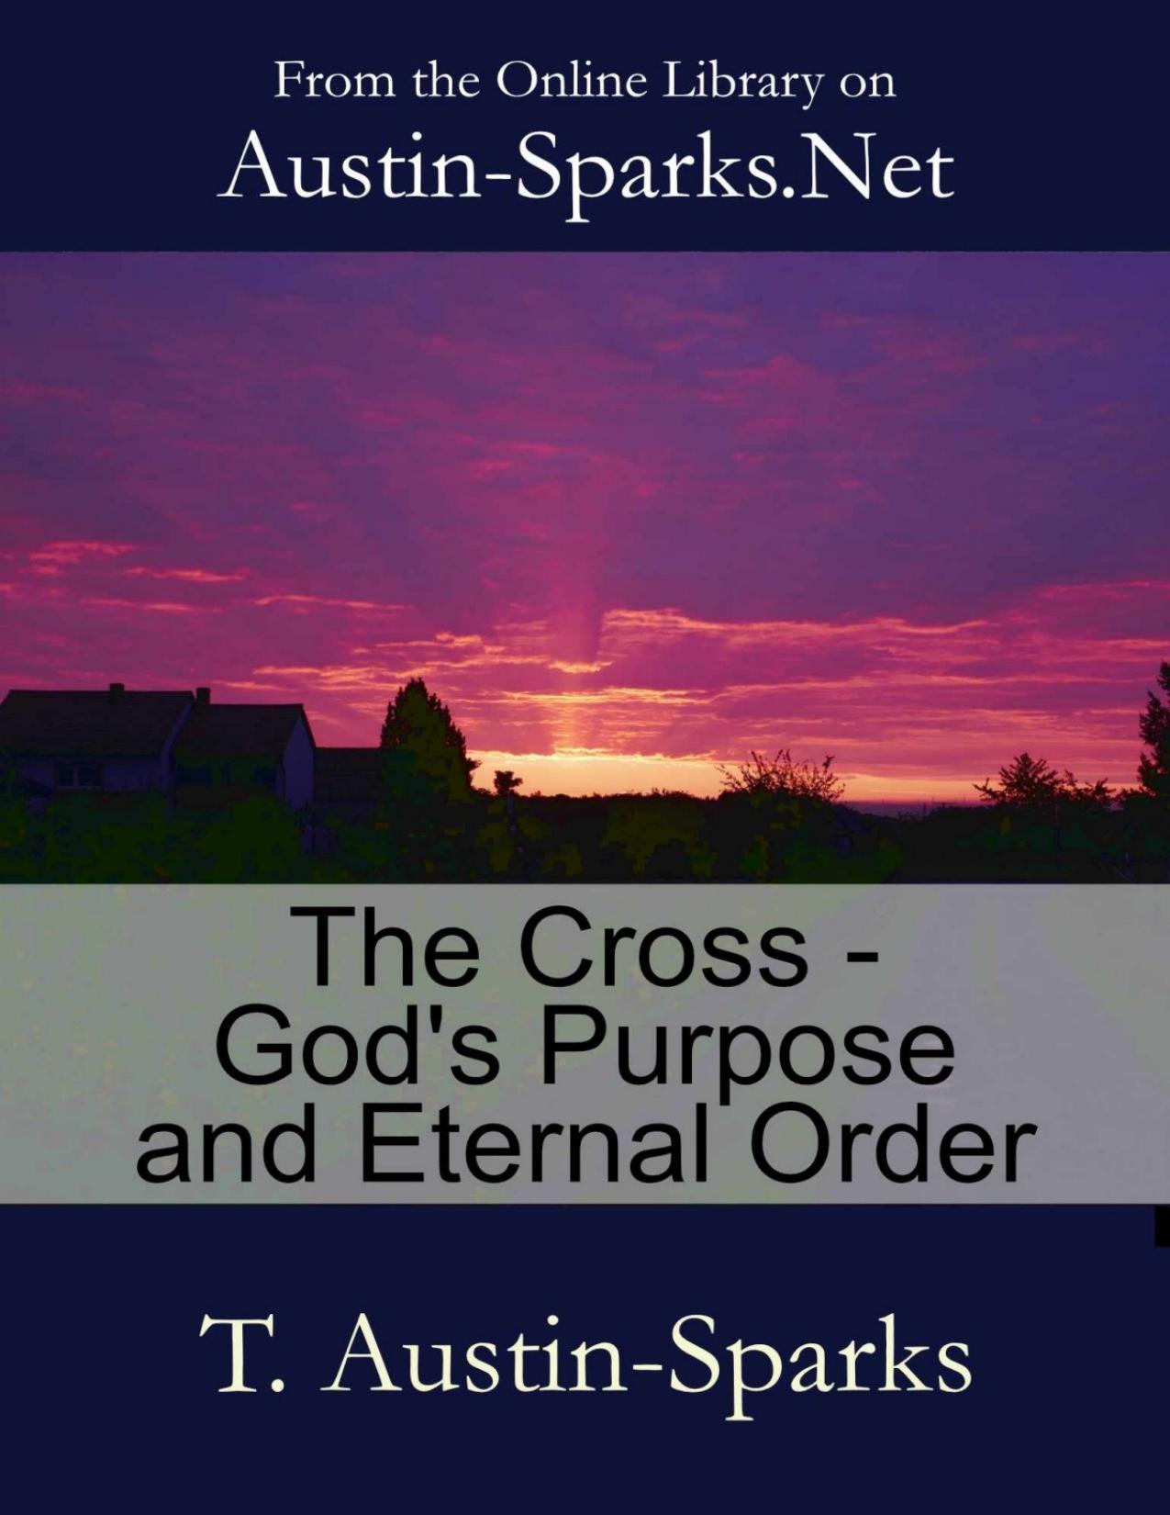

Table of Contents
Chapter 1 - The Cross in Relation to God's
Chapter 2 - The Cross in Relation to God's
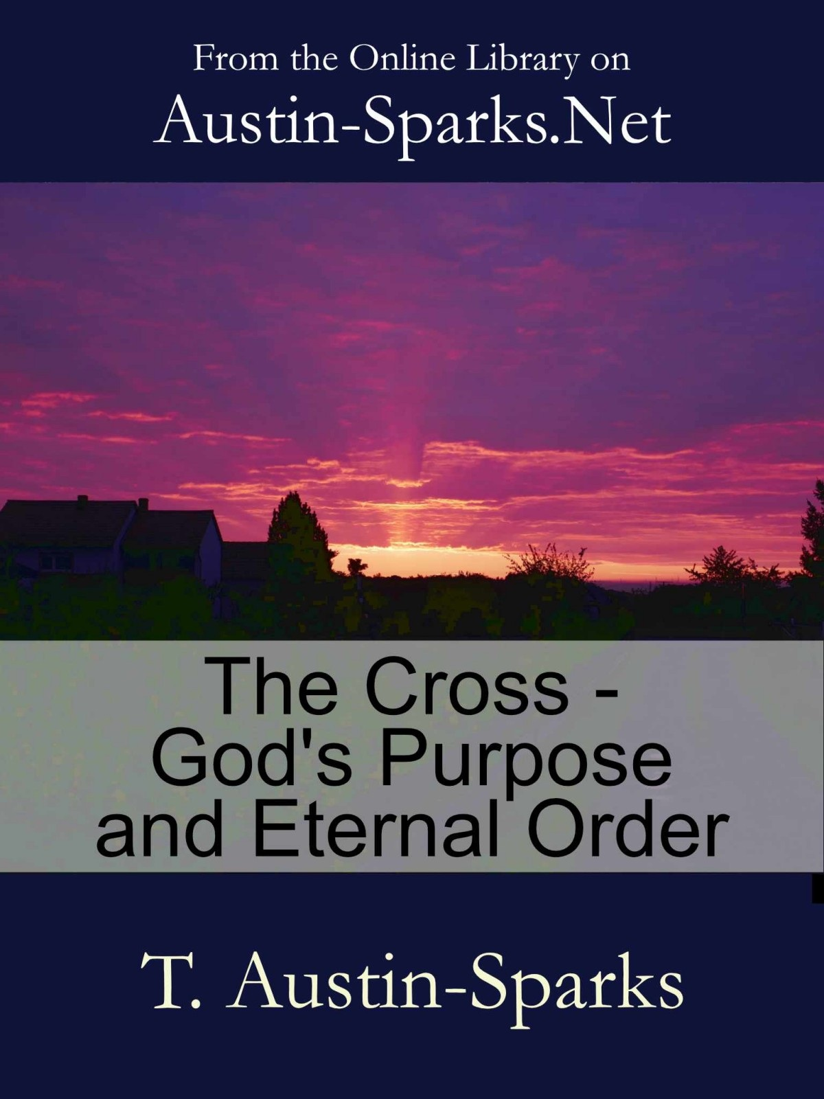
2
3

Author's Rights
Published as an E-book
by
Austin-Sparks.Net
Email: info@austin-sparks.net

ISBN: 978-1-927326-49-7

In keeping with T. Austin-Sparks' wishes that what was freely received should be freely given and not
sold for profit, and that his messages be reproduced word for word, we ask if you choose to share
these messages with others, to please respect his wishes and offer them freely - free of any changes,
free of any charge (except necessary distribution costs) and with this statement included.

4
The Cross - God's Purpose and Eternal Order
by T. Austin-Sparks
Edited and supplied by the Golden Candlestick Trust.

Contents

Chapter 1 - The Cross in Relation to God's Original Purpose
Chapter 2 - The Cross in Relation to God's Eternal Order

5

Chapter 1 - The Cross in Relation to God's
Original Purpose
"Far be it from me to glory, save in the cross of our Lord Jesus Christ" (Gal. 6:14).
The words which are to be the key to our meditation are words which are very familiar to you - "The cross of our Lord Jesus Christ".
We shall take a little time to consider some of the relationships in which we must see the cross if it is going to have its full effect in our lives, for the full power of the cross demands that it is apprehended in its full relationships. We shall never know the power of the cross, the dynamic of the cross, in any real fulness while we hold it down to ourselves, while we make our particular world (however needy that world may be) while we make our world of spiritual need the world of the cross. We will have to leave our ground, we will have to leave ourselves, and move on and touch some of these greater relationships, and then the thing will come back at us with something of its tremendous power. God is greater than our hearts, and the cross is vastly greater than our greatest need, and not until we have seen that shall we find that this thing, our need, ourselves, just loses a great deal of its importance. It is swallowed up, we are delivered, we have seen and felt the impact of the greatness of the cross.
God's Purpose Centred in His Son
So, in these greater relationships of the cross, I think the first is its connection with, or relation to, God's original purpose in this universe. We know now so well as a matter of truth, and doubtless also as a matter of faith, that the purpose of God, that great purpose of the ages, as it is called, is centred in and compassed by His Son; or shall I say by sonship, for sonship is something very inclusive. It certainly takes its rise in Him, the Son, but it embraces many as it goes on. Let us look at those words on this matter in the first chapter of the letter to the Colossians -
"...the kingdom of the Son of His love... who is the image of the invisible God, the firstborn of all creation; for in Him were all things created, in the heavens and upon the earth, things visible and things invisible, whether thrones or dominions or principalities or powers; all things have been created through Him, and unto Him; and He is before all things, and in Him all things consist. And He is the head of the body, the church: who is the beginning, the firstborn from the dead; that in all things He might have the preeminence. For it was the good pleasure of the Father that in Him should all the fulness dwell" (13, 15-19).
That is the first half of the matter where the universe is Christo-centric. Now comes the change, the other half.
"and through Him to reconcile all things unto Himself, having made peace through the blood of His cross; through Him, I say, whether things upon the earth, or things in the heavens. And you..." (20,21).
That makes the cross the centre of the universe; redempto-centric. That is in itself one of the most wonderful statements in Scripture. There are few things in all the Word of God to compare with it as a statement. Paul had earlier hinted at this in former letters, but it would seem that even with Paul the thing had not yet come with its full force. It had been intimated, signified, even on the Damascus
6
road. He had further intimations and indications as he went on, but this situation in Colosse, which had arisen there, the false teaching as to the universe and its spiritual government, seems to have made Paul gather up everything that he did know on the matter, and, so to speak, throw himself into this. As he did so, it took its full shape, and in these few lines, 15 to 21 in this arrangement, he gives us the concentrated essence and full range of this double truth which had come to him with such emancipating power, and which he gave forth here with the intention of delivering the church from one of the most sinister and subtle attempts to put Christ in a place where God never intended Him to be, or to rob Christ of the place which God always intended Him to have. And what is gathered into this short paragraph is this double thing, that Christ was the Creator of all things, and then that Christ was the Redeemer of all things; that all creation was through and unto Him and by Him, and then all redemption was through Him as well. That may sound very simple as a statement, but if you could recognize what that meant as over against the teaching which he was refuting, if we were able to enter more fully into the meaning of this tremendous thing we shall see there is nothing simple about it in the sense of it being elementary.
The Image of the Invisible God
But look at one or two of the fragments in verse 15. He "is the image of the invisible God". That word 'ikon' is a word which means something more, and something very much more, than just a likeness of the invisible God, or a likeness to the invisible God. It means an actual manifestation of the original. 'Who is an actual manifestation of the invisible God', not just a likeness. Therein lies the satanic subtlety of ikon worship in those systems where they set up ikons and pray to them and worship before them. The real meaning is that they are not just doing that to some kind of replica, some reproduction. The real meaning is that this is something which in itself is to be worshipped; it conveys the original, it has the original there, and that is the real meaning of the word. The Lord Jesus is not just a likeness of God, some second thing. He is the image, the actual manifestation, of the original, the arch-type, not a second thing made like the first, but so utterly one with the first that they are not two things at all. It is the original present in Jesus Christ. That is the whole argument of the New Testament which we, of course, believe as a part of our very faith or the Faith, but you have got to get right to that before you are able to grasp the significance of the cross. That is where it begins: that God was in Christ creating and God was in Christ redeeming and Christ was in God creating and Christ was in God redeeming, and these are not two, these are one.
The Firstborn of All Creation
The next clause - "the firstborn of all creation". The phrase in our English, which is, I suppose, as near as can be got to the original and yet imperfect, and is calculated to let in a thought, an idea, that is something less than what it really means. This does not mean the first of created beings. "The firstborn of all creation" does not mean the first of created beings, but it does mean born first before all creation. It is in the very word that is used. It means priority and sovereignty, and that is as in respect of creation, and that is borne out by what follows.
All Things Created in Him
"For in Him were all things created" - not by Him in the first place. That will be said as a later thing. You will find that in chapter one of John, and that is quite true, but that is not the first thing that is said about the creative activity. "In Him" - and what is meant by that statement is that He was the conditioning cause of creation; that is, He contained in Himself all that was to be found in creation. That is a tremendous statement: the conditioning cause; that creation was to take its character from Him; that when you come to look into the whole creation with enlightened eyes, divinely enlightened

7
eyes, you would trace this Son of God, you would find Him implicit in the whole creation. It was in Him that all things were created, not only by Him and through Him. It is true it is said here "through Him". He was the mediate instrument of creation. But that is something much more than that. It is not one who is manufacturing something in an objective way. He is bringing all this into being with Himself in its very essence. That is how it will be in the end, and our eyes will then be enlightened and we shall find in the creation as God reconstitutes it in virtue of the cross, all things reconciled through the cross, in virtue of the cross, that very divine nature of the Son, of the Father, will be there in every part of the universe, traceable in the whole creation. We again need a very big apprehension of Christ to be able to appreciate that. But that is the meaning of the statement here.
All Things Created Through Him
Then there will follow that through Him all things were created, when you have got the 'in Him'. That little clause, two words, "were created" is in the aorist tense which means a definite act in time. All things were created as a definite act in time. They were created, and that at a point in time, by a divine act. We do not need to have that argued, but it is as well just to notice what is stated here. All that Paul says of these other things and all that Paul has said on this matter goes to the wind if one fragment is false. If you can prove evolution, Paul's ministry goes out at once, the whole of it, and all this revelation is forfeited. He says it was a divine act in time. You can follow it through fragment by fragment. We have enough to bring us to this word 'sonship'. All the divine purpose is centred in, and compassed by, sonship.
Sonship a Spiritual Life Relationship
What, then, is sonship, the essence of sonship? Firstly, it is a spiritual life relationship. The very word, the very idea of father and son means that. I am careful in the words I use. A spiritual life relationship. Of course, we do not believe in a physical relationship between Christ and the Father. Sonship is not on a physical basis as regards both of them. The incarnation is something subsequent to sonship. Sonship goes back long before the incarnation. It is therefore a spiritual life relationship that is God imparting His spiritual nature in a spiritual life to a spiritual seed. When it comes to believers, the many sons, who, having been made accepted in the Beloved One, the Son of His love, are brought into that relationship with God by the imparting of a spiritual life, setting up this particular relationship with God.
Sonship Becomes Actual Through Faith
It becomes actual through faith. Here I want to dwell upon that matter of faith making things actual, and in particular this relationship with the Father in Christ, made actual through faith. We often hear the phrase 'a faith position', and I am afraid that very often that phrase is used with a kind of abstract, nebulous mentality that that is, after all, only a faith position, it is not an actual one; you believe it is, but it is not! You take an attitude towards it like that, but really it is not actually so, it is a 'faith position'. Now let us clear that up. Is your new birth a 'faith position' and not an actuality? I am sorry for you! Is your union with God 'a faith position' and not an actuality? There is something wrong with it! Faith is the vital contact, the result of which is begetting in the first place, creating, bringing about a new entity, a new existence, a new being. It is the union of two into one. Oh, get this! Do not miss this as to what faith is! Faith is that vital contact by which two are made one. It is a union of two into one as in marriage. It is the surrender of an alone and an apart position. That is faith, and you will find that all the workings of faith, all the testings of faith, all the trials of faith, bring you to that; leaving your own ground and taking God's, leaving a ground separate and apart and alone, and becoming one with God. Faith is going to get you on to God's ground, and immediately you get onto

8
God's ground and you merge into God, something happens. While we are standing back in our trial of faith, moving apart, arguing, resisting, contending, still walking as alone and apart, nothing happens. We know that well enough. Immediately we get away from that ground of ourselves, in mind, in heart or in will and forsake ourselves, our father and our mother spiritually, our inheritance, our old Adam relationships, all that we are producing of ourselves, immediately we get away from that and by faith get right into God, something happens. It is not a faith position in a doctrinal or theoretical sense; it is actual. If you have this kind of faith, which is the only real faith, if it is only faith as a grain of mustard seed, something happens, it is the vital contact.
There is something very much deeper in the divine thought in marriage than ever we have yet seen. What is marriage? It is, on the one hand, the forsaking of an alone and apart ground, the forsaking of your own relationships. "For this cause shall a man leave..." (Matt 19:5). It is leaving, and it really should be a tremendous act of faith, and it is that act of faith that really gives it its value. Oh today, where does faith come in in this relationship? People just run into it, thoughtlessly, with little consideration, on an impulse, an emotion. They do not stand back and ask, "What is this going to involve? Let us face all that this will probably lead to. Let us look right on and right in, and then, well, am I prepared for that? As far as I can understand and see and know of what this marriage relationship involves and implies, as far as I have been able to grasp its significance, am I prepared for that? I can see that, while there may be a good many things pleasant and desirable about it, I can see it is also going to involve responsibilities and trials and so on. If I commit myself, it will be an act of faith, especially on the woman's side." Forgive my pressing the illustration. It is an act of faith. I am committing everything, putting myself into the hands of another. I do not know how it is going to work out, but it is a sheer act of faith - of course, born of love.
Now, that is the principle of faith. It is the church's relationship to Christ. Here we are. We have our own life, we like an independent life, a free life, to go our own way, do as we like. And then the whole question arises of our marriage to Christ, and our individual personal liberties are going to be given up, all our mind about things, our will, our feeling, let go. It is going to be Himself. He is going to have all the rights in His hands. Am I prepared for that? This is a step of faith. Mark you, if we did but know it, that lies right at the heart even of our conversion. We do not recognize all that, but He does, and Christ has never yet accepted anybody except on the ground of a sheer act of committal in faith; He has never yet made it a matter of our just signing a card, or something like that. No! You get a real case of regeneration, and there has been tremendous exercise of faith, a real challenge -"Am I prepared for this?" And the deeper that goes, the more thorough is the immediate result. And what is true at the beginning is true all through our Christian life. This principle of faith is the principle of making something actual. How do you read the end of Hebrews 10 and the beginning of Hebrews 11? "Now faith is..." what? That is not a definition of faith. It is a statement of fact, and the whole of that chapter 11 is the bearing out of that, that when men really got onto God's ground, something happened, something became actual. It makes actual. It is not 'a faith position', it is an actuality. Sonship is founded in that implicit faith which has produced such a oneness that there are not two, only one. "The two shall become one flesh" (Eph. 5:31). The apostle says, "I speak in regard of Christ and the church" (Eph. 5:32). Not two, but one; an uttermost committal where, in a sense, our very personality is exchanged for His. Henceforth it is to be Christ living His personality as far as possible, progressively, in us, and not we living our own. Faith produces that oneness.
Now do you see why the Lord is dealing with us so much on this faith basis? What is He after? Read Hebrews 12. You have the whole thing in essence and substance. There you have, "My son, regard not lightly the chastening of the Lord, nor faint when thou art reproved of Him; for whom the Lord loves He chastens, and scourges every son whom He receives". The very principle of sonship is developed by the testing of faith which has as its object some fuller oneness between us and the
9
Lord, some fuller expression of that basic oneness. So we must look at our trials of faith, and the further we go with the Lord the more they are and the more severe they are, and I say this with a certain amount of reserve, but maybe the final step by which we merge into our utter oneness with the Lord will be the most severe test of faith that we have ever had. We must take up these matters of our trials of faith, and say, "What is there here that represents two things, the Lord and myself?" and my business now is to say, "No, not myself, but the Lord; not what I would, but the Lord". When we really get through with it and that is over, something happens spiritually, there is something produced. The law of progress, production, is through two merged into one on the basis of the same life.
That is wrought in the creation as a spiritual thing manifested in the natural. All things are created in Him, He gives the character to everything, and this thing will be manifested in the creation when it is as He made it, not what it is now. And when all the work of His cross is effected, there will be such a oneness which will be Christ, only Christ; not Christ and us and others, but only Christ. There will be such a perfect oneness, which means such a perfect harmony, well, to say we shall not know ourselves is to put it very weakly. But just think in a world like this, a world as it is now, with all its conflicting fragments, to have only one mind, only one heart, only one will, only one interest, all one and no two things about it, that is divine! There you have the heart of the cross. The cross is a tremendous thing.
Now you can work inward if you like, but get your vast setting first, and see that that is what the cross is for, that is what He has accomplished by His cross, that is the dynamic of the cross. The cross will deal with all divisions, great and small, which hinder the oneness of the Body as a whole. But it starts right out there in that eternal purpose of God. The cross is related to the eternal purpose and it is firstly expressed in the principle of sonship, and sonship is that oneness of which we have spoken, where there are no two minds, two wills, two ways, two desires, but complete merging, surrender of all apartness and all aloneness, and that is what made the cross of the Lord Jesus a victory. It was not in the cross that this was fully worked out, but the cross was the final seal to this. For three and a half and probably more years, He had been in this testing as to whether there could be two minds, two wills, two desires, two ways, and He had fought the battle of the cross out thoroughly from Jordan to Calvary, and then sealed the whole thing there, not on the earth, but in the whole universe. The cross was cosmic, universal, but the victory of the cross was the cumulative victory of all those victories where He had been tempted to take ground apart from the Father; all on the principle of faith. "Shall I trust My Father? Shall I do as the flesh would demand and as Satan says is the reasonable thing to do - turn stones into bread? Or shall I trust My Father?" It was like that all the way through, the merging of Himself with the Father. That is sonship in principle, and that is the reconciling of all things, the reconciling of all estranged, divided things by His cross. Oh, the fulness, the depth of it!
I think we must stop there for the present. It is just a glimpse, but I trust a glimpse that is going to mean something where we are concerned, a glimpse of the tremendous setting of the cross, and the power of that cross. Oh, if it can do it on that range, it can do it in me, it can do it in you. However big our personal world may seem to be as a problem and a difficulty, let us bring it right into the greatness of the cross, and it will not be quite so big when we see it in its right setting.

10

Chapter 2 - The Cross in Relation to God's
Eternal Order
The letter to the Colossians sets forth God's eternal order, and it sets it forth over against the work of the Evil One in the direction of disorder and disruption, and significantly enough, that work of the enemy all focused upon one thing which betrays it at once, and that one thing was to get Christ out of His place as Head where Christians are concerned. We can, of course, easily trace the trail of the serpent when that is the thing which is in view. The apostle is meeting this terrible thing. It would take too long and be far too wearisome to you if I were to enter upon what this thing was that the apostle was meeting, a mixture of religion and philosophy that had been developed among the Greeks as to spiritual orders, their system of principalities and powers and rulers in the unseen, the orders, the ranges of spiritual intelligences, and the whole issue of it was that, whoever Jesus might be, He was, after all, only one of those orders, perhaps of a superior kind. He was a created being in the same sense as the others, and He had to take His place as a created being even if it were in the unseen realm. He was only one, even if occupying a rank above many. That is, in very short, the situation and thus the enemy brought this thing along to the Greeks whose very temperament was to be interested in these profound, abstruse matters; brought that along to Christians, the church, and was gradually working that in, undermining the uniqueness of the Lord Jesus - His aloneness. So Paul says that these very dominions, things invisible, thrones and powers, were all created by Him. The undermining of the supremacy of the Lord Jesus was the thing that the apostle was meeting and undercutting; that there is a Divine order beginning at the Throne of absolute sovereignty, and that is the Son, and then through Him and unto Him other thrones and dominions and principalities and powers created by Him; things visible and things invisible, all created by Him. That is God's order.
The Divine Eternal Order is Organic
There is an eternal order that is according to God's mind in this vast universe, an order of spiritual intelligences, but there is a disorder which has been introduced by the rebel, by the other one whose one business it is to disintegrate, break up the Divine order to bring about disorder, and in the light of that you can read this letter. To me, that opens up this letter, and makes it something more than fascinating. You find that this Divine eternal order is organic, resultant from Christ's Headship. It is as of a body in perfect organic order by reason of the Head being in His place, and being accorded complete sovereignty. The apostle speaks about holding fast the Head, from Whom all the Body is fitly framed; an organic order, not created by man, but spontaneously resultant from Christ being in His place.
"He is the head of the body, the church: who is the beginning, the firstborn from the dead; that in all things He might have the pre-eminence" (Col. 1:18).
"...having blotted out the bond written in ordinances that was against us, which was contrary to us: and He hath taken it out of the way, nailing it to the cross" (Col. 2:14).
The cross and the Divine order as to the heavenly orders: "for in Him were all things created, in the heavens and upon the earth, things visible and things invisible, whether thrones or dominions or principalities or powers; all things have been created through Him, and unto Him" (Col. 1:16).
They are the heavenly orders, and then this is where we link up again with believers. The church is
11
brought in as the instrument and sphere for the manifestation of that eternal order of God, through the cross, "through Him to reconcile all things unto Himself, having made peace through the blood of His cross; through Him, I say, whether things upon the earth, or things in the heavens. And you, being in time past alienated and enemies in your mind in your evil works, yet now hath He reconciled in the body of His flesh through death, to present you holy and without blemish and unreprovable before Him" (Col. 1:20-22).
The Church the Instrument of the Recovered Spiritual Order
So the church comes in as the instrument of a recovered spiritual order, but - and here again is the crucial and vital point - the church, in order to be that instrument, that sphere of the manifested recovered eternal order has to come by the way of the cross where its own separate position is abandoned. That is what we have in words like these:
"If ye died with Christ..." (Col 2:20).
"If then ye were raised together with Christ, seek the things that are above, where Christ is, seated on the right hand of God. Set your mind on the things that are above, not on the things that are upon the earth. For ye died, and your life is hid with Christ in God" (Col. 3:1-3).
In that very connection, go back to Chapter 1:27.
"...to whom God was pleased to make known what is the riches of the glory of this mystery among the Gentiles, which is Christ in you, the hope of glory; whom we proclaim, admonishing every man and teaching every man in all wisdom, that we may present every man perfect in Christ" (Col. 1:27-28).
The Church and the Cross
You see where we have arrived. There is a Divine eternal order. That order is summed up in Christ as Head, to be expressed and manifested in His Body corporately. Unto that, that Body has to have passed by the way of the cross unto all that - the separate, independent life has been completely yielded up - and in which that which was another, making two, has been merged into Him. Paul's figure is "planted together with Him" (Rom. 6:5), merged into Him in His death, in His resurrection; not two; not Christ and you, me; not Christ and a body as apart, but one, just one. And the apostle is arguing that it is only by means of that church on those grounds that God can be satisfied as to the order which He eternally intended to exist in this universe, and you will find that, as in the second part of the letter to the Ephesians, so in the second part of the letter to the Colossians, this matter is brought down to the practical affairs of everyday life, and those affairs are the affairs, as you will notice, of relationships. You are not dealing with an external system of things. You are dealing with deeply-rooted spiritual principles. So relationships are taken up - husbands, wives; wives, husbands; children, parents; parents, children; masters, servants; mistresses and handmaids; relationships -domestic, business, social; all those spheres in which there can be such independent activity, such divided life, such a clash or such a separateness - this whole matter of Christ's Headship of the Body is brought down there.
Now, that is where we are caught at once. We are in the net. We do not start from the other end. We start right from heaven, right from God, right from eternity. This great eternal order which has been disrupted right through the universe, in the unseen as well as in the seen, is all recovered in Christ personally by the cross, and then recognised in the church His Body in vital relationship with Himself. But the existence of the church presupposes that it has been to the cross.
12
Oh, are you interested in the cross, are you interested in the church, are you interested in the Body of Christ? Do you not see what the Holy Spirit does? He brings it right down here and says, "Look here, that vast eternal range of things impinge right upon your domestic relationships and to believe in the Body, the cross, the Headship of Christ and profess to be in accordance with that teaching, and to hold that truth, and for there to be amongst believers in the same home schism, division, is a contradiction of the whole". And amongst those in business relationships who are the Lord's, for there to be a pulling apart, a working against, an independence, is a violation of the whole eternal order. It is not a little local thing, a little family affair, a little business affair where you make your business one thing and your Christianity another. This is a thing which touches that vast range of God's eternal order. It comes right down there, we cannot get away with it. If we violate the Life, if we work against the Holy Spirit, if we set aside the sovereign Headship of Christ, if all that we find in the first two and a half chapters of the Colossian letter is still for us wonderful objective truth, marvellous revelation; it is the mystery which has been hid from all ages and generations but now made known unto us - and right there in the home two children of God who are not one - the whole order is violated. That is what the enemy is after. It is not just incompatibility. If they are responsible Christians in their senses, walking together, and not finding a place of oneness (maybe not oneness right through to perfection but a place of oneness where they go on together and there is no fighting) well, so far as all this is concerned, it goes for nothing. This matter of God's eternal order is tremendously practical.
It all comes back to this after all. What do we know about the cross? If as masters we can be drivers, intolerant, not understanding, unsympathetic; if as relations we can allow strain which puts us apart to go on and on and never clear it up, what do we know about the cross? The cross touches God's eternal order right to the fringe of the universe, through all hierarchies, and then brings it down to immediate local, domestic, business matters where Christians are concerned. Is not the point usually, if not invariably, a matter of yieldedness? That is why the little Philippian letter is sandwiched in between Ephesians and Colossians. Euodia and Syntyche are not of one mind and there is strain being brought into the church in Philippi because there is not one mind; two dear believing Christian women, but it is making difficulties in the church, and the apostle, with wisdom from heaven, says, "Look here, the Lord Jesus let go all His rights and all His possessions and all His positions, and emptied Himself of all in order to destroy this disruption, completely destroy this divisive, disintegrating work of the evil forces, to bring about oneness; let that mind be in you, let go. You have fears as to what will happen if you let go. That is not faith. Nothing will happen if it is on the basis of fears. Faith is the vital link". Consequences are with God when you have let go. Oh, the vast revelation of the mystery of Ephesians, all the marvellous revelation of the Headship in Colossians -it depends upon this in between for its practical outworking - He emptied Himself, you do the same. That is what the apostle says really. He emptied Himself, you do the same; otherwise what are you doing? - violating all that is in Ephesians and all that is in Colossians. This little letter to the Philippians takes Ephesians and Colossians in either hand, so to speak, and makes them vitally one in expression. Let go, empty yourself. Oh yes, it is getting down.
I can only hope that what we have been saying indicates something that you are able, if you have seen it before, to see in some fresh way, with some clearer perception, that the cross of our Lord Jesus Christ has the ultimate things of God's universe bound up with it. Those ultimate things are brought right into the church, the Body of Christ, and that church is not the church when it is met in some building; it is still the church when it is at home or in the office, still the church in the social circle when you are visiting one another. How much of the Lord and the Lord's things occupy conversation in social visits? You are, if you are Christians, still the church wherever you are, and church principles have to operate in every sphere, in every place. Do not let us leave our church
13
ground when we go home to be something else. Remember that there were no special ecclesiastical meeting places at the beginning. The church was everywhere and anywhere where believers were, and these principles apply there. The Lord give us grace to receive and respond to His word.

14

