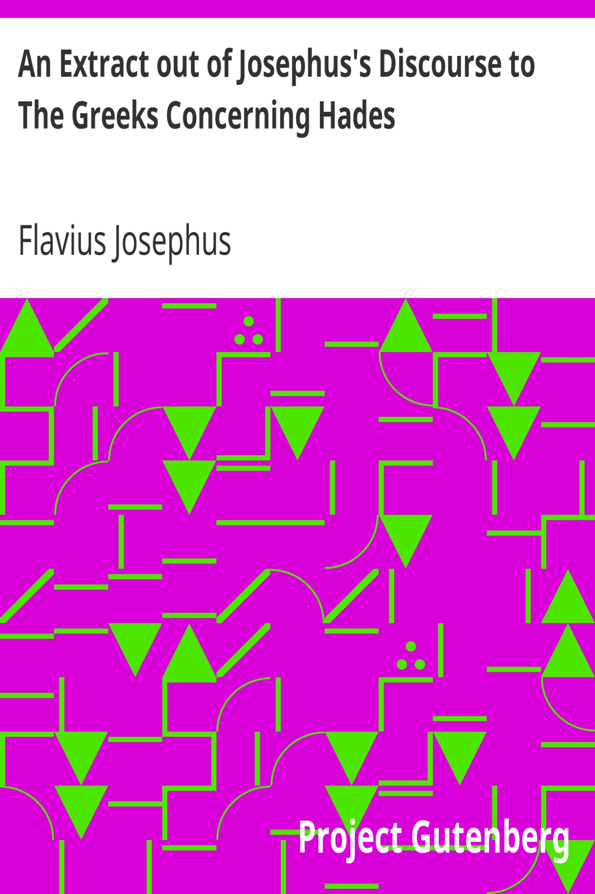

# Table of Contents

AN EXTRACT OUT OF JOSEPHUS'S DISCOURSE TO THE GREEKS CONCERNING HADES

Translated by William Whiston

THE FULL PROJECT GUTENBERG LICENSE

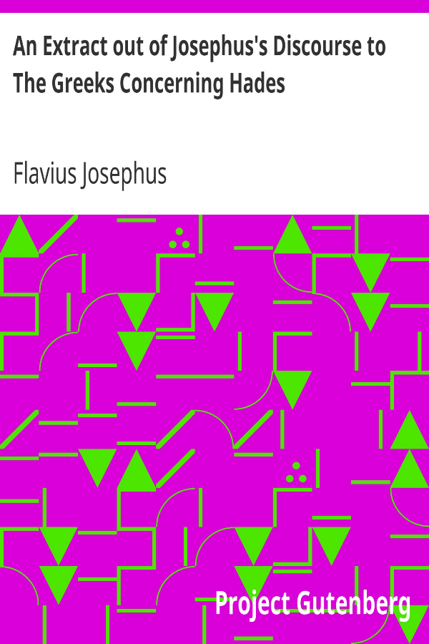

The Project Gutenberg eBook of An Extract out of Josephus's Discourse to The Greeks Concerning Hades

This ebook is for the use of anyone anywhere in the United States and most other parts of the world at no cost and with almost no restrictions whatsoever. You may copy it, give it away or re-use it under the terms of the Project Gutenberg License included with this ebook or online at [www.gutenberg.org](https://www.gutenberg.org). If you are not located in the United States, you will have to check the laws of the country where you are located before using this eBook.

Title: An Extract out of Josephus's Discourse to The Greeks Concerning Hades

Author: Flavius Josephus

Translator: William Whiston

Release date: October 1, 2001 [eBook #2847]  
 Most recently updated: August 15, 2016

Language: English

Credits: Produced by David Reed, and David Widger

*** START OF THE PROJECT GUTENBERG EBOOK AN EXTRACT OUT OF JOSEPHUS'S DISCOURSE TO THE GREEKS CONCERNING HADES ***

# AN EXTRACT OUT OF JOSEPHUS'S DISCOURSE TO THE GREEKS CONCERNING HADES

By Flavius Josephus

### Translated by William Whiston

1. Now as to Hades, wherein the souls of the good things they see, and rejoice in the righteous and unrighteous are detained, it is necessary to speak of it. Hades is a place in the world not regularly finished; a subterraneous region, wherein the light of this world does not shine; from which circumstance, that in this region the light does not shine, it cannot be but there must be in it perpetual darkness. This region is allotted as a place of custody for souls, ill which angels are appointed as guardians to them, who distribute to them temporary punishments, agreeable to every one's behavior and manners.

2. In this region there is a certain place set apart, as a lake of unquenchable fire, whereinto we suppose no one hath hitherto been cast; but it is prepared for a day afore-determined by God, in which one righteous sentence shall deservedly be passed upon all men; when the unjust, and those that have been disobedient to God, and have given honor to such idols as have been the vain operations of the hands of men as to God himself, shall be adjudged to this everlasting punishment, as having been the causes of defilement; while the just shall obtain an incorruptible and never-fading kingdom. These are now indeed confined in Hades, but not in the same place wherein the unjust are confined.

3. For there is one descent into this region, at whose gate we believe there stands an archangel with an host; which gate when those pass through that are conducted down by the angels appointed over souls, they do not go the same way; but the just are guided to the right hand, and are led with hymns, sung by the angels appointed over that place, unto a region of light, in which the just have dwelt from the beginning of the world; not constrained by necessity, but ever enjoying the prospect of the good things they see, and rejoice in the expectation of those new enjoyments which will be peculiar to every one of them, and esteeming those things beyond what we have here; with whom there is no place of toil, no burning heat, no piercing cold, nor are any briers there; but the countenance of the and of the just, which they see, always smiles them, while they wait for that rest and eternal new life in heaven, which is to succeed this region. This place we call The Bosom of Abraham.

4. But as to the unjust, they are dragged by force to the left hand by the angels allotted for punishment, no longer going with a good-will, but as prisoners driven by violence; to whom are sent the angels appointed over them to reproach them and threaten them with their terrible looks, and to thrust them still downwards. Now those angels that are set over these souls drag them into the neighborhood of hell itself; who, when they are hard by it, continually hear the noise of it, and do not stand clear of the hot vapor itself; but when they have a near view of this spectacle, as of a terrible and exceeding great prospect of fire, they are struck with a fearful expectation of a future judgment, and in effect punished thereby: and not only so, but where they see the place [or choir] of the fathers and of the just, even hereby are they punished; for a chaos deep and large is fixed between them; insomuch that a just man that hath compassion upon them cannot be admitted, nor can one that is unjust, if he were bold enough to attempt it, pass over it.

5. This is the discourse concerning Hades, wherein the souls of all men are confined until a proper season, which God hath determined, when he will make a resurrection of all men from the dead, not procuring a transmigration of souls from one body to another, but raising again those very bodies, which you Greeks, seeing to be dissolved, do not believe [their resurrection]. But learn not to disbelieve it; for while you believe that the soul is created, and yet is made immortal by God, according to the doctrine of Plato, and this in time, be not incredulous; but believe that God is able, when he hath raised to life that body which was made as a compound of the same elements, to make it immortal; for it must never be said of God, that he is able to do some things, and unable to do others. We have therefore believed that the body will be raised again; for although it be dissolved, it is not perished; for the earth receives its remains, and preserves them; and while they are like seed, and are mixed among the more fruitful soil, they flourish, and what is sown is indeed sown bare grain, but at the mighty sound of God the Creator, it will sprout up, and be raised in a clothed and glorious condition, though not before it has been dissolved, and mixed [with the earth]. So that we have not rashly believed the resurrection of the body; for although it be dissolved for a time on account of the original transgression, it exists still, and is cast into the earth as into a potter's furnace, in order to be formed again, not in order to rise again such as it was before, but in a state of purity, and so as never to be destroyed any more. And to every body shall its own soul be restored. And when it hath clothed itself with that body, it will not be subject to misery, but, being itself pure, it will continue with its pure body, and rejoice with it, with which it having walked righteously now in this world, and never having had it as a snare, it will receive it again with great gladness. But as for the unjust, they will receive their bodies not changed, not freed from diseases or distempers, nor made glorious, but with the same diseases wherein they died; and such as they were in their unbelief, the same shall they be when they shall be faithfully judged.

6. For all men, the just as well as the unjust, shall be brought before God the word: for to him hath the Father committed all judgment: and he, in order to fulfill the will of his Father, shall come as Judge, whom we call Christ. For Minos and Rhadamanthus are not the judges, as you Greeks do suppose, but he whom God and the Father hath glorified: Concerning Whom We Have Elsewhere Given A More Particular Account, For The Sake Of Those Who Seek After Truth. This person, exercising the righteous judgment of the Father towards all men, hath prepared a just sentence for every one, according to his works; at whose judgment-seat when all men, and angels, and demons shall stand, they will send forth one voice, and say, Just Is Thy Judgment; the rejoinder to which will bring a just sentence upon both parties, by giving justly to those that have done well an everlasting fruition; but allotting to the lovers of wicked works eternal punishment. To these belong the unquenchable fire, and that without end, and a certain fiery worm, never dying, and not destroying the body, but continuing its eruption out of the body with never-ceasing grief: neither will sleep give ease to these men, nor will the night afford them comfort; death will not free them from their punishment, nor will the interceding prayers of their kindred profit them; for the just are no longer seen by them, nor are they thought worthy of remembrance. But the just shall remember only their righteous actions, whereby they have attained the heavenly kingdom, in which there is no sleep, no sorrow, no corruption, no care, no night, no day measured by time, no sun driven in his course along the circle of heaven by necessity, and measuring out the bounds and conversions of the seasons, for the better illumination of the life of men; no moon decreasing and increasing, or introducing a variety of seasons, nor will she then moisten the earth; no burning sun, no Bear turning round [the pole], no Orion to rise, no wandering of innumerable stars. The earth will not then be difficult to be passed over, nor will it be hard to find out the court of paradise, nor will there be any fearful roaring of the sea, forbidding the passengers to walk on it; even that will be made easily passable to the just, though it will not be void of moisture. Heaven will not then be uninhabitable by men, and it will not be impossible to discover the way of ascending thither. The earth will not be uncultivated, nor require too much labor of men, but will bring forth its fruits of its own accord, and will be well adorned with them. There will be no more generations of wild beasts, nor will the substance of the rest of the animals shoot out any more; for it will not produce men, but the number of the righteous will continue, and never fail, together with righteous angels, and spirits [of God], and with his word, as a choir of righteous men and women that never grow old, and continue in an incorruptible state, singing hymns to God, who hath advanced them to that happiness, by the means of a regular institution of life; with whom the whole creation also will lift up a perpetual hymn from corruption, to incorruption, as glorified by a splendid and pure spirit. It will not then be restrained by a bond of necessity, but with a lively freedom shall offer up a voluntary hymn, and shall praise him that made them, together with the angels, and spirits, and men now freed from all bondage.

7. And now, if you Gentiles will be persuaded by these motives, and leave your vain imaginations about your pedigrees, and gaining of riches, and philosophy, and will not spend your time about subtleties of words, and thereby lead your minds into error, and if you will apply your ears to the hearing of the inspired prophets, the interpreters both of God and of his word, and will believe in God, you shall both be partakers of these things, and obtain the good things that are to come; you shall see the ascent unto the immense heaven plainly, and that kingdom which is there. For what God hath now concealed in silence [will be then made manifest,] what neither eye hath seen, nor ear hath heard, nor hath it entered into the heart of man, the things that God hath prepared for them that love him.

8. In whatsoever ways I shall find you, in them shall I judge you entirely: so cries the End of all things. And he who hath at first lived a virtuous lift, but towards the latter end falls into vice, these labors by him before endured shall be altogether vain and unprofitable, even as in a play, brought to an ill catastrophe. Whosoever shall have lived wickedly and luxuriously may repent; however, there will be need of much time to conquer an evil habit, and even after repentance his whole life must be guarded with great care and diligence, after the manner of a body, which, after it hath been a long time afflicted with a distemper, requires a stricter diet and method of living; for though it may be possible, perhaps, to break off the chain of our irregular affections at once, yet our amendment cannot be secured without the grace of God, the prayers of good men, the help of the brethren, and our own sincere repentance and constant care. It is a good thing not to sin at all; it is also good, having sinned, to repent; as it is best to have health always, but it is a good thing to recover from a distemper. To God be glory and dominion for ever and ever Amen.

*** END OF THE PROJECT GUTENBERG EBOOK AN EXTRACT OUT OF JOSEPHUS'S DISCOURSE TO THE GREEKS CONCERNING HADES ***

Updated editions will replace the previous one—the old editions will be renamed.

Creating the works from print editions not protected by U.S. copyright law means that no one owns a United States copyright in these works, so the Foundation (and you!) can copy and distribute it in the United States without permission and without paying copyright royalties. Special rules, set forth in the General Terms of Use part of this license, apply to copying and distributing Project Gutenberg™ electronic works to protect the PROJECT GUTENBERG™ concept and trademark. Project Gutenberg is a registered trademark, and may not be used if you charge for an eBook, except by following the terms of the trademark license, including paying royalties for use of the Project Gutenberg trademark. If you do not charge anything for copies of this eBook, complying with the trademark license is very easy. You may use this eBook for nearly any purpose such as creation of derivative works, reports, performances and research. Project Gutenberg eBooks may be modified and printed and given away—you may do practically ANYTHING in the United States with eBooks not protected by U.S. copyright law. Redistribution is subject to the trademark license, especially commercial redistribution.

START: FULL LICENSE

THE FULL PROJECT GUTENBERG LICENSE

PLEASE READ THIS BEFORE YOU DISTRIBUTE OR USE THIS WORK

To protect the Project Gutenberg™ mission of promoting the free distribution of electronic works, by using or distributing this work (or any other work associated in any way with the phrase “Project Gutenberg”), you agree to comply with all the terms of the Full Project Gutenberg™ License available with this file or online at www.gutenberg.org/license.

Section 1. General Terms of Use and Redistributing Project Gutenberg™ electronic works

1.A. By reading or using any part of this Project Gutenberg™ electronic work, you indicate that you have read, understand, agree to and accept all the terms of this license and intellectual property (trademark/copyright) agreement. If you do not agree to abide by all the terms of this agreement, you must cease using and return or destroy all copies of Project Gutenberg™ electronic works in your possession. If you paid a fee for obtaining a copy of or access to a Project Gutenberg™ electronic work and you do not agree to be bound by the terms of this agreement, you may obtain a refund from the person or entity to whom you paid the fee as set forth in paragraph 1.E.8.

1.B. “Project Gutenberg” is a registered trademark. It may only be used on or associated in any way with an electronic work by people who agree to be bound by the terms of this agreement. There are a few things that you can do with most Project Gutenberg™ electronic works even without complying with the full terms of this agreement. See paragraph 1.C below. There are a lot of things you can do with Project Gutenberg™ electronic works if you follow the terms of this agreement and help preserve free future access to Project Gutenberg™ electronic works. See paragraph 1.E below.

1.C. The Project Gutenberg Literary Archive Foundation (“the Foundation” or PGLAF), owns a compilation copyright in the collection of Project Gutenberg™ electronic works. Nearly all the individual works in the collection are in the public domain in the United States. If an individual work is unprotected by copyright law in the United States and you are located in the United States, we do not claim a right to prevent you from copying, distributing, performing, displaying or creating derivative works based on the work as long as all references to Project Gutenberg are removed. Of course, we hope that you will support the Project Gutenberg™ mission of promoting free access to electronic works by freely sharing Project Gutenberg™ works in compliance with the terms of this agreement for keeping the Project Gutenberg™ name associated with the work. You can easily comply with the terms of this agreement by keeping this work in the same format with its attached full Project Gutenberg™ License when you share it without charge with others.

1.D. The copyright laws of the place where you are located also govern what you can do with this work. Copyright laws in most countries are in a constant state of change. If you are outside the United States, check the laws of your country in addition to the terms of this agreement before downloading, copying, displaying, performing, distributing or creating derivative works based on this work or any other Project Gutenberg™ work. The Foundation makes no representations concerning the copyright status of any work in any country other than the United States.

1.E. Unless you have removed all references to Project Gutenberg:

1.E.1. The following sentence, with active links to, or other immediate access to, the full Project Gutenberg™ License must appear prominently whenever any copy of a Project Gutenberg™ work (any work on which the phrase “Project Gutenberg” appears, or with which the phrase “Project Gutenberg” is associated) is accessed, displayed, performed, viewed, copied or distributed:

This eBook is for the use of anyone anywhere in the United States and most other parts of the world at no cost and with almost no restrictions whatsoever. You may copy it, give it away or re-use it under the terms of the Project Gutenberg License included with this eBook or online at [www.gutenberg.org](https://www.gutenberg.org). If you are not located in the United States, you will have to check the laws of the country where you are located before using this eBook.

1.E.2. If an individual Project Gutenberg™ electronic work is derived from texts not protected by U.S. copyright law (does not contain a notice indicating that it is posted with permission of the copyright holder), the work can be copied and distributed to anyone in the United States without paying any fees or charges. If you are redistributing or providing access to a work with the phrase “Project Gutenberg” associated with or appearing on the work, you must comply either with the requirements of paragraphs 1.E.1 through 1.E.7 or obtain permission for the use of the work and the Project Gutenberg™ trademark as set forth in paragraphs 1.E.8 or 1.E.9.

1.E.3. If an individual Project Gutenberg™ electronic work is posted with the permission of the copyright holder, your use and distribution must comply with both paragraphs 1.E.1 through 1.E.7 and any additional terms imposed by the copyright holder. Additional terms will be linked to the Project Gutenberg™ License for all works posted with the permission of the copyright holder found at the beginning of this work.

1.E.4. Do not unlink or detach or remove the full Project Gutenberg™ License terms from this work, or any files containing a part of this work or any other work associated with Project Gutenberg™.

1.E.5. Do not copy, display, perform, distribute or redistribute this electronic work, or any part of this electronic work, without prominently displaying the sentence set forth in paragraph 1.E.1 with active links or immediate access to the full terms of the Project Gutenberg™ License.

1.E.6. You may convert to and distribute this work in any binary, compressed, marked up, nonproprietary or proprietary form, including any word processing or hypertext form. However, if you provide access to or distribute copies of a Project Gutenberg™ work in a format other than “Plain Vanilla ASCII” or other format used in the official version posted on the official Project Gutenberg™ website (www.gutenberg.org), you must, at no additional cost, fee or expense to the user, provide a copy, a means of exporting a copy, or a means of obtaining a copy upon request, of the work in its original “Plain Vanilla ASCII” or other form. Any alternate format must include the full Project Gutenberg™ License as specified in paragraph 1.E.1.

1.E.7. Do not charge a fee for access to, viewing, displaying, performing, copying or distributing any Project Gutenberg™ works unless you comply with paragraph 1.E.8 or 1.E.9.

1.E.8. You may charge a reasonable fee for copies of or providing access to or distributing Project Gutenberg™ electronic works provided that:

• You pay a royalty fee of 20% of the gross profits you derive from the use of Project Gutenberg™ works calculated using the method you already use to calculate your applicable taxes. The fee is owed to the owner of the Project Gutenberg™ trademark, but he has agreed to donate royalties under this paragraph to the Project Gutenberg Literary Archive Foundation. Royalty payments must be paid within 60 days following each date on which you prepare (or are legally required to prepare) your periodic tax returns. Royalty payments should be clearly marked as such and sent to the Project Gutenberg Literary Archive Foundation at the address specified in Section 4, “Information about donations to the Project Gutenberg Literary Archive Foundation.”

• You provide a full refund of any money paid by a user who notifies you in writing (or by e-mail) within 30 days of receipt that s/he does not agree to the terms of the full Project Gutenberg™ License. You must require such a user to return or destroy all copies of the works possessed in a physical medium and discontinue all use of and all access to other copies of Project Gutenberg™ works.

• You provide, in accordance with paragraph 1.F.3, a full refund of any money paid for a work or a replacement copy, if a defect in the electronic work is discovered and reported to you within 90 days of receipt of the work.

• You comply with all other terms of this agreement for free distribution of Project Gutenberg™ works.

1.E.9. If you wish to charge a fee or distribute a Project Gutenberg™ electronic work or group of works on different terms than are set forth in this agreement, you must obtain permission in writing from the Project Gutenberg Literary Archive Foundation, the manager of the Project Gutenberg™ trademark. Contact the Foundation as set forth in Section 3 below.

1.F.

1.F.1. Project Gutenberg volunteers and employees expend considerable effort to identify, do copyright research on, transcribe and proofread works not protected by U.S. copyright law in creating the Project Gutenberg™ collection. Despite these efforts, Project Gutenberg™ electronic works, and the medium on which they may be stored, may contain “Defects,” such as, but not limited to, incomplete, inaccurate or corrupt data, transcription errors, a copyright or other intellectual property infringement, a defective or damaged disk or other medium, a computer virus, or computer codes that damage or cannot be read by your equipment.

1.F.2. LIMITED WARRANTY, DISCLAIMER OF DAMAGES - Except for the “Right of Replacement or Refund” described in paragraph 1.F.3, the Project Gutenberg Literary Archive Foundation, the owner of the Project Gutenberg™ trademark, and any other party distributing a Project Gutenberg™ electronic work under this agreement, disclaim all liability to you for damages, costs and expenses, including legal fees. YOU AGREE THAT YOU HAVE NO REMEDIES FOR NEGLIGENCE, STRICT LIABILITY, BREACH OF WARRANTY OR BREACH OF CONTRACT EXCEPT THOSE PROVIDED IN PARAGRAPH 1.F.3. YOU AGREE THAT THE FOUNDATION, THE TRADEMARK OWNER, AND ANY DISTRIBUTOR UNDER THIS AGREEMENT WILL NOT BE LIABLE TO YOU FOR ACTUAL, DIRECT, INDIRECT, CONSEQUENTIAL, PUNITIVE OR INCIDENTAL DAMAGES EVEN IF YOU GIVE NOTICE OF THE POSSIBILITY OF SUCH DAMAGE.

1.F.3. LIMITED RIGHT OF REPLACEMENT OR REFUND - If you discover a defect in this electronic work within 90 days of receiving it, you can receive a refund of the money (if any) you paid for it by sending a written explanation to the person you received the work from. If you received the work on a physical medium, you must return the medium with your written explanation. The person or entity that provided you with the defective work may elect to provide a replacement copy in lieu of a refund. If you received the work electronically, the person or entity providing it to you may choose to give you a second opportunity to receive the work electronically in lieu of a refund. If the second copy is also defective, you may demand a refund in writing without further opportunities to fix the problem.

1.F.4. Except for the limited right of replacement or refund set forth in paragraph 1.F.3, this work is provided to you ‘AS-IS’, WITH NO OTHER WARRANTIES OF ANY KIND, EXPRESS OR IMPLIED, INCLUDING BUT NOT LIMITED TO WARRANTIES OF MERCHANTABILITY OR FITNESS FOR ANY PURPOSE.

1.F.5. Some states do not allow disclaimers of certain implied warranties or the exclusion or limitation of certain types of damages. If any disclaimer or limitation set forth in this agreement violates the law of the state applicable to this agreement, the agreement shall be interpreted to make the maximum disclaimer or limitation permitted by the applicable state law. The invalidity or unenforceability of any provision of this agreement shall not void the remaining provisions.

1.F.6. INDEMNITY - You agree to indemnify and hold the Foundation, the trademark owner, any agent or employee of the Foundation, anyone providing copies of Project Gutenberg™ electronic works in accordance with this agreement, and any volunteers associated with the production, promotion and distribution of Project Gutenberg™ electronic works, harmless from all liability, costs and expenses, including legal fees, that arise directly or indirectly from any of the following which you do or cause to occur: (a) distribution of this or any Project Gutenberg™ work, (b) alteration, modification, or additions or deletions to any Project Gutenberg™ work, and (c) any Defect you cause.

Section 2. Information about the Mission of Project Gutenberg™

Project Gutenberg™ is synonymous with the free distribution of electronic works in formats readable by the widest variety of computers including obsolete, old, middle-aged and new computers. It exists because of the efforts of hundreds of volunteers and donations from people in all walks of life.

Volunteers and financial support to provide volunteers with the assistance they need are critical to reaching Project Gutenberg™’s goals and ensuring that the Project Gutenberg™ collection will remain freely available for generations to come. In 2001, the Project Gutenberg Literary Archive Foundation was created to provide a secure and permanent future for Project Gutenberg™ and future generations. To learn more about the Project Gutenberg Literary Archive Foundation and how your efforts and donations can help, see Sections 3 and 4 and the Foundation information page at www.gutenberg.org.

Section 3. Information about the Project Gutenberg Literary Archive Foundation

The Project Gutenberg Literary Archive Foundation is a non-profit 501(c)(3) educational corporation organized under the laws of the state of Mississippi and granted tax exempt status by the Internal Revenue Service. The Foundation’s EIN or federal tax identification number is 64-6221541. Contributions to the Project Gutenberg Literary Archive Foundation are tax deductible to the full extent permitted by U.S. federal laws and your state’s laws.

The Foundation’s business office is located at 809 North 1500 West, Salt Lake City, UT 84116, (801) 596-1887. Email contact links and up to date contact information can be found at the Foundation’s website and official page at www.gutenberg.org/contact

Section 4. Information about Donations to the Project Gutenberg Literary Archive Foundation

Project Gutenberg™ depends upon and cannot survive without widespread public support and donations to carry out its mission of increasing the number of public domain and licensed works that can be freely distributed in machine-readable form accessible by the widest array of equipment including outdated equipment. Many small donations ($1 to $5,000) are particularly important to maintaining tax exempt status with the IRS.

The Foundation is committed to complying with the laws regulating charities and charitable donations in all 50 states of the United States. Compliance requirements are not uniform and it takes a considerable effort, much paperwork and many fees to meet and keep up with these requirements. We do not solicit donations in locations where we have not received written confirmation of compliance. To SEND DONATIONS or determine the status of compliance for any particular state visit [www.gutenberg.org/donate](https://www.gutenberg.org/donate/).

While we cannot and do not solicit contributions from states where we have not met the solicitation requirements, we know of no prohibition against accepting unsolicited donations from donors in such states who approach us with offers to donate.

International donations are gratefully accepted, but we cannot make any statements concerning tax treatment of donations received from outside the United States. U.S. laws alone swamp our small staff.

Please check the Project Gutenberg web pages for current donation methods and addresses. Donations are accepted in a number of other ways including checks, online payments and credit card donations. To donate, please visit: www.gutenberg.org/donate.

Section 5. General Information About Project Gutenberg™ electronic works

Professor Michael S. Hart was the originator of the Project Gutenberg™ concept of a library of electronic works that could be freely shared with anyone. For forty years, he produced and distributed Project Gutenberg™ eBooks with only a loose network of volunteer support.

Project Gutenberg™ eBooks are often created from several printed editions, all of which are confirmed as not protected by copyright in the U.S. unless a copyright notice is included. Thus, we do not necessarily keep eBooks in compliance with any particular paper edition.

Most people start at our website which has the main PG search facility: [www.gutenberg.org](https://www.gutenberg.org).

This website includes information about Project Gutenberg™, including how to make donations to the Project Gutenberg Literary Archive Foundation, how to help produce our new eBooks, and how to subscribe to our email newsletter to hear about new eBooks.

## Table of Contents

AN EXTRACT OUT OF JOSEPHUS'S DISCOURSE TO THE GREEKS CONCERNING HADES

Translated by William Whiston

THE FULL PROJECT GUTENBERG LICENSE