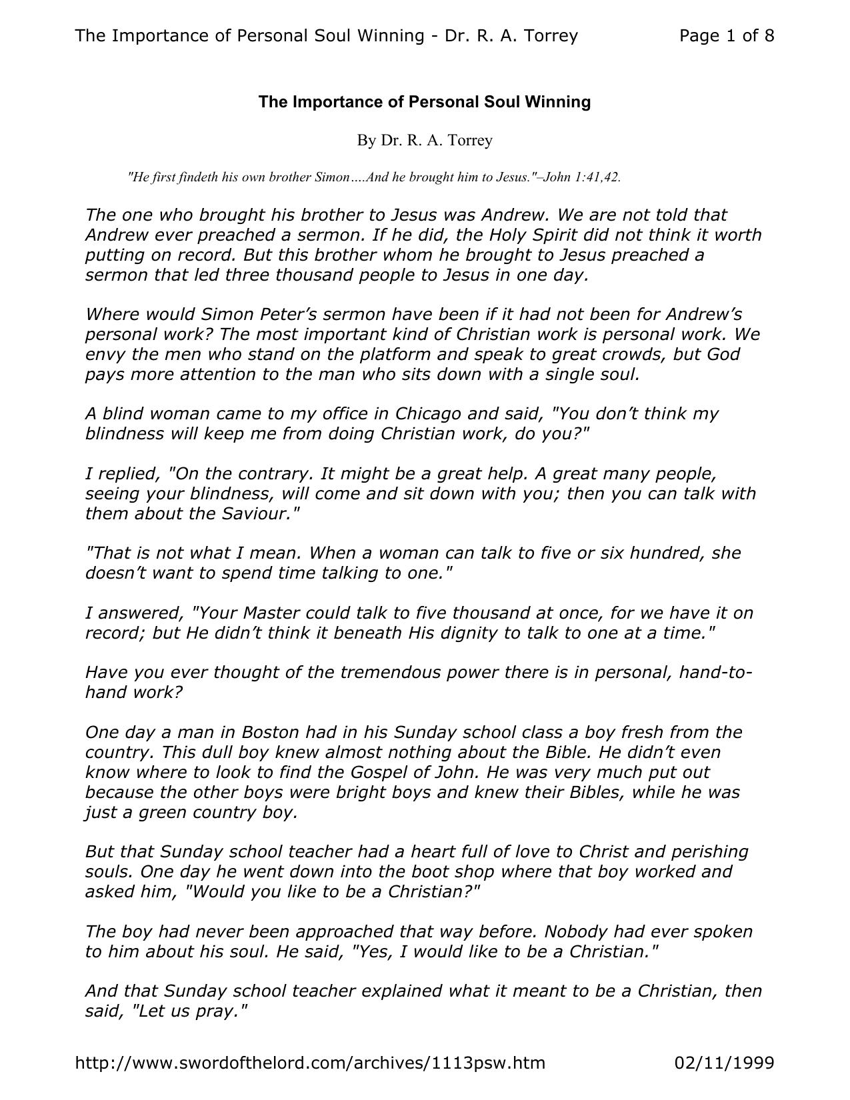

# The Importance of Personal Soul Winning

By Dr. R. A. Torrey

"He first findeth his own brother Simon….And he brought him to Jesus."–John 1:41,42.

The one who brought his brother to Jesus was Andrew. We are not told that

Andrew ever preached a sermon. If he did, the Holy Spirit did not think it worth

putting on record. But this brother whom he brought to Jesus preached a

sermon that led three thousand people to Jesus in one day.

Where would Simon Peter’s sermon have been if it had not been for Andrew’s

personal work? The most important kind of Christian work is personal work. We

envy the men who stand on the platform and speak to great crowds, but God

pays more attention to the man who sits down with a single soul.

A blind woman came to my office in Chicago and said, "You don’t think my

blindness will keep me from doing Christian work, do you?"

I replied, "On the contrary. It might be a great help. A great many people,

seeing your blindness, will come and sit down with you; then you can talk with

them about the Saviour."

"That is not what I mean. When a woman can talk to five or six hundred, she

doesn’t want to spend time talking to one."

I answered, "Your Master could talk to five thousand at once, for we have it on

record; but He didn’t think it beneath His dignity to talk to one at a time."

Have you ever thought of the tremendous power there is in personal, hand-to-

hand work?

One day a man in Boston had in his Sunday school class a boy fresh from the

country. This dull boy knew almost nothing about the Bible. He didn’t even

know where to look to find the Gospel of John. He was very much put out

because the other boys were bright boys and knew their Bibles, while he was

just a green country boy.

But that Sunday school teacher had a heart full of love to Christ and perishing

souls. One day he went down into the boot shop where that boy worked and

asked him, "Would you like to be a Christian?"

The boy had never been approached that way before. Nobody had ever spoken

to him about his soul. He said, "Yes, I would like to be a Christian."

And that Sunday school teacher explained what it meant to be a Christian, then

said, "Let us pray."

They knelt down in the back of that boot shop, and the boy became a Christian.

That boy was Dwight L. Moody.

If it had not been for Edward Kimball’s faithful personal work, where would

Dwight L. Moody and his great work throughout the world have been?

Who knows who there is in that little class of yours? Who knows what your

ignorant little ragged boy may become? Teacher, make up your mind that you

will at least make an honest effort to lead everyone in your Sunday school class

to Christ. This world could soon be evangelized by personal work.

Let us suppose there are two thousand people in this audience this morning.

Suppose every one of you became a personal worker. And suppose, by your

very best effort, you only succeeded in leading one to Christ in a year, and that

one led one to Christ the next year, and so on. What would be the result?

At the end of the year there would be 4,000; at the end of two years, 8,000; at

the end of three years, 16,000; at the end of four years, 32,000; at the end of

five years, 64,000; at the end of six years, 128,000; at the end of seven years,

256,000; and at the end of eight years your whole city would be won for Christ.

At the end of thirty-five years every man, woman and child on the face of the

earth would have heard the Gospel.

There is not one who cannot lead at least one to Christ this year. You can

instruct everyone whom you lead to Christ to go out and be a soul winner. After

you get hold of him, send him out, when converted, to lead another; and he

bringing one, and that one bringing in another–you will soon touch the whole

city.

I want to talk about the advantages of personal work.

The first advantage:

Anybody Can Do It

You cannot all preach. I am glad you can’t. What an institution this world would be if we were all preachers!

You cannot all sing like Charles Alexander. I am glad you can’t, for if you could, he would be no curiosity; and you

would not come to hear him sing and give me a chance to preach to you!

You cannot all teach Sunday school classes. Some have an idea that any converted person can teach a Sunday school

class. I don’t believe it. I think we are making a great mistake in setting the unqualified to teaching.

But there is not a child of God who cannot do personal work. A mother with a large family knows she is not called to

be a preacher (at least I hope she does); but she can do personal work better than anybody else in her home.

A lady came to me–she had five children–and said (I think she had been reading the life of Frances Willard), "I wish I could do some work like that for Christ."

I said, "You can work for Christ among all the people you are surrounded by."

I watched that woman. Every one of her children was brought to Christ–every one! Every maid who came to work in that home was dealt with about her soul. Every grocer’s boy who came around to the door was dealt with about his soul. Every time she went out shopping, she made it a point to talk with the one behind the counter. And when, one dark day, death came into the home and took away a sweet little child, she did not forget to speak to the undertaker who came to do the last offices for the dead, about his soul. He told me that nothing had ever impressed him as that

woman, in the midst of her sorrow, being interested in his soul.

An invalid can do personal work. I have a friend in New York City who has left a life of wealth and fashion to go out to

work among the outcast.

One day she got hold of a poor outcast girl. The girl didn’t live much over a year after that lady had led her to Christ. My friend took her to her home to die. As Delia was dying, she wrote to her friends, some in Sing Sing Prison, some in the Tombs of New York City–all her friends were among the criminal class–about Christ. Those who were not behind

prison bars she invited to come and see her.

My friend told me, "There was a constant procession up the stairway to the outcast–women and men who came to see

Delia. Before Delia died, one hundred of the most hopeless men and women in New York City she had led to Christ."

That puts us to shame! Suppose God kindled a fire right here in your hearts and you received the anointing of the Spirit of Christ, and every one of you should start out to do personal work; you would not need any evangelist to come from

abroad.

We have come to stir you up to do it.

The second advantage:

You Can Do It in Any Place

You cannot preach in every place. You can preach in the churches two or three times a week; you can preach in the town hall occasionally; you can preach in the streets sometimes; but you cannot go down in the factories and preach

often. You cannot go there and hold services, but you can go there and do personal work, if you press the point enough.

One man who came to our meetings in Liverpool from Hudson’s dry soap factory was converted. Every once in awhile

I get a letter telling me of meetings there in the factory. Now they conduct meetings outside the building.

In Bradley’s foundry a workman got a card announcing the meetings. He could not come, so he handed it over to the most wicked man in the shop. That man was grateful for the invitation and thought he would go. He did and was

converted at the very first meeting. He went back and told his companions, resulting in a revival in the foundry.

A telegraph messenger was converted in Manchester. Before we were through, seventy messenger boys were converted

there. There is not a hotel or a factory or a public house where you cannot do personal work.

The third advantage:

You Can Do It at Any Time

Certainly you cannot preach every hour of the day, but there is not an hour of the day or night when you cannot do personal work. You can go out on the streets at any time and find some poor wanderer.

When I lived in Minneapolis, I employed a woman missionary to go out on the streets to speak to the drunkards, to the outcast women, and to night workers. Some of the best conversions were among these people. She had been an outcast

herself at one time; now she was leading others to Christ.

Soon after Mr. Moody was converted, he made up his mind that he would not let a day go by without speaking to

someone about his soul.

One night he came home late–it was nearly ten o’clock. He realized he hadn’t spoken to any man that day. He thought, I guess I have lost my chance. But looking out he saw a man standing in the lamplight. He thought, There’s my chance.

He hurried up to him and asked, "Are you a Christian?"

"It’s none of your business. And if you were not sort of a preacher, I would knock you into the gutter."

"Well," Mr. Moody said, "I just wanted to lead you to Christ."

The next day this same man went to a friend of Mr. Moody’s and said, "That man Moody has zeal without knowledge. He spoke to me on the street last night. He asked me if I were a Christian. It was none of his business. If he had not

been sort of a preacher, I would have knocked him down. He is doing more harm than good."

Moody’s friend came to Moody and said, "Moody, it is all right to be in earnest; but you have zeal without knowledge. You are doing more harm than good." (Let me say here, it is better to have zeal without knowledge than knowledge

without zeal.)

Mr. Moody went away feeling rather cheap and crestfallen.

A few weeks passed. One night there was a pounding at his door. Moody got up and opened the door. There stood this very man he had witnessed to. He said, "Mr. Moody, I have not had a night’s peace since you spoke to me that night

under the lamp-post. I have come to ask you to show me how to be a Christian."

Mr. Moody took him in and showed him the way of life, and he was saved.

When the Civil War broke out, that man laid down his life for his country.

Another time the thought came to Moody after he was in bed, You have not spoken to your man today. But he argued

with himself: I am in bed. I can’t get up and go out now.

He could not rest, so he got up, dressed and opened the door. It was pouring rain. He thought, There is no use going out

on the street this awful night. Not a soul will be out in this pouring rain.

Just then he heard the patter of a man’s feet. As he came close, Mr. Moody rushed out and said, "Can I have the shelter

of your umbrella?"

"Certainly."

"Have you a shelter in the time of storm?"–and he pointed the man to Jesus.

The fourth advantage:

# It Reaches All Classes

In preaching, one has to be more or less general. In personal work, you have just one person to talk to, and you can hit

the mark every time.

Henry Ward Beecher went out shooting with his father. He had often gone before, but he had never shot anything.

Way down yonder was a squirrel. His father said, "Henry, do you see that squirrel?"

"Yes, Father."

"Would you like to hit it?"

"Yes, Father; but I never hit anything in my life."

"You lay the barrel of your gun across the top rail down here and look right down along the barrel. Henry, do you see

the squirrel?"

"Yes, Father."

"Well, pull the trigger."

He pulled the trigger, and the squirrel fell at the first shot–the first thing he ever shot in his life. Why? Because it was

the first thing he had ever aimed at.

That is the trouble with a good deal of our preaching: we aim at nothing and hit it every time. This is the advantage of

personal work: we aim at one definite person.

But in our preaching, as Mr. Moody used to say, "I speak to this lady on the front seat, and she passes it over her shoulder to the man back of her; he passes it to the woman back of him; she passes it to the man back of her. They keep

passing it on till they pass it out the back door."

We have a wonderful power of applying the good points of a sermon to somebody else. When it comes to personal

work, there is nobody else to apply it to.

I try to be personal in my preaching; but be as personal as I can, I can still miss my mark.

A man came to my church one morning who had been talking about "the deeper life." He had all the phraseology of the deepest Christian experience. He talked about being filled with the Spirit, yet cheated others in business. When I saw him coming in, I said to myself, I am glad you have come. I will hit you this morning. I have a sermon just adapted to

you.

While I was preaching, I looked right at him so he would know I meant him. He sat there beaming up at me.

When the sermon was over, he came down to me rubbing his hands. He said, "Oh, Brother Torrey, I came eight miles

to hear you this morning. I have so enjoyed it."

That was just what I did not want to hear: I wanted to make him miserable. But I had him now face-to-face, and he

didn’t enjoy it.

That is the advantage of personal work. You can aim right square at the mark and hit it.

The minister can preach all he pleases, but when he looks you right in the eye, you know it means you. It aims right

straight at the mark and hits it.

The fifth advantage:

It Is Effective

Personal work succeeds where every other kind of work fails. I don’t care who the preacher is, how good a preacher he may be; one not affected by the sermon will be reached by some very ordinary person with the love of God and of souls

in his heart.

Take Mr. Moody, for example. I think he was as good a preacher as I ever heard. I would rather hear Mr. Moody preach a sermon that I had heard a dozen times than to hear any other man preach a sermon I had never heard. But as

good a preacher as Mr. Moody was, thousands would go out utterly unmoved by his message.

I have seen uneducated, very ordinary working people with the love of Christ and of souls in their hearts get hold of a

person who had gone out of Mr. Moody’s meeting utterly untouched and in ten or fifteen minutes lead him to the Lord.

The sixth advantage:

It Meets the Specific Need of the Individual

After a man comes to Christ, he still may have difficulties and doubts, troubles and questions. He cannot ask them of the preacher. How often a man sits down in the audience and says to himself, I wish I could speak to that preacher

alone.

In this personal, hand-to-hand work, a man can ask all the questions he wants to, and you can meet his difficulties. I am

getting letters from people all over the world who have difficulties.

My father used to tell a story (he did not vouch for its truth) of a physician in the village who kept a certain jug. He took a little of every kind of medicine he had in his shop and put it in that jug, and then shook it up. When one came to him and he did not know just what his ailment was, he would give him a spoonful out of that jug, thinking, There is

something in it that will meet his case anyhow.

We do that in our preaching. We take a little comfort and put it in the sermon, a little bit of conviction, a little bit to

show the way of life, shake it all up and give it to the people.

If I were going to be doctored, I would want the doctor to find out my specific need.

In personal work you give specific passages of Scripture for specific difficulties.

The seventh advantage:

It Produces Abundant Results

In great services where the ministers may speak to 500 or 1,000 or 5,000, they do not produce as abundant results.

Suppose a man were pastor of a church of a hundred members; suppose he were a very faithful minister, and as a result of his preaching there were added fifty to his church each year on confession of faith. That would be a pretty good

record.

Now suppose that pastor said, "I am going to train my people to do personal work," and he trained his people to do personal work. Suppose only one-half of them would consent to do it. Suppose these fifty trained workers only

succeeded in winning one a month apiece to Christ. That would mean six hundred a year!

Friends, some of us think we pay the minister to do personal work. You do nothing of the kind. Your minister is your

leader, and you are supposed to work under his leadership.

One reason why the church of which I am pastor always has a revival is that the people are trained to do personal work. We have had a revival ever since I have been pastor. There have been ten years of revival. There has never been a month that we have not received new members. We would not know what to make of it if there were a Sunday without

conversions.

I do not think there has been any day in the week of all this time–3,650 days in all–that someone has not been won to

Christ in or about the building.

The preacher who will preach in my absence will see conversions. In the Sunday school there will be conversions, as well as in the evening meeting tonight. Why? Because our people believe in and do personal work. Every Sunday while I preach, I know the unsaved are right near someone in that church who knows how to lead a soul to Christ. Workers are in every section of the church. I like it in Chicago, because just as surely as somebody gets up and leaves, I know at least one person will speak to him that night. Someone will drop down the stairs behind the one leaving and perhaps

follow him a block or two before he speaks to that one.

Go to the people and ask God to give you power. The Holy Spirit is for every one of us. I do thank God that the great gift of the Holy Ghost is for every saved person. "If ye then, being evil, know how to give good gifts unto your children: how much more shall your heavenly Father give the Holy Spirit to them that ask him?" Just ask; then go out. Of course, you need to know something about the Bible in order to do personal work, but you only need one or two

texts to start with.

When Mr. Moody first came to New Haven, we thought we would go out and hear this strange, uneducated man. I was in the senior class in the theological department of the university, and was just about to take my B.D. degree. I knew

more then than I will ever know in my life again! We thought we would patronize Mr. Moody a little bit.

He did not seem at all honored by our presence.

As we heard that untutored man, we thought, He may be uneducated, but he knows some things we don’t. Some of us had sense enough to go to him and say, "Mr. Moody, we wish you would tell us how to do it." He told us to come round

early the next night and he would tell us.

We theologues went up to the meeting. He said a few words to us, gave us a few texts of Scripture, then said, "You go

at it!"

The best way to learn how to do it is to do it. "He that goeth forth and weepeth, bearing precious seed, shall doubtless

come again with rejoicing, bringing his sheaves with him."

If, however, you make a stupid blunder the first time, go at it again. But if you never start until you are sure you will

not make a blunder, you will make the biggest blunder of your life.

Get alone with God first, and see if you are right with Him; put away every known sin out of your life, surrender absolutely to God, ask for the fullness of the Holy Spirit, and then pitch in.