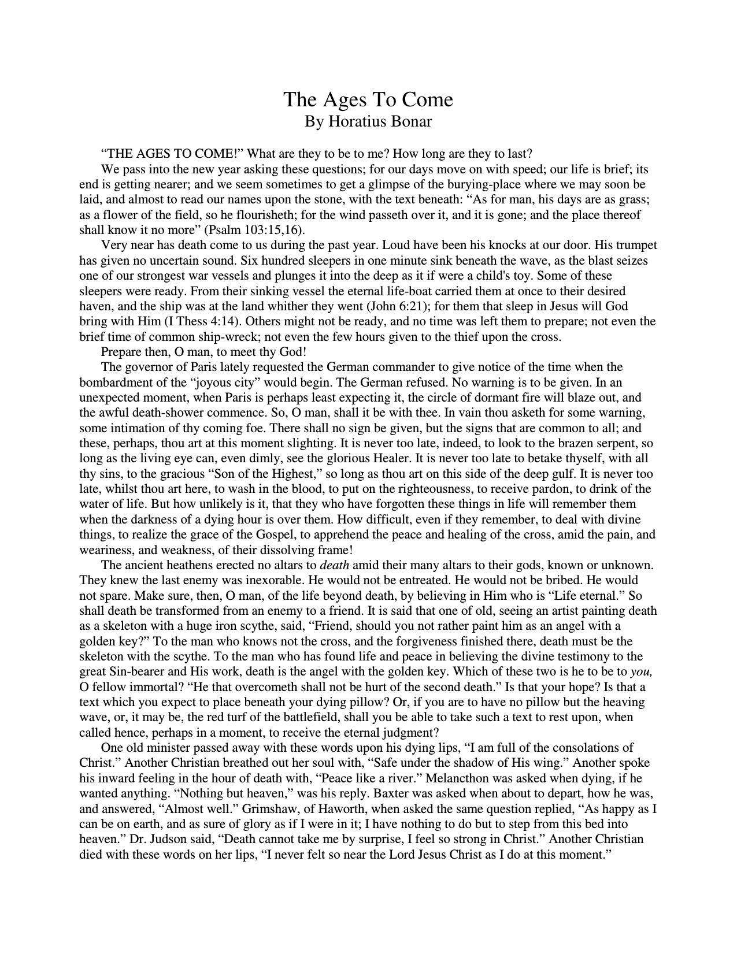

The Ages To Come

By Horatius Bonar

“THE AGES TO COME!” What are they to be to me? How long are they to last?

We pass into the new year asking these questions; for our days move on with speed; our life is brief; its

end is getting nearer; and we seem sometimes to get a glimpse of the burying-place where we may soon be

laid, and almost to read our names upon the stone, with the text beneath:

“As for man, his days are as grass;

as a flower of the field, so he flourisheth; for the wind passeth over it, and it is gone; and the place thereof

shall know it no more” (Psalm 103:15,16).

Very near has death come to us during the past year. Loud have been his knocks at our door. His trumpet

has given no uncertain sound. Six hundred sleepers in one minute sink beneath the wave, as the blast seizes

one of our strongest war vessels and plunges it into the deep as it if were a child's toy. Some of these

sleepers were ready. From their sinking vessel the eternal life-boat carried them at once to their desired

haven, and the ship was at the land whither they went (John 6:21); for them that sleep in Jesus will God

bring with Him (I Thess 4:14). Others might not be ready, and no time was left them to prepare; not even the

brief time of common ship-wreck; not even the few hours given to the thief upon the cross.

Prepare then, O man, to meet thy God!

The governor of Paris lately requested the German commander to give notice of the time when the

bombardment of the “joyous city” would begin. The German refused. No warning is to be given. In an

unexpected moment, when Paris is perhaps least expecting it, the circle of dormant fire will blaze out, and

the awful death-shower commence. So, O man, shall it be with thee. In vain thou asketh for some warning,

some intimation of thy coming foe. There shall no sign be given, but the signs that are common to all; and

these, perhaps, thou art at this moment slighting. It is never too late, indeed, to look to the brazen serpent, so

long as the living eye can, even dimly, see the glorious Healer. It is never too late to betake thyself, with all

thy sins, to the gracious “Son of the Highest,” so long as thou art on this side of the deep gulf. It is never too

late, whilst thou art here, to wash in the blood, to put on the righteousness, to receive pardon, to drink of the

water of life. But how unlikely is it, that they who have forgotten these things in life will remember them

when the darkness of a dying hour is over them. How difficult, even if they remember, to deal with divine

things, to realize the grace of the Gospel, to apprehend the peace and healing of the cross, amid the pain, and

weariness, and weakness, of their dissolving frame!

The ancient heathens erected no altars to *death* amid their many altars to their gods, known or unknown.

They knew the last enemy was inexorable. He would not be entreated. He would not be bribed. He would

not spare. Make sure, then, O man, of the life beyond death, by believing in Him who is “Life eternal.” So

shall death be transformed from an enemy to a friend. It is said that one of old, seeing an artist painting death

as a skeleton with a huge iron scythe, said, “Friend, should you not rather paint him as an angel with a

golden key?” To the man who knows not the cross, and the forgiveness finished there, death must be the

skeleton with the scythe. To the man who has found life and peace in believing the divine testimony to the

great Sin-bearer and His work, death is the angel with the golden key. Which of these two is he to be to *you,*

O fellow immortal? “He that overcometh shall not be hurt of the second death.” Is that your hope? Is that a

text which you expect to place beneath your dying pillow? Or, if you are to have no pillow but the heaving

wave, or, it may be, the red turf of the battlefield, shall you be able to take such a text to rest upon, when

called hence, perhaps in a moment, to receive the eternal judgment?

One old minister passed away with these words upon his dying lips, “I am full of the consolations of

Christ.” Another Christian breathed out her soul with, “Safe under the shadow of His wing.” Another spoke

his inward feeling in the hour of death with, “Peace like a river.” Melancthon was asked when dying, if he

wanted anything. “Nothing but heaven,” was his reply. Baxter was asked when about to depart, how he was,

and answered, “Almost well.” Grimshaw, of Haworth, when asked the same question replied, “As happy as I

can be on earth, and as sure of glory as if I were in it; I have nothing to do but to step from this bed into

heaven.” Dr. Judson said, “Death cannot take me by surprise, I feel so strong in Christ.” Another Christian

died with these words on her lips, “I never felt so near the Lord Jesus Christ as I do at this moment.”

Another once and again repeated the words, “Death hath no sting, Christ hath taken it away.” Another

exclaimed, “If this is the valley of the shadow of death, there is no darkness in it—it is all light.”

“LET ME DIE THE DEATH OF THE RIGHTEOUS, AND LET MY LAST END BE LIKE HIS.“

To him who reads these pages there may be but short time remaining. “This year thou shalt die,” were

the awful words that once came to a sinner from a prophet's lips. And though no prophet comes thus to

sound his trumpet in your ears, it may not be the less true that this year may be your last on earth.

Be it so or not, we speak to you as one who still liveth upon this earth, and to whom, therefore, in all its

gracious plenty, the Gospel comes. It speaks to you as a dying creature; it speaks to your undying soul. It

speaks the words of grace; yet it urges you to make haste. It points to the open gate of the glorious city; yet it

says, that in a moment that gate may be shut. It tells you of eternal life through Him who died and rose

again. It assures you that whosoever believeth is saved.

That which makes up the “good news” for sinners, God has most fully made known. We need not be at a

loss to find out what is “the gospel of the grace of God.” In love He gave His Son, as the Bearer of our sins;

as “the Lamb of God, which taketh away the sin of the world.” In love He has written down for us the whole

story of the life and death of this divine Sin-bearer. “The Word was made flesh” at Bethlehem; the Son of

God there became very man, bone of our bone, and flesh of our flesh. There He who knew no sin came

under the burden of our sins. For sin is so evil, and God is so just, and the law is so holy, that either we must

bear our own sins or another must bear them for us; they cannot pass unpunished. There must be a substitute,

if there is to be salvation.

For thirty-three years “the Son of the Blessed” dwelt among us, speaking words of grace, doing deeds of

mercy, revealing God to us, carrying out the great work of love, and completing the great propitiation for

sin. He went up to the cross as the Sin-bearer; He went down to the grave as such; He rose again the third

day as one who had done the whole work, and who had been accepted by the Father as such. “He was

delivered for our offences, and rose again for our justification.” “He suffered, the Just for the unjust, that He

might bring us to God.” “He hath made peace by the blood of His cross.”

All the perfection of Christ's person and work is now presented to the sinner, that he may receive it, and

be saved. The Gospel comes to him with the finished work of the Substitute, and presses that work on his

acceptance; so that in simply taking it as God presents it, he may stand on a new footing, even that of the

perfectness of Christ, instead of his own imperfectness.

Thus we press the treasures of the Gospel on each reader of these lines. It speaks to you of the fulness of

Christ, and the open way of access for you, a sinner, to all that fulness. It bids you welcome to the mercy-

seat with all your worthlessness. It beckons you with the eager hand of love, to return to God and enter the

city of refuge. It contains “good news”—the best tidings to the sons of men; and it sums up with, “ONLY

BELIEVE.”

“THE AGES TO COME.” Perhaps the eyes of some mourner may rest on these lines. Cast your sorrow

upon Jesus, who is your Sorrow-bearer, as well as your Sin-bearer; and look forward to that city of light

where darkness cannot dwell, neither sorrow nor crying; and where tears are wiped from every eye. The

days of thy mourning shall be ended. The night shall pass away, and the morning star appear. Christian

mourner, lean on the arm of your Lord, and pour your sorrows into His bosom.

A lady, a missionary in Persia, was once teaching a class of inquiring natives. Worn out with the

fatigues of a busy day, she could hardly sit erect. One of the converts, observing her weakness, placed

herself behind her as a pillow, saying, “Lean on me.” The loving teacher leant a little, but was afraid of

leaning too much. The same kind voice again spoke out, “If you love me, lean hard.” Oh, sorrowful

Christian, lean on Jesus. He says to you, “If you love Me, lean hard.”

“THE AGES TO COME.” How soon will they be here! With their untold riches of joy, and song, and

brightness, they will soon be here. With their happy re-unions, their everlasting fellowships, their never-

ending rest, their never-setting suns, they will soon be here! Our labors done, our victory gained; our

weariness at an end; our vexations and troubles gone like a dream of the night; our wounds all healed; our

heartaches soothed; our heaviness of spirit exchanged for heavenly buoyancy; our ignorance all forgotten in

divine wisdom and knowledge; our hanging hands lifted up, and our feeble knees made strong; our wrinkled

foreheads soothed by the same tender hand that wipes all tears from our eyes; all the imperfections of earth

lost in the perfection of heaven!

The arrival of all these things may be nearer than we think. For “He that shall come will come, and will

not tarry.” “What manner of persons,” then, “ought we to be, in all holy conversation and godliness!” Surely

we are called to a higher style of Christian life than most of us are living! How much holier, more prayerful,

more unworldly, more self-denying, more loving and spiritual, ought all who name the name of Christ to be!

We shall be like Him when we shall see Him as He is. Shall we not seek to be like Him here?

What makes us holy? Close intimacy with Jesus. What makes faith grow? Dealing much with Jesus.

What fills us with joy? Looking into the face of Jesus. What keeps us steadfast? Leaning on the arm of

Jesus. What comforts us in sorrow? Resting on the bosom of Jesus. For Christ *is* all and in all; and we have

all in Him. Let us seek to honor His fulness by receiving it fully, and to enjoy His love.